**CONTENT**

[INTRODUCTION 1](#_Toc434224964)

[Chapter 1 PROJECT DESCRIPTION 1-1](#_Toc434224965)

[1.1 PROJECT NAME 1-1](#_Toc434224966)

[1.2 PROJECT OWNER 1-1](#_Toc434224967)

[1.3 PROJECT LOCATION 1-1](#_Toc434224968)

[1.4 PROJECT DEVELOPMENT DESIGN 1-3](#_Toc434224969)

[1.4.1 Overall Development and Production Plan 1-3](#_Toc434224970)

[1.4.2 Su Tu Trang Field Characteristics 1-7](#_Toc434224971)

[1.4.3 Facilities of Su Tu Trang Full Field Development Phase 1 Project 1-13](#_Toc434224972)

[1.4.4 Project Technology 1-49](#_Toc434224973)

[1.4.5 List of main STT FFD Phase 1 Project Equipment and facilities 1-57](#_Toc434224974)

[1.4.6 Material Usage 1-59](#_Toc434224975)

[1.5 INVESTMENT CAPITAL 1-61](#_Toc434224976)

[1.6 ORGANIZATION AND LABOUR 1-63](#_Toc434224977)

[1.7 SUMMARY OF SOME MAIN INFORMATIONS OF STT FFD PHASE 1 PROJECT 1-65](#_Toc434224978)

[Chapter 2 DESCRIPTIONS OF NATURAL, ENVIRONMENTAL AND SOCIO-ECONOMIC CONDITIONS 2-1](#_Toc434224979)

[2.1 NATURAL CONDITION AND ENVIRONMENTAL CHARACTERISTICS 2-1](#_Toc434224980)

[2.1.1 Geographic and geological characteristic 2-1](#_Toc434224981)

[2.1.2 Meteorological characteristics 2-4](#_Toc434224982)

[2.1.3 Oceanographic characteristics 2-14](#_Toc434224983)

[2.1.4 Existing natural environment 2-20](#_Toc434224984)

[2.1.5 Existing Biological resources 2-27](#_Toc434224985)

[2.1.6 Environmental sensitivity and recovery potential at the project area 2-38](#_Toc434224986)

[2.1.7 Suitability of project site selection with the surrounding environmental natural conditions 2-38](#_Toc434224987)

[2.2 SOCIO - ECONOMIC CONDITIONS 2-40](#_Toc434224988)

[2.2.1 Economic conditions 2-40](#_Toc434224989)

[2.2.2 Social conditions 2-45](#_Toc434224990)

[2.2.3 Suitability of the project site selection with the socio-ecomomic conditions of the surrounding area 2-48](#_Toc434224991)

[Chapter 3 ENVIRONMENTAL IMPACT ASSESSMENT 3-1](#_Toc434224992)

[3.1 ENVIRONMENTAL ASPECTS AND IMPACT ASSESSMENT 3-4](#_Toc434224993)

[3.1.1 INSTALLATION AND COMMISSIONING PHASE 3-4](#_Toc434224994)

[3.1.2 DRILLING PHASE 3-15](#_Toc434224995)

[3.1.3 PRODUCTION PHASE 3-32](#_Toc434224996)

[3.1.4 ENVIRONMENTAL ASPECTS AND IMPACTS FROM ONSHORE SUPPORT 3-47](#_Toc434224997)

[3.1.5 DECOMMISSION PHASE 3-50](#_Toc434224998)

[3.1.6 ACCUMULATIVE ENVIRONMENTAL IMPACTS FROM PETROLEUM OPERATIONS IN THE VICINITY 3-52](#_Toc434224999)

[3.1.7 ACCIDENTAL EVENTS 3-55](#_Toc434225000)

[3.1.8 SOCIAL AND ECONOMIC IMPACTS 3-69](#_Toc434225001)

[3.2 DETAIL AND RELIABILITY OF ASSESSMENT METHODOLOGY 3-70](#_Toc434225002)

[3.2.1 Details of the EIA 3-70](#_Toc434225003)

[3.2.2 Reliability of the environmental impact assessment 3-71](#_Toc434225004)

[Chapter 4 MITIGATION, PREPAREDNESS & EMERGENCY RESPONSE MEASURES 4-1](#_Toc434225005)

[4.1 INTRODUCTION 4-1](#_Toc434225006)

[4.2 MITIGATION MEASURES TO REDUCE AND PREVENT THE NEGATIVE IMPACTS OF PROJECT TO THE ENVIRONMENT 4-2](#_Toc434225007)

[4.2.1 INSTALLATION AND COMMISSIONING PHASE 4-2](#_Toc434225008)

[4.2.2 DRILLING PHASE 4-6](#_Toc434225009)

[4.2.3 PRODUCTION PHASE 4-19](#_Toc434225010)

[4.2.4 DECOMMISSIONING ACTIVITIES 4-31](#_Toc434225011)

[4.3 PREVENTION MEASURES AND RESPONSE TO POTENTIAL RISK AND INCIDENTS 4-31](#_Toc434225012)

[4.3.1 INSTALLATION AND CONSTRUCTION PHASE 4-32](#_Toc434225013)

[4.3.2 DRILLING PHASE 4-32](#_Toc434225014)

[4.3.3 PRODUCTION PHASES 4-34](#_Toc434225015)

[4.3.4 Decommissioning phase 4-36](#_Toc434225016)

[4.3.5 Emergency response procedure 4-36](#_Toc434225017)

[4.3.6 Oil Spill Contingency Plans 4-38](#_Toc434225018)

[4.4 METHODS AND ORGANIZATION OF IMPLEMENTING THE ENVIRONMENTAL PROTECTION FACILITIES 4-51](#_Toc434225019)

[Chapter 5 ENVIRONMENTAL MANAGEMENT AND MONITORING PROGRAMS 5-1](#_Toc434225020)

[5.1 ENVIRONMENTAL MANAGEMENT PROGRAM (EMP) 5-1](#_Toc434225021)

[5.1.1 CLJOC Policy on Health, Safety & Environment 5-1](#_Toc434225022)

[5.1.2 CLJOC’s Health, Safety and Environmental Management System 5-3](#_Toc434225023)

[5.1.3 Establishment and implementation of Environmental management plan and program 5-7](#_Toc434225024)

[5.1.4 Summary of Environmental Management Plan for all phases of project 5-12](#_Toc434225025)

[*5.2* ENVIRONMENTAL MONITORING PROGRAM 5-32](#_Toc434225026)

[5.2.1 Basis of the environmental monitoring program (EMP) 5-32](#_Toc434225027)

[5.2.2 Periodical waste source monitoring program 5-33](#_Toc434225028)

[5.2.3 Field Environmental Monitoring Program in the Development and Production Phases 5-35](#_Toc434225029)

[5.2.4 Environmental Monitoring Program for Decommissioning Phase 5-40](#_Toc434225030)

[Chapter 6 PUBLIC CONSULTATION 6-1](#_Toc434225031)

[Chapter 7 CONCLUSIONS, RECOMMENDATIONS AND COMMITMENTS 7-1](#_Toc434225032)

[7.1 CONCLUSIONS 7-1](#_Toc434225033)

[7.2 RECOMMENDATIONS 7-6](#_Toc434225034)

[7.3 COMMITMENTS 7-6](#_Toc434225035)

[**REFERENCES** 7-9](#_Toc434225036)

LIST OF TABLE

[Table 1.1 Overall Schedule for the STT FFD Phase 1 Project 1-6](#_Toc434225037)

[Table 1.2 STT Reservoir PVT Properties from BHS’s in DST’s 1-8](#_Toc434225038)

[Table 1.3 Basement Reservoir Rheological Properties of STT stream 1-8](#_Toc434225039)

[Table 1.4 Composition of STT Condensate 1-8](#_Toc434225040)

[Table 1.5 Composition of STT Gas 1-10](#_Toc434225041)

[Table 1.6 STT FFD PHASE 1 Reservoir Recovery Oil Reserves 1-10](#_Toc434225042)

[Table 1.7 STT Average Production Profile (P50 – STT Phase 1 – Case P2) 1-12](#_Toc434225043)

[Table 1.8 STT FFD Phase 1 Project Design Basis 1-12](#_Toc434225044)

[Table 1.9 STT-PIP Location and Design Capacity 1-17](#_Toc434225045)

[Table 1.10 Overall capacities of the STV-CPP and facilities 1-41](#_Toc434225046)

[Table 1.11 Proposed Casing Program and Mud System 1-52](#_Toc434225047)

[Table 1.12 List of main equipment relating to environment on the STT FDP Phase 1 Facilities 1-57](#_Toc434225048)

[Table 1.13 Typical Main Chemicals and Consumption of Drilling Operations 1-59](#_Toc434225049)

[Table 1.14 Characteristics of production chemicals 1-60](#_Toc434225050)

[Table 1.15 Estimation of budget for environmental protection for STT FFD Phase 1 Project 1-62](#_Toc434225051)

[Table 2.1 Specific Seasonal Wind Types and Wind Speed 2-4](#_Toc434225052)

[Table 2.2 The statistical data of direction and maximum speed in Block 15-1 during 7 years (2008-2014) 2-5](#_Toc434225053)

[Table 2.3 Velocity/direction of wind in storms/tropical low pressures in 100 years, 10 years and 1 year 2-6](#_Toc434225054)

[Table 2.4 Statistical data of air temperature in the study area 2-6](#_Toc434225055)

[Table 2.5 Statistical data on air pressure at offshore study area 2-8](#_Toc434225056)

[Table 2.6 The statistics of average humidity in the study area 2-9](#_Toc434225057)

[Table 2.7 Statistical data on monthly rainfall during 5 years in the study area 2-10](#_Toc434225058)

[Table 2.8 Frequency of storms and tropical depressions in 2008 – 2012 2-11](#_Toc434225059)

[Table 2.9 Recorded seismics in the region and surrounding area 2-13](#_Toc434225060)

[Table 2.11 Statistical data of monthly tidal height at Phu Quy station during 2009 – 2012 2-14](#_Toc434225061)

[Table 2.12 Statistical Data on Current in Block 15-1 within 1, 10, and 100 years 2-15](#_Toc434225062)

[Table 2.13 Statistical data about wave at Phu Quy station during 2009 – 2013 2-18](#_Toc434225063)

[Table 2.14 Statistics of Wave Regime in the Block 15-1 in 5 Years 2-19](#_Toc434225064)

[Table 2.15 The coordinates of sampling sites of STT Field 2-21](#_Toc434225065)

[Table 2.16 The analytical results of seawater quality in the study area 2-23](#_Toc434225066)

[Table 2.17 The analytical results of heavy metal contents in seawater 2-23](#_Toc434225067)

[Table 2.18 Analytical results of sediment size in the study area 2-23](#_Toc434225068)

[Table 2.19 Analytical results of sediment size and Hydrocarbon content 2-24](#_Toc434225069)

[Table 2.19 Analytical Results of Benthos in the Study Area 2-27](#_Toc434225070)

[Table 2.26 Statistical data on population of Binh Thuan and BR-VT Provinces in 2011-2012 2-45](#_Toc434225071)

[Table 2.28 Number of Schools, Teachers and Pupils of the Coastal in the Area from Binh Thuan to Ba Ria - Vung Tau in 2012 2-46](#_Toc434225072)

[Table 3.1 Ranking system of impact quantitative system (IQS) 3-2](#_Toc434225073)

[Table 3.2 Air emission sources in installation and commissioning phase 3-5](#_Toc434225074)

[Table 3.3 Estimation of diesel volume to be used in the installation and commissioning phase 3-6](#_Toc434225075)

[Table 3.4 Estimated of air emission from the installation and commissioning phase 3-6](#_Toc434225076)

[Table 3.5 Impacts magnitude of air emission during installation and commissioning phase 3-7](#_Toc434225077)

[Table 3.6 Wastewater sources in Installation and commissioning phase 3-7](#_Toc434225078)

[Table 3.7 Estimation of domestic wastewater for the Installation and commissioning phase of ST-FFDP1 3-8](#_Toc434225079)

[Table 3.8 Impacts Magnitude of Aqueous Discharges during Installation and Commissioning Phase of ST-FFDP1 3-9](#_Toc434225080)

[Table 3.9 Source of solid wastes from installation and commissioning phase 3-9](#_Toc434225081)

[Table 3.10 Estimated quantities of solid wastes in installation and commissioning phase 3-10](#_Toc434225082)

[Table 3.11 Impacts Magnitude of Solid Waste during Installation and Commissioning Phase from STT FFDP1 3-11](#_Toc434225083)

[Table 3.12Impacts magnitude of physical interactions during installation and commissioning phase of STFFDP1 3-13](#_Toc434225084)

[Table 3.13 Source of air emissions in drilling phase of STT FFDP1 3-16](#_Toc434225085)

[Table 3.14Emission factors by UKOOA 3-16](#_Toc434225086)

[Table 3.15Estimated total loads of air emissions from drilling phase 3-17](#_Toc434225087)

[Table 3.16 Impacts magnitude of atmospheric emission during drilling phase 3-18](#_Toc434225088)

[Table 3.17 Effluent sources in drilling phase of STT FFDP1 3-18](#_Toc434225089)

[Table 3.18 Estimated effluent discharge in drilling phase of ST-FFDP1 3-18](#_Toc434225090)

[Table 3.19Impacts magnitude of wastewater in the drilling phase of ST-FFDP1 3-19](#_Toc434225091)

[Table 3.20 Drilling waste sources in drilling phase of ST-FFDP1 3-20](#_Toc434225092)

[Table 3.21 Estimation of discharge volume of WBM and SBM drilling cuttings from ST-FFDP1 3-21](#_Toc434225093)

[Table 3.22Estimation of discharge quantity of SBF adhered on drilling cuttings from STT FFDP1 3-22](#_Toc434225094)

[Table 3.33Air Emission Coefficient of UKOOA 3-34](#_Toc434225095)

[Table 3.46 Solid waste sources in production phase 3-44](#_Toc434225096)

[Table 3.47Quantity of Solid wastes in production phase of STT FFDP1 3-45](#_Toc434225097)

[Table 3.49 Impacts magnitude of physical interaction during operation phase 3-47](#_Toc434225098)

[Table 3.62 Summary of Impacts on local society and economy caused by STT FFDP1 activities (exception of accidental events) 3-70](#_Toc434225099)

[Table 4.1 Designed capacity of produced water treatment system on STV - CPP before and after starting STT FFDP1 Project 4-21](#_Toc434225100)

[Table 4.2 Tired Response Cooperation and Mobilization Resources 4-39](#_Toc434225101)

[Table 5.1 Environmental Management Plan of STT FFDP Phase 1 13](#_Toc434225102)

[Table 5.2 Sampling location & frequency in waste source monitoring program 5-34](#_Toc434225103)

[Table 5.3 Analytical parameters in waste source monitoring 5-35](#_Toc434225104)

[Table 5.4 Co-ordinates of proposed sampling stations 5-36](#_Toc434225105)

[Table 5.5 Analytical Parameter & Procedure Of Seawater 5-38](#_Toc434225106)

[Table 5.6 Analytical Parameter & Procedure Of Seabed Sediment 5-39](#_Toc434225107)

LIST OF FIGURE

[Figure 1.1 Block 15-1 Location Map 1-2](file:///E:\Projects\Truc\STT\Eng\EIA%20report%20for%20STT%20FFDP%20Phase%201%20(Eng).docx#_Toc434225108)

[Figure 1.2 Overall Scheme of the anticipated facilities in the Block 15-1 During STT FFD Phase 1 1-4](#_Toc434225109)

[Figure 1.3 Overall Scheme of the anticipated facilities in the Block 15-1 during STT FFD Phase 1 1-6](#_Toc434225110)

[Figure 1.4 STT FFD Phase 1 Production Profile 1-11](#_Toc434225111)

[Figure 1.5 ST-PIP 4 legged platform Isometric View 1-15](#_Toc434225112)

[Figure 1.6 ST-LQ 4 legged platform Isometric View 1-22](#_Toc434225113)

[Figure 1.7 Overall Process Flow Diagram of ST-PIP 1-26](#_Toc434225114)

[Figure 1.8 Flow Diagram of Fuel Gas Systems ST-PIP 1-27](#_Toc434225115)

[Figure 1.9a Open & Closed Drain Systems on ST-PIP 1-28](#_Toc434225116)

[Figure 1.24 1-64](file:///E:\Projects\Truc\STT\Eng\EIA%20report%20for%20STT%20FFDP%20Phase%201%20(Eng).docx#_Toc434225117)

[Figure 2.1 Topographic Map of Cuu Long Basin 2-2](#_Toc434225118)

[Figure 2.2 Tectonic Map of Cuu Long Basin 2-3](#_Toc434225119)

[Figure 2.3 Cenozoic stratigraphy 2-3](#_Toc434225120)

[Figure 2.4 Variation of air temperature during a year 2-7](#_Toc434225121)

[Figure 2.5 Variation of air pressure 2-8](#_Toc434225122)

[Figure 2.6 Variation of monthly rainfall in a year 2-10](#_Toc434225123)

[Figure 2.7 Frequency-magnitude relationship 2-12](#_Toc434225124)

[Figure 2.8 Zoning map for maximum credible earth¬quakes in Vietnam 2-12](#_Toc434225125)

[Figure 2.9 Ring of Earthquakes in SE Vietnam Sea 2-14](#_Toc434225126)

[Figure 2.10 Current Rose at the Project Area 2-16](#_Toc434225127)

[Figure 2.11 Typical Wave and Wind Regimes Offshore Vietnam 2-17](file:///E:\Projects\Truc\STT\Eng\EIA%20report%20for%20STT%20FFDP%20Phase%201%20(Eng).docx#_Toc434225128)

[Figure 2.12 Wave Rose at the project area 2-20](#_Toc434225129)

[Figure 2.13 Sampling Site Grid of the STT Field 2-22](file:///E:\Projects\Truc\STT\Eng\EIA%20report%20for%20STT%20FFDP%20Phase%201%20(Eng).docx#_Toc434225130)

[Figure 2.14 Variation of sediment parameters 2-26](#_Toc434225131)

[Figure 2.15 Map of pelagic fish distribution along Binh Thuan-Vung Tau sea area 2-29](#_Toc434225132)

[Figure 2.16 Map of Demersal fish distribution along sea of Binh Thuan-Vung Tau area 2-29](#_Toc434225133)

[Figure 2.17 Map of shrimp distribution at the southeast Vietnam sea 2-31](#_Toc434225134)

[Figure 2.18 Distribution of Cuttle fish Grounds in the Northeast Monsoon Season in the SE Vietnam Sea 2-32](#_Toc434225135)

[Figure 2.19 Distribution of cuttle-fish grounds in the Southwest Monsoon Season in the SE Vietnam Sea 2-32](#_Toc434225136)

[Figure 2.20 Distribution of coral reefs in Ca Na bay (Cu Lao Cau) 2-34](#_Toc434225137)

[Figure 2.21 Distribution Map of Functional Areas in Phu Quy Island 2-35](#_Toc434225138)

[Figure 2.22 Distribution of Seagrass around Phu Quy Island - Binh Thuan 2-36](#_Toc434225139)

[Figure 2.23 A rare sea turtle species have been also found on the Phu Quy Island on June 11th 2011. This shows that this area also has natural beach for turtle spawning 2-37](#_Toc434225140)

[Figure 2.24 The Environmental Sensitivity Map of project area 2-39](#_Toc434225141)

[Figure 2.25 Petroleum Operations in Cuu Long Basin 2-43](#_Toc434225142)

[Figure 2.26 The Maritime Routes in Study Area 2-44](file:///E:\Projects\Truc\STT\Eng\EIA%20report%20for%20STT%20FFDP%20Phase%201%20(Eng).docx#_Toc434225143)

[Figure 2.27 Conservation Areas in the Southern of Vietnam Area 2-47](#_Toc434225144)

[Figure 3.1Significance scale of impact qualitative system 3-3](#_Toc434225145)

[Figure 3.2Safe marine area surrounding Su Tu Fields at Block 15-1 3-14](#_Toc434225146)

[Figure 3.3 Potential sources of main environmental effects in drilling operations 3-15](#_Toc434225147)

[Figure 3.4 Dispersal direction of discharged WBM and SBM drilling cuttings at ST-PIP 3-25](#_Toc434225148)

[Figure 4.1 VSM 300 Shale Shakers System on Rig 4-8](#_Toc434225149)

[Figure 4.2 Diagram of solid control system operation 4-9](#_Toc434225150)

[Figure 4.3 Simple concept of the rotary cutting vacuum dryer 4-10](#_Toc434225151)

[Figure 4.4 Domestic wastewater treatment system Hamworthy ST6A Super Trident IMO MEPC 2(VI) 4-12](#_Toc434225152)

[Figure 4.5 Diagram of domestic wastewater treatment system IMO MEPC 2(VI) 4-13](#_Toc434225153)

[Figure 4.6 Oily water treatment system Hamworthy HS0.5-M 4-14](#_Toc434225154)

[Figure 4.7 Typical Food Grinder HOBART FP-300 4-16](#_Toc434225155)

[Figure 4.8 Solid Waste Collecting, Transferring and Treating Process 4-17](#_Toc434225156)

[Figure 4.9 Produced Water Treatment Process on STV - CPP 4-23](file:///E:\Projects\Truc\STT\Eng\EIA%20report%20for%20STT%20FFDP%20Phase%201%20(Eng).docx#_Toc434225157)

[Figure 4.10 Process diagram of sewage treatment plant on ST-LQ 4-24](#_Toc434225158)

[Figure 4.11 Oil Spill Response Cooperation Organization 4-42](file:///E:\Projects\Truc\STT\Eng\EIA%20report%20for%20STT%20FFDP%20Phase%201%20(Eng).docx#_Toc434225159)

[Figure 4.124 Tier 1 Command and Control 4-43](#_Toc434225160)

[Figure 4.135 Tier 2 and Tier 3 Notifications 4-44](#_Toc434225161)

[Figure 4.146 CLJOC Tier 1 Response decision flow chart 4-46](#_Toc434225162)

[Figure 4.157 CLJOC Tier 2/3 Response decision flow chart 4-49](#_Toc434225163)

[Figure 4.168 Dispersant decision making process 4-50](#_Toc434225164)

[Figure 5.1 Elements of CLJOC HSE Management Plan 5-3](#_Toc434225165)

[Figure 5.2 Diagram of CLJOC Waste Management Plan 5-8](#_Toc434225166)

[Figure 5.3 Waste Mitigation, Handling and Disposal Decision Chart 5-9](#_Toc434225167)

[Figure 5.4 Diagram of CLJOC Chemical Management Strategy 5-10](#_Toc434225168)

[Figure 5.5 Sampling Grid 5-37](#_Toc434225169)

# INTRODUCTION

##### PROJECT PROFILE

###### Block 15-1 background

The Petroleum Contract with respect to exploration of Block 15-1 was signed between PetroVietnam, Conoco (now ConocoPhillips UK Cuulong Ltd.), SK Cooperation, Pedco (now Korea National Oil Company KNOC) and Geopetrol on September 16, 1998. The Business License No. 2073/GP was issued by MPI on September 17, 1998 (see Appendix 1).

Cuu Long Joint Operating Company (CLJOC) was formed on 26 October 1998 with the charter to operate the Block 15-1 license area. Block 15-1 originally covered 4,634 square-kilometers and is located in the Cuu Long Basin offshore southern Vietnam. Based on results of the exploration appraisal stages and the production phase 1 lasting 7 years which ended in October 25, 2005, CLJOC remains about 17% (approximately 800 km2) of the original contract area (Block 15-1) that includes the structures Su Tu Den, Su Tu Vang, Su Tu Trang, Su Tu Nau and other potential structures. Location of Block 15-1 (the final retention area) is outlined in yellow in Figure 1-1 in Chapter 1.

###### Exploration and Development History in Block 15-1

Exploration of Block 15-1 has resulted in important discoveries of the Su Tu Den (2000), Su Tu Vang (2001), Su Tu Trang (2003) and Su Tu Nau (2005) Fields.

***Su Tu Den Phase 1 Development and Production Project (STD SW)***

In 1999, CLJOC had conducted a 3D seismic campaign in a 337 km2 survey area. First wildcat Well 15-1-SD-1X discovered 1,366 BOPD from the Oligocene, 5,600 BOPD from the Lower Miocene and 5,655 BOPD from the basement in the Southeast portion on the Su Tu Den Structure in October 2000. This oil discovery was confirmed with the drilling of well 15-1-SD-2X in July 2001. The 15-1-SD-2X well testing allowed the declaration of first commercial discovery in the fractured Basement and Miocene reservoirs of the STDSW area to be made on 8th August 2001.

***Su Tu Den Phase 1 Development and Production Project (STD Phase 1 DP)***

CLJOC carried out the exploration and appraisal activities in the STDSW. Based on the appraisal results of the wells in the STDSW, the STD Phase 1 DP was approved by the Prime Minister. The Environmental Impact Assessment Report for STD Phase 1 DP was approved by the MoSTE (now is MONRE) in October 2002.

The STDSW first produced oil stream was achieved in October 2003. Up to 31 December 2014, approximate 180,244,379 million barrels of crude oil (MMBO) was produced from the STDSW Field and the STDSW daily production rate is about 38,000 barrels/day.

***Discoveries of Su Tu Vang Structure***

Su Tu Vang Structure is located about 7.0 Km from South of the Su Tu Den Structure and was discovered when drilling the SV-1X well. Following that, the wells SV-2X/3X/4X/5X and SV-6X were drilled in Southwest and Northeast of this area. SV-6X is final appraisal wells was drilled and suspended in 19 July 2012 at the Southwest of STV area. The success of the above appraisal wells help to confirm potential commercial development of the Su Tu Vang Structure and speed up development complex Su Tu Den/Su Tu Vang Full Field Development Project (STD/STV CFFDP).

***Su Tu Den/Su Tu Vang Complex Full Field Development Project (STD/STV CFFDP)***

Parallel with oil and gas development process in STD Southwest, CLJOC has been implemented full field development and production of the STD/STV Complex Field. The STD/STV Complex Full Field Development and Production Plan (STD/STV CFFDP) was approved by Prime Minister on 16th November 2005. The Environmental Impact Assessment Report for STD/STV CFFDP was approved at the Decision No. 494/QĐ-BTNMT by the MONRE in 9 April 2007.

The STV and STDNE first produced oil stream was achieved in 28 October 2009 and 9 June of 2010. Up to 31 December 2014, 49,062,303 million of barrels and 24,342,989 million of barrels of crude oil (MMBO) was produced from the STV Field and STDNE Field respectively. Currently daily production rate of STV/STD is about 21,500 and 14,500 BOPD.

**Discovery of STT Field and STT LTPTP**

CLJOC found the gas and condensate in STT Formation in 2003. CLJOC has conducted the Su Tu Trang Long Term Testing Production Program (STTLTPTP) in Block 15-1. EIA report for STT-LTPTP was approved by the MONRE at the decision No. 498/QĐ-BTNMT dated 18/04/2009.

The first gas from STT LTPTP was gained on 15 September 2012. Up to 31 December 2014, about 5,299,693 million barrels of condensate was produced from STT Field. Currently daily production rate of STT is 6,000 barrels of condensate and 50 mmscfd.

***Discoveries of oil in the Su Tu Nau (STN) structure***

The Su Tu Nau (Brown Lion) field was discovered on August 27th, 2005 after testing the SN-1X Well. CLJOC have planned development of Su Tu Nau Field. First Oil of STN DP is targeted on 14 September 2014. The Environmental Impact Assessment report for Su Tu Nau Development was approved by MONRE on February 5th, 2013.

***Development of SV-5X (Su Tu Vang North East) Area***

SV-5X well was drilled on June 2015. Re-DST of SV-5X was conducted on May 2012. Based on the re-DST of SV-5X well, the Su Tu Vang North East (SVNE) area has been being developed since 2012. First Oil of SVNE DP was achieved on November, 2013. Up to 31 December 2014, approximate 24,342,989 million of barrels were produced from STV NE area.

The Environmental Impact Assessment report for Su Tu Vang North East Development Project (SVNE DP) was approved by MONRE on August 29th, 2013 at the Decision No.1534/QĐ-BTNMT.

***Development of Su Tu Vang South West (STV SW) Area***

In July 2012, CLJOC drilled the appraisal well SV-6X in STV SW Area which locates about 7.5 km from Centre Processing Production (STV-CPP) in the Southwest area of the existing STV Field, Block 15-1. Based on the appraisal result, SVSW Area was recognized as a potential location to accelerate the STV production. The first oil of STV SW was gained on 19/9/2014.

The Environmental Impact Assessment report for Su Tu Vang South West Development Project (SVSW DP) was approved by MONRE on 6 May 2014 at the Decision No. 801/QĐ-BTNMT.

###### Su Tu Trang Full Field Development Phase 1 Project (STT FFD Phase 1 Project)

Su Tu Trang Field (STT) was produced from September 2012 by the STT LTPTP. Production of STT Field is now bottlenecked by the CPP process capacities and most significantly by gas export pipeline to shore and the gas sales demand in South Vietnam.

To enhance the production capacity of STT Field, CLJOC has decided to carry out the STT Full Field Development Plan which is approved the outline plan (including some development scenarios) by MoIT and PVN in June 2014. The Gas Re-injection Phase 1 Option is proposed to overcome these bottle-necking constraints and accelerate the recovery of condensate. At the same time provision of re-injection capacity is expected to provide, in the longer term, the possibility to enhance future condensate recovery. The first gas of STT FFDP Phase 1 is expected on December 2016.

###### Approval agency of project investment

Su Tu Trang Full Field Development Plan is prepared and will be submitted to MoIT and the Prime Minister in June, 2015.

##### LEGISLATIONS FOR ENVIRONMENTAL IMPACT ASSESSMENT (EIA)

###### Current Vietnamese Legislation

At present, the primary legislation to pollution control and environmental management are as follows:

1. Law on environmental protection No.55/2014/QH13 ratified on June 23th, 2014;
2. Law on amending and supplementing some articles of the Petroleum Law No.19/2000/QH10 ratified on June 9th, 2000;
3. Law on amending and supplementing some articles of the Petroleum Law No.10/2008/QH12 ratified on June 3rd, 2008;
4. Law on amending and supplementing some articles of the labor codes No. 35/2002/QH10 ratified on April 02nd, 2002.
5. Maritime codes ratified on June 14th, 2005.
6. Chemical law No.06/2007/QH12 ratified on November 21st, 2007;
7. Atomic Energy Law No. 18/2008/QH12 June 3rd, 2008.
8. Decree No.19/2015/ND-CP ratified on 14 February, 2015 by the Prime Minister about som specific regulations of Vietnam Law of Environmental Protection;
9. Decree No. 18/2015/ND-CP ratified by the Government on February 14th, 2015 about Strategic Environmental Impact Assessment, Environmental Impact Assessment and Commitment of Environmental Protection;
10. Decree No. 179/2013/ND-CP ratified by the Government on November 14, 2013 Administration Fine Law violations in the field of environmental protection;
11. Decree No. 115/2009/ND-CP ratified by the Government on December 24th 2009 on amending and supplementing some articles of Decree No. 48/2000/ND-CP;
12. Decree No. 03/2002/ND-CP ratified by the Government on January 07th, 2002 on Safety and Security Assurance;
13. Decree No. 74/2011/ND-CP ratified by the Government of August 25th, 2011 on environmental protection fee for mineral exploitation;
14. Decree No. 38/2015/ND-CP dated on 24 April, 2015 about Scrap Management;
15. Circular No. [158/2011/TT-BTC ratified on 16 Nov., 2011 of the Minister of Finance about Guidances to implement the regulations of Decree No. 74/2011/ND-CP ratified by the Government of August 25th, 2011 on environmental protection fee for mineral exploitation;](http://luatvietnam.vn/VL/662/Thong-tu-1582011TTBTC-cua-Bo-Tai-chinh-ve-viec-huong-dan-thuc-hien-Nghi-dinh-742011NDCP-ngay-2508201/3F434BF9-91A3-4B5E-9222-F0CE8D436838/default.aspx)

1. Decree No. 26/2011/ND-CP on amending and supplementing some articles of Decree No. 108/2008/ND-CP ratified by the Government on October 07th, 2008 on Detail regulations and guideline of conducting some articles of Chemical Law;
2. Decree No. 25/2009/ND-CP ratified by the Government on March 06th, 2009 about Regulations on natural resources management and environmental protection for marine areas and islands.
3. Decree No. 113/2010/ND-CP ratified on December 9th, 2010 about Environmental Loss Definition.
4. Circular No. 36/2015/TT-BTNMT ratified on June 30th, 2015 by the Ministry of Natural Resources and Environment about Regulations on Hazardous Waste Management.
5. Circular jointing Ministry of Trade with Ministry of Public Security No. 15/2001/TTLT-BTM-BCA ratified on May 10th, 2006 about Regulations on Equipping and managing the fire extinguishers in petroleum storages.
6. Circular No. 22/2015/BTNMT of MoNRE ratified on 28/5/2015 about the regulations on environmental protection of using the drilling muds, waste management and monitoring for offshore petroleum activities.
7. Circular No. 27/2015/TT-BTNMT of MoNRE ratified on 29/5/2015 about Guidelines of Strategical Impact Assessment, Environmental Impact Assessment and Environmental Protection Plan.
8. Decision No. 41/1999/QD-TTg ratified on March 08th, 1999 by the Prime Minister about Regulations on Safety management in petroleum operations.
9. Decision No. 84/2010/QD-TTg ratified on December 15th, 2010 by the Prime Minister about Regulations on Petroleum Exploitation/Development.
10. Decision No. 02/2013/QD-TTg ratified January 14th, 2013 by the Prime Minister about Issuing Regulations on the Oil Spill Response Activities;
11. Decision No. 63/2014/QĐ-TTg raified on 11 November, 2014 by the Prime Minister about Amending and Supplementing some articles of the Regulations on the Oil Spill Response Activities which is promulgated at the Decision No. 02/2013/QD-TTg ratified January 14th, 2013 by the Prime Minister and is valid since 01 January, 2015;
12. Decision No. 37/2005/QD-BCN ratified on November 25th, 2005 by the Minister of Ministry of Industry about Regulations on well abandonment and maintenance.
13. Decision No. 40/2007/QD-TTg ratified on March 21st, 2007 by the Prime Minister about Clearing the fixed petroleum constructions, equipment and facilities.
14. Law No. 50-L/CTN ratified on 25 June, 1996 by National Assembly about the Radiation Safety and Control.

###### Some Vietnamese standards can be applied in the project are:

***2.2.1 Vietnamese standards and technical regulation:***

1. QCVN 1: 2007/BKHCN – National Technical Regulation on gasoline and diesel;
2. QCVN 05:2010/BKHCN- National Technical Regulation on radiation safety;
3. QCVN 26:2010/BTNMT - National Technical Regulation on noise;
4. QCVN 27: 2010/BTNMT - National Technical Regulation on vibration;
5. QCVN 05:2013/BTNMT- National Technical Regulation on ambient air quality;
6. QCVN 07:2009/BTNMT- National Technical Regulation on hazardous waste thresholds;
7. QCVN 35:2010/BTNMT - National Technical Regulation on discharged produced water for offshore oil and gas facilities;
8. QCVN 36:2010/BTNMT - National Technical Regulation on discharge of drilling fluids and drilling cuttings for offshore oil and gas facilities;
9. QCVN 43:2012/BTNMT - National Technical Regulation on sediment quality;
10. QCVN 44:2012/BTNMT - National Technical Regulation on Off-Shore Water Quality;

***2.2.2 Internation Conventions:***

Some international conventions will be refered:

1. International Convention For The Prevention Of Pollution From Ships (MARPOL 73/78);
2. 1977 United Nations Environmental Modification Convention (ENMOD);
3. 1994 United Nations Convention On The Law On The Sea;
4. 1992 United Nations Framework Convention On Climate Change;
5. 1992 International Convention On Biological Diversity;
6. 1992 International Convention on Civil Liability for Oil Pollution Damage (1992 CLC)

###### Technical Basis

The environmental impact assessment for the STT FFDP Phase 1was based on the following documents:

1. Su Tu Trang Full Field Development Phase 1 Project, February 2015;
2. FEED of Su Tu Trang Full Field Development Phase 1 Project, 26 January 2015;
3. CLJOC Policy on Heath, Safety & Environment Management System;
4. CLJOC Onshore Oil Spill Contingency Plan;
5. CLJOC Offshore Oil Spill Contingency Plan;
6. CLJOC Crisis Management and Emergency Response (incident Management Tier II/Level 2 Response
7. Oil Spill Risk Assessment;
8. Chemicals list for Cuu Long 2014;
9. Environmental Baseline Survey Report for STT Field – CLJOC, 2007;
10. Toxicity Test for Saraline 200 and Neoflo 1-58;
11. STT Post Drilling Survey Report – CLJOC, 2015.

###### Other references

1. Decision No. 3044/QĐ-ATSKMT ratified on June 13, 2005 by General Manager of PVN about promulgating “Guidelines on applying the environmental protection regulations related to chemicals, cuttings usage and discharge for offshore oil and gas facilities”;
2. PVN’s guideline on monitoring and analyzing the marine areas in vicinity of offshore oil and gas facilities – Hanoi, 2014.
3. Offshore Chemical Notification Scheme (OCNS) (refer only, it is not applicable and treaties

###### Database used in environmental impact assessment

The documents and data used in this report, including the scientific literature which was published in Vietnam and the world, and the private data established by Research & Development Center for Petroleum Safety and Environment (CPSE). List of references are detailed in the attached.

The data used in this EIA report is not only comprehensive, reliable but also detailed and always updated. It was the following data:

* The information and technical data about Su Tu Trang Full Field Development Phase 1 Project provided by CLJOC.
* The information was collected through the 2007 and 2015 monitoring surveys at the project area. They include sediment characteristics, the oil content, the content of heavy metals in sediment, water quality in the region, number of species and density of the benthos in the project area.
* Hydrometeorology data were collected in 2008 & 2013 and statistics of storms and the evolution of storms in the recent years which has been collected from the top experts in the field of hydrometeorology through the signing of data contracts between CPSE and the Southern Region Hydro Meteorological Center. The information on natural disasters or adverse weather (storms, earthquakes, tsunami, etc.) in the study area is provided by the provincial Center for Storms and Flood Rescue or referred from scientific journals with high reliability.
* The data on aquatic resources, rare animals and plants were collected from the top scientific reports which have been published in Vietnam.
* The data on the fishing, aquaculture industries and socio-economic conditions which are extracted from 2010 Statistical Yearbook and collected from two field surveys in Binh Thuan and Ba Ria- Vung Tau provinces in November, 2013.

In general, data sources have a high confidence because the used date (both references and private materials) are scientific and conducted by the professional organizations. They are also appraised, approved and widely published or internally circulated. Thus, the parameters and data sources given in this report can meet the reliability for an EIA report and in accordance with the recent standards and laws of Vietnam

##### METHODOLOGIES SUPPORTING TO DEVELOP THE ENVIRONMENTAL IMPACT ASSESSMENT (EIA) REPORT

###### Sampling and Analyzing methods

***Sampling method***

The environmental baseline survey was conducted in 2007 and in 2015 by CPSE in accordance with PVN’s Guidelines on monitoring and analyzing the marine areas in vicinity of offshore oil and gas facilities (which was mentioned specifically in Chapter 2).

***Analyzing method***

The analyzing methods are compliance with PVN’s Guidelines and Vietnamese and International Standard Methods for analyzing the seawater and sediment samples. They are:

* Atomic Absorption Spectrophotometric - AAS;
* Gas chromatography–mass spectrometry - GC/MS;
* Other physic-chemical methods.

###### Environmental Impact Assessment (EIA)

The EIA methodologies are:

* Field survey: EIA team conducted 02 field trips combined with meeting with the relevant authorities in Binh Thuan and Ba Ria-Vung Tau provinces to collect the documents on natural environment and socio-economic condition in the vicinities of the project area;
* Statistical description: base on the results of field surveys, the EIA team will synthetic and analyze the documents to present the natural environment and socio-economic condition of shorelines near the project area;
* Matrix of impacts: list all potential impacts of the project (including the impacts related or unrelated to waste source) which are presented in phases;
* Impact Quantitative System (IQS): is used to quantify the magnitude of impacts;
* Modeling method:
* Run OIL MAP model to anticipate the direction of oil slick and the optional affected areas from oil spill caused by a well blowout incident or a ship collision from STT FFDP Phase 1;
* Run MUDMAP and CHEMMAP models to predict the dispersion of drilling cuttings and WBM muds discharged into the sea.
* Use the environmental sensitive map of the SE Vietnam coastal areas: identify the high sensitive areas which are firstly protected when there is an incident from this project.

These methods are developed based on:

* Exploration and Production Forum (E&P Forum)/ UNEP’s Environmental Impact Management System in Oil and Gas;
* EIA Manual of UNEP – Rev. 2;
* EIA Manual of World Bank (WB);

##### ENVIRONMENTAL IMPACT ASSESSMENT (EIA) STUDY TEAM

CLJOC is the project owner of STT FFDP Phase 1who is responsible for preparing the EIA report. On December, 2014, CLJOC has assigned Research and Development Center for Petroleum Safety & Environment (CPSE) to implement the environmental baseline monitoring in Block 15-1 and to cooperate with CLJOC establishing the EIA study for the STT FFDP Phase 1.

**CPSE Office**

**Address:** 2nd Floor, G1, Thanh Da Hotel, Ward 27, Binh Thanh District, HCMC.

**Director:** **Dr. Hoang Nguyen**

**Tel:** (84) 08 35566075 / 35566077

**Fax:** (84) 08 35566076

CLJOC’s specialists who participate in conducting the EIA report for STT FFD Phase 1 Project are:

| **Member** | **Position** | **Major** | **Signature** |
| --- | --- | --- | --- |
| Mr. Bernard Castanet | HSE Coordinator | HSE |  |
| Ms. Nguyen Thi Mai Huong | Senior HSE Specialist | Environmental Chemistry |  |
| Mr. Le Vu Dung | Manager of Development Dept. | Petroleum Exploration and Development |  |

The consultant team of CPSE includes:

| **Member** | **Position** | **Diploma** | **Major** | **Signature** |
| --- | --- | --- | --- | --- |
| Ms. Bui Hong Diem | Deputy Director | MSc. | Environmental Management |  |
| Ms. Pham Thi Dung | Expert | MSc. | Environmental Technology |  |
| Ms. Mai Thanh Truc | Deputy Manager of Environmental Management Department | MSc. | Environmental Management |  |
| Mr. Nguyen Ngoc Son | Deputy Manager of Administrative Department | B.Sc.,  Eng. | Geology,  Information Technology |  |
| Mr. Dinh Ba Phu | Environmental Specialist | B.Sc. | Enviromental Science |  |
| Ms. Tran Thi Cam Tu | Environmental Specialist | B.Sc. | Environmental Management |  |
| Mr. Vo Van Anh Pha | IT Specialist | B.Sc. | Information Technology |  |

# PROJECT DESCRIPTION

## PROJECT NAME

The project’s name is:  **Su Tu Trang Full Field Development Phase 1 Project**

**(STT FFD Phase 1 Project)**

## PROJECT OWNER

Cuu Long Joint Operating Company (CLJOC) was formed on 28th October 1998. CLJOC partnership is comprised of the following companies:

PetroVietnam Exploration and Production Company (PVEP) 50.00%

Perenco 23.25%

Korea National Oil Company (KNOC) 14.25%

SK Corporation 9.00%

Geopetrol 3.50%

**CLJOC Office**

**Address:** 10th Floor Diamond Plaza, Le Duan Street - District 1 - HCMC.

**Generl Manager: Mr. Nguyen Van Que**

**Tel:** 08 38257709

**Fax:** 08 38257711

# CLJOC operates Block 15-1 under the terms and conditions defined in the Block 15-1 Petroleum Contract. The current contract term for oil production will expire in 2023.

# 

## PROJECT LOCATION

The Su Tu Trang Field is located in Block 15-1, offshore Southeast Vietnam Sea. The Block 15-1 belongs to the northern portion of the Cuulong basin and is located 68 kilometers Northwest of Ke Ga Cape, 141 and 189 kilometers Southeast of Vung Tau and Ho Chi Minh City respectively. The STT Field locates approximately ~20 km from Centre Production Processing STV-CPP and at approximately 56 meters of water. STT Field also borders on Rang Dong Field of JVPC and Ruby Field, Blocks 01 & 02 of PETRONAS in Southeast side and East side respectively.

Block 15-1 location map and STT FFD Phase 1 Project location is illustrated in Figure 1.1.

Figure 1.1 Block 15-1 Location Map

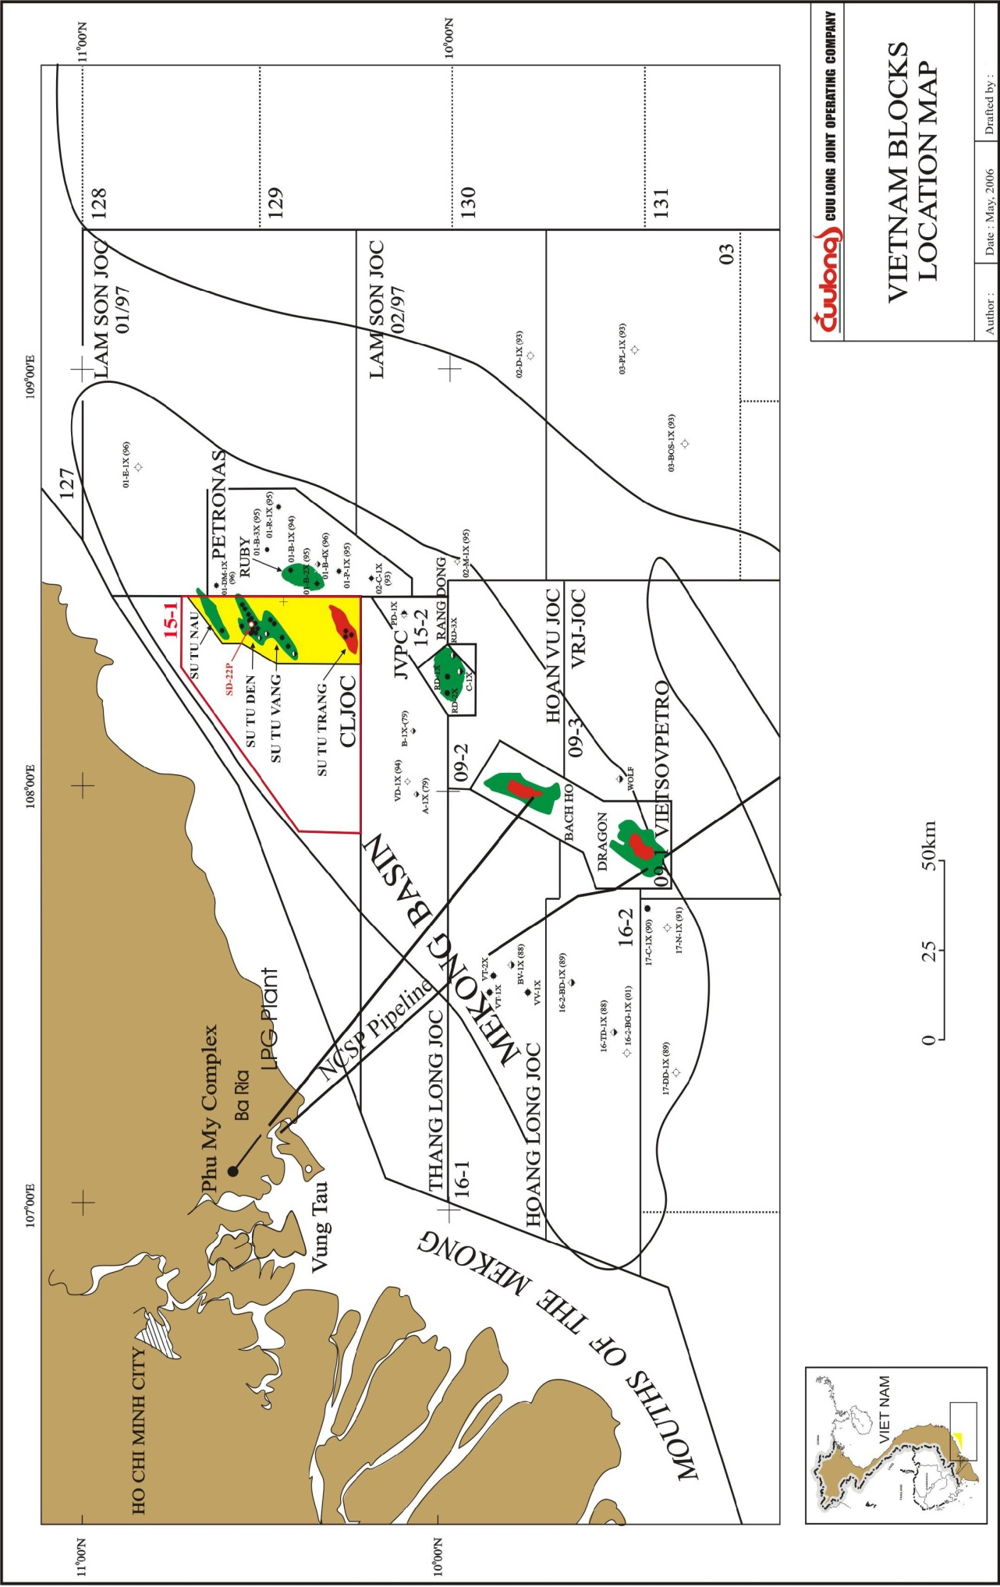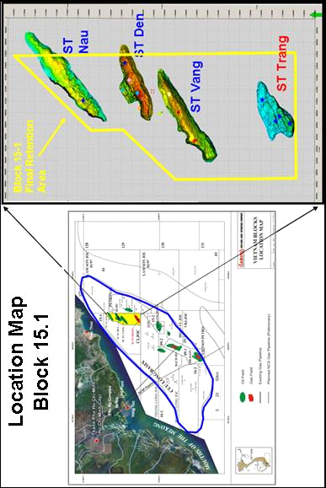

**STT FFD Phase 1**

**SVSW**

## PROJECT DEVELOPMENT DESIGN

### Overall Development and Production Plan

#### Development Strategy

The Su Tu Trang Field development started in September 2012 with the Long Term Production Testing Phase (LTPTP). This project includes a unmanned wellhead platform (WHP-C) that is connected to STV-CPP. The present production is about 6000 barrels/day of condensate and 50MMSCFD of gas. All STT LTPTP produced stream are exported to the STV-CPP. Production of STT Field is now bottlenecked by the CPP process capacities and most significantly by gas export pipeline to shore and the gas sales demand in South Viet Nam.

Outline Plan for Su Tu Trang Full Field Development was approved by authorities (MOIT & PVN) in July 2014. Some scenarios were studied.

**Scenario A**: It assumes no Phase 1 but full field development (FFD) starting from October 1st, 2018 with a constant gas sales requirement of 400 MMscfd and no injection.

**Scenario B:** It includes Phase 1 and Phase 2.

Phase 1 starting at Quarter 4, 2016 with 150 MMscfd production, 50 MMscfd sales and 100 MMscfd injection; and

Phase 2 starting at October 1st, 2018 with 500 MMscfd production, 400 MMscfd sales and 100 MMscfd continued injection.

Development strategy of STT FFD Phase 1 Project (Gas Re-injection Project) was approved as a part of Outline Plan for Su Tu Trang Full Field. The development of STT FFD Phase 1 Project is based on a simple concept: install a gas compression and re-injection platform (ST-PIP) bridged to STT WHP-C, drill more production wells ST-5P/ST-6P from, produce a total of 150 MMscfd of STT gas, re-inject a total of 100 MMscfd in the existing ST-1P and ST-2P, export on average 50 MMscfd (when the demand increases, the export rate can reach to 90 MMscfd) and benefit from an incremental 13,000 bopd production. The first gas re-injection is targeted in Q4 2016.

Scheme of STT FFD Phase 1 facilities is shown as in the Figure 1.2.

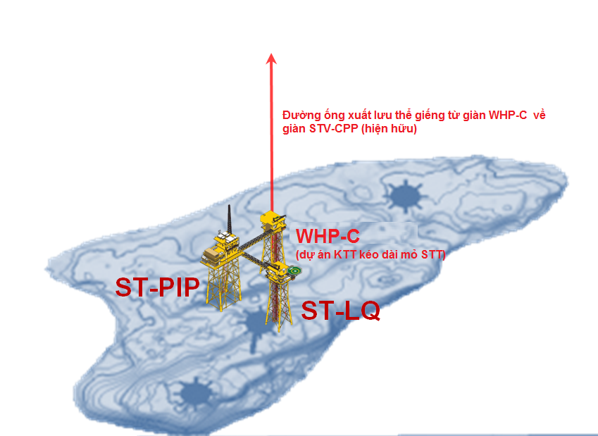

Figure 1.2 Overall Scheme of the anticipated facilities in the Block 15-1 During STT FFD Phase 1

#### Recommended Development Concept

To select a development concept for STT FFD Phase 1, a study on 2 main scenarios and sub-scenarios has been analyzed & evaluated.

The **Gas Re-injection Phase 1 Option** is proposed to overcome these bottle-necking constraints and accelerate the recovery of condensate. At the same time provision of re-injection capacity is expected to provide, in the longer term, the possibility to enhance future condensate recovery.

The STT FFD Phase 1 Project (the Gas Re-injection Project) is recommended to be the initial Phase of the FFD for the following reasons:

1. Gas re-injection is a necessity to increase the ultimate liquid recovery of the STT field and the earlier the re-injection starts the higher the impact;
2. Gas re-injection enables earlier incremental liquid production (not waiting on final Su Tu Trang Full Field Development -Final STT FFD);
3. During this first phase of gas re-injection, new wells are drilled, new production and data are acquired and this is necessary to reduce the uncertainties, in order to decide on an optimum final STT FFD implementation;
4. Gas re-injection project facilities are integrated to the STT FFD, none of these facilities will become redundant as the injection should remain in service during a significant portion of the Field production life (due to beneficial impact on recovery and subject to sales requirement);
5. Gas re-injection Phase 1 brings flexibility for the overall STT FFD (it limits the value loss if Phase 2 is delayed, it enables to step-up on compression if needed to adjust the demand or improve the recovery).
6. Gas re-injection is perfectly in line and supporting the MOIT and PVN strategy to limit and eliminate the flaring of natural gas;

#### Scope of STT Full Field Development Phase 1 Project

Proposed main facilities for Su Tu Trang Full Field Development Phase 1 Project (STT FFD Phase 1 Project) include:

* A gas compression and re-injection platform (ST- PIP) bridged to the existing WHP-C of the ST-LTPTP;
* A living quarter platform for 20 pax. and be bridged to the ST-PIP;
* Modification of WHP-C that is connected to STV –CPP;
* Use of the jack-up drilling rig to drill 2 gas production wells (ST-5P an ST-6P at Q4, 2015;
* Converting 02 production wells (ST-1P/ST-2P) as gas injection wells in among of 4 production wells that were drilled during STT LTPTP;

This project will not invest a new produced water treatment facility on ST-PIP and ST-LQ which will connect to the existing produced water treatment system on STV-CPP.

The jacket and topside of ST- PIP and Living Quarter Platform will be fabricated at onshore fabrication yard of PTSC M&C in PTSC BS port, Vung Tau. Management and handle of solid wastes (main recycling wastes) generated from the fabrication those facilities will be followed the waste management procedure for the fabrication yard. No industrial wastewater generated from the onshore commissioning action because this is mechanical trial of the equipment. Environmental impacts of this fabrication and commissioning have been detailed in the approved EIA report of PTSC M&C’s yard. So, these activities are not mentioned in the EIA.

Detailed design of new build facilities, WHP-C modification and existing facilities in Block 15-1 that is tie in to STT FFD Phase 1 project is presented in the Section 4.3.1 below.

**Figure 1.3** illustrate scheme of overall scheme of the existing facilities in Block 15-1 when having the STT FFD Phase 1 Project.

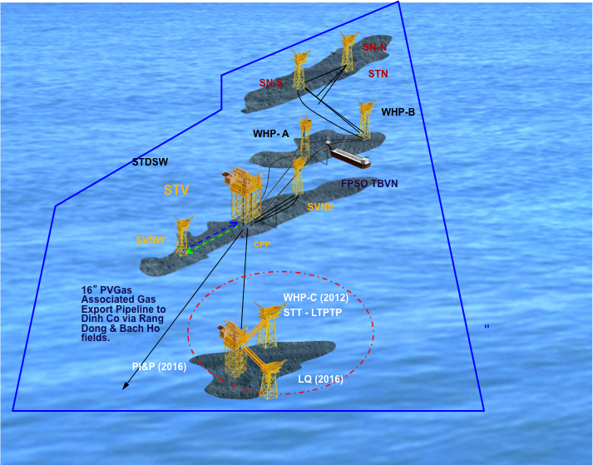

Figure 1.3 Overall Scheme of the anticipated facilities in the Block 15-1 during STT FFD Phase 1

#### Overall Development Schedule

First gas for the first phase (Re-Injection phase) is expected in Q4, 2016, after offshore installation & HUC completed. Major milestones for the STT FFD Phase 1 Project are summarized in Table 1.1.

Table 1.1 Overall Schedule for the STT FFD Phase 1 Project

|  |  |
| --- | --- |
| Approve FDP | June 2015 |
| Preliminary Engineering (done) | March 2015 |
| Detailed Engineering (12 months) | March 2015 – March, 2016 |
| St-PIP Jacket LOSF/Installation (6.5 months) | January 2015 to July 2015 |
| Fabrication & construction of ST-PIP Topside module 1/module 2, and pre-commissioning (14.5 months) | 8 June 2015 to 23 August 2016 |
| Fabrication ST-LQ jacket (5.5 months) | October 2015 to 15 March 2016 |
| Fabrication and construction of ST-LQ topside and pre-commissioning (11 months) | 12 August 2015 to 12 July 2016 |
| Drilling two wells ST-5P & ST-6P | Start 15 October 2015 |
| Installation of ST-PIP jacket (25 days) | Start August, 2015 |
| Installation of ST-PIP topside | Start August, 2016 |
| Installation of St-LQ jacket (20 days) | Start August, 2016 |
| Installation of ST-LQ topsides & Bridges (17 days) | Start August, 2016 |
| Offshore WHP-C and field modification (60 days) | Start September 2016 |
| Offshore Hook up and Commissioning | September – November 2016 |
| First Gas Target | Q4, 2016 |

### Su Tu Trang Field Characteristics

#### Geological Summary

The Su Tu Trang field is located in the southern portion of the Cuu Long basin with approximately 56 meters of water depth. This basin, situated on the Vietnam continental shelf off the Mekong river delta, was formed during rifting in the Early Oligocene. The subject field displays structural architecture typical of a rift basin…i.e., fault bounded, half horst and half graben geometry. The primary reservoir targets are located in the E and F Oligocene sequences, which represent a fluvial dominated system overprinted with shoreface reworking and occasional lacustrine flooding events.

Overall thickness of the F Sequence along with structural mapping indicates that deposition occurred during earliest rifting of the basin in this area. Most of the F sand is dominated by high energy braided stream and meandering fluvial deposition. The upper F is characterized by decreasing net sand and an increase in short-lived lacustrine flooding events that transition into the lacustrine shale dominated F shale interval. Near the top of the F shale there appears to be a maximum flooding surface, and just above that is a significant sequence boundary that is the base of the E Sequence sand.

The E Sequence is subdivided into 3 units: lower, middle and upper E sand. The lower E sand is composed of several fluvial depositional episodes, each followed by lacustrine transgression. The middle E sand is mostly high energy fluvial deposition with relatively consistent thickness across the field. Upper E sand again marks the onset of increased frequency of lacustrine flooding events. The upper unit also has the greatest change in thickness across the field and down the flanks of the structure indicating increased uplift and rotation of the Su Tu Trang basement Block. The top of the E sand is a significant angular unconformity buried by onlapping lacustrine shales.

#### Development Reservoirs

The primary reservoir targets are located in the basement sequences. The parameters of these reservoirs are summarized in **Table 1.2** below.

Table 1.2 STT Reservoir PVT Properties from BHS’s in DST’s

|  |  |
| --- | --- |
| **Parameters (basement) of Typical well** | **Value** |
| Oil Gravity | 0.716 |
| GOR in cubit feet at 14.70 psia & 15.6oC (Rscf/stb) | 7486 |
| Reservoir Pressure (psia) | 4750 |

#### Su Tu Trang gas and Condensate Properties

Reservoir rheological properties of STT gas and condensate is presented inTable 1.3.

Table 1.3 Basement Reservoir Rheological Properties of STT stream

|  |  |
| --- | --- |
| **Properties of Typical well** | **Value** |
| Pour point  oC | 12-21 |
| Flash point  oC | 36 |
| Wax Freeze. point (degC) | 44-449 |
| Viscosity@30 oC (cp) | 30 – 1.7 |
| Wax content (wt%) | 12.4 – 10.3 % |
| Maximum of Hg: Gas phase  Condensate | 296 - 361 micrograms/Nm3  21-136 ppb wt |
| Maximum of H2S: Gas phase  Condensate | 50ppv  50-175 ppmv wt |

*Source: Basic of STT FFD Phase 1 Project-REV.A*

Other properties and likely composition of the associated gas from STT is presented in Table 1.4 & 1.5.

Table 1.4 Composition of STT Condensate

| **Composition** | **(Mole % - Weight)** |
| --- | --- |
| Carbon Dioxide\* | 0.00 – 0.00 |
| Nitrogen\* | 0.00 – 0.00 |
| Methane | 0.2 – 0.02 |
| Ethane | 0.38 – 0.08 |
| Propane | 1.5 – 0.48 |
| Iso-Butane | 1.17 – 0.50 |
| Normal-Butane | 2.84 -1.21 |
| Iso-Pentane | 2.96 – 1.56 |
| Normal-Pentane | 4.15 – 2.18 |
| n-Hexanes | 2.828 |
| n-Heptanes | 3.821 |
| Octanes | 4.550 |
| Nonanes | 3.471 |
| Decanes | 2.819 |
| Undecanes | 2.191 |
| Dodecanes | 1.820 |
| Tridecanes | 1.742 |
| Tetradecanes | 1.518 |
| Pentadecanes | 1.803 |
| Hexadedcanes | 1.317 |
| Heptadecanes | 1.125 |
| Octadecanes | 1.158 |
| Nonadecanes | 1.061 |
| Eicosanes Plus | 17.948 |
| Hexane - C6 | 8.54 – 6.25 |
| M-C Pentane | 4.22 – 3.03 |
| Benzene | 1.23 – 0.75 |
| Cyclohexane | 1.27 – 0.78 |
| Heptane C7 | 8.54 – 6.25 |
| M-C-Hexane | 4.22 – 3.03 |
| Toluene | 2.97 – 2.0 |
| Octane C8 | 9.97 – 8.27 |
| E- Benzene | 0.39 – 0.30 |
| M-/P-Xylene | 2.63 – 2.04 |
| O-Xylene | 0.63 – 0.49 |
| Nonanes C9 | 7.12 – 6.67 |
| 1,2,3-TMB | 0.67 – 0.59 |
| Decanes C10 | 6.41 – 6.66 |
| Undecanes C11 | 5.23 – 5.61 |
| Dodecanes C12 | 4.34 – 5.10 |
| Tricosane C13 | 3.64 – 4.65 |
| Tetracosanes C14 | 2.73 – 7.39 |
| Pentacosanes C15 | 2.30 – 3.46 |
| Hexancosane C16 | 1.77 – 2.87 |
| Heptadecane C17 | 1.47 – 2.55 |
| Otacosane C18 | 1.42 – 2.55 |
| Nonacosane C19 | 1.55 – 2.20 |
| Eicosane C20 | 0.92 – 1.85 |
| Heneicosane C21 | 0.81 – 1.73 |
| Decosanes C22 | 0.69 – 1.54 |
| Tricosanes C23 | 0.63 – 1.47 |
| Tetracosanes C24 | 0.55 – 1.32 |
| Pentacosanes C25 | 0.49 – 1.22 |
| Hexacosanes C26 | 0.43 – 1.12 |
| Heptacosane C27 | 0.37 – 1.00 |
| Octacosanes C28 | 0.31 – 0.88 |
| Non-acosanes C29 | 0.27 – 0.79 |
| Triacosanes C30 | 0.22 – 0.68 |
| Hentriacotanes C31 | 0.18 – 0.57 |
| Dotriacontanes C32 | 0.14 – 047 |
| Tritriacontanes C33 | 0.12 – 0.41 |
| Tetratriacontanes C34 | 0.10 – 0.35 |
| Pentatriacotanes C35 | 0.09 – 0.30 |
| Hexatriacontanes Plus C36+ | 0.38 – 1.53 |
| Note: (\*): 0.00 means less than 0.005 | |

Table 1.5 Composition of STT Gas

|  |  |  |
| --- | --- | --- |
| **Component** | **Mole%** | **Weight %** |
| |  | | --- | | H2S  CO2 | | N2 | | C1 | | C2 | | C3 | | I-C4 | | N-C4 | | I-C5 | | N-C5 | | C6 | | C7 | | C8 | | C9 | | C10 | | C11 | | |  | | --- | | 0.000000  0.000695541 | | 0.00127747 | | 0.778347 | | 0.0999032 | | 0.0574619 | | 0.0135912 | | 0.021307 | | 0.00770604 | | 0.00789713 | | 0.00582489 | | 0.002263645 | | 0.003601135 | | 5.53744E-05 | | 3.90505E-05 | | 2.87081E-05 | | |  | | --- | | 0.000000  0.001369 | | 0.001601 | | 0.55852 | | 0.134367 | | 0.113336 | | 0.035333 | | 0.055392 | | 0.024868 | | 0.025485 | | 0.022425 | | 0.009478 | | 0.017082 | | 0.000299 | | 0.000245 | | 0.000198 | |

*Source: Condensate and gas component of well ST-2P done by Core Lab Australia PTY LTD.*

With the maximum amount of H2S and Hg in the STT gas is very low, so the STT gas can be regarded as a clean fuel, promising a direct use for facilities of the project on site.

#### Reserves, Field Life and Production Profile

***Oil and Gas Reserves:*** Oil reserves for each reservoir and category was estimated by using OIIP from volumetric method and recovery factors (RF=15.7 %). Gas reserves for each reservoir were estimated by using oil reserves and gas and condensate rate (GOR at 1305 psig) 6433 Rscf/stb. The estimated Hydrocarbon reserves of each reservoir with scenario P50 was calculated by using ECLIPSE Models are summarized in **Table 1.6.**

Table 1.6 STT FFD PHASE 1 Reservoir Recovery Oil Reserves

|  |  |
| --- | --- |
| **Recovery condensate Reserves** *(MMStb)-P50* | |
| Probable (P2) | 11.2 |
| (P3) | 53 |
| **STT Reservoir Gas Reserves ( bcf) – P50** | |
| Probable (P2) | 78.1 |
| (P3) | 368.1 |

***Field Life and Production Profile***

The range of reservoir simulation models (P90, P50, P10) were constructed based on Geological models with same grid-block size of 75x75x50m.

As production forecast, estimation of condensate and gas recovery from the STT FFD Phase 1 and Phase 2 areas (base case P50) from 2014 to the end of 2025 for oil and 2028 for gas is about 53.7 (MMstb) and 693.4 **(bcf)** respectively. The production profiles (for P10, P50 & P90) are shown in the Figure 1.4.

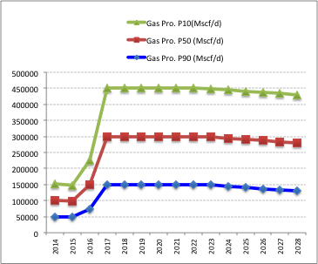

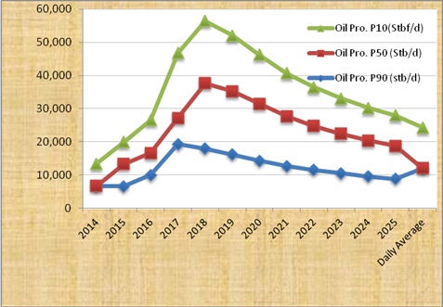

Figure 1.4 STT FFD Phase 1 Production Profile

Table 1.7 STT Average Production Profile (P50 – STT Phase 1 – Case P2)

|  |  |  |  |  |  |
| --- | --- | --- | --- | --- | --- |
|  | **Gas Pro. (MMscf/d)** | **Gas Sale (MMscf/d)** | **Gas Injection (MMscf)** | **Condensate**  **Pro. (stb/d)** | **Produced water (stbbl/d)** |
| 2016 | 58.5 | 50.0 | 8.5 | 7,823 | 437 |
| 2017 | 150.0 | 50.0 | 100 | 19.633 | 707 |
| 2018 | 150.0 | 50.0 | 100 | 19,018 | 785 |
| 2019 | 150.0 | 50.0 | 100 | 17,217 | 921 |
| 2020 | 150.0 | 50.0 | 100 | 15,070 | 1054 |
| 2021 | 150.0 | 50.0 | 100 | 13,259 | 1070 |
| 2022 | 150.0 | 50.0 | 100 | 11,860 | 1069 |
| 2023 | 150.0 | 50.0 | 91 | 10,803 | 1052 |
| 2024 | 150.0 | 50.0 | 15 | 9,960 | 1031 |
| 2025 | 150.0 | 50.0 | 0 | 9,301 | 1009 |
| 2026 | 150.0 | 50.0 | 0 | 8,784 | 965 |
| 2027 | 150.0 | 50.0 | 0 | 8,372 | 901 |
| 2028 | 150.0 | 50.0 | 0 | 8,042 | 833 |
| **Daily average** | **142.96\*** | **50.00\*** | **92.96\*\*\*** | **12,242** | **910** |
| **Project cum.** | **693,396.8** | **255,396.8** | **404591.5** | **53,753,094** | **2,856,599** |

*Source: STT FFDP Phase 1*

*Note: (\*) Daily average of production gas from (2016 t0 2028 – terminal contract)*

*(\*\*) Daily average of production oil from 2016 to 2028*

*(\*\*\*) Average of injection gas from 2016 to 2024*

The production forecasted daily gas production within 13 years of STT FFD Phase 1 Project (from 2016 – 2028) is about ~ 142.96 MMscf in which 92.96 mmfcf is injected and used as fuel gas daily into ST-1P & ST-2P and fuel gas (occupies 65%), an average of sale gas is 50 MMscfd (occupies 35%). In the future, the demand of natural gas increases, the total export of natural gas from STT Field can increase to 90 MMscfd.

Table 1.8 below provides select parameters from the basic of design of STT FFD Phase 1 Project.

Table 1.8 STT FFD Phase 1 Project Design Basis

|  |  |
| --- | --- |
| Plateau Production | 12.5 years |
| Well Head Flowing Temperature | 118 deg C |
| Well Head Shut-in Pressure | 530 barg |
| Well Head Flowing Pressure | 90-260 barg |

Number and configuration of the well slots of the Phase 1 - STT FFD Phase 1 Project are as follow as:

|  |  |  |
| --- | --- | --- |
|  | **STT LTPTP (WHP-C)** | **ST-PIP** |
| Well Slots | 4 Single | 6 Single |
| Producers | 2 nos. (already installed)   1. QAY-2853 (ST-3P) 2. QAY-2854 (ST-4P) | Install: 2 nos.   1. QAY-2855 (ST-5P) 2. QAY-2856 (ST-6P)   Future: 1 no. |
| Injectors | 2 nos. (converted from producers)   1. QAY-2851 (ST-1P) 2. QAY-2852 (ST-2P) | Future: 3 nos (production wells and injection wells) will be developed in the phase 2. |

STT FFD Phase 1 Production System Design:

|  |  |
| --- | --- |
| Maximum/Design Production from wells on ST-PIP | 150MMscfd |
| Maximum gas Production from wells on WHP-C | 10MMscfd |
| Maximum gas Production to be injected to the export pipeline STV-CPP | 50MMscfd |
| Maximum gas Production to be injected to ST-1P and ST-2P | 100 MMscfd |

### Facilities of Su Tu Trang Full Field Development Phase 1 Project

**New facilities to be built:**

* The gas compression and re-injection platform (ST- PIP) bridged to the existing ST-LTPTP facility WHP-C;
* The living quarter platform (ST-LQ) designed 20 pax during the phase 2 but be extendable to 60 paxs for Phase 2 and to be bridged to the ST-PIP;
* Bridges to be connected ST-PIP with WHP-C and ST-LQ;
* Flowlines and umbilical will be installed on the bridge connecting from ST-PIP and WHP-C.

***Existing facilities in Block 15-1 to be used for STT FFD Phase 1 Project***

* WHP-C will be modified to be bridged to ST-PIP
* Su Tu Vang Procesing Platform (STV-CPP) being connected to WHP-C and FPSO-TBVN
* FPSO-TBVN will be used to store combined oil production (STT condensate and crude oil of STV and STN Fields) that is routed from the STV-CPP

Additional, the jack-up drilling rig PVD1 of PV Drilling shall support to drill new production 2 wells (ST-5P & ST-6P) in the end of 2015;

Below is detail of design of the main facilities for STT FFD Phase 1 Project and existing facilities in Block 15-1 to be used for STT FFD Phase 1 Project.

#### Description of STT FFD Phase 1 New Facilities

1. ***Design of gas compression and re-injection platform (ST- PIP)***

***General description:***

The gas compression and re-injection platform (ST- PIP***)*** will be installed in distance of about 18.748 km far from Centre Production Processing (STV-CPP) of the existing STV Field. ST-PIP shall be designed as a manned processing and wellhead platform bridge linked to the WHP-C.

The ST-PIP platform will consist of a 4-legged jacket with insert leg piles, drilling deck and modularized topside with flare boom and utilities facilities, conductors and associated appurtenances. The ST-PIP shall be configured for drilling by a jack-up drilling rig and connected to the existing ST-LTPTP (WHP-C) via a 40m long bridge. The design shall allow for pre-drilling of 2 slots and flexibility of installations of the subsequent 4 conductors after the completion of drilling the 2 wells.

The ST-PIP will be designed for using in 20 years and in according to International Standards (API, ANSU, AISC, IEC AOSC, ASTM, AWs, BIPM, DNV, DN) and applicable Vietnamese Regulations, HSE standards and practice of Petroleum industry and CLJOC requirements

***Structures of ST-PIP Jacket:***

The jacket will be designed with 4 legged for using in 20 years as per API RD 2 A to support for the followings:

* Drilling the wells from the platform by jack-up drilling
* Connecting to the existing WHP-C via 40m long bridge
* 1 x 10” Maximum and J-Tube, one 10” insulated production export line,
* 1 x 6" diameter riser for lift gas lift
* A spare riser for future water injection line
* One 10” J-Tube for Submarine cable from STV- CPP
* Support of up to 500 tons topsides including crane
* Boat landing on West Platform as primary access for personnel transfer for ST-PIP;

Figures 1.5 shows the ST-PIP isometric view.

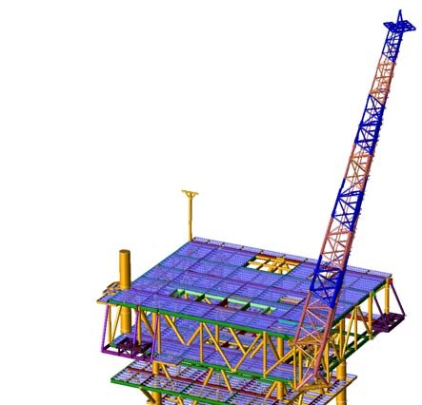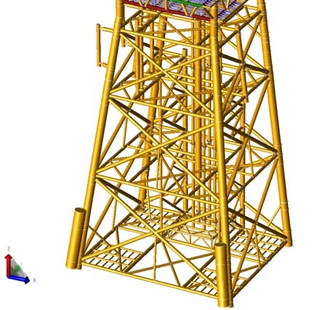

Figure 1.5 ST-PIP 4 legged platform Isometric View

***ST-PIP and and WHP-C Bridge:*** The Bridge was designed with a span of 80 m measured from pin point at ST-PIP 10m from Row ‘B’ to sliding point at WHP-C at Row “2”.

***ST-PIP and ST-LQ Bridge:***The Bridge was designed with a span of 72.4m measured from pin point at ST-PIP 9.0m from Row ‘2’ to sliding point at ST-LQ 9.5m from at Row “1”.

***ST- PIP Topside Structure:***

The design life of ST-PIP topside structure shall be 20 years. All design shall be carried out in compliance with the applicable Vietnamese/International standard and International Codes (API, AISC, AWS, AISC, ASME…).

The topsides shall comprise a sub-cellar, cellar, mezzanine and main deck. The deck shall have trusses in both transverse and longitudinal directions. Estimated weights for the topside and the jacket are respectively 4000 and 1800 tons.

***ST-PIP Facilities and Equipment***

***ST-PIP process equipment*** consists of well production such as wellheads, well flowlines, 02 new production manifolds (Production manifold 1 & Production Manifold 3, 01 new test manifold and 01 gas injection manifold for 03 injection wells of the phase 2. The ST-PIP topside will consist of a minimal process facility including basic gas/liquid separation without specific gas treatment, wet gas re-injection into reservoir with 530barg injection pressure design. Liquids (condensates and water) will be routed and joined to the existing WHP-C then flowed to CPP facilities for further processing and export to the FPSO TBVN.

ST-PIP will be equipped with the main following production systems:

* Well bay for 06 wells with manifolds
* Production separator
* Two stages Centrifugal compressors driven by Gas Turbine
* Common Gas Injection Compression Suction and Interstage coolers (sea water cooled)
* Common Gas Injection Compression Suction and Interstage gas scrubbers
* MPFM for well test service
* Control & safety systems such as BPCS, SIS and Fire & Gas Systems
* Wellhead Control Panel (Hydraulic)
* Heating, Ventilation and Air Conditioning (HVAC)

Design capacity of the main equipment system on ST-PIP is present in Table 1.9

***Utility systems***

All hazardous utilities shall be located in ST- PIP. In general, all utilities will continue to remain independent with respect to supporting individual platform production. However, the utilities between ST- PIP and WHP-C shall be integrated for flexibility of production. The Utility systems envisaged in ST-PIP include:

* Fuel gas System
* Sea water system
* Electro-chlorination system
* Cooling water system
* HP and LP Flare
* Open and Closed Drain systems
* Main power generation systems
* Electrical Support Systems (Grounding, Lighting, NavAids, etc.)
* Pedestal Crane

Other utilities to be required for ST-PIP will be supported from WHP-C and ST-LQ includes chemical Injection System from WHP-C, Nitrogen, instrument and utilities air, diesel system, fresh water & Potable water and Emergency Power from ST-LQ. (***see page 1.25 for further information***).

Table 1.9 STT-PIP Location and Design Capacity

|  |  |
| --- | --- |
| **Location of ST-PIP** | |
| Coordinates | 1,130.610 Northing |
| 866,928 Easting |
| Water Depth (MSL) | 56 m |
| Distance to STV-CPP | ~ 20 km |
| **Design capacity** | |
| Production gas | 150 MMscfd |
| Production condensate | 33,000bbls |
| Test Separator | 188 MMscfd  34000 bbls produced water |
| 01 gas compressors Package | 1 x100 MMscfd |
| Gas Injection Compression | 100 MMscfd |
| Gas export | 50 MMscfd |
| Flare system (high pressure flare) | 300 MMscfd |
| Fuel gas system | 6 MMscfd |
| Coolling water system: 02 pumps  Temperature of sea water disposal caisson | 950 m3/h x2  500C |

**Production separation facility and process (see Figure 1.6a)**

**Production separation facilities**

The production separation facilities on ST-PIP consist of a main 2 phases production separator to separate the production stream to gas and liquid, which is routed to gas compression train and to export pipeline respectively.

The Production Separator with capacity 188 MMscfd gas and 34 bblpwd shall be designed to provide retention time of minimum 2 minutes on liquid flow rate as specified by API 12J. The internals shall be provided for the Production Separator to enhance the separation performance. The required performance specification of vessel and internals is to remove 99% of particles above 10 micron from vapor and the maximum liquid carry over is 0.1 Gallon/MMSCF.

The operating and design pressures of the Production Separator shall be maintained at 91 barg and the operating and design temperature of Production Separator shall be at 80-118oC respectively. This pressure is controlled by suction pressure control of compressor. In case of high pressure which cannot be further controlled by increasing Compressor speed, the upstream wellhead choke valves will be throttled to reduce the production and hence pressure. If the pressure continues to increase, a certain amount of gas (with a limit of 30-50 MMscfd) will be sent to flare by opening the pressure control valve located on the flare line.

**Production process**: the separator separate the production stream from Production Manifold - 2**,** Production Manifold - 3 and Test Manifold - 2 to gas and liquid.

The gas outlet stream will be split into two streams: one to compression train and the remaining is routed to the export pipeline controlled by a flow control valve. The flow control to export pipeline will be set as per the export demand which is as per design is 50 MMscfd maximum. The export gas will be commingled with separated liquid stream and the commingled stream will be routed to the export pipeline at WHP-C via the bridge. A part of gas from Production Separator will routed to Fuel Gas Conditioning system to be used as fuel gas (primary source) for compressor turbine/ gas turbine generator, purge and pilot gas for Flare system.

Gas compression facility on ST-PIP and process (Figure 1.6b)

The Compression configuration of 1x100% shall be provided on the platform ST-PIP. The compressor is designed with maximum capacity of 100 MMscfd. Gas Compressor and Turbine shall fully comply with local legislative requirements- TCVN5339-2005, QCVN07-2009 and QD3733-2002BYT

After compressing gas to targeted pressure, the high pressure gas shall be routed to existing WHP-C via the bridge and distribute to the wells by an injection manifold. A space shall also be provided on ST-PIP to allow installing an additional injection manifold for 02 more wells if necessary. The design gas injection rate will be 70 MMscfd for each future injection well and the manifold shall be designed for 100 MMscfd.

Gas Re-injection Facility

There will be one Gas Re-Injection manifold on each platform.

* Gas Re-Injection Manifold - 1:This manifold is on existing WHP-C and is designed for gas injection of 2 wells at 100 MMSCFD at an operating pressure from 330 to 530 barg.
* Gas Re-Injection Manifold - 2:This manifold is on ST-PIP and is designed for gas injection of 02 wells (in future – STT FFD Phase 2) at 100 MMSCFD at an operating pressure from 330 to 530 barg. All future connections shall be provided with blind flanges only.

***Fuel Gas System (Figure 1.7)***

Fuel gas is designed and installed on ST-PIP to supply fuel gas for facilities power generation, compression consumption. The ST-PIP will include HP and LP fuel gas systems. The major equipment in the fuel gas system includes fuel gas pre-cooler, fuel gas scrubber, fuel gas filters and fuel gas super-heater. Capacity of fuel gas package and gas scrubber shall be designed to be 6 MMscfd. Condensate pumps with capacity 3.5m3/h will be also provided.

Power Generation System

The ST-PIP main power supply will be provided by gas turbine generators. Moreover, there is also a diesel-driven Emergency Generator on ST-LQ which will provide a nominal 2.7 MW emergency power facility to start-up from a “black-start” condition.

***Gas turbine Generator (GTGs):***

Two gas turbine generators (2 x 100%) will be installed on ST-PIP to provide normal power (3800 KW) for the ST-PIP and ST-LQ operations. The GTGs will use treated natural gas (6-7 MMscfd) as a main fuel supplied by the fuel gas system. GTGs also shall be interconnected power system on WHP-C to provide power to WHP-C if it needed.

**An Emergency Diesel Generator (EDG)** be installed on ST-LQ shall be provided to cater for all essential loads and shall have the facility to start-up from a “black-start” condition. The platform’s initial power requirements shall be supplied by the EDG, and once the fuel gas system is established, the normal power generation will be started then paralleled momentarily to the emergency source for a bumpless load transfer. The EDG will be stopped once the load transfer has been established. This EDG shall also size to cater for all essential loads on ST-PIP and ST-LQ in the event the GTGs on ST-PIP are on long shutdown.

***Vent/Flare system (see Figure 1.6)***

Flare system on ST-PIP will be designed to handle all relief, blowdown from the topside processing facilities. The flare system will collect all relief stream and depressurization steam to cover separated condensate and disposal gas in safety. This consists of HP flare system and combined LP flare/Closed drain system. All relief from PSVs, blow down, manual venting shall be routed to the HP flare. Venting from low pressure sources (i.e. with maximum operating pressures less than 5 barg) such as the Reinjection Compressor Seals, Cooling Water Expansion Vessel shall be routed to LP flare.

***Closed Drain system:* (see Figures 1.8a/1.8b).**

The Closed Drain System in the ST-PIP will be combined with LP Flare System. The Closed drain system consists of varies Closed Drains Lines, Deck sub header, main header, Closed Drain Vessel, Close Drain Vessel Heater (20 KW), 2 Closed Drain Pumps (2x100) with capacity 5m3/h. Closed Drain Vessel with 11.8 m3 shall be designed to handle treat 5m3/h liquid and can collect hydrocarbon and waste water from pressurized equipment.

*Close drain process:* closed drain lines will collect all maintenance drain streams from process vessels and route them to the Closed Drain Vessel. Also the LP flare header collects all hydrocarbons vented from low pressure sources and routes them to the Closed Drain Vessel.

***Open Drain Systems (Figures 1.9 a & 1.9b)***

* Hazardous Open Drain Systems consist of the series on non-pressurize gravity drains which receive the disposed waste water from the various process, utility equipment, instrument drains and rain water from open decks of the platform, 2 Open Drain Headers, Hazardous Open Drain Tank with 34.8m3 volume (can hold a volume equivalent to the maximum exposed deck area during 30 minutes rainfall at 50mm/hour intensity), 2 x 100 % open drain pumps with capacity 2 m3/h (one on duty, one standby). To prevent hazardous vapor from one deck to other decks and from hazardous area to other non-hazardous and hazardous areas, each collection header will be equipped with a liquid seal arrangement.
* Process waste water treatment of Hazardous Open Drain System: Waste water collected from the all hazardous area sources in the open drain headers will subsequently be routed to the open drain tank for recovery of hydrocarbon by gravity settling. The recovered hydrocarbon liquid in the open drain tank will be pumped to the closed drain vessel for recycle to the main process. The waste water that collected in the Open Drain Tank will gravity drain to the Open Drain Caisson with 160cm for final disposal overboard.

***Non-Hazardous Open Drain System:***

The Non-Hazardous Open Drain System will collect water from platform areas with no expected hydrocarbon exposure and route them directly to the Open Drain Caisson. Clean water is discharged to the sea and any hydrocarbons that may have accumulated are skimmed off the top of the water layer and pumped to the LP Flare Scrubber via the Closed Drain Header by pump.

Open Drain Caisson: Open drain caisson shall be sized to evacuate maximum collected inventory within a reasonable period of 6-8 hours maximum (with size 1600 ID x 49000 T/T), operating capacity of temperature and pressure will be 30oC and 10 -65 barg. Two caisson pumps having pumping capacity will be 2m3/h. The caisson structural part is 35m from MSL.

Cooling Water System (see figure 1.13)

A closed loop Cooling Water System will be installed on ST-PIP to provide cooling water at for Gas Rejection Suction Cooler and Gas Reinjection Inter-stage Cooler. The Treated fresh water provided from ST-LQ will be used for Cooling Water System. The Cooling Water System consists of Cooling Water Expansion Vessel (1x100%), Cooling Water System Chemical Dosing Pump (1x100%), Cooling Water Circulation pumps (02 x100%), Cooling Water Trim Filters and Sea Water/Cooling Water Exchange.

Cooled water will be supplied to the gas compression Suction Cooler and the Gas Reinjection Compression Interstage Cooler at a temperature 35oC. The heater cooling water will be returned to the Cooling Water Expansion Tank Water then it is pumped through the Seawater/Cooling Water Exchanger where the hot cooling water is cooled by using sea water before returning to the Gas Compression Coolers. The Cooling Water System will be designed to supply at cooled water at 35oC and hot returning cooling water to be at 60oC as maximum.

Chemical dosing (biocide, Oxygen, Scavenger, Corrosion Inhibitor) will only used during start up/make up for making up water. No discharge cooling water to the sea due to this is closed loop system.

Firewater and Foam Systems

Two diesel engines driven Firewater Pumps will supply seawater to the firewater ring mains. This will avoid the need to size the emergency generator to supply for the Electric Fire Water pump. The pumps will be configured as 2 x 100% at 10.3 barg. Both pumps will be started automatically on low ring main pressure.

***2) ST- Living Quarter Platform (ST-LQ)***

ST-LQ will consist of a jacket through log piles with helideck integrated with living quarter module, a liked bridge from ST-PIP. Topside will comprise sub-cellar, cellar, intermediate deck and main deck. The ST-LQ designed for 20 pax during phase 1, but be extendable to 60 pax at a later stage. In addition to the accommodations, ST-LQ will be equipped with most of the utilities for ST-PIP. All utilities on ST-LQ shall be sized for future occupancy of 60 pax. It is also designed to be bridged to a separated Center Gas Facility Platform (CGF) in future (phase 2). It will include the following facilities:

* Dormitories, kitchen, dining room, recreation areas, clinics.
* Helideck
* Potable water treatment
* Sewage treatment
* Fire detection and Fire Fighting system
* Crane
* Boat Landing

All non-hazardous utilities shall be provided in ST-LQ and will be routed to ST-PIP by the linked bridge.

Utilities will be equipped on ST-LQ for supporting ST-PIP are as below:

* Chemical Injection system (from WHP-C)
* Nitrogen (from WHP-C)
* Instrument and Utility Air (from ST-LQ)
* Diesel (from ST-LQ)
* Fresh Water and Potable water (from ST-LQ)
* Emergency Diesel Generator (EDG)

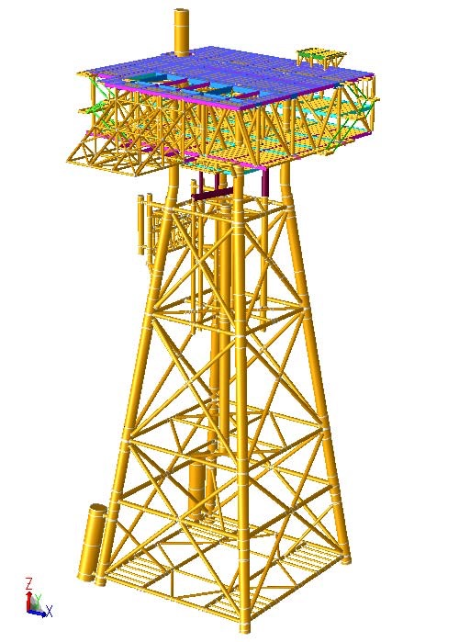

Figure 1.6 ST-LQ 4 legged platform Isometric View

Detail design of the systems relating to environmental issues on ST-PIP and ST-LQ.

|  |  |
| --- | --- |
| **Coordinate of ST-LQ:** | 1,130,517.7m Northting  866,989.1 m Easting |
| **Equipment/System** | **Capacity & Process Flow Diagram (PID)** |
| Service sea water | 40 m3/h |
| Sewage treatment system | 20 m3/day |
| Firewater & foam | NA |
| Diesel system | Loading 80 m3/h, transfer 5 m3/h |
| Diesel storage tanks | 33 m3 |
| Diesel generator | 1.8 MW |
| Gas & smoke (fire) detectors | 1. Gas, smoke, heat detector with addressable F&G system 2. FM 200 fire suppression system |

Diesel System on ST-LQ

The diesel storage system 33 m3 is designed to provide fuel for the Backup Generator (1.8 MW), Fire water pump and platform cranes. The system will consist of storage 33 m3, loading pumps 80 m3/h transfer pumps, 5 m3/h, and filtration. Diesel will be supplied to the facility by workboat. Loading connections will be provided at the boat landings on the platform. Diesel will be supplied to the platform crane manually (i.e. Operator controlled) while remote filling capability of the Backup Generator diesel tank will be provided.

**Emergency Diesel Generator (EDG)**

The Back-up power and black start capability will be met by a suitably rated diesel engine generator which will supply power 1.1 MW to all essential consumers. The diesel generator will be fitted with a day tank sized to run the unit at full load for 12 hours.

Sewage Treating (Figure 4.10 of Section 4.2.3.2)

The ST-LQ will include a conventional toilet system for collecting, treating, and disposing of sewage from the accommodation building. The system will include collection piping within the living quarters, treatment unit, and waste discharge caisson. The sewage treatment package will include a multi-compartment tank for biological agents and discharge pumps. The unit design capacity will be 20 m3 /day to be sufficient to sustain a 60-man living quarters plus 10% margin to accommodate additional personnel onboard (<20 m3/day). All facility black water will be routed through the sewage treatment package. Routing of grey water, including from hospital, will be confirmed by sewage treatment package vendor. (see Section 4.2.3.2 for more detail information).

Service, Fresh, and Potable Water Systems

The ST-LQ will include systems to provide service water (seawater), fresh water (hot and cold), and potable water for the processing facilities and the accommodation building. This system can treat 80 m3/h of sea water to provide service water for the ST-LQ and ST-PIP facilities.

Washdown System

A wash water system is provided for deck washing and general equipment cleaning. It is anticipated that the portable unit will include a Soap Tank, Washdown Pump and skid-mounted heater. Washdown water for general maintenance will be supplied via seawater lift pump.

***STT FFD Phase 1 Facility Control Systems (FCS)***

Two new FCS shall be provided one at the ST-PIP and another one at the ST-LQ. The ST-LQ control philosophy shall be able to control, monitor process and down load data from ST- PIP via fiber optical linked and yet, ST-PIP shall be capable to control, monitor and configure as a “stand alone” system. Likewise, ST-LQ / ST-PIP FCS shall be able transfer data to STV CPP via telecom. The bases of the design for the FCS system shall consist of the following documents:

* + Basic Process Control System (BPCS);
  + Safety Instrumented System (SIS);
  + Fire & Gas Detection System (FGS):

***Emergency Shut Down System (ESD)***

All ESD points shall be hardwired and would operate as a separate control system from the main control system. The ESD system shall be designed on a fail-safe basis utilizing a Deenergize- to-trip philosophy. During normal operation, discrete inputs to the ESD system and discrete outputs to the final control elements shall be energized. This design shall also ensure a shutdown on loss of electrical power to the system inputs, outputs or logic. All ESD valves shall fail open or fail closed as appropriate to ensure protection of equipment and personnel.

**ST-PIP Production and Injection process**

ST-PIP will be designed as production and injection platform with equipment such a as test separator, 2 phase production separators to process production 150MMscf gas and 20000 to 30000 BOPD (condensate) produced from the ST-5P and ST-6P. This platform also will be equipped the gas compression system and gas injection systems for treating gas from the separators and inject treated gas to the wells ST-1P and ST-2P from WHP-C.

2 phases production stream (associated gas, condensate and small produced water content) produced from choke well the ST-5P and ST-6P is pipelined to the Production Manifold – 2and Test Manifold – 2 to the production separator and test separator in which produced stream shall be separated into to gas and liquid. Separated liquid including condensate and small produced water will be commingled with remaining compression gas stream to the export pipeline at WHP-C via the bridge to joint to WHP-C exporting pipeline before flowing to STV-CPP.

The gas outlet stream at separators will be split into two streams: one to compression trains for treatment and the remaining is routed to the export pipeline controlled by a flow control valve. The flow control to export pipeline will be set as per the export demand which is as per design is 50 MMscfd maximum. The export gas will be commingled with separated liquid stream and the commingled stream will be routed to the export pipeline at WHP-C via the bridge.

A part of gas from Production Separator will routed to Fuel Gas Conditioning system to be used as fuel gas (primary source) for compressor turbine/ gas turbine generator, purge and pilot gas for Flare system.

The operating and design pressures of the Production Separator shall be 90.3 barg and 130 barg respectively. The operating and design temperature of Production Separator shall be at 80-118oC respectively. The pressure is controlled by suction pressure control of compressor. In case of high pressure which cannot be further controlled by increasing Compressor speed, the upstream wellhead choke valves will be throttled to reduce the production and hence pressure. If the pressure continues to increase, a certain amount of gas (with a limit of 30-50 MMscfd) will be sent to flare by opening the pressure control valve located on the flare line.

The gas route to the two gas compression trains for two stage cooling to dehydrate and compress gas. *After compressing gas to targeted pressure, the high pressure gas shall be routed to existing WHP-C via the bridge and distribute to the wells ST-1P/ST-2P by an injection manifold 1.*

As STT FFD Phase 1 production profile forecasted, the produced waste water rate on the STT production steam is small, daily average of produced water is about 523bbl per day. After commingling on WHP-C, the STT FFD Phase 1 production stream including produced water will be flowed to STV-CPP for further treatment process. The produced water will be treated by the produced water system on STV-CPP.

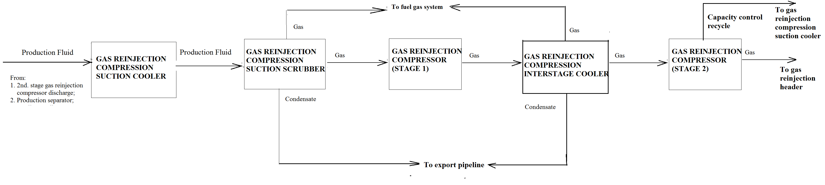

Figure 1.7 Overall Process Flow Diagram of ST-PIP

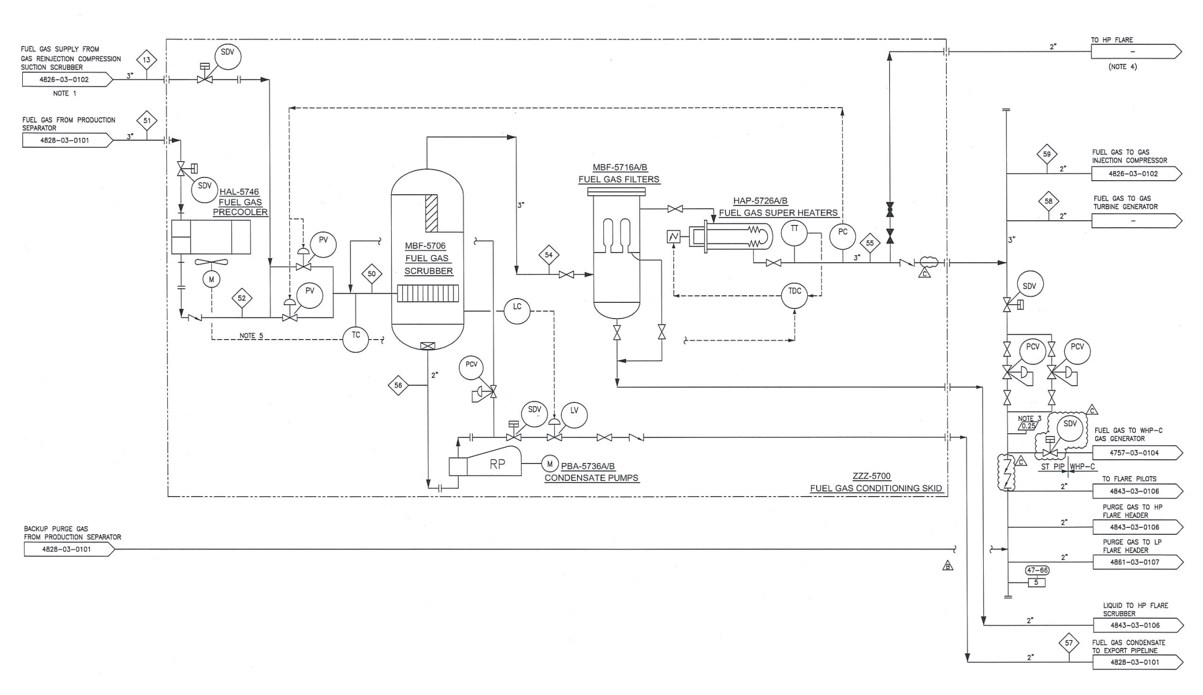

Figure 1.8 Flow Diagram of Fuel Gas Systems ST-PIP

**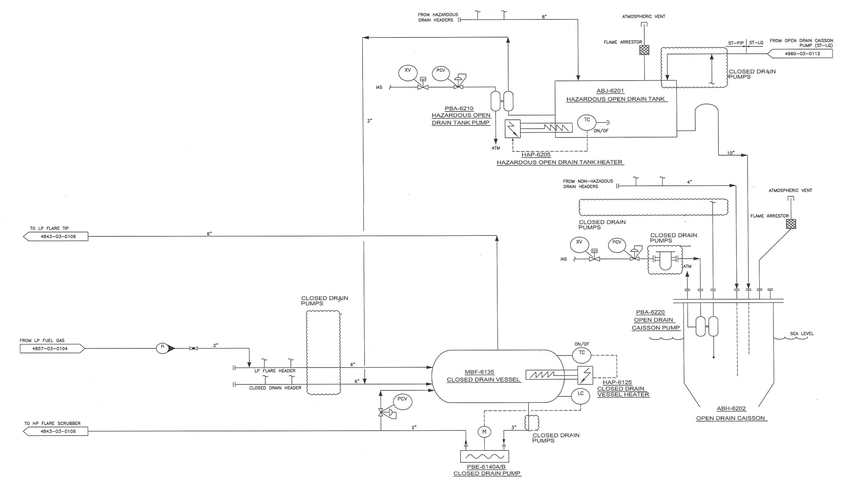**

Figure 1.9a Open & Closed Drain Systems on ST-PIP

**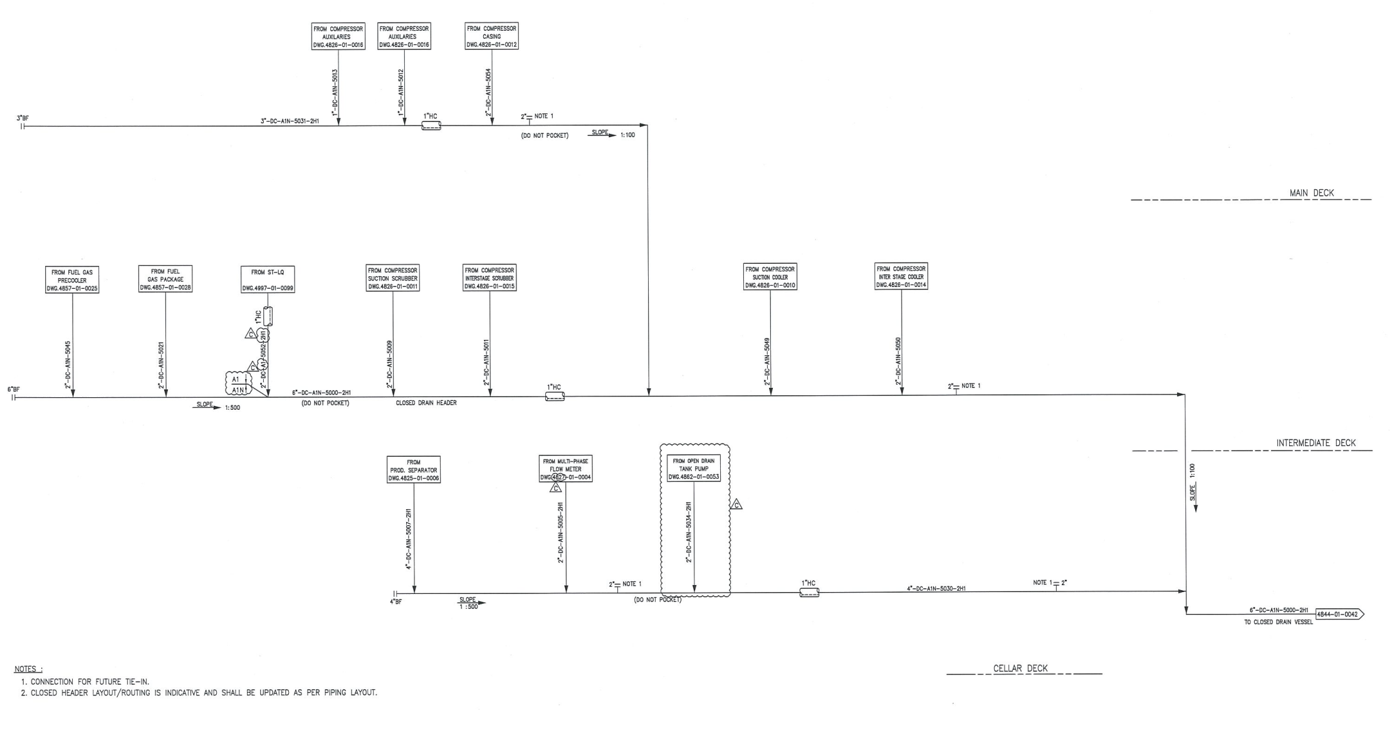**

Figure 9b Piping and Instrumentation of Closed Drain Header – ST-PIP

**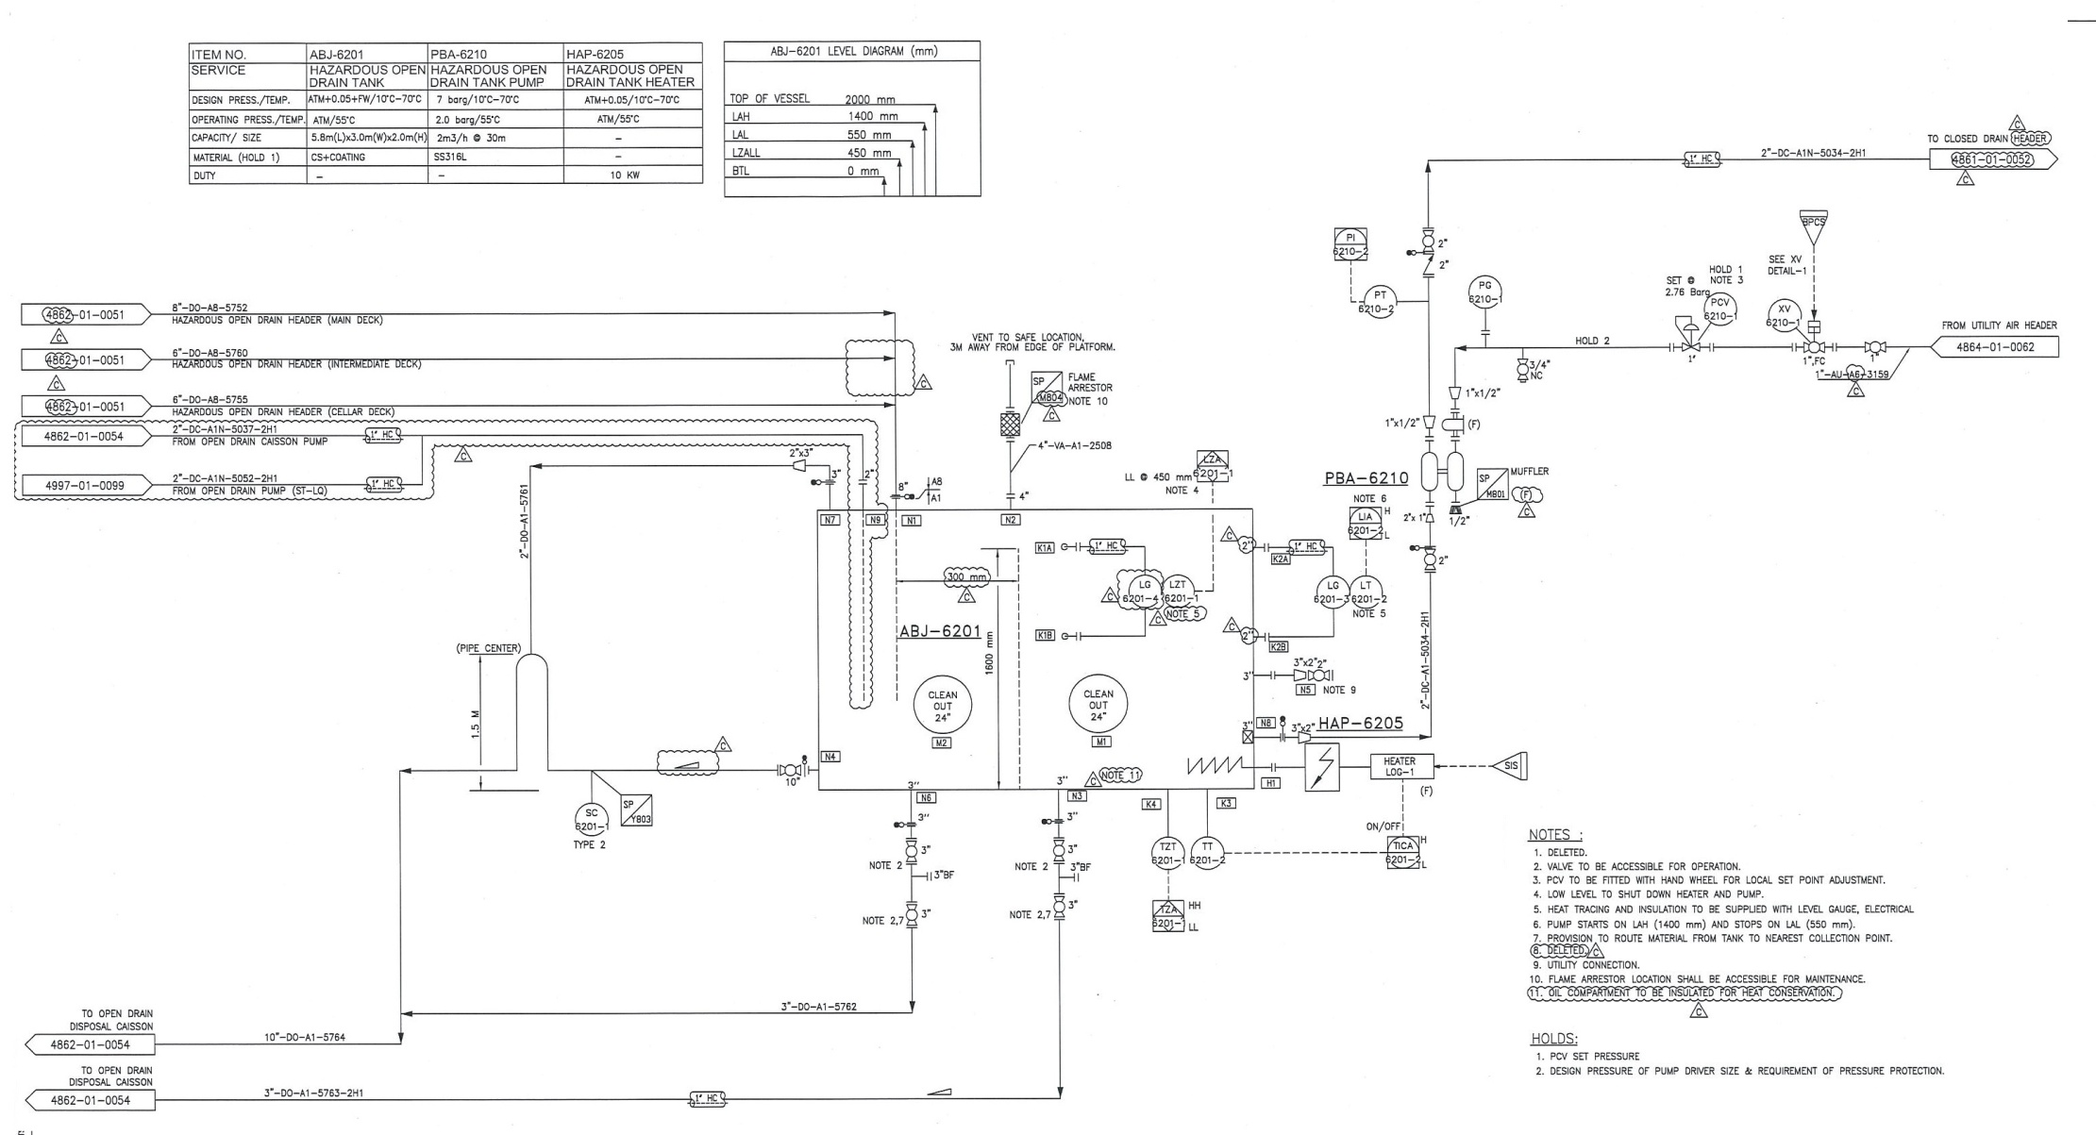**

Figure 1.10a ST-PIP PID Open Drain Tank

**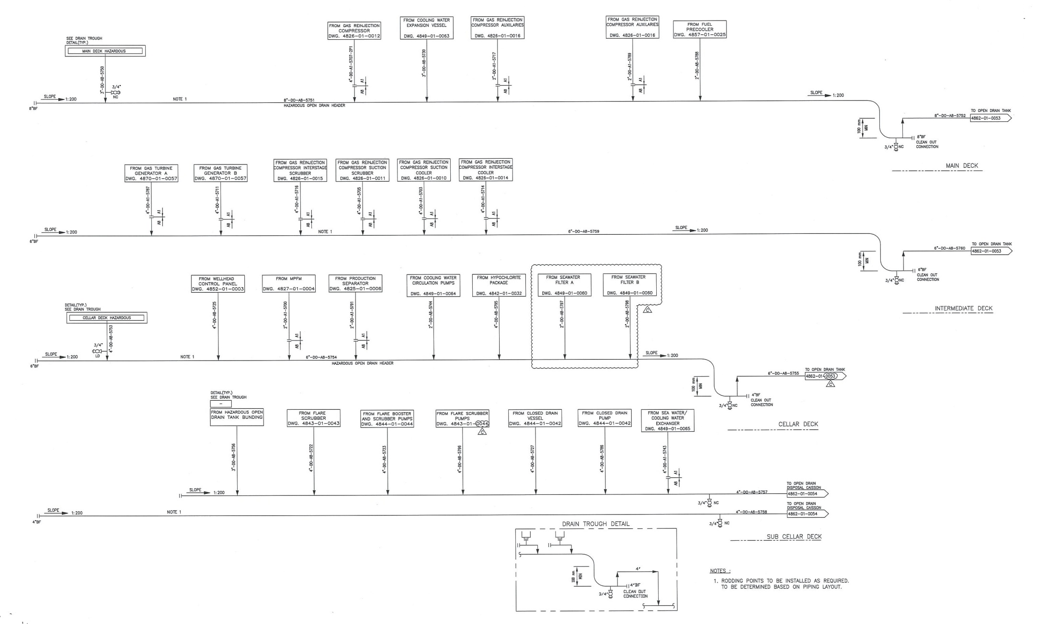**

Figure 1.10b Piping and Instrumentation of Hazardous Open Drain header on ST-PIP

***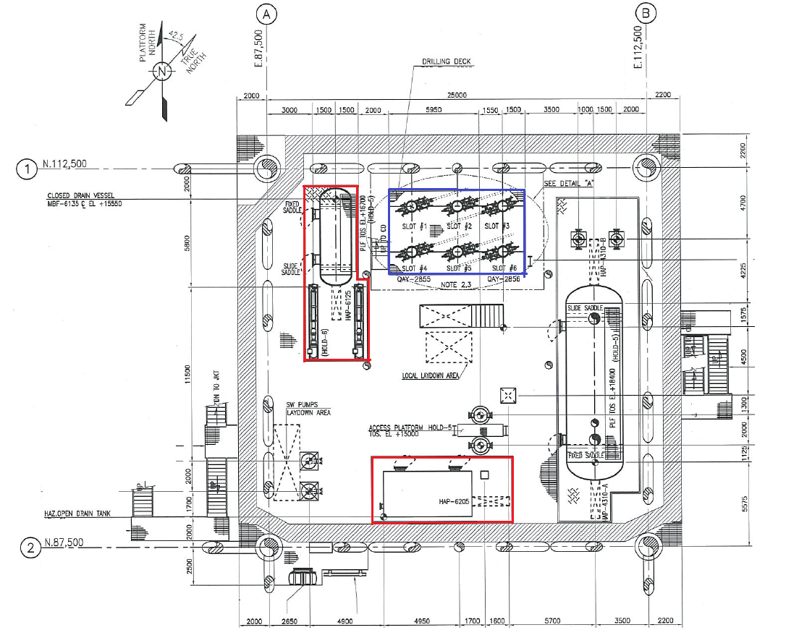***

Figure 1.11 Arrangement of Close drain and open drain on ST-PIP

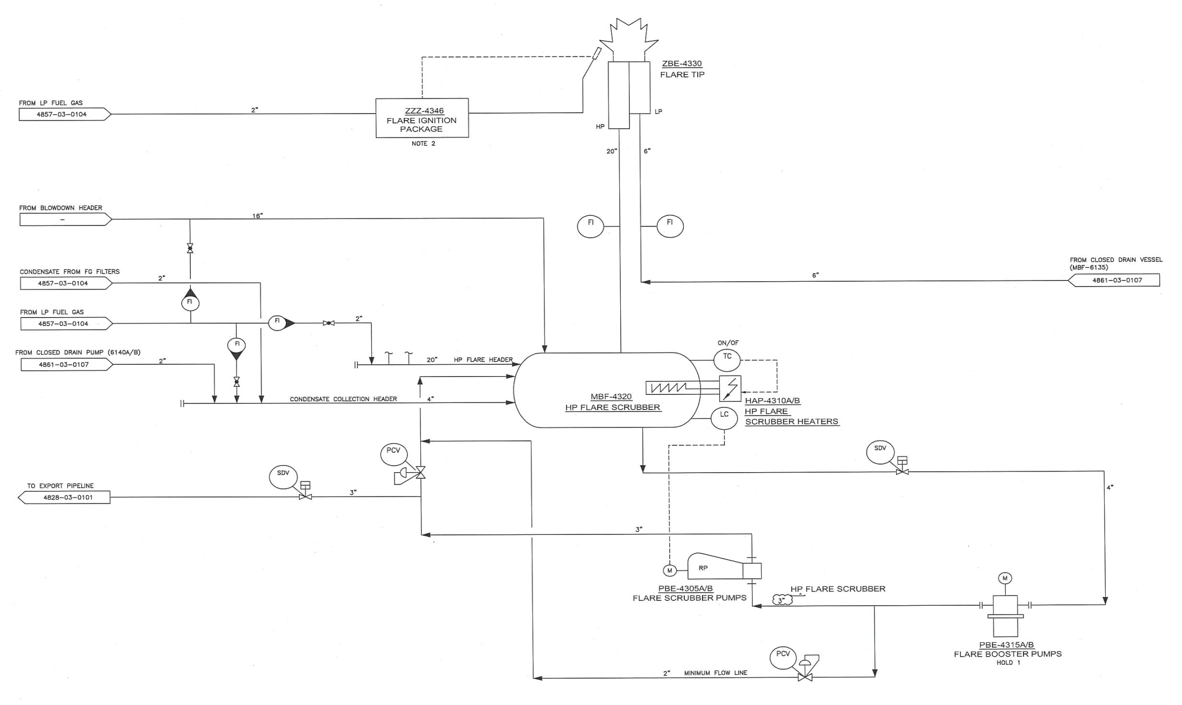

Figure 1.12 HP and LP Flare Systems on ST-PIP of STT FFD Phase 1 Project

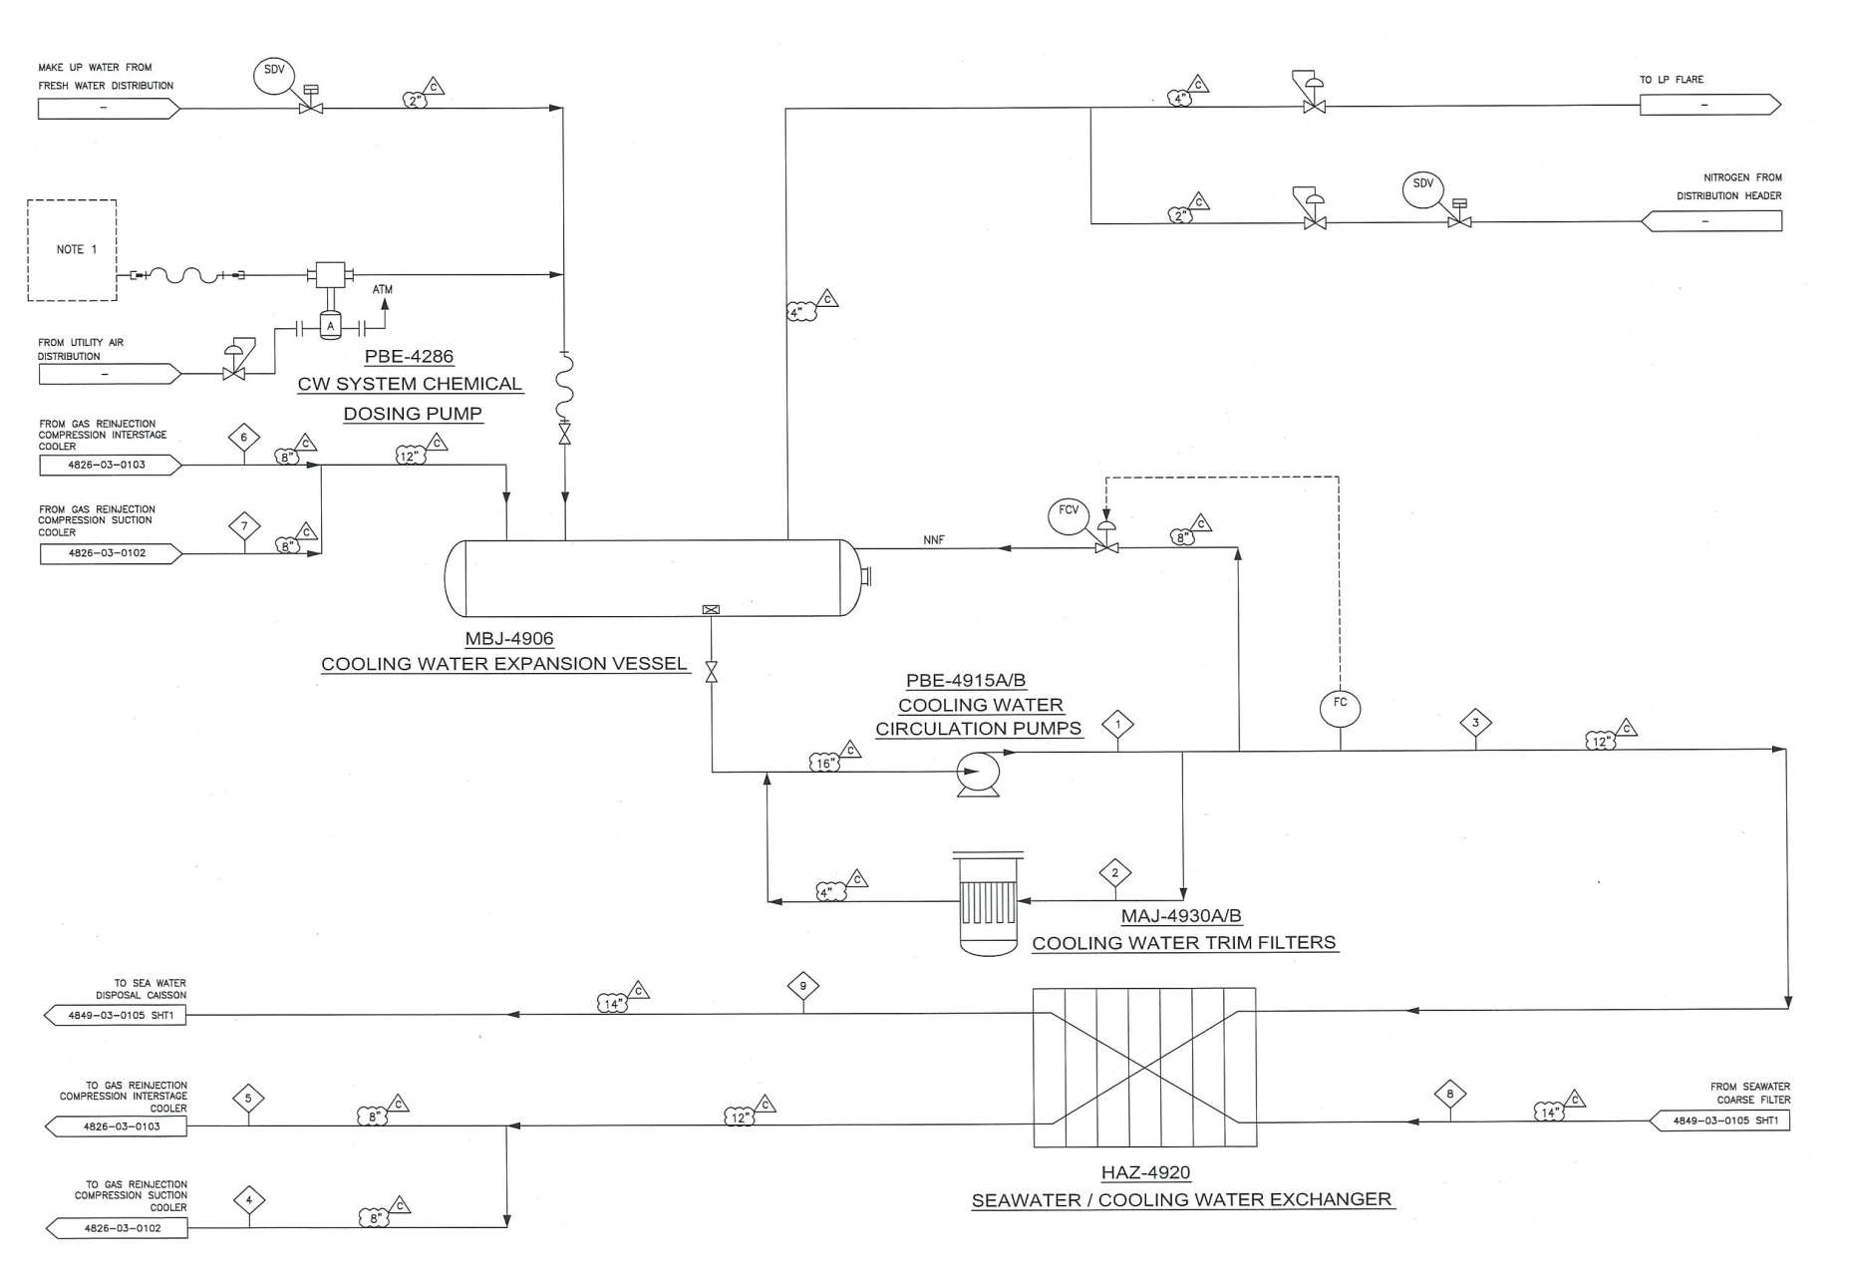

Figure 1.13 Seawater Cooling and Freshwater System on ST-PIP of STT FFD Phase 1 Project

3) New pipeline system

In STT FFD Phase 1 Project, CLJOC will install some pipelines as follows:

* 1 x 10” Maximum and J-Tube, one 10” insulated production export line, from ST-PIP to be tie-in the WHP-C for routing to STV-CPP;
* 1 x 6" diameter riser for lift gas lift;
* 01 stream production pipeline 6” and cable from WHP-C to ST-P&IP
* Cable from ST-PIP to ST-LQ to for providing power and communication to ST-PIP;

These pipelines will be located on the bridges connecting from ST-PIP to WHP-C and from ST-PIP to ST-LQ. There is no subsea pipeline in this project, so it’s no need to carry out the hydrotest activities.

#### Description of the existing facilities which connected to new STT FFD Phase 1 Project facilities

***1) Su Tu Trang Long Term Testing Production facilities – WHP-C Modification***

Unmanned platform - WHP-C was designed as unmaned platfrom and installed for Su Tu Trang Long Term Testing Production project on Sep. 2012. To support for production process on WHP-C, the STT LTPTP process facilities was designed and provided the following system and equipment:

* Production wells (max 4 wells),
* Production and test manifolds,
* Test/Production separator, and
* A pipeline pig launcher.

The following utility/auxiliary systems are furnished to support these process facilities:

* Low pressure fuel gas system
* Chemical injection systems
* Open and closed drain systems
* Flare System
* Diesel system

During STT LTTP Project, 4 production wells (ST-1P/2P/3P&4P) were drilled from WHP-C.

No modification requirements for of the equipment relating to the environmental issues such a as open drain system, closed drain system. Those equipments were also certified by MoNRE at the Decision No. 333/TCMT-TD dated on 3 March 2014 (see attached document in appendix 1).

WHP-C will be modifined to be suit the new process development scheme and condition of the STT FFD Phase 1. Main WHP-C mobilization include:

* Converting two existing gas production wells ST-1P and ST-2P into injection wells;
* Modificating associated piping and instrument to carter the new hing pressure gas injection from ST-PIP;
* Installing new dedicated production manifold to collect the production fluid from ST-3P and ST-4P from WHP-C and routed to the production separator on ST-PIP. This manifold shall be used in future phase 2;
* Modificating the chemical injection system including Scale Inhibitor, Methanol, Wax Inhibitor, Corrosion Inhibitor for ST-PIP to provide supply required dosage chemicals to process system on ST-PIP;
* Modificating existing nitrogen system to provide nitrogen to injection compressor on ST-PIP;
* Modification flare system to handle new relief from new service installed on WHP-C
* Interconnecting the other utility systems like diesel, instrument/utility air system, Fresh Water and Fuel Gas between ST-PIP, ST-LQ and WHP-C and
* Modifications of structure for bridge installation to connect with ST-PIP for STT FFD Phase 1 and ST-CGF for STT FFD phase 2;
* Export gas and condensate from ST-PIP shall be routed and joined to WHP-C export pipeline then flowed to SV-CPP. So a tie in point shall be located dowstream of existing export Shutdown Valve of WHP-C;

***Modification of main equipment***

Utilize the utility systems of WHP-C to the maximum extent feasible. It is also desired to minimize the modification on WHP-C. Therefore, if any existing utility system at WHP-C is not found to be adequate for the total production of ST-PIP/WHP-C, augmenting its capacity shall be considered as the first preference if the modifications envisaged are not complicated

***Modification of Flare System***

The flare is designed to handle blocked discharge relief. It will also dispose of vapor from emergency de-pressurization of the topsides facilities and miscellaneous maintenance gas discharges. The Flare Tip will be a high efficiency, sonic-type design with a design capacity of 50 MMSCFD and will be mounted on a tripod boom structure. The Flare Ignition System will comprise of several pilot/igniter assemblies and a local panel to ignite the flare. Estimation continue flare purge and flare pilots is about 320 SCFH and 150 SCFH respectively.

***Modification of Diesel System***

Diesel fuel for the black start/backup diesel generator and the crane will be stored in the crane pedestal. It will be brought to the platform by boat and a loading filter is provided. Two transfer pumps and a coalescer are provided to distribute diesel to the consumers.

***Chemical Storage and Injection Skids (Figure 1.17)***

The STT FFD Phase 1 facilities shall include provision for potential injection of a variety of chemicals to support production and effluent treatment. Modification of existing chemical injection system including Scale Inhibitor, Methanol, Wax Inhibitor, Corrosion Inhibitor on WHP-C for provising chemicals to ST-PIP.

* **Corrosion Inhibitor** includes chemical tank with design capacity 3.8 m3, 02 pumps with capacity 5.5l/hour. If chemical is used, it will be injected to downstream of the wellhead choke**.**
* **Pour point dispersant:** includes chemical tank with design capacity of 5.6 m3, 02 pumps with capacity 16.6 L/hour. If chemical is used, it will be injected to downstream of the wellhead choke**.**

**WHP-C production process (See Figure 1.18):**

Two existing gas production wells ST-1P and ST-2P shall be convered into injection wells. To be support and suit to production process on the ST-PIP, the associated piping and instrument on the WHP-C will modified to carter the new hing pressure gas injection from ST-PIP.

Production steam from the ST-3P & ST-4P wells will flow to either the production manifold or the test manifold. The production from production manifold will be joined to ST-PIP production stream than be sent directly to the Su Tu Vang Central Processing Platform via 12” pipeline with length 19.5km for further processing.

Injection manifold 1 on WHP-C will receive treated pressured gas from ST-PIP and injected to the ST-1P/ST-2P wells.

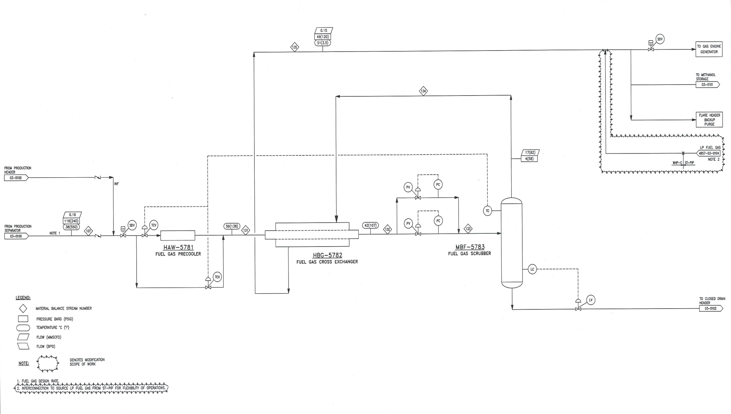

Figure 1.14 Modification Fuel Gas System on WHP-C -STT FFD Phase 1 Project

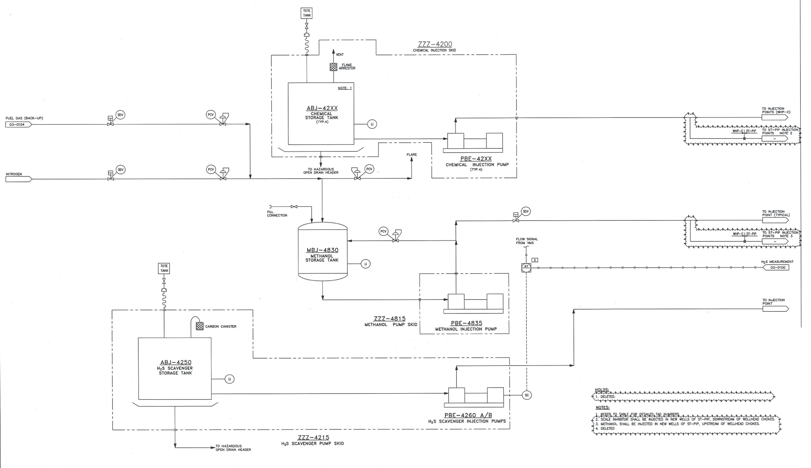

Figure 1.15 Modification of Chemical Injection System on WHP-C – STT FFD Phase 1 Project

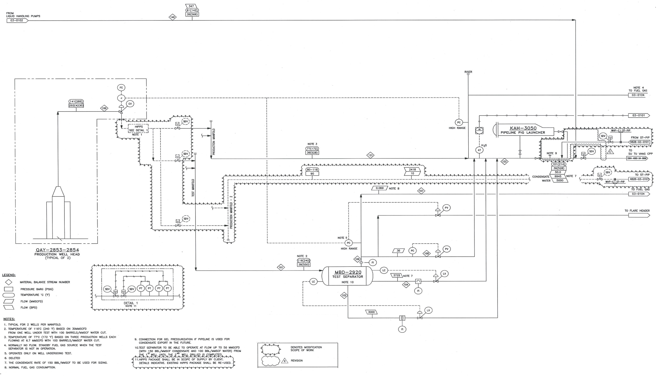

Figure 1.16 Flow Chart Process Diagram of WHP-C – STT FFD Phase 1 Project

**2) Centre Processing Production (STV-CPP)**

***STV-CPP’s facilities and design***

Currently, Su Tu Trang Long Term Testing steam production is routed from WHP-C to STV-CPP for further processing. When ST-PIP starts production, ST-PIP production stream will be joined to WHP-C Production stream, then commingled 03 phase stream production will be flowed to STV-CPP for separating gas, condensate and water via existing multi pipeline 12” from WHP-C to STV-CPP. So there is no CPP modification during development of STT FFD Phase 1.

STV-CPP was installed at the existing STV field and stated production sing 28 October 2008. Produced water treatment system was provided to STV-CPP and certified by MoNRE in July 2009. Capacity of STV-CPP was designed to sufficiently receive and treat the production fluid of the existing STV, STD Northeast, Su Tu Trang Long Term Production Testing (Sep 2012), Su Tu Vang Northeast (SVNE) fields, Su Tu Vang South West (STVSW) (Sep. 2014), Su Tu Nau, and Su Tu Trang FFD Phase 1.

Principal facility systems of the STV-CPP are categorized as follow:

* Subsea facilities: production wells;
* Production equipment including
* Oil separation and stabilization system;
* Produced water treating system;
* Gas handling systems (gas lift, gas/liquid recovery, HP/LP fuel gas, seal gas, HP/LP flare, gas export etc.);
* Water injection system;
* Power system; and
* Miscellaneous systems (chemical storage and injection, control and communication, safety, drain, life support, etc.).

Table 1.10 Overall capacities of the STV-CPP and facilities

| **System** | **Capacity** | **Current Production rate (STVs/STDNE/ STN & STT LTPT)** | **STT FFD Phase 1 Project including STT- LTPTP** | **Total including STT FFD Phase 1** |
| --- | --- | --- | --- | --- |
| Oil Production (BOPD) (Condensate) | 100,000 | 74,200 | 13 000 | 87,200 |
| Total Produced Fluids (BFPD) | 175000 | 126,920 | 19,452 | 146,372 |
| Produced Water 1/01 hydro cyclones (BWPD) | 130,000 (65,000 x2) | 59,000 \* | 798 | 59,798 |
| Produced Water Flotation Cell 2 (BWPD) | 130,000 | 37,000 | 576 | 37,576 |
| Total Capacity Treatment Produced Water 2 (BWPD) | 130,000 | 65,000 | 1,070 | 66,070 |
| Injected Seawater (BWPD) | 225,000 | NA | NA |  |
| Gas Liquids Recovery (Gas / Condensate)3 MMscfd | 66.5 (1.89m3/ 2800BOPD) | 65.5 | No Change | 65.5 |
| HP Gas Handling4 MMscfd | 182 | 115 | No change, | 115 |
| Lift Gas Compression5 MMscfd | 160 MMSCFD | 160 | 9 | 169 |
| As Liquids Recovery (Gas / Condensate)3 (MMscfd | 13.5 | 2  Note: 2 MMCFD vented to LP lare due to limited compression of both LGCs when full gas export. LPGC standby mode | No change | 65.6 |
| Oil Transfer Rate – FPSO - TBVN (BOPD) | 75,000 BOPD | 74.200 | 9000 | 83.200 |

**Note***:*

1. *Two (02) hydro cyclones with design capacity 65.000 BWPD was installed for STV-CPP, and equivalent with the flotation cell design capacity*
2. *CPP Flotation Cell capacity to be expandable to 130,000 BWPD with only circulation pump impeller change.*
3. *Gas rate is feed gas to the system prior to liquids removal. Maximum gas export rate includes associated gas from STV, STDNE, STT LTPTP, SVNE and SVSW, STN and STT FFD Phase 1 production in future*
4. *Includes recycled gas lift volumes and high pressure associated gas production.*
5. *Gas rate is discharge flowrate from two compression trains. Gas rate is prior to liquids recovery due to cooling. LP Gas compression rate is lower.*

Data shown in Table 1.10 indicates that STV-CPP design capacities are enough to handle existing production rates of existing STDNE, SVNE, STVSW, STN and STT FFD Phase 1 Project in future**.** Produced Water Treatment System was installed on STV-CPP. This system was certified by MoNRE in July 2009. **Produced water rate in STT FFD Phase 1 Project is very low (maximum 1,070 bbls per day) so capacity of the CPP** Produced Water Treatment System capacities are enough to handle the produced water generated from STT FFD Phase 1 Project.

***The production processing on the STV-CPP (Figure 1.17)***

At the STV-CPP, the multiphase production fluid from the existing STV/SVNE/STDNE/SVSW will combined to stream production of STT FFD Phase 1 will be then routed to through the separators (HP Separator and IP and LP Separators) for further processing. The HP Separator will provide the primary separation of the production into gas and liquid flows. From the HP Separator, the liquids will flow to the IP and LP production separators for further removal of gas and water. The oil is finally treated in the Electrostatic Treated to meet the BS&W specification of 0.5%. The crude oil will be pumped to the FPSO-TBVN.

Off associated gas collected from IP/LP separators will be compressed by the LP Compressor and then combined with the HP gas. The combined gas is then treated to remove condensate and water through scrubbing/cooling and dehydration in order to have the final maximum water content of 6 lbs/MMSCFD. The final gas is then distributed to gas lift and fuel gas systems for existing STV/STDNE/SVNE/SVSW fields via pipeline from STV-CPP.

Currently, total of 75 MMscfd of associated gas of Block 15-1 is produced, in which 17.3% (13 MMscfd) of the associated gas in Block 15-1 is used for fuel gas to provide power for the facilities. And 76.3% of associated gas (~ 57.4 MMscfd) is exported to ashore for commercial purpose. Hence, about 6.4% (~4.8 MMscfd) of residual associated gas is flared to maintain the production process pressure.

For STT FFD Phase 1 Project, forecasted daily production gas will be 142.96 MMscfd in which 92.96 MMscfd (~65%) of gas production will be injected to the wells and about 50 MMscfd (~ 35%) of gas production will be exporting to ashore via Bach Ho Pipeline for commercial purpose.

***Produced water treating system***

The produced water treating system on STV-CPP includes two hydrocyclones and flotation cell, an online oil contact monitor. This system will be designed to process maximum 130Mbbls produced water per day to sufficiently treat the produced water generated form STV/STDNE/STT/SVNE/STN (65,000 bbls) STT FFD Phase 1 (maximum 1070 bbls produced water per day) as well as to reduce the oil in water content from 1000 ppm down to less than 40 ppm. Online monitoring of the produced water discharge and a sample point for taking samples from the produced water treatment shall be provided.

Produced water effluents collected from HP/IP separators are sent to the Produced Water Treating System. The oil content of the treated water at the outlet of the water treating system will not exceed 40ppm. Treated produced water will be discharged overboard. Skimmed oil from the treatment process is routed to the Closed Drain Header before being routed back to the main process.

Process of this system in described *in* ***Section 4.2.3.2*** Measures to minimize produced waster effluent discharge.

***Associated Gas Export on STV-CPP (operation since 2008)***

The STV-CPP was equipped with the ability to export associated gas to ashore for commercial purpose as well as provide gas lift from the Lift Gas System to a neighboring field facility via a dedicated pipeline. Provisions include space for allocation metering consisting of dual trains of ultrasonic meters combined with on line chromatography (single unit), direct flow control of the export gas rate coupled with upstream and downstream pressure control overrides and piping.

***Crude Export System on FPSO TBVN***

The crude oil from STDs/STVs fields and the condensate from STT FFD Phase 1 Project will be routed to store in the FPSO-TBVN tanks until ready for offloading. The vessels are sized, outfitted, and designed for tandem offloading of processed crude product at a maximum of 35,000 bbls/hour to tankers with loads ranging from 50,000 to 275,000 DWT.

The crude export system on FPSO-TBVN consist of the tanker mooring system, export manifolds, pumping systems, offloading hose, and metering systems. A load cell provides to monitor the mooring loads during offloading.

A workboat is supplied to perform hose handling and other activities around the FPSO-TBVN. Export tankers will connect to the FPSO- TBVN via mooring hawser and a quick release hook.

**Note:** STV-CPP started production since October 2008. The environmental protection equipment on this paltform were certified by MoNRE at the certificate No. 494/QD-BTNMT issued on 25th, April in 2009.

**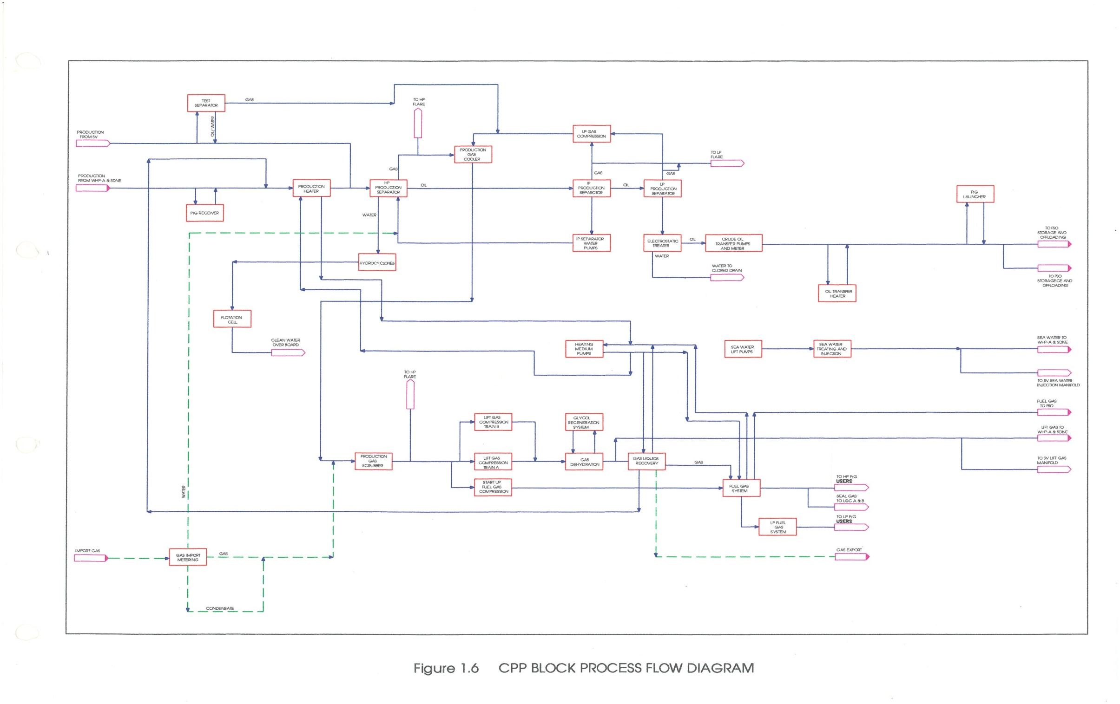**

Figure 1.1

Figure 1.17 STV-CPP Process Flow Diagram

Infield pipeline system

Existing 3 phase production pipeline with 12”, length 19.5 Km from WHP-C to STV-CPP will also be used for routing the multi phase production STT FFD Phase 1 to STV-CPP project. There is no infield pipeline to be installed during the development of STT FFD Phase 1 Project.

Routine pipeline pigging is likely to be needed due to the waxy nature of the condensate. Provision will be made to routinely pig the line after start-up.

Figure 1.20 illustrates the internal pipeline system of Su Tu Complex Fields in Block 15-1.

**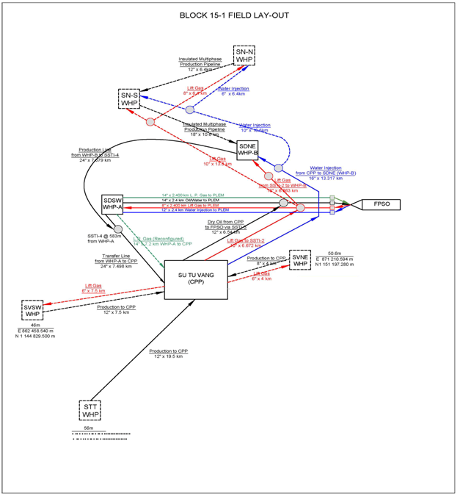**

Figure 1.18 Internal pipeline system of Su Tu Complex Field in Block 15-1

#### Drilling Jack-up Rig

The jack up rig PVD1 of PV Drilling will support to drill 02 new production ST-5P & ST-6P wells. The rig PVD1 can obtain at least 6,000 m or more drilling depth capability with 70m water depth. The cantilever system shall reach 15.7m distance with 4.55m L & R allowance to accommodate existing field slot drilling envelope (2.59 x 2.44 well spacing).

***Well Control***

The well control system includes blowout preventer (BOP) stacks, diverter system, power and control system, and choke-and-kill system. All systems are designed, manufactured and maintained to API standards.

[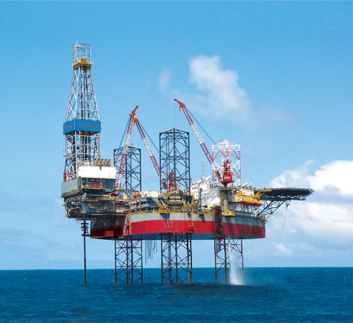](http://www.google.com.vn/url?sa=i&rct=j&q=&esrc=s&source=images&cd=&cad=rja&uact=8&ved=0CAcQjRw&url=http://www.pvdrilling.com.vn/vi-VN/Gian-khoan/Gian-khoan-bien-Jack-up/Gian-khoan-bien-PV-DRILLING-I/pvd.htm&ei=lh0vVdT3G8LUmgWT8ICgAQ&bvm=bv.91071109,d.dGY&psig=AFQjCNHggHauM5CdgjQSuQ3zcqkVccS0-A&ust=1429237502112469)

Figure 1.19 PVD1 Drilling Rig

***Fire and Gas Detection***

The fire and gas detection system is approved and certified fit-for-purpose by the classification society. The unit is equipped with totally independent fire and gas detection systems. These systems have combustible gas H2S gas, smoke and heat sensors located at strategic points throughout the drilling unit.

***Solid control system***

The jack up rig PVD1 is equipped a solid control system, that includes Thule VSM 300 Shale Shaker System with four (4) separate shale shakers (Thule VSM is provided by Brandt in 2003), two Big Bowl Centrifuges Brandt with processing capacity 757L/minute and speed 4000 rpm (Big Bowl Centrifuges was provided by Brandt n 2005), a Cutting Vacuum Dryer with treatment capacity 8 tons/h and a sandy separator (Cutting Vacuum Dryer was provided by Halliburton in 2007) which is efficient in removing the oil from the cuttings. After treating by the above system SBF adhering on SBM cuttings will be treated to meet the allowable limitation (less than or equivalent 9.5% cuttings weight) before discharge to the sea.

More detail of the solid control system and operating principle of SBM cuttings is presented in Section 4.2.2.2 (Mitigation measures to minimize impact of drilling discharge).

***Pollution Prevention System***

The Jack-up Drilling Rig PVD 1 is equipped following pollution prevention systems:

* An oily/water treatment system
* A sanitary water treatment system

All these anti-pollution systems comply with regulations and standards of the Annex 1 MARPOL 73/78 International Convention.

***Domestic waste water treatment system***

PVD1 Rig is provided a domestic wastewater treatment system –ST6A Super Trident Sewage Unit IMO MEPC 2(VI). The domestic waste water provided by Hamworth in 2005. Capacity of system is designed to treat the sewage generated from the personnel on the rig.

The domestic wastewater treatment system on PVD1 Rig was certified in accordant with the International Maritime Organization Regulation MEPC (VI) and meet with Annex IV MARPOL 73/78.

***Drainage system and oil water treatment***

PVD1 Rig is equipped “Hamworthy HSO.5-M oily water separator to IMO MEPC 107 (49)” with 12m3/day capacity for treating oil content in wastewater lower than 15ppm. This oily water separator was provided by Hamworthy in 2005).

The waste water from the equipment and rig floor, drip/pollution pans is collected by the drain system then is routed to Hamworthy HSO.5-M oily water separator to treat oil in waste water meet the Annex 1 of MARPOL 73/78 before discharging to the sea. When using SBM, a completely closed drain system (all overboard line plugged), including drip/pollution pans under the rig floor, around base of the BOP area and wellhead, under all utility pumps and quick–connect or hammer union will be able to prevent spillage into the sea.

#### Onshore Support Base

***Transport of Materials (Supply Vessel/Helicopter)***

Material, equipment and manpower supporting the STT FFD Phase 1 project will normally be supplied by supply boat. Helicopter transport shall be used to provide supplies or to transport manpower to the ST-PIP and ST-LQ during operations and critical maintenance requirements. Operation programs of these supply boat are as below:

* Standby vessels will always be in attendance at the PVD1 rig, STV-CPP, ST-PIP & ST-LQ, STV-CPP, FPSO-TBVN in Block 15-1;
* 1 supply boat trip per week from CLJOC Supply Base in Vung Tau to ST-PIP and ST-LQ. Normally, it takes up to 12 hours for the service ship to arrive at the destination.

***Operations Base and Materials Storage Yard / Warehouse***

The existing CLJOC Supply Base in PTSC SB in Vung tau will be used to support the drilling and operation of the projects of CLJOC including STT FFD Phase 1 Project.

CLJOC Supply Base includes 02 materials storage yard with 27,000 m2 and 03 warehouses with total 3,200 m2 for servicing CLJOC operations during implementation of STT FFD Phase 1 Project will be located in this Base. Spare parts as well as other required materials for CLJOC operation will be stored and maintained at these storage yards and warehouse in a manner which ensures their readiness, quality and safe.

### Project Technology

#### Construction, Installation and Commissioning

As CLJOC’s experiences in developing the Su Tu Fields, tug barges, derrick barges, vessels will be used for supporting the offshore installation of the STT FFD Phase facilities. Manpower, and schedule for offshore Installation of STT FFD Phase 1 Project is summarized below table.

|  |  |  |  |  |
| --- | --- | --- | --- | --- |
| **Items** | **Installation duration** | **Target**  **(Start day)** | **Barge & Vessel** | **Total Manpower** |
| ST-PIP Jacket installation | 25 days | August 2015 | 6 | 150 |
| ST-LQ Jacket installation | 20 days | July 2016 | 6 | 150 |
| ST-PIP & ST-LQ Topside installation | 17 days | July 2016 | 6 | 150 |
| WHP-C modification | 60 days | September 2016 | 6 | 300 |
| ST –PIP/ ST-LQ  Hook up & commissioning | 60 days | September 2016 | 2 | 400 |

***Installation of ST-PIP and* ST-LQ jackets and topsides**

After completing fabrication of ST-PIP and ST-LQ Jackets at PTSC M&C yard in PTSC SB port, Vung Tau, these jackets will be lifted onto a transportation barge for towing to the installation site by supporting by 02 transportation barges and 02 support vessels. Prior to the tow, the jacket will be sea-fastened to the transportation barge in accordance with pre-engineered sea-fastening drawings. The derrick barge will be set up at the jacket installation site and a seabed survey will be carried out to make sure the sea floor is clear in the area where the jacket will be set. Any debris will be cleared.

When the jackets and transportation barge reach the STT installation site the sea-fastenings will be cut and the jacket will be lifted into the water on its side. Once the jacket is stable in the water, the lift slings connected to the bottom of the jacket legs will be released and the lower end of the jacket will be allowed to sink under its own weight until the jacket is in the upright position. Once the jacket is in the upright position the derrick barge will move the jacket to a point near the final location. Surveyors will confirm the final set down location and the proper orientation for the jacket and the jacket will be lowered to the sea floor. Steel piles will be driven below the mudline through each of the four jacket legs to pin the jacket to the sea floor.

After installation of the jacket, the topsides will be floated over the jacket and secured into place by derrick barge. After the installation of ST-PIP Jacket, the rig will be moved over the location for drilling the new production wells and put them on stream.

***Infield Pipeline System installation***

The existing multi production pipeline 12” from WHP-C to STV-CPP (installed 2010 during development of the STT Long term testing production project) will be used for transfer production stream of STT FFD Phase 1 to STV-CPP for further treatment.

The 12” pipelines connecting from ST-PIP and WHP-C on the Bridge is about 80m will be installed during bridge installation.

There is no infield subsea pipeline to be installed during development of STT Field Development, so no need hydrotesting.

***Commission***

The equipment of ST-PIP and ST-LQ topsides will be commissioned as much as possible onshore to minimize the offshore commissioning requirements. The integrated nature of the topsides design will minimize the hook-up and commissioning requirements thereby minimizing offshore discharge and waste generation.

Any facility installed will be tested thoroughly prior to regular operation in order to guarantee safety and efficiency performance. All instrument and electrical controls including the ESD and Fire and Gas Detection systems will be tested prior to start-up. The hook-up and commissioning phase will take a total of 60 days for completion.

#### Drilling Operations

a) ST-1P & ST-2P conversion as injectors

At the moment the two wells ST-1P and ST-2P are producers in respectively E/F and F sands. Both wells have the same design (20” Conductor, 13 3/8” casing, 9 5/8” casing). ST-1P and ST-2P will be converted to injection well. This simulation gives the main injection parameters:

|  |  |
| --- | --- |
| ST-1P | ST-2P |
| Injection rate 40 MMSCF/day  Tubing head pressure 7325psi | Injection rate 60 MMSCF/day  Tubing head pressure 7680psi |

b) ST-5P and ST-6P well Drilling

* Beside 4 existing production wells, maximum two (02) development wells (ST-5P & ST-6P) are planned to drill during STT FFD Phase 1. The drilling activities for 2 new wells will be conducted as the same manner of the previous drilling activities in STT Field. Total of days drilling and completion for 02 wells is 150 days;
* ST-PIP jacket installation is planned on September 2015 then ST-5P & ST-6P will be drilled from 15 October 2015;

***Drilling Program and Casing Program***

***Proposed Mud Drilling Program***

For STT wellbore, the drilling muds will be used with the WBM/SBM ratio of 9,200 bbls/ 11.300 bbls. Table 1.11 and Figure 1.20 shows summary of Proposed Casing Program and Mud System for STT FFD Phase 1 (ST-5P/ST-6P wells) and t*ypical Single STT Well Diagrams.*

Table 1.11 Proposed Casing Program and Mud System

| **Hole x Casing** | **Hole Depth MDRT (TVDss) (M)** | **Mud Program** | **Volume of Mud (bbl)** |
| --- | --- | --- | --- |
| **30” (TVD)** | +/- 250 m | WBM (Sea Water with Hi-Vis pre-hydrated gel sweep) | 3400 |
| **16” x 13-3/8” (MD)** | +/- 2219 (1954) m | KCL/Polymer | 5800 |
| **12-1/4” x 10-3/4” x 9-5/8” (MD)** | +/- 3594 (3325) m | SBM  (Neoflo 1-58 or Saraline 185V) | 3800 |
| **9-1/2 & 8-1/2 x 7” (MD)** | +/- 4534 (3830) m | SBM  (Neoflo 1-58 or Saraline 185V\*) | 4200 |
| **6” x 4-1/2” (MD)** | +/- 4724 (3960) m | SBM  (Neoflo 1-58 or Saraline 185V\*) | 3300 |

*Note: (\*) Saraline to be used in case of contingency only*



Figure 1.20 Schematic ST-5P and ST-6P

All SBM hole sections the cuttings will be washed and processed with solids control equipment and Cuttings Treatment Vacuum Dryer to ensure the SBM fluid on cuttings is less than or equal to 9.5% by cuttings weight to meet the existing standard for cuttings discharge required by QCVN 36:2010/BTNMT of Vietnam.

***Cementing program***

Conceptually, all casing strings will be cemented using a conventional cementing program based on the experience acquired during the LTPTP.

One stage cementing method is applied for all casing strings. The 13-3/8” is cemented with a single slurry. Lead and tail slurries are planned for 9-5/8” casing string with 150 m of tail slurry and top lead cement is about 150m above top of Bach Ho formation. The 7” liner system will be cemented at approximately 70m above the 9-5/8” shoe and the 5” liner 70m above the 7” shoe.

**Completion Design**

Figure 1.21 shows a typical STT well completed with the Cased Hole Perforation alternative.



Figure 1.21 Typical Completion Design of typical for Cased Hole Perforation Wellhead & Christmas Tree Design

Drilling and completion procedures will incorporate a conventional wellhead system and Christmas tree. Once completed, each well can be produced, serviced and worked over independently. All wellheads and trees will be designed for 10,000 psi maximum working pressure.

#### STT FFD Phase 1 Production

In the production phase, gas and condensate will be produced from 02 existing production wells ST-3P/ST-4P and new production wells ST-5P/ST-6P. ST FFD Phase 1 First Gas is scheduled for October, 2016. According to the P50 production forecast for P2 (Base Case), the gas rate will start at 75 MMscfd in 2016 and reach 150MMscfd in 2017 and keep this rate until 2028. Estimated cum. Gas produced during STT FFD (from 2016 to 2028) is about 693,396 MMscf.

Condensate rate of ST FFD Phase 1 Project will start at 7823 BOPD in 2016 and then reach the peak of 19,633 BOPD in 2017, and they decrease to 8,075 BOPD in 2028, when CLJOC’s current Operators license expires. In summary, the production activities in ST FFD Phase 1 Project, in Block 15-1 will provide cumulative about 53 MMBO (~ daily average oil production rate of ~ 12,242 BOPD during 13 years of production (from Oct. 2016 to the end of 2028). Produced water rate of ST FFD Phase 1 Project is low. Daily average produced water rate within 13 years of production from Oct. 2014 is estimated about 910 BPWPD reach peak 1070 BPWPD in 2021.

As presented in Section 1.4.3.1, production wellstream flow from ST-PIP (2 wells ST-5P/ST-6P) is adjusted by choke valve of each well and be routed to production systems (test separator, production separator) for separating gas and condensate. Then production fluid will is routed to the pipeline of WHP-C the STV-CPP where it will be co-mingled with the production fluid of WHP-C before flowing to STV-CPP via the 3 phase pipeline 12”.

The gas outlet stream at separators on ST-PIP will be split into two streams: one to compression trains for treatment and the remaining is routed to the export pipeline controlled by a flow control valve. The flow control to export pipeline will be set as per the export demand which is as per design is 50 MMscfd maximum. The export gas will be commingled with separated liquid stream and the commingled stream will be routed to the export pipeline at WHP-C via the bridge.

Estimated that during ST-FFD Phase 1 Project volume of gas to be injected to the wells ST-1P/ST-2P from 2017 to 2024 is about 100 MMscfd.

* Selection basis of the production technology of STT FFDP1 Project:

The technology applied for STT FFDP1 Project is selected based on the maximizing the existing facilities of Su Tu Fileds in Block 15-1 and enhance the oil and gas recovery rate of STT Field. So that, gas injection option is selected that helps to increase the ultimate liquid recovery of STT Field, no need to wait for the full field development project; use part of the gas produced from this field as gaslift and gas field that minimize the gas flaring during the production. Therefore, this production option will minimize the emissions generated during the production activities of STT Field.

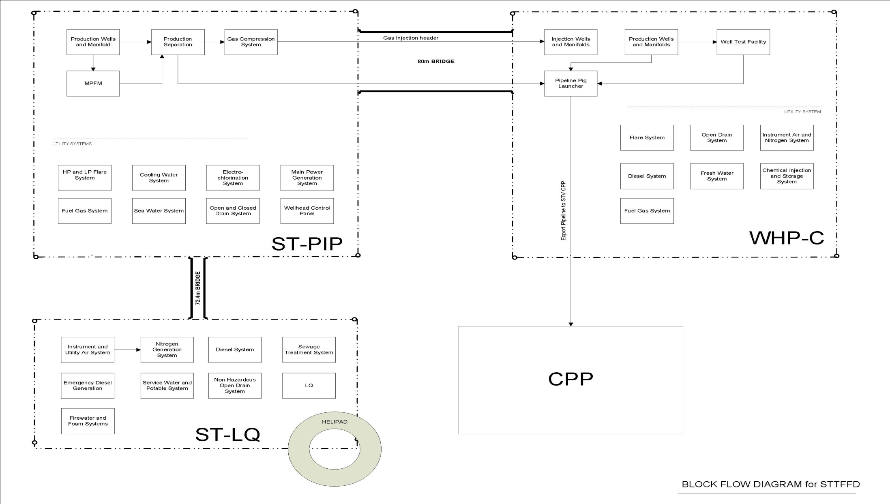

Figure 1.22 Block flow diagram for STT FFD

#### Decommission Phase

Overall Decommissioning Plan for all facilities in Block 15-1 including STT FFD Phase 1 facilities (WHP-C, ST-PIP, ST-LQ) will be submitted to PVN and MoIT for approve. Within 01 year before decommissioning STT FFD Phase 1 facilities, CLJOC will develop a detail decommissioning plan for those production facilities, and submit to PVN and MoIT in compliance with Decision No. 40/2007/QD-TTg of the Prime Minister, ratified on 21 March 2007 about “*Decommissioning of fixed installations, equipment and facilities used for petroleum operations”*.

Another hand, before implementing the decommissioning activities, CLJOC will conduct the environmental monitoring survey, develop Monitoring Report, and submit to PVN and MoNRE. Within 09 months since completing the decommissioning activities of ST production facilities, CLJOC will conduct the environmental monitoring survey, establish monitoring report , and submit to PVN and MoNRE. The Environmental Monitoring Program will be developed in compliance with “*Guidelines on Monitoring the marine environment in the vicinity of offshore petroleum installations*” of PVN ratified in 2014.

### List of main STT FFD Phase 1 Project Equipment and facilities

List of main STT FFD Phase 1 Project equipment and facilities relating to the environmental protection will be presented in Table 1.12.

Table 1.12 List of main equipment relating to environment on the STT FDP Phase 1 Facilities

|  |  |  |
| --- | --- | --- |
| ***ST-PIP*** | | |
| **Equipment/System** | **Capacity & Process Flow Diagram (PID)** | **Status** |
| Power generators | 2.7 MV | New |
| Fuel gas system | 6 MMscfd | New |
| Cooling Seawater system | 1650 m3/h | New |
| Open drain:  Hazardous open drain  Non-hazardous open drain | * Open Drain Tank: 34.8 m3; * 02 Open Drain Pump: 2 m3/h * Open Drain Heater: 20Kw | New |
| Closed drain system | * Close Drain Tank: 2 m (ID) x 5 m (L) * 02 Close Drain Pump: 5 m3/h * Close Drain Heater: 20 Kw | New |
| Flare system | 300 MMscfd | New |
| ***ST- LQ*** | |  |
| **Equipment/System** | **Capacity & Process Flow Diagram (PID)** | **Status** |
| Service sea water | 40 m3/h | New |
| Sewage treatment system | 20 m3/day | New |
| Firewater & foam | NA | New |
| Gas & smoke (fire) detectors | * Gas, smoke, heat detector with addressable F&G system * FM 200 fire suppression system | New |
| **WHP-C modification** | | |
| **Equipment/System** | **Capacity & Process Flow Diagram (PID)** | **Status** |
| Flare system | N/A | Installed in 2012 |
| Fuel gas system | N/A | Installed in 2012 |
| The systems were certified by MoNRE (March 2014) | | Installed in 2012 |
| Open systems (Open drain Tank) and vent | Contaminated rain, waste water from hazardous areas by Open Drain Header   * Open Drain Tank: 4.0 m3; * Open Drain Pump: 5 m3/h * Open Drain Heater 10Kw | Installed in 2012 |
| Close Drain and Vent System | Collect the oily water from the maintenance of equipment, leakage form over pressure by closed drain header.   * Close Drain Tank with volume 11.7 m3: liquid 5.0/h m3, gas 4MMCFD * 02 Close Drain Pump with drip pan: 2.5 m3/h * Close Drain Heater 10Kw   02 vent line can the peak load (peak gas flowrate from the topside is 4 MMCFD) generated during blowdown as no relief load. Treat vent volume of (maximum vent gas volume is approximately 2.0 m3 during emergency event. | Installed in 2012 |
| **Equipment on STV-CPP (was installed on STV-CPP and certified by MoNRE in 2009)** | | |
| Produced Water Treatment System\* | 130,000 BPWPD | Installed in 2012 |

***Note:*** *(\*) The volume of produced water generated the STT FFD Phase 1 Project will be very low (maximum 1070 bbls/day). STT FFD Phase 1 production stream shall be flowed to to STV-CPP for separated produced water. Combining production water from the separators on STV-CPP flows to the existing produced water treatment system (hydrocyclone and floatation cell) for treating before discharging into the sea. This system was designed to treat maximum produced water (130,000 BWPD) that is generated from the Su Tu Vang fields, Su Tu Nau and STT FFD Phase 1 Project (included STT LTPTP).*

### Material Usage

***Drilling Chemicals***

Chemicals that intend to be used for the STT FFD Phase 1 Project are not changed in comparison with previous drilling campaigns in the Block 15-1. Typical consumption for the development well using SBM is shown in the Table 1.13. List of drilling chemicals is presented in **Appendix 2.**

Table 1.13 Typical Main Chemicals and Consumption of Drilling Operations

| **Chemical** | **Unit** | **Quantity** |
| --- | --- | --- |
| SBM (Neoflo 1-58)\* | % | 64% |
| Barite (mt) | Metric ton | 218 |
| Bentone (lb) | Pound | 5,350 |
| CaCl2 (kg) | Kilogram | 7,425 |
| Lime (kg) | Kilogram | 9,675 |
| Novatec F (lt) | Litres | 1,067 |
| Novatec P (lt) | Litres | 4,160 |
| Novatec S (lt) | Litres | 2,080 |
| Versatrol (lb) | Pound | 6,117 |
| Note: % Synthetic Based Fluid in the standard SBM formulation is: 64% | | |

*(\*) or Saraline 185 V may be used to drill the complicated technical well as**contingency plan*

*Source: BJ Services*.

Appendix 2 shown list of all chemicals that intend to be used for drilling STT FFD Phase 1 Project wells.

***Production Chemicals***

A variety of chemicals are used for the different stages of process of the gas and oil production operations. The chemicals assist in the control of bacteria activity (biocides), reduction of corrosion, inhibition of scale and prevention of hydrate formation, emulsion and foaming. In general, these chemicals were approved to use for the production and drilling for previous projects in Block 15-1. In-selecting chemicals, CLJOC assessed the safety and eco-toxicity of the Chemicals as well as consider current industry practice to choose the chemicals which have good biodegradation, low toxicity and low bioaccumulation for the drilling and production operations in the Block 15-1. Chemicals that are intended to use for STT FFD Phase 1 Project is listed in Appendix 2.

Table 1.14 Characteristics of production chemicals

| **Type of chemical** | **Process** | **Target Concentration** | **Ecological toxicity/ OCNS Group/OSPAR** | **Injection Rate/total volume (L or kg per year)** | **Components** |
| --- | --- | --- | --- | --- | --- |
| **Or HQ ranging group** |
| Corrosion Inhibitor | Production fluid (Gas/Condensate) | 0.25 L / MMSCF gas | May cause long-term adverse effects in aquatic environment | 4,563 | * Methanol: 10-30%; * Quaternary ammonium compounds, benzyl-C10-21-alkyldemethyl, chloride: 1-5%; * Salts of mediazolines: 10-30%; * Thioalcohol: 1-5%; |
| H2S Scavenger | Production fluid (Gas/Condensate) | 0.26 L / MMSCF gas / 1 ppm H2S reduction | The product components are not classified as environmentally hazardous. However, this does not exclude the possibility that large or frequent spills can have a harmful or damaging effect on the environment./ HQ ranging group: Gold | 189,800 | * 1,3,5 TRIALKYLHEXAHYDRO TRIAZINE: 30-60% |
| Hypochlorite | Seawater system | 2 ppm | NA | 1,752 | * Sodium hypochlorite: 5-10%; * Sodium chloride: 5-10%; * Sodium hydroxide: 1-5% |
| Methanol | Production fluid (Gas/Condensate) | 500 L/ well/ cold start | OCNS Group: E | 8,000 | * Methanol: 60-100%; |
| Scale Inhibitor | Production fluid (Gas/Condensate) | 5% of H2S scavenger rate | The product components are not classified as environmentally hazardous. However, this does not exclude the possibility that large or frequent spills can have a harmful or damaging effect on the environment./ HQ ranging group: Gold; no discharge to the sea | 9,490 | * ORGANIC PHOSPHONATE: 10-30% |
| Oxygen Scavenger | Fresh Water (as cooling medium) | 100 ppm | The product components are not classified as environmentally hazardous./ OCNS Group: E; no discharge to the sea | 2,000 | * AMMONIUM BISULPHITE: 60-100% |

*Source: Baker Hughes.*

The recently issued “Guidelines on the implementation of Requirements on use and discharge of chemicals and drilling fluids in petroleum operations offshore Vietnam” by PVN will be applied as a basis in selecting chemicals by CLJOC. Moreover, the Offshore Chemical Notification Scheme (OCNS) and other relevant (OSPAR), international standards are also referred to select suitable and environmentally friendly chemicals.

## INVESTMENT CAPITAL

Total budget for whole STT FFD Phase 1 Project (case 1:10 year - from 2016 to 2018 without Phase 2) is 9,878.3 Billions of VND ( ~453.76 MM$) in which facilities CAPEX: 7,648.4 Billions of VND (~ 355.74 MM$): the Drilling (DRILLEX) CAPEX: 2,107.4 Billions of VND (~ 98.02 MM$), and OPEX: 989 Billions of VND (~45.43 MM$). Estimation of total budget for environmental protection is about 137.9 Billion of VND (~ 6.4 MM$) and contributes 1.3% of the whole project budget. Estimation of budget for environmental protection for STT FFD Phase 1 Project is summarized in Table 1.15.

Table 1.15 Estimation of budget for environmental protection for STT FFD Phase 1 Project

| **Item** | **Project Total Budget (USD)** | **Annual Budget (USD)** | **Project Total Budget (MM VND)** | **Annual Budget (MM VND)** |
| --- | --- | --- | --- | --- |
| **1. Drilling Support** |  |  |  |  |
| Modification to accommodate and install Vaccum Dryers | 398,573 | 39,857 | 8,569 | 857 |
| Cost Increase for use Neoflo 1-58 | 348,872 | 34,887 | 7,501 | 750 |
| **Sub-total** | **747,445** | **74,744** | **16,070** | **1,607** |
| EIA + Baseline Survey | 58,000 | 5,800 | 1,247 | 125 |
| Fuel gas system | 1,300,000 | 130,000 | 27,950 | 2,795 |
| Flare system | 800,000 | 80,000 | 17,200 | 1,720 |
| Cooling water system | 1,000,000 | 100,000 | 21,500 | 2,150 |
| Sewage treatment system on ST-LQ | 400,000 | 40,000 | 8,600 | 860 |
| ST-PIP Open and closed drains | 800,000 | 80,000 | 17,200 | 1,720 |
| Smock, gas fire detector and alarm system | 300,000 | 30,000 | 6,450 | 645 |
| Fire fighting system | 100,000 | 10,000 | 2,150 | 215 |
| **Sub-total** | **4,758,000** | **59,788** | **102,297** | **10,230** |
| **3. Production Phase** |  |  |  |  |
| ***Environmental Monitoring & Environmental management*** | | |  |  |
| Environmental monitoring | 132,240 | 13,224 | 2,843 | 284 |
| Solid waste disposal | 235,200 | 23,520 | 5,057 | 506 |
| Environmental Management | 538,857 | 53,886 | 11,585 | 1,159 |
| **Sub-total** | **906,297** | **90,630** | **19,485** | **1,949** |
| **Total** | **6,411,742** | **641,174** | **137,852** | **13,785** |

*Note: USD/VND: 1USD /21,500 VND*

## ORGANIZATION AND LABOUR

In addition to the CLJOC’s staff working in the HCMC Office, offshore working personnel in each phase of the project are:

* Total of manpower for installation and commissioning STT FFD Phase 1 facilities in offshore (182 days) is 150 people with maximum 400 persons/day during modification WHP-C and ST-PIP & ST-LQ commission;
* Drilling (150 days): maximum manpower is 112 persons/day;
* Production phase: maximum 131 persons/days on STV-CPP (including for STV/STT/SVNE & SVSW fields) and 20 persons/day on ST-LQ
* Decommissioning: 300-400 persons/day (similar to the installation phase);

All office and offshore personnel of CLJOC are adequately trained with the HSEMS of CLJOC. CLJOC has set up a department, consisting of environmental, safety, health experts, and legislation permitting staff to be in charge of management, implementation, and supervision of HSE plans and performances in all activities of the STT FFD Phase 1 Project. Moreover, in each offshore working team, there is a safety officer responsible for ensure safety for everyone in both normal and emergency cases. With this organization, CLJOC will ensure to comply fully with Vietnamese and International regulations on life safety, working safety and hygiene, and environmental protection.

Figure 1.10

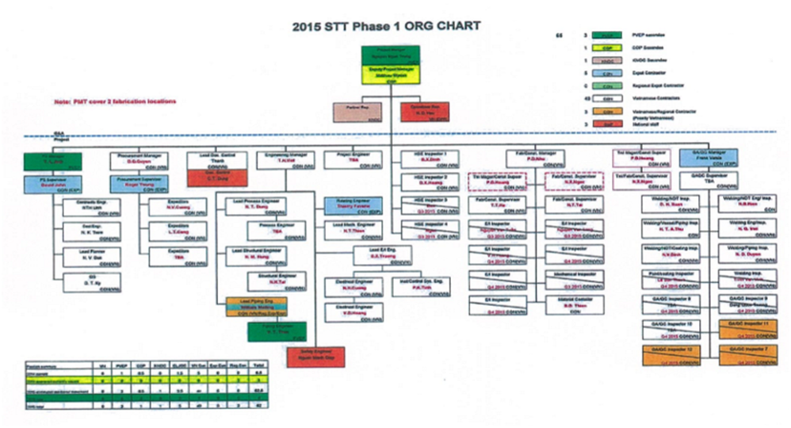

Figure 1.23 Organization Chart of STT FFDP1 Project

## SUMMARY OF SOME MAIN INFORMATIONS OF STT FFD PHASE 1 PROJECT

| Phase | Activities | Duration | Technology/ Operation Manner | Impacts to environment |
| --- | --- | --- | --- | --- |
| 1 | 2 | 3 | 4 | 5 |
| Installation and Commission | * ST-PIP Jacket Installation (25 days); * ST-LQ Jacket Installation (20 days); * ST-PIP & ST-LQ Topsides Installation (17 days); * WHP-C modification (60 days); * ST–PIP/ ST-LQ Hook-up and Commission (60 days). | From T8/2015 to T9/2016 | * After onshore fabrication completes, the jackets and topsides will be transported to offshore by barges and vessels for installation; * The new pipelines will be installed on the bridge connecting ST-PIP to ST-LQ and from ST-PIP to WHP-C; * Maximize the onshore commission to minimize offshore hook-up and commission. | * Generate the wastes during the transportation, installation and commission, such as emissions, wastewaters and solid wastes; * Make the physical disturbance from anchoring and the presence of barges and vessels participating in this phase. |
| Drilling | * Drilling activities (150 days) | Start from 10/2015, uncontinuously | * Drill; * Casing; * Cementing; * Well completion; | * Generate wastes: emissions, wastewaters, solid wastes and drilling wastes; * Physical interactions: the presence of drilling rig and support vessels. |
| Production | Produce from the wells ST-3P/ 4P/5P and 6P. | Start from Q4, 2016 | * The production fluid from the wells ST-5P and ST-6P on ST-PIP will be routed to the separators onboard to separate into gas and condensate. Production fluid will be routed to WHP-C, co-mingled with the WHP-C’s well fluid, and then be transported to STV-CPP via 12” three-phase pipeline for further production. | * Wastes: emissions, wastewaters, solid wastes * Physical interaction: there is a safety zone which was set-up not allow the fishing and maritime vessels get into the surrounding area of Su Tu Fields. |
| Decommision | Decommision the facilities of STT Field | At the end of 2028 | The Decommission Plan for Su Tu Fields in Block 15-1 has been approved by MoIT. Now, this plan will be revised and resubmitted to MOIT for approval in the near future. | Similar to installation and commission phase. |

# DESCRIPTIONS OF NATURAL, ENVIRONMENTAL AND SOCIO-ECONOMIC CONDITIONS

This chapter provides a description of the environmental characteristics of the planned area of Su Tu Trang Full Field Development Phase 1 Project (STT FFD Phase 1 Project), coastal areas and onshore areas, which potentially could be affected if large oil spill accident occurred.

Concurrently, this chapter also mentions data of meteorology, sea water and sediment quality and marine resources of both offshore and coastal environments. The considered coastal areas the area from Khanh Hoa to Ca Mau cape. However, in order to avoid too wide and general description, this chapter will focus on description of the natural and socio-economical conditions of: Ho Chi Minh City, Ba Ria – Vung Tau Province, especially the coastal area of Binh Thuan Province, which are closest proximity to the western of the project. The socio-economic characteristics of the study area are also described.

The mentioned information will be the based environmental data of the project area which is the foundation for the environmental impact assessment and proposal of mitigation measures and environmental monitoring program for deploying and operating the project as well as response methods in emergency situations.

## NATURAL CONDITION AND ENVIRONMENTAL CHARACTERISTICS

### Geographic and geological characteristic

#### Geography

STT FFDPP1 locates at the end of Block 15-1 in water depth about 40m and far from Su Tu Vang field about 20 kilometers South. Block 15-1 locates in the Cuu Long Basin which is about 180 kilometers Southwest far from Ho Chi Minh city, 68 kilometers far from Ke Ga cape and approximately 141 kilometers far from Vung Tau City.

#### Geology

Su Tu Trang Field belonging to Cuulong basin, was formed during rifting in the Early Oligocene. The subject field displays structural architecture typical of a rift basin…i.e., fault bounded, half horst and half graben geometry. The primary reservoir targets are located in the E and F Oligocene sequences, which represent a fluvial dominated sytem overprinted with shoreface reworking and occasional lacustrine flooding events.

#### Topography

* **Seabed topography**

Cuulong Basin is a submerged shelf which has the depth of 0-70m and slide gradually into Southeast direction. In the Southwestern on Cuulong Basin is Con Son Island with the height of 558m and in the Northeastern is Phu Quy Island.

The offshore area containing Block 15-1 has a slope of about 2o and is located in the front of a vast plain of the Vietnamese continental shelf. On the ground surface of this part there are many channels, shoals, sub-surface hills and slopes. Channels are common on the whole seabed, starting at water depth of over 20m and disappearing at water depth of 80-100m. These channels trend from NW to SE and then change into SW to NE [1].



Figure 2.1 Topographic Map of Cuu Long Basin

* **Tectonic**

Cuu Long basin is the subsidence of the Dalat magma zone in Kainozoic aged, which influenced mainly by fluctuations of Kon Tum massif with bow stretch type and partly by stretch of Eastern Vietnam Sea. Thus, the whole Cuu Long Basin locates in the continental crust and is classified as internal continent Rift basin. Morphological structure of this basin is a pattern of alternate swell of basement and hollows with structural components are: Bac Lieu differentiation sunken, Ca Coi differentiation sunken, Cuu Long swell, Phu Quy swell, Cuu Long basin, Northwestern slope incline, Southeast slope incline, Northeast hollow, Western and Eastern Bach Ho hollow, swells (Central, Northwest and East) and Northwest - Southeast differentiation zones.

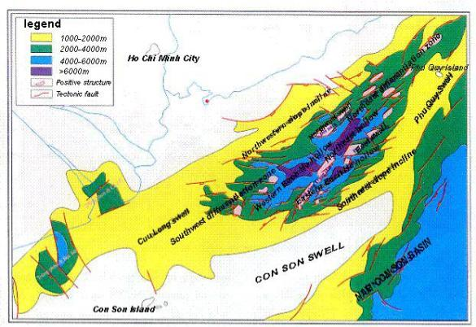

Figure 2.2 Tectonic Map of Cuu Long Basin

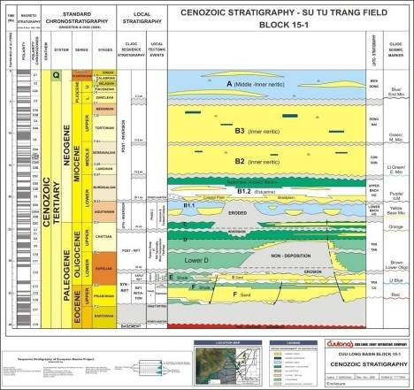

Figure 2.3 Cenozoic stratigraphy

* **Islands**

In the study area Block 15-1, there are 2 large islands which can be affected by the project: Phu Quy and Con Dao Island.

* Phu Quy Island (Cu Lao Thu) includes 10 small islands, which are under the jurisdiction of Binh Thuan Province. The geographical coordinates are 10o28’58’’-10o33’35’’N and 108o55’13’’-108o58’12’’E. It covers an area of about 1,639.4 ha with an oblique rectangular shape. The length and width are 7km from the North to South and 4.5 km from the East to West. Phu Quy is 80 km southeast far from Phan Thiet City, 160 km in the East of Vung Tau, 274 km Northeast from Con Dao. The topographic feature of Phu Quy Island includes hills, mountains and coastal benches and its high decreases gradually from North to South [2].
* Con Dao is an archipelago including 16 large and small islands in offshore of Ba Ria – Vung Tau province. It locates between 8o34’-11o49’ N and 106o31’-106o45’ E and is 180 km far from Vung Tau City. Total natural area of Con Dao is about 76.7 km2. The relief of Con Dao is characterized by mountains and hills which amount to 88.4% total area of island. The mountains and hills are very steep, whilst plains are very small and narrow [3].

### Meteorological characteristics

* **Wind**

There are two (2) distinct monsoons in the study area: the Northeast Monsoon and the Southwest Monsoon. The Northeast Monsoon usually lasts from November to April of the successive year. The Southwest Monsoon late from June to September. The periods from April to early May and late September to October are the transitional periods with its unstable speed and direction.

Seasonal wind characteristics in the South region are presented in Table 2.1 as below:

Table 2.1 Specific Seasonal Wind Types and Wind Speed

*Unit: m/s*

|  |  |  |  |
| --- | --- | --- | --- |
| **Month** | **Specific wind type** | **Max speed** | **Average**  **speed** |
| January | NE Monsoon | 18 | 3.0 |
| February | 16 | 2.8 |
| March | 12 | 2.8 |
| April | Transitional months between NE and W-SW monsoon | 17 | 2.6 |
| May | 16 | 3.1 |
| June | SW Monsoon | 16 | 3.7 |
| July | W Monsoon | 17 | 3.8 |
| August | 18 | 3.9 |
| September | 15 | 4.3 |
| October | Transitional month between NE and W-SW monsoon | 16 | 3.2 |
| November | NE Monsoon | 20 | 4.0 |
| December | 18 | 4.1 |

*Source: Southern Region Hydro Meteorological Center, 2014*

Statistical data on maximum wind speed and direction observed in the Project area (Block 15-1) by CLJOC from 2008 to 2014 is shown in Table 2.2 [4].

Table 2.2 The statistical data of direction and maximum speed in Block 15-1 during 7 years (2008-2014)

*Unit: m/s*

|  |  |  |  |  |  |  |  |  |  |  |  |  |
| --- | --- | --- | --- | --- | --- | --- | --- | --- | --- | --- | --- | --- |
| **Year** | **2008** | | | | | | | | | | | |
| Month | **1** | **2** | **3** | **4** | **5** | **6** | **7** | **8** | **9** | **10** | **11** | **12** |
| Speed | 16 | 16 | 13 | 10 | 9 | 10 | 11 | 11 | 10 | 8 | 13 | 15 |
| Direction | NE | NE | NE | VAR | W | WSW | WSW | W | WSW | VAR | ENE | NE |
| **Year** | **2009** | | | | | | | | | | | |
| Month | **1** | **2** | **3** | **4** | **5** | **6** | **7** | **8** | **9** | **10** | **11** | **12** |
| Speed | 17 | 11 | 10 | 9 | 8 | 9 | 11 | 9 | 10 | 9 | 14 | 15 |
| Direction | NE | ENE | ENE | VAR | VAR | WSW | WSW | VAR | W | VAR | ENE | ENE |
| **Year** | **2010** | | | | | | | | | | | |
| Month | **1** | **2** | **3** | **4** | **5** | **6** | **7** | **8** | **9** | **10** | **11** | **12** |
| Speed | 14 | 10 | 11 | 8 | 7 | 9 | 9 | 10 | 6 | 11 | 13 | 14 |
| Direction | ENE | ENE | ENE | VAR | VAR | SW | WSW | WSW | VAR | VAR | ENE | ENE |
| **Year** | **2011** | | | | | | | | | | | |
| Month | **1** | **2** | **3** | **4** | **5** | **6** | **7** | **8** | **9** | **10** | **11** | **12** |
| Speed | 15 | 14 | 15 | 10 | 7 | 9 | 10 | 9 | 10 | 9 | 13 | 15 |
| Direction | ENE | ENE | ENE | ENE | VAR | SW | WSW | WSW | WSW | VAR | NE | NE |
| **Year** | **2012** | | | | | | | | | | | |
| Month | **1** | **2** | **3** | **4** | **5** | **6** | **7** | **8** | **9** | **10** | **11** | **12** |
| Speed | 14 | 11 | 9 | 6 | 8 | 9 | 10 | 11 | 8 | 9 |  |  |
| Direction | NE | NE | NE | VAR | WSW | WSW | WSW | WSW | VAR | VAR |  |  |
| **Year** | **2013** | | | | | | | | | | | |
| Month | **1** | **2** | **3** | **4** | **5** | **6** | **7** | **8** | **9** | **10** | **11** | **12** |
| Speed | 15 | 14 | 8 | 7 | 6 | 8 | 8 | 10 | 4 | 9 | 5 | 15 |
| Direction | ENE | ENE | ENE | ENE | - | SW | WSW | WSW | WSW | - | NE | NE |
| **Year** | **2014** | | | | | | | | | | | |
| Month | **1** | **1** | **1** | **1** | **1** | **1** | **1** | **1** | **1** | **1** | **1** | **1** |
| Speed | 15 | 15 | 15 | 15 | 15 | 15 | 15 | 15 | 15 | 15 | 15 | 15 |
| Direction | NE | NE | NE | NE | NE | NE | NE | NE | NE | NE | NE | NE |

*Sources: CLJOC, 2012*

*Note: VAR: Variable*

**Tropical Cyclones**

Tropical cyclones form one of the many atmospheric circulation systems. During their life-span tropical cyclones may reach different wind level, classified by the wind speed prolonged near the cyclone centre. In the Northwestern area of the Pacific Ocean and in the Southeast Vietnam sea region, these classifications are:

* Tropical Depression: wind speed less than 34 knots (17.5m/s);
* Tropical Storm: wind speed from 34 to 63 knots (17.5-32m/s);
* Typhoon: wind speed from 64 to 129 knots (33-66m/s);
* Super Typhoon: wind speed exceeds 130 knots (> 67m/s).

According statistical data from CLJOC for Block 15-1 area, the wind speed//direction of storm and tropical depression within 100 years, 10 years and one year are presented as Table 2.3 below:

Table 2.3 Velocity/direction of wind in storms/tropical low pressures in 100 years, 10 years and 1 year

| Return interval | One hour sustained wind velocity at EL.(+) 10,0m –m/s | | | | | | | |
| --- | --- | --- | --- | --- | --- | --- | --- | --- |
| **Wind Direction** | | | | | | | |
| N | NE | E | SE | S | SW | W | NW |
| 100 years (Extra storm) | 23 | 23 | 28 | 21 | 19 | 17 | 19 | 24 |
| 10 years (operating storm) | 18 | 18 | 22 | 16 | 15 | 14 | 15 | 19 |
| 1year | 18 | 18 | 18 | 13 | 12 | 12 | 14 | 16 |

*Source: CLJOC- 2014.*

* **Air temperature**

Air temperature in this area varies from 24.6oC to 30.1oC, annual average temperature is ranged about 24.6 – 27.8oC. Air temperature is often lower during the Northeast Monsoon period (from November to March) and higher during the time of Southwest Monsoon (from May to September) and transition periods. Statistical data of monthly average air temperature in the study area during 5 recent years is shown in Table 2.4.

Table 2.4 Statistical data of air temperature in the study area

*Unit: oC*

| **Month**  **Year** | **1** | **2** | **3** | **4** | **5** | **6** | **7** | **8** | **9** | **10** | **11** | **12** | **Aver.** |
| --- | --- | --- | --- | --- | --- | --- | --- | --- | --- | --- | --- | --- | --- |
| **Phu Quy Insland** | | | | | | | | | | | | | |
| 2009 | 24.6 | 25.9 | 25.6 | 27.8 | 28.1 | 27.8 | 28.3 | 28.2 | 28.4 | 27.5 | 27.2 | 25.0 | 27.0 |
| 2010 | 26.0 | 26.7 | 27.1 | 28.7 | 29.8 | 29.8 | 29.0 | 28.4 | 28.3 | 27.2 | 26.3 | 25.8 | 27.8 |
| 2011 | 24.6 | 25.4 | 25.5 | 26.5 | 28.6 | 28.1 | 28.2 | 28.4 | 28.0 | 27.4 | 26.9 | 25.1 | 26.9 |
| 2012 | 24.6 | 25.5 | 26.7 | 27.9 | 28.8 | 28.0 | 28.3 | 28.6 | 27.9 | 27.7 | 27.7 | - | 27.4 |
| 2013 | 25.3 | 26.3 | 27.7 | 29.2 | 30.1 | 28.7 | 28.2 | 27.9 | 28.2 | 27.3 | 26.7 | 24.9 | 27.5 |
| **Aver.**  **5 years** | **25.0** | **26.0** | **26.5** | **28.0** | **29.1** | **28.5** | **28.4** | **28.3** | **28.2** | **27.4** | **27.0** | **25.2** | **27.3** |
| **Con Dao Island** | | | | | | | | | | | | | |
| 2009 | 25.6 | 25.8 | 27.6 | 29.1 | 28.3 | 29.2 | 28.1 | 27.9 | 27.6 | 27.7 | 27.5 | 26.3 | 24.6 |
| 2010 | 26.5 | 27.2 | 27.9 | 29.0 | 30.1 | 28.8 | 27.8 | 27.7 | 27.5 | 27.1 | 26.9 | 26.1 | 26.0 |
| 2011 | 25.4 | 25.5 | 26.5 | 26.8 | 28.7 | 28.5 | 28.4 | 28.0 | 27.7 | 28.0 | 27.4 | 26.0 | 24.6 |
| 2012 | 25.5 | 26.1 | 26.8 | 28.3 | 28.6 | 28.7 | 28.1 | 28.5 | 27.4 | 27.9 | 28.0 | - | 24.6 |
| 2013 | 26.1. | 26.6 | 27.5 | 28.4 | 28.6 | 28.3 | 27.6 | 27.9 | 27.8 | 27.7 | 27.2 | 25.9 | 27.6 |
| **Aver.**  **5 years** | **25.0** | **26.6** | **27.5** | **28.4** | **28.6** | **28.3** | **27.6** | **27.9** | **27.8** | **27.7** | **27.2** | **25.9** | **27.4** |

*Source: Southern Hydro-Meteorological station-2014*

Variation of average air temperature at Phu Quy and Con Dao station is illustrated in below figure:

|  |
| --- |
|  |

Figure 2.4 Variation of air temperature during a year

Above figure shows that air temperature is often lower during the Northeast Monsoon period (from November to March of the next year) and higher during the time of Southwest Monsoon (from May to September).

* **Air Pressure**

Statistical data on air pressure at offshore study area is shown in Table 2.5.

Table 2.5 Statistical data on air pressure at offshore study area

*Unit: mb*

| **Month**  **Year** | **1** | | **2** | **3** | **4** | **5** | **6** | **7** | **8** | **9** | **10** | **11** | **12** |
| --- | --- | --- | --- | --- | --- | --- | --- | --- | --- | --- | --- | --- | --- |
| **Phu Quy Island** | | | | | | | | | | | | | |
| 2009 | 1012 | | 1010 | 1010 | 1008 | 1007 | 1007 | 1006 | 1006 | 1006 | 1008 | 1009 | 1011 |
| 2010 | 1013 | | 1012 | 1012 | 1010 | 1008 | 1008 | 1008 | 1009 | 1009 | 1008 | 1010 | 1009 |
| 2011 | 1010 | | 1010 | 1010 | 1010 | 1008 | 1007 | 1007 | 1007 | 1007 | 1009 | 1008 | 1011 |
| 2012 | 1011 | | 1010 | 1010 | 1010 | 1007 | 1007 | 1007 | 1008 | 1009 | 1000 | 1010 | - |
| 2009 | 1012 | | 1010 | 1010 | 1008 | 1007 | 1007 | 1006 | 1006 | 1006 | 1008 | 1009 | 1011 |
| **Aver.5 years** | **1011** | | **1011** | **1011** | **1009** | **1008** | **1007** | **1007** | **1008** | **1008** | **1007** | **1009** | **1011** |
| **Con Dao Island** | | | | | | | | | | | | | |
| 2008 | 1010 | 1010 | | 1009 | 1008 | 1007 | 1008 | 1008 | 1008 | 1008 | 1009 | 1009 | 1010 |
| 2009 | 1012 | 1012 | | 1010 | 1009 | 1008 | 1007 | 1008 | 1007 | 1008 | 1008 | 1009 | 1010 |
| 2010 | 1012 | 1012 | | 1011 | 1010 | 1007 | 1008 | 1008 | 1008 | 1008 | 1007 | 1008 | 1008 |
| 2011 | 1010 | 1010 | | 1009 | 1009 | 1008 | 1007 | 1008 | 1008 | 1008 | 1009 | 1009 | 1010 |
| 2012 | 1010 | 1009 | | 1009 | 1009 | 1007 | 1007 | 1007 | 1008 | 1009 | 1009 | 1009 | - |
| **Aver.5 years** | **1010.8** | **1010.6** | | **1009.6** | **1009** | **1007.4** | **1007.4** | **1007.8** | **1007.8** | **1008.2** | **1008.4** | **1008.8** | **1009.5** |

*Source: Southern Hydro-Meteorological Station, 2013.*

Below figure shows that air pressure has highest value during Northeast monsoon (from November to March next year) and lowest one during Southwest monsoon (from May to September).

Figure 2.5 Variation of air pressure

* **Air Humidity**

Humidity is high and stable over the year. Statistical average humidity in the study area during 5 years is shown in Table 2.6.

Table 2.6 The statistics of average humidity in the study area

*Unit: %*

| **Month**  **Station** | **1** | **2** | **3** | **4** | **5** | **6** | **7** | **8** | **9** | **10** | **11** | **12** |
| --- | --- | --- | --- | --- | --- | --- | --- | --- | --- | --- | --- | --- |
| **Phu Quy Island** | | | | | | | | | | | | |
| 2009 | 73 | 72 | 78 | 77 | 76 | 76 | 77 | 76 | 80 | 75 | 74 | 75 |
| 2010 | 80 | 81 | 79 | 79 | 80 | 80 | 81 | 84 | 84 | 87 | 86 | 79 |
| 2011 | 77 | 77 | 82 | 83 | 84 | 86 | 84 | 84 | 85 | 87 | 84 | 80 |
| 2012 | 83 | 84 | 84 | 83 | 85 | 89 | 87 | 87 | 85 | 83 | 84 | - |
| 2013 | 79 | 81 | 80 | 81 | 80 | 87 | 85 | 87 | 84 | 82 | 85 | 76 |
| **Aver.5 years** | **78.4** | **79.0** | **80.6** | **80.6** | **81.0** | **83.6** | **82.8** | **83.6** | **83.6** | **82.8** | **82.6** | **77.5** |
| **Con Dao Island** | | | | | | | | | | | | |
| 2009 | 76 | 82 | 82 | 80 | 84 | 79 | 81 | 81 | 82 | 86 | 81 | 78 |
| 2010 | 79 | 79 | 78 | 78 | 78 | 83 | 84 | 84 | 86 | 86 | 86 | 81 |
| 2011 | 78 | 81 | 81 | 83 | 80 | 79 | 79 | 80 | 80 | 81 | 81 | 79 |
| 2012 | 81.0 | 81.4 | 85.0 | 80.2 | 80.1 | 78.8 | 80 | 78 | 83 | 81 | 82 | 81 |
| 2013 | 77 | 80 | 81 | 84 | 85 | 84 | 82 | 82 | 82 | 81 | 83 | 78 |
| **Aver.5 years** | 77.5 | 80.5 | 80.5 | 81.3 | 81.8 | 81.3 | 81.2 | 81.0 | 82.6 | 83.0 | 82.6 | 79.4 |

***Source:*** *Southern Hydro-Meteorological station, 2014.*

* **Rainfall**

Rainfall is quite high in the study area and clearly diverged to seasons. Rainy days are from 140 to 160 days/year. Annually, rainy season lasts for 8 months from May to middle of December, with total rainfall occupying 90% of total annual rainfall. Dry season starts from December to April of the next year.

Statistical data on monthly rainfall during 5 years in the study area is shown in the Table 2.7.

Table 2.7 Statistical data on monthly rainfall during 5 years in the study area

Unit: mm

| Month  Station | 1 | 2 | 3 | 4 | 5 | 6 | 7 | 8 | 9 | 10 | 11 | 12 | **All Year** |
| --- | --- | --- | --- | --- | --- | --- | --- | --- | --- | --- | --- | --- | --- |
| **Phu Quy Island** | | | | | | | | | | | | | |
| 2009 | 9.7 | 12.5 | 19.2 | 181.3 | 227.3 | 61.1 | 84.3 | 86.9 | 210.0 | 211.2 | 150.0 | 85.2 | 1.338.7 |
| 2010 | 143.3 | 0.3 | 1.5 | 63.9 | 48.0 | 94.0 | 94.3 | 175.5 | 369.3 | 762.7 | 244.0 | 100.4 | 2.097.2 |
| 2011 | 22.3 | 0 | 346.9 | 10.2 | 194.2 | 85.6 | 105.7 | 107.7 | 118.6 | 113.2 | 23.7 | 61.4 | 1.189.5 |
| 2012 | 2.4 | 11.6 | 92.0 | 139.7 | 72.5 | 48.9 | 104.8 | 73.3 | 282.5 | 82.1 | 107.8 | - | 1.017.6 |
| 2013 | 110.3 | 23.8 | 202 | 69.5 | 124.6 | 245.4 | 279.6 | 45.4 | 91.9 | 117.5 | 321.4 | 26.3 | 1.657.7 |
| **Aver. 5 years** | **57.6** | **9.6** | **132.3** | **92.9** | **133.3** | **107.0** | **133.7** | **97.8** | **214.5** | **257.3** | **169.4** | **68.3** | **1.473.8** |
| **Con Dao Island** | | | | | | | | | | | | | |
| 2009 | 1.9 | 28.9 | 36.7 | 36.1 | 27.3 | 145.8 | 507.3 | 247.6 | 418.7 | 359.2 | 169.5 | 21.1 | 2.000.1 |
| 2010 | 8.8 | 0 | 2.1 | 18.7 | 91.9 | 343.0 | 323.8 | 228.2 | 287.8 | 548.2 | 219.3 | 21.5 | 2.093.3 |
| 2011 | 0.8 | 0 | 135.1 | 0.8 | 90.0 | 306.3 | 138.7 | 250.1 | 265.2 | 112.3 | 62.2 | 14.5 | 1.376.0 |
| 2012 | 25 | 0 | 12 | 11 | 253 | 195 | 188 | 150 | 495 | 98 | 184 | - | 1.611.0 |
| 2013 | 61.9 | 48.0 | - | 174.4 | 190.5 | 444.9 | 208.7 | 276.3 | 363.9 | 329.7 | 233.8 | 18.8 | 2.350.9 |
| **Aver. 5 years** | **19.7** | **15.4** | **46.5** | **48.2** | **130.5** | **287.0** | **273.3** | **230.4** | **366.1** | **289.5** | **173.8** | **19.0** | **1.899.4** |

Source**:** Southern Hydro-Meteorological Station, 2014 [5].

Variation of monthly rainfall in year at Phu Quy and Con Dao stations is illustrated in Figure 2.6.

Figure 2.6 Variation of monthly rainfall in a year

Above figure shows that Rainfall is high in the study area and clearly diverges from seasons; rainfall is high during southwestmonsoon and much decrease in northeast monsoon.

* **Storms**

In the Eastern Vietnam Sea, the typhoon season usually starts in July and ends in December under the direction of movement are West and West - Northwest. However, the current storms tend to occur earlier.

Normally, from January to May, storms rarely occur, but within recent five years from 2006 to 2010 and even in 2011, storms and tropical depressions had occurred in Vietnam Sea. These ones are more strengthen when combined with the northeast monsoon.

Statistic of storms and tropical depressions in the period 2008 - 2012 are summarized in Table 2.8.

Table 2.8 Frequency of storms and tropical depressions in 2008 – 2012

| **Year** | **No. of storms** | **No. of tropical depressions** | **Total** | **Some large storms** |
| --- | --- | --- | --- | --- |
| 2008 | 10 | 05 | 15 | Kammuri, Hagupit, Mekkhala, Noul |
| 2009 | 11 | 03 | 14 | Ketsana, Molave, Linfa, Chan-hom |
| 2010 | 06 | 05 | 11 | Conson, Chanthu, Megi |
| 2011 | 07 | 10 | 17 | Sarika (10/6 to 11/6), Hatma (21/6 to 24/6), Nocten (27/7 to 30/7), Haitang (25/9 to 27/9), Nesat (27/9 to 30/9), Nalgae (1/10 to 4/10), Banyan (13/10 to 16/10) |
| 2012 | 10 | 6 | 16 | Pakhar (29/3 to 19h 1/4), Talim (18/6 to 20/6), Doksuri (28/6 to 30/6), Vicente (19h 21/7 to 24/7), Kaitak (15/8 to 17/8), Tembin (24/8 to 27/8), Gaemi (1/10 to 6/10), SonTinh (25/10 to 29/10), Bopha (6/12 to 9/12), Wukong (27/12) |

***Source****: Hydro – Meteorological reports from 2008 to 2012, National Centre for Hydro – Meteorological Forecasting.*

The study area is less directly affected by tropical cyclones, but it is still affected indirectly, such as causing big waves, strong winds, causing damage and sinking many boats/ships.

* **Earthquake in Southeast Vietnam sea** [6]

Seismic studies by the Vietnam Institute of Geophysics (VIG) have established a data­base for the frequency-magnitude relationship (Fig. 2.7) and a zoning map for maximum credible earth­quakes in Vietnam (Fig. 2.8).

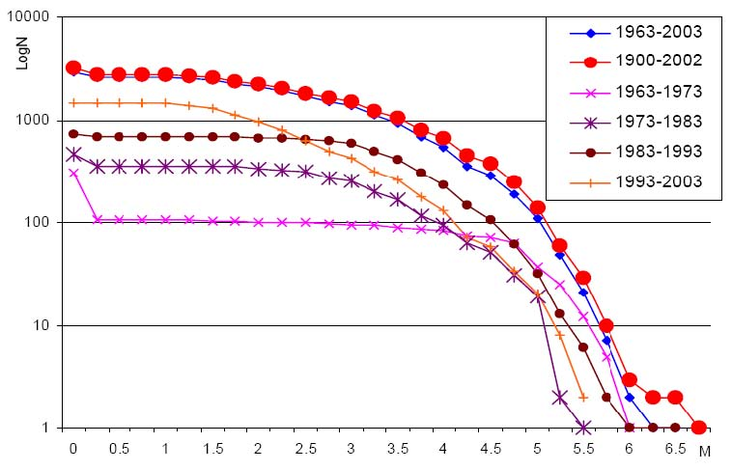

Figure 2.7 Frequency-magnitude relationship

|  |  |
| --- | --- |
| Figure 2.8 Zoning map for maximum credible earth¬quakes in Vietnam | According to the zoning map, the maximum earthquake observed in the Nam Con Son (II.15) Ms=5.0­5.9, Con Son (II.16) Ms=6.0-6.9, Cuu Long (II.17) Ms=7.0, Phu Quoc (II.18) Ms=5.0­5.9, and Trung Tam Bien Dong (III) Ms=5.0­. |

In 2007, Southeast Vietnam area ocurred two slight earthquakes on November 8th, 2007 and November 28th, 2007. On 8th November, 2007 an earthquake with the magnitude of 5.2 Richter lasted for 3 seconds affecting to the Southeast coastal areas of Vietnam. According to the Global Physical Institute of Vietnam, the earthquake at night on November 28th, 2007 occurred at the fault zone from Binh Thuan – Vung Tau, which locates about 200km far from Vung Tau Sea. Its magnitude was 4.5-5 Richter at seismic focus and affected the coastal provinces from Binh Thuan to Vung Tau [6]. Evolution of the earthquakes is described in detail in Table 2.9.

Table 2.9 Recorded seismics in the region and surrounding area

|  |  |  |  |  |  |  |
| --- | --- | --- | --- | --- | --- | --- |
| **No** | **Location** | **Mmax** | **Mmin** | **b** | **H, km** | **v** |
| 1  2  3  4  5 | Cuu Long basin  Nam Con Son basin  Phu Quy Island  Meridian of 109o30  Meridian of 110 | 5.5  5.5  6.1  6.1  6.1 | 4.5  4.5  4.5  4.5  4.5 | 0.97  0.97  0.97  0.97  0.97 | 12  12  17  17  17 | 0.14  0.02  0.02  0.02  0.02 |

*Source: Final metocean and Environmental design criteria for Dai Hung Field, 2007*

From 2002-2012, the development of earth quake at the project area and its vicinity in the East Sea in the recent three years (2010 to 2012). Table 2.10 presents the earthquakes in the SE Vietnam Sea**.**

Table 2.10 Earthquake development in the SE Vietnam Sea from 2010 – 2012

| **No.** | **Date** | **Time (GMT)** | **Latitude** | **Longitude** | **Depth (km)** | **Amplitude (Richter)** |
| --- | --- | --- | --- | --- | --- | --- |
|
|  |
|  | 23/06/2010 | 01:55:00 | 10.5 | 109 |  | 4.7 |
|  | 25/08/2011 | 18:03:00 | 13.12 | 112.95 | 15 | 5.4 |
|  | 06/03/2011 | 14:59:41 | 09.46 | 108.37 | 10 | 4.75 |
|  | 26/01/2011 | 07:24:30 | 9.94 | 108.33 | 10 | 4.7 |
|  | 07/06/2012 | 16:21:25 | 8.58 | 107.51 | 12 | 4.6 |

*Source: Global Physic Institute (*[*http://www.igp-vast.vn/*](http://www.igp-vast.vn/)*)*

Ring of Earthquakes in SE Vietnam Sea [7] is shown in Figure 2.10.

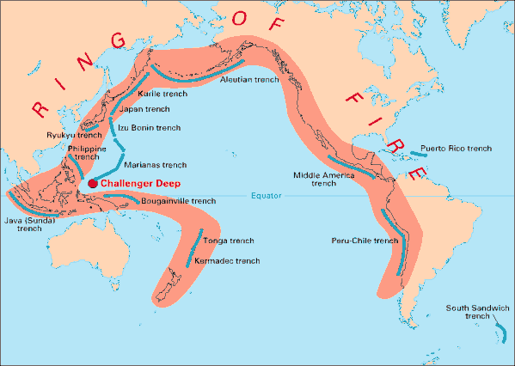

Figure 2.9 Ring of Earthquakes in SE Vietnam Sea

### Oceanographic characteristics

* **Tides**

These tides in the Southeast Vietnam Sea are uneven semi-diurnal and diurnal tides. The characteristic of uneven diurnal tide gradually weakens and an uneven semi-diurnal tide gradually increases when approaching shore.

The differences of tide between moths in a year are not significant. The maximum water height of tide during the period of 2009-2012 was 306 cm, and the minimum was 106 cm. The statistical data of monthly tidal height from 2009-2012 at Phu Quy station is showed in Table 2.11**.**

Table 2.101 Statistical data of monthly tidal height at Phu Quy station during 2009 – 2012

Unit: cm

|  |  |  |  |  |  |  |  |  |  |  |  |  |  |
| --- | --- | --- | --- | --- | --- | --- | --- | --- | --- | --- | --- | --- | --- |
| **Year** | **Month** | | | | | | | | | | | | **Whole Year** |
| **1** | **2** | **3** | **4** | **5** | **6** | **7** | **8** | **9** | **10** | **11** | **12** |
| **Maximum** | | | | | | | | | | | | | |
| 2009 | 302 | 292 | 286 | 266 | 246 | 304 | 306 | 252 | 289 | 280 | 284 | 226 | 306 |
| 2010 | 301 | 282 | 280 | 293 | 296 | 286 | 292 | 296 | 279 | 294 | 302 | 292 | 302 |
| 2011 | 296 | 300 | 293 | 286 | 284 | 282 | 290 | 292 | 294 | 298 | 298 | 312 | 294 |
| 2012 | 300 | 296 | 290 | 284 | 291 | 292 | 306 | 292 | 290 | 286 | 292 | 300 | 306 |
| **Average** | | | | | | | | | | | | | |
| 2009 | 227 | 216 | 218 | 219 | 217 | 220 | 217 | 206 | 222 | 223 | 230 | 221 | 219 |
| 2010 | 220 | 216 | 221 | 222 | 215 | 216 | 216 | 216 | 217 | 230 | 233 | 224 | 221 |
| 2011 | 226 | 212 | 227 | 209 | 212 | 215 | 218 | 224 | 229 | 225 | 232 | 233 | 226 |
| 2012 | 224 | 224 | 224 | 214 | 216 | 213 | 223 | 222 | 228 | 228 | 229 | 234 | 223 |
| **Minimum** | | | | | | | | | | | | | |
| 2009 | 122 | 113 | 143 | 135 | 106 | 126 | 113 | 127 | 145 | 135 | 135 | 109 | 106 |
| 2010 | 113 | 117 | 143 | 160 | 124 | 127 | 129 | 130 | 140 | 150 | 129 | 131 | 113 |
| 2011 | 131 | 146 | 158 | 123 | 124 | 135 | 128 | 140 | 161 | 147 | 130 | 139 | 131 |
| 2012 | 126 | 130 | 155 | 135 | 107 | 112 | 128 | 136 | 155 | 142 | 133 | 125 | 107 |

*Source: Hydrometeorological Observatory Southern Vietnam, 2013*

* **Currents**

The currents observed in this area are the combination of the tidal current, the spreading current and the windy current. The NE Monsoon is often stronger than the SW Monsoon. In the transition season, the current is often weak and its direction often changes.

* During the NE Monsoon, currents move from NE to SW, along with the coast. From the North to Phan Thiet, currents have a high velocity, 40cm/s in average, sometime up to 60cm/s. From the Southern of Phan Thiet, currents are weaker with average velocity of 15cm/s, 30cm/s on maximum.
* During the SW Monsoon, currents from Dai Lanh to Ca Na cape still trend NE to SW, moving southwards along the Northern coast of Ca Na cape where they meet with other currents, moving northwards from the South, then change their current direction, moving away from the coast and joining the circular current of the Eastern Vietnam Sea [8].

In Block 15-1 area, the statistical data of current within one year, 10 years and 100 years are listed as Table 2.12.

Table 2.11 Statistical Data on Current in Block 15-1 within 1, 10, and 100 years

|  |  |  |  |  |  |  |  |  |  |  |
| --- | --- | --- | --- | --- | --- | --- | --- | --- | --- | --- |
| **Description** | **Unit** | **N** | **NE** | **E** | **SE** | **S** | **SW** | **W** | **NW** | **Omni** |
| **1 year** | | | | | | | | | | |
| Near – Surface Current | m/s | 0.6 | 0.6 | 1.1 | 0.5 | 0.4 | 0.5 | 1.0 | 0.5 | 1.1 |
| Mid – Depth Current | m/s | 0.2 | 0.3 | 0.6 | 0.2 | 0.2 | 0.2 | 0.6 | 0.2 | 0.6 |
| Near – Bed Current | m/s | 0.2 | 0.2 | 0.2 | 0.2 | 0.2 | 0.2 | 0.2 | 0.2 | 0.2 |
| **10 year** | | | | | | | | | | |
| Near – Surface Current | m/s | 0.5 | 0.6 | 1.2 | 0.5 | 0.5 | 0.5 | 1.0 | 0.6 | 1.2 |
| Mid – Depth Current | m/s | 0.2 | 0.3 | 1.0 | 0.2 | 0.2 | 0.2 | 0.6 | 0.2 | 1.0 |
| Near – Bed Current | m/s | 0.2 | 0.2 | 0.5 | 0.2 | 0.2 | 0.2 | 0.2 | 0.2 | 0.5 |
| **100 year** | | | | | | | | | | |
| Near – Surface Current | m/s | 0.7 | 0.8 | 1.4 | 0.7 | 0.6 | 0.6 | 1.1 | 0.8 | 1.4 |
| Mid – Depth Current | m/s | 0.2 | 0.4 | 1.2 | 0.2 | 0.2 | 0.3 | 0.7 | 0.2 | 1.2 |
| Near – Bed Current | m/s | 0.2 | 0.3 | 0.7 | 0.2 | 0.2 | 0.2 | 0.3 | 0.2 | 0.7 |

*Source: CLJOC, 2015.*

*Note: The steady current near bottom is to be taken @ 1m above the seabed.*

Basing on current data observed at Block 15-1 [4], frequency and velocity of annual current to 16 directions are shown in current rose in Figure 2.10.

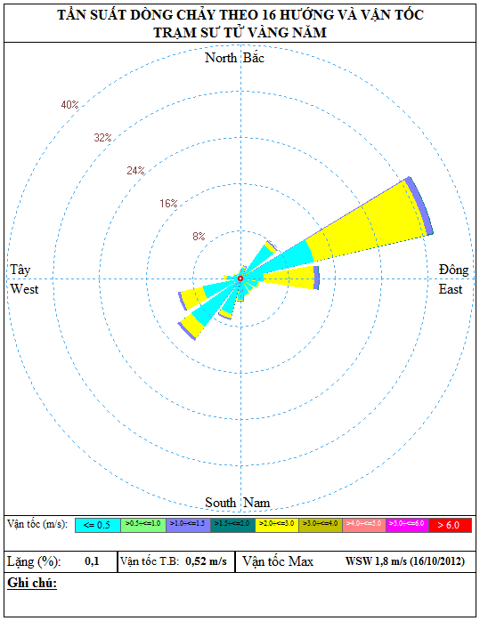

Figure 2.10 Current Rose at the Project Area

* **Waves**

Waves on the Southeastern Vietnam Sea are usually mixed waves from wind and swell. Annual average wave height and period are correspondingly 1.6 m and 5.5 seconds. Maximum height and period are 10.5m and 11.5 seconds. Huge waves often appear during the Northeast monsoon period. Waves often have the height of less than 3.5m during the Southwest monsoon period [9].

The characteristics of wind and wave regimes of Vietnam Sea are presented in Figure 2.11.

Figure 2.11 Typical Wave and Wind Regimes Offshore Vietnam

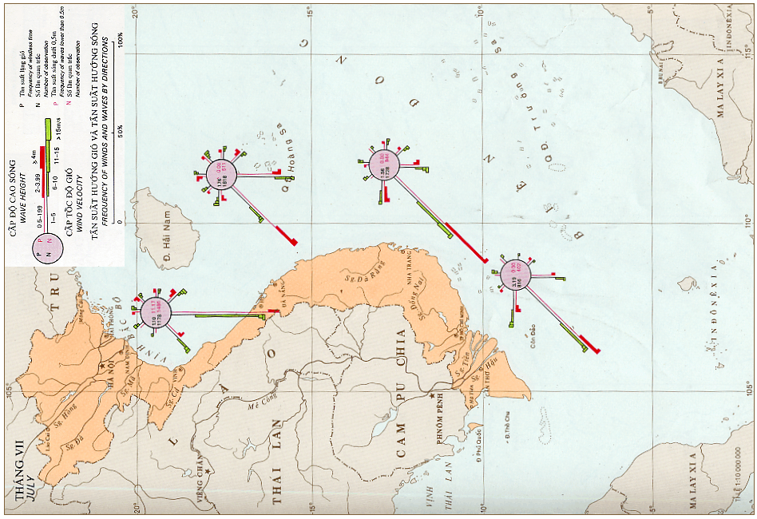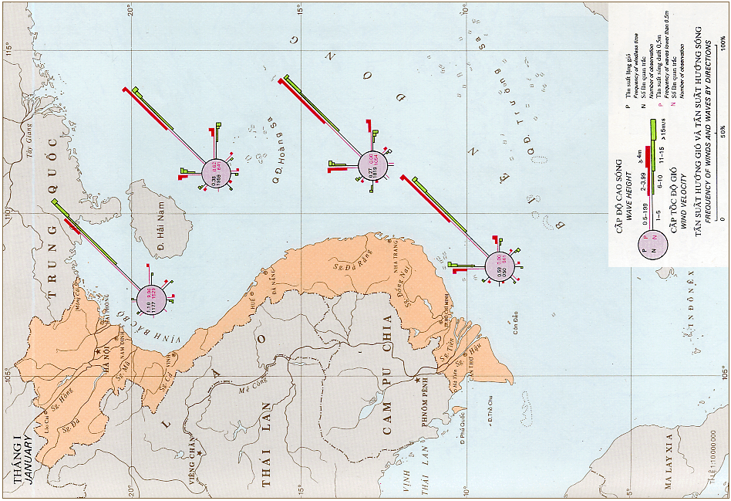

The Southeastern Vietnam Sea area is open, quite deep and mostly surrounded by oceans, therefore it does not create long cycle swell. Besides, with quite homogeneous wave conditions and insignificant effects from terrain, the current direction at project area is the same with wind direction. The statistical data about wave height and direction is described in **Table 2.13**.

Table 2.12 Statistical data about wave at Phu Quy station during 2009 – 2013

*Unit: m*

| **Month**  **Value** | **1** | **2** | **3** | **4** | **5** | **6** | **7** | **8** | **9** | **10** | **11** | **12** |
| --- | --- | --- | --- | --- | --- | --- | --- | --- | --- | --- | --- | --- |
| **Year of 2009** | | | | | | | | | | | | |
| Highest Wave | 2.5 | 2.5 | 2.0 | 1.5 | 2.5 | 3.0 | 3.5 | 3.0 | 4.0 | 1.3 | 2.5 | 2.0 |
| Direction | EN | EN | EN | EN | WS | W | W | WS | W | W | EN | EN |
| **Year of 2010** | | | | | | | | | | | | |
| Highest Wave | 2.0 | 1.5 | 2.0 | 10 | 2.0 | 2.5 | 3.0 | 3.0 | 2.5 | 2.5 | 2.0 | 2.5 |
| Direction | EN | EN | EN | EN | WS | WS | W | W | W | WS | E | E |
| **Year of 2011** | | | | | | | | | | | | |
| Highest Wave | 2.5 | 2.0 | 2.0 | 1.5 | 2.0 | 3.0 | 3.5 | 3.0 | 3.5 | 2.5 | 2.5 | 2.5 |
| Direction | NE | ENE | NE | NE, SW | WSW | WSW | W | WSW | W | WSW | W | NE |
| **Year of 2012** | | | | | | | | | | | | |
| Highest Wave | 2.5 | 2.0 | 2.0 | 2.0 | 3.0 | 3.0 | 3.5 | 3.5 | 3.0 | 2.0 | 1.5 | 2.0 |
| Direction | NE | NE | NE | SW | WSW | SW,W | W | W | W | SW,W | NE | NE |
| **Year of 2013** | | | | | | | | | | | | |
| Highest Wave | 2.5 | 2.0 | 2.0 | 1.5 | 2.0 | 3.5 | 3.5 | 3.0 | 3.0 | 2.5 | 2.0 | 2.5 |
| Direction | NE | NE | NE | NE | SW | W | W | W | W | NE | NE | NE |

*Source: Hydrometeorological Observatory Southern Vietnam, 2014.*

According to statistical data about waves at Phu Quy station, the maximum height of waves at Phu Quy station varied from 1.5 to 3.5 cm. Waves have two main direction which are northeast and southwest and change direction at the same time with wind.

The statistics of wave regime in the Block 15-1 in recent 5 years are listed in Table 2.14.

Table 2.13 Statistics of Wave Regime in the Block 15-1 in 5 Years

|  |  |  |  |  |  |  |  |  |  |  |  |  |
| --- | --- | --- | --- | --- | --- | --- | --- | --- | --- | --- | --- | --- |
| Year | **2008** | | | | | | | | | | | |
| Month | **1** | **2** | **3** | **4** | **5** | **6** | **7** | **8** | **9** | **10** | **11** | **12** |
| Wave height (m) | 3 | 3.5 | 2.7 | 1.5 | 1 | 1.5 | 2 | 2 | 2 | 1 | 2.5 | 3.5 |
| Wave Direction | NE | NE | NE | VAR | WSW | WSW | WSW | WSW | WSW | VAR | NE | NE |
| Year | **2009** | | | | | | | | | | | |
| Month | **1** | **2** | **3** | **4** | **5** | **6** | **7** | **8** | **9** | **10** | **11** | **12** |
| Wave height (m) | 3.9 | 2 | 1.5 | 1.2 | 0.5 | 1 | 1.5 | 1.5 | 1.9 | 1.1 | 2.5 | 3 |
| Wave Direction | NE | ENE | ENE | VAR | VAR | WSW | WSW | VAR | WSW | VAR | ENE | ENE |
| Year | **2010** | | | | | | | | | | | |
| Month | **1** | **2** | **3** | **4** | **5** | **6** | **7** | **8** | **9** | **10** | **11** | **12** |
| Wave height (m) | 2.6 | 1.1 | 1.5 | 0.8 | 0.7 | 1 | 1.1 | 1.4 | 0.8 | 1.6 | 2 | 2.8 |
| Wave Direction | ENE | ENE | ENE | VAR | VAR | SW | WSW | WSW | VAR | VAR | ENE | ENE |
| Year | **2011** | | | | | | | | | | | |
| Month | **1** | **2** | **3** | **4** | **5** | **6** | **7** | **8** | **9** | **10** | **11** | **12** |
| Wave height (m) | 3.4 | 2.8 | 3.2 | 1.9 | 1.2 | 1.8 | 2 | 1.8 | 2.1 | 1.8 | 2.4 | 2.8 |
| Wave Direction | ENE | ENE | ENE | ENE | VAR | SW | WSW | WSW | WSW | VAR | NE | NE |
| Year | **2012** | | | | | | | | | | | |
| Month | **1** | **2** | **3** | **4** | **5** | **6** | **7** | **8** | **9** | **10** | **11** | **12** |
| Wave height (m) | 2.6 | 2.1 | 1.9 | 0.9 | 1.4 | 1.7 | 1.8 | 2 | 1.5 | 1.7 |  |  |
| Wave Direction | NE | NE | NE | VAR | WSW | WSW | WSW | WSW | VAR | VAR |  |  |
| Year | **2013** | | | | | | | | | | | |
| Month | **1** | **2** | **3** | **4** | **5** | **6** | **7** | **8** | **9** | **10** | **11** | **12** |
| Wave height (m) | 2,9 | 2,9 | 1,5 | 1,4 | 1,1 | 1,5 | 1,6 | 1,8 | 0,5 | 1,6 | 2,3 | 3,17 |
| Wave Direction | NE | NE | NE | VAR | WSW | WSW | WSW | WSW | VAR | VAR | VAR | VAR |
| Year | **2014** | | | | | | | | | | | |
| Month | **1** | **2** | **3** | **4** | **5** | **6** | **7** | **8** | **9** | **10** | **11** | **12** |
| Wave height (m) | 3,2 | 1,9 | 1,9 | 0,4 | 2,8 | 1,8 | 1,9 | 1,5 | 1,5 | 1,1 | 2,2 | 3 |
| Wave Direction | NE | NE | NE | VAR | WSW | WSW | WSW | WSW | VAR | VAR | VAR | VAR |

*Source: CLJOC, 2015*

Basing on observed data at CPP, frequency of wave height toward 16 directions and its velocity are illustrated in wave rose as Fig. 2.12.

*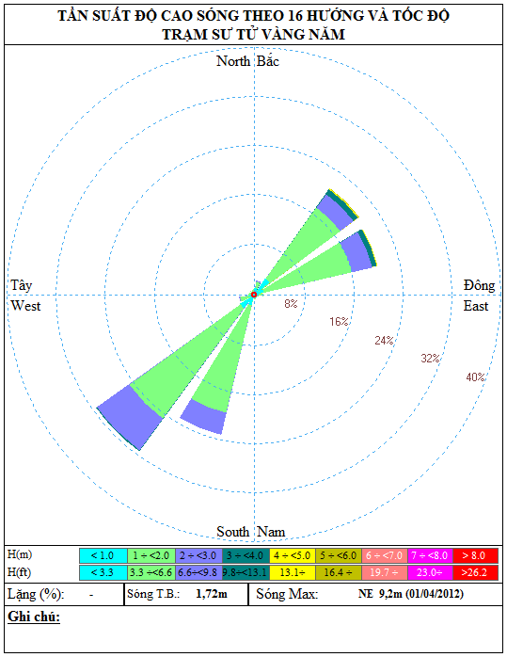*

Figure 2.12 Wave Rose at the project area

### Existing natural environment

In order to monitor status of the environment in the project area, this part will summarize the environmental analytical results of Su Tu Trang field and Su Tu Vang field during the surveys.

* ***Situation of seawater and sediment quality in Su Tu Trang field***

CLJOC conducted the baseline monitoring in the STT field area of Block 15-1 area, First environmental monitoring (baseline monitoring) conducted in 2007, the second environmental monitoring conducted in March, 2015. The analytical results were used as basic to assess the accumulation impacts on the environmental in association with the development and operations of the STT FFDP 1, and to manage the operations of the project in the friendly manner to the environment.

The methods and monitoring process was carried out complying with “*Circular No. 22/2015/BTNMT of MoNRE ratified on 28/5/2015 about the regulations on environmental protection of using the drilling muds, waste management and monitoring for offshore petroleum activities*.

The coordinates and the diagram of sampling gird of STT Field are presented in **Table 2.15** and **Figure 2.13** below.

Table 2.14 The coordinates of sampling sites of STT Field

|  |  |  |  |
| --- | --- | --- | --- |
|  | **East (m)** | **North (m)** | **Distance to STT WHP** |
| STT WHP | 867000 | 1130700 |  |
| CPP | 868051 | 1149400 | 18730 |
| 60 | 867177 | 1130877 | 250 |
| 61 | 866823 | 1130877 | 250 |
| 62 | 866823 | 1130523 | 250 |
| 63 | 867177 | 1130523 | 250 |
| 64 | 867354 | 1131054 | 500 |
| 65 | 866646 | 1131054 | 500 |
| 66 | 866646 | 1130346 | 500 |
| 67 | 867354 | 1130346 | 500 |
| 68 | 867707 | 1131407 | 1000 |
| 69 | 866293 | 1131407 | 1000 |
| 70 | 866293 | 1129993 | 1000 |
| 71 | 867707 | 1129993 | 1000 |
| 72 | 868414 | 1132114 | 2000 |
| 73 | 865586 | 1129286 | 2000 |
| 74 | 869828 | 1133528 | 4000 |
| R75 | 859929 | 1123629 | 10000 |
| R76 | 874071 | 1123629 | 10000 |
| P-77 | 867561 | 1140684 | 10000 |

Figure 2.13 Sampling Site Grid of the STT Field



**ST WHP**

#### Air quality

Due to STT locates in offshore and belongs to a high energy zone which can disperse well; the ambient environment of STT will disperse the pollutants quickly to recover to initial condition. Therefore, the parameter of air quality is considered as unimportant factor. Moreover, there is no regulation on the air quality of an offshore industrial project. Therefore, CPSE will not collect the data of air quality in this area.

#### Seawater quality

The analytical results of seawater quality are presented in Tables **2.16** and **2.17** below:

Table 2.15 The analytical results of seawater quality in the study area

|  |  |  |  |  |  |  |  |  |  |  |  |  |  |
| --- | --- | --- | --- | --- | --- | --- | --- | --- | --- | --- | --- | --- | --- |
| **Stations** | **Ring**  **(m)** | **pH** | | **Temp.**  **(0C)** | | **Salinity**  **(‰)** | | **DO**  **(mg/l)** | | **TSS**  **(mg/l)** | | **THC**  **(mg/l)** | |
| Year 2007 | Year 2015 | Year 2007 | Year 2015 | Year 2007 | Year 2015 | Year 2007 | Year 2015 | Year 2007 | Year 2015 | Year 2007 | Year 2015 |
| 62 | 250 | 8.13 | 8.2 | 28.6 | 28 | 32.8 | 3.3 | 5.7 | 5.9 | 8 | 16.5 | 0.009 | 0.056 |
| R75 | 10,000 | 8.20 | 8.0 | 28.5 | 28 | 32.6 | 3.3 | 6.0 | 6.1 | 12 | 13.3 | 0.010 | 0.019 |
| P77 | 10,000 | 8.13 | 8.1 | 29.3 | 27 | 33.1 | 3.2 | 5.9 | 6.1 | 7 | 15.1 | 0.014 | 0.014 |
| **QCVN 44:2012/ BTNMT** |  | **7.5-8.5** | | - | | - | | - | | - | | **0.3** | |

Table 2.16 The analytical results of heavy metal contents in seawater

|  |  |  |  |  |  |  |  |  |  |  |  |
| --- | --- | --- | --- | --- | --- | --- | --- | --- | --- | --- | --- |
| **Stations** | **Ring**  **(m)** | **Pb**  **(mg/l)** | | **Zn**  **(mg/l)** | | **Cd**  **(mg/l)** | | **Ba**  **(mg/l)** | | **Hg**  **(mg/l)** | |
|  |  | Year 2007 | Year 2015 | Year 2007 | Year 2015 | Year 2007 | Year 2015 | Year 2007 | Year 2015 | Year 2007 | Year 2015 |
| 62 | 250 | <0.001 | 0.0041 | <0.005 | 0.004 | <0.005 | 0,001 | < 0,25 | 0,005 | < 0,001 | 0,0001 |
| R75 | 10.000 | <0.001 | 0.005 | <0.005 | 0.002 | <0.005 | 0,001 | < 0,25 | 0,006 | < 0,001 | 0,0001 |
| P77 | 10.000 | <0.001 | 0.004 | <0.005 | 0.003 | <0.005 | 0,001 | < 0,25 | 0,004 | < 0,001 | 0,0001 |
| **QCVN 44:2012 /BTNMT** |  | **0.005** | | **0.02** | | **0.001** | | **-** | | **0.00016** | |

In general, the seawater quality in STT LTPTP area was good with pH≈8 and the dissolved oxygen content was high (DO ≈ 6 mg/l). The TSS and the THC in seawater were low. All of three seawater samples had the low heavy metal contents. This proved that the seawater quality has no polluted signals.

The 2015 value of TSS and THC in the sediment were much higher than the 2007 value, however these values were also below the limitation level as required in QCVN 44:2012/BNTMT (it is in the variation of analyzing method 's error). Therefore, the bearing capacity of the sea water is still good.

#### Seabed sediment Characteristics

1. ***Seabed sediment distribution***

Table 2.17 Analytical results of sediment size in the study area

| **Sampling Ring (m)** | **Total Hydrocacbon** | | | | | |
| --- | --- | --- | --- | --- | --- | --- |
| **Mean phi** | | **Ratio of Fine Sand (%)** | | **Type of sediment** | |
|  | Year 2007 | Year 2015 | Year 2007 | Year 2015 | Year 2007 | Year 2015 |
| 250 | 2.35 | 3.07 | 18.86 | 29.02 | Fine sand | Very fine sand |
| 500 | 2.30 | 2.78 | 17.66 | 25.09 | Fine sand | Fine sand |
| 1000 | 2.18 | 2.47 | 17.33 | 19.24 | Fine sand | Fine sand |
| 2000 | 2.26 | 2.44 | 19.98 | 19.51 | Fine sand | Fine sand |
| 4000 | 2.26 | 2.26 | 18.45 | 17.54 | Fine sand | Fine sand |
| **Average of field** | **2.27** | **2.69** | **18.25** | **23.33** | Fine sand | Fine sand |
| Reference | 2.53 | 3.38 | 21.71 | 31.47 | Fine sand | Very fine sand |

The sediments at surrounding STT Field are homogeneous and are classified into fine sand to very fine sand as Wentworth scale. Mean phi (2.69 Φ) at the surveyed stations is lower than the value of reference stations (3.38 Φ). The fine ratio and mean phi of the sediment surrounding WHP-C were at high value.

1. ***The distribution of the sediment Hydrocarbon:***

Table 2.18 Analytical results of sediment size and Hydrocarbon content

in the study area

| **Sampling Ring (m)** | **Total Hydrocacbon** | | | | | |
| --- | --- | --- | --- | --- | --- | --- |
| **UCM**  **(mg/kg)** | | **∑n-C13-35**  **(mg/kg)** | | **THC**  **(mg/kg)** | |
|  | Year 2007 | Year 2015 | Year 2007 | Year 2015 | Year 2007 | Year 2015 |
| 250 | 1.6 | 62.999 | 0.15 | 13.950 | 2 | 72.831 |
| 500 | 7.1 | 7.185 | 0.28 | 14.707 | 8 | 9.259 |
| 1000 | 1.3 | 2.273 | 0.2 | 11.210 | 2 | 3.573 |
| 2000 | 1.3 | 1.773 | 0.2 | 10.046 | 2 | 2.952 |
| 4000 | 1.8 | 2.337 | 0.2 | 9.470 | 2 | 3.825 |
| **Average of field** | **3.0** | **19.712** | **0.2** | **12.202** | **4** | **23.492** |
| Reference | 1.1 | 2.697 | 0.2 | 9.427 | 2 | 3.909 |
| **QCVN 43: 2012/BTNMT** | **-** | | **-** | | **100** | |

As the monitoring results, the 2015 value of THC in the sediment was much higher than the 2007 value. This is quite suitable with the actual petroleum activities occurring in the field. However, this value is much lower than the limit level regulated in the QCVN 43:2012/BTNMT. Therefore, the bearing capacity of the seabed sediment of STT Field is still good.

1. ***Heavy metal in the sediment***

Table 2.20 Analytical results of sediment metals in the study area

| **Sampling Ring (m)** | **Cu**  **(mg/kg)** | | **Pb**  **(mg/kg)** | | **Zn**  **(mg/kg)** | | **Ba (\*)**  **(mg/kg)** | | **Cr**  **(mg/kg)** | | **Hg**  **(mg/kg)** | |
| --- | --- | --- | --- | --- | --- | --- | --- | --- | --- | --- | --- | --- |
|  | Year 2007 | Year 2015 | Year 2007 | Year 2015 | Year 2007 | Year 2015 | Year 2007 | Year 2015 | Year 2007 | Year 2015 | Year 2007 | Year 2015 |
| 250 | 8.2 | 13.97 | 18 | 17.12 | 43 | 75.80 | 400 | 6131.56 | 24 | 44.42 | 0.047 | 0.15 |
| 500 | 8.3 | 11.45 | 19 | 23.52 | 44 | 71.14 | 570 | 7141.68 | 25 | 55.20 | - | 0.04 |
| 1.000 | 7.9 | 7.45 | 16 | 17.66 | 43 | 56.28 | 330 | 1152.89 | 24 | 46.83 | - | - |
| 2.000 | 9.7 | 7.12 | 19 | 17.51 | 47 | 56.78 | 290 | 787.74 | 28 | 47.44 | 0.069 | - |
| 4.000 | 8.0 | 3.94 | 20 | 14.41 | 43 | 43.18 | 430 | 517.40 | 24 | 37.04 | - | - |
| **Average of field** | 8.3 | 9.98 | 18 | 18.84 | 44 | 64.64 | 420 | 3986.50 | 25 | 47.85 | 0.058 | 0.12 |
| Reference | 9.3 | 8.23 | 21 | 17.99 | 47 | 60.08 | 201 | 380.75 | 30 | 49.06 | 0.052 | 0.01 |
| **QCVN 43**  **2012/BTNMT** | **108** | | **112** | | **271** | | **-** | | **160** | | **0.7** | |

Most of trace metals found in the sediment of STT Field were low and equal to the reference values. The analytical data was not much various between sampling rings. Most of metal value were lower than the limit values regulated in QCVN 43:2012/BTNMT. Therefore, the bearing capacity of the seabed sediment of STT Field is still good.

However, the Barium content was found at high value at the sampling station, especially in the ring of 1.000m from the discharge site. Barium is a inert and does not cause pollution at the project's site. However, this is the indicator of drilling activities due to it is the main element in the drilling cuttings. The content of Barium was found high in the sediment of the project area shows that there had been drilling activities in the project area in the past.

The content of Cr in the sediment found in 2015 has a slight variation in comparison with the one found in 2007, however they were much lower than the offshore sedimental quality (QCVN 43:2015/BTNMT). This could be some variation in analytical methods (because the Cr content in the sediment is just minor).

* **The environmental analytical results of Su Tu Vang field**

To monitoring situation of environemtal quality in Block 15-1, CLJOC carried out three periodic from 1999 to 2012 monitoring surveys as below table.

|  |  |  |  |  |
| --- | --- | --- | --- | --- |
| **Information of the survey** | | **2006 survey** | **2009 survey** | **2012 survey** |
| Purpose of the survey | | Baseline | 1st post-drilling | 2nd post-drilling |
| Time of survey | | Apr-06 | Jul-09 | Jul-12 |
| Number of stations | Around the well | 15 | 15 | 15 |
| Reference stations | 2 | 2 | 2 |
| Scale of survey | | Study stations at 100m, 250m, 500m, 1000m, 2000m, 4000m rings and 10000m for reference statons | Study stations at 250m, 500m, 1000m, 2000m, 4000m rings and 10000m for reference stations | Study stations at 250m, 500m, 1000m, 2000m, 4000m rings and 10000m for reference stations |

*Source: Baseline monitoring report and environmental monitoring reports -CPSE&CLJOC*

Some assessments on variation of sea water and sediment are drawn as follows:

* The quality of seawater in the project development was still in the natural condition. There were not any crucial changes of the sea water quality through years.
* For Grain size, the change in the sediment characteristics was not significant throughout the surveys lasting a long period (2006-2012). Ba content, THC and PAH values in 2012 survey was higher thanPAH valued measured durinh two previous surveys. This result could be explained by the discharge of the 349 tons drillcuttings with content of Neoflor 1-58 (5.6%) in the STV-CPP area. This monitoring carried out in July 2012 after drilling activities of SV-12P & 12P-ST well finished 3 months ago.

Variation of sediment parameters is ilustrated by following chart.

Figure 2.14 Variation of sediment parameters

Source: CPSE&CLJOC, 2012

Result of Station 31 (far 4000m from CPP), content of THC and Ba value is approximated to the values of the reference station and baseline value.

### Existing Biological resources

#### Phytoplankton Communities

Phytoplankton

The Southeast Vietnam Sea has approximately 257 species of phytoplankton which have been identified as belonging to the following three groups:

* *Bacillariophyta :* 173 species
* *Dinophyceae :* 81 species
* *Cyanophyceae :* 3 species

The density of these algal species changes depending on the season. They are more abundant during the Southwest monsoon (September-October). The average density of phytoplankton in the Cuulong Basin is 0.5 million cells/m3 (during the Northeast monsoon) and from 0.5-2.5 million cells/m3 (during the Southwest monsoon).

Zooplankton

In Southeast Vietnam Sea, 290 species of zooplankton (62% total species of Vietnam Sea) have been identified and belong to 14 groups in which 158 species of *Copepoda* accounting for 50.3% and 51 species of *Coelenterate* account for 16.2%.

The average biomass of zooplankton in Southeast Vietnam Sea is 30 mg/m3, the coastal region may have the average mass of 40 mg/m3. Being influenced by the Mekong River delta, the average concentration is highest in the nearshore shallow areas and gradually decreases towards the offshore.

#### Benthic Community

Table 2.19 Analytical Results of Benthos in the Study Area

|  |  |  |  |  |  |  |  |  |  |  |
| --- | --- | --- | --- | --- | --- | --- | --- | --- | --- | --- |
| **Sampling Ring (m)** | **No. of species** | | **Density**  **(ind./m2)** | | **H(s)** | | **Hmax** | | **J** | |
|  | Year 2007 | Year 2015 | Year 2007 | Year 2015 | Year 2007 | Year 2015 | Year 2007 | Year 2015 | Year 2007 | Year 2015 |
| 250 | 44.0 | 59 | 253.5 | 372 | 4.65 | 5.25 | 0.85 | 0.90 | 0.06 | 0.04 |
| 500 | 48.8 | 74 | 277.5 | 509 | 4.77 | 5.63 | 0.85 | 0.91 | 0.07 | 0.03 |
| 1.000 | 50.8 | 72 | 281.0 | 461 | 4.84 | 5.61 | 0.86 | 0.91 | 0.07 | 0.03 |
| 2.000 | 47.0 | 67 | 286 | 414 | 4.52 | 5.43 | 0.81 | 0.09 | 0.09 | 0.03 |
| 4.000 | 46.0 | 61 | 264 | 392 | 4.54 | 5.37 | 0.82 | 0.91 | 0.09 | 0.03 |
| **Averageof field** |  | **71** |  | **463** |  | **5.57** |  | **0.91** |  | **0.03** |
| **Ref.** | **35.7** | **57** | **193.3** | **393** | **4.13** | **5.10** | **0.84** | **0.89** | **0.09** | **0.04** |

Generally, number of benthic species in STT field is quite abundant, in comparison with the 2007, the number of species increased to about 59 – 74 species and the average number of species in the whole field is 71 species. The density of benthic community also increased at nearly two time of the 2007 value (250 ind./m2 in 2007 to 463 ind./m2 in 2015). The H(s) and J values were stable among the stations and the reference.

As the above results, it can see that the development of benthic community surrounding STT Field is abundant and stable. It shows that the benthic organism adapt well with the ambient environment where happen the petroleum activities.

#### Fishery Resources [10]

With a coastline of 192 km, waters area of more than 52 thousand km2 and Phu Quy island district far from land 56 miles, Binh Thuan is one of the largest fishing grounds with rich marine resources. According to the baseline studied survey showed that fish reserves at sea area of 50 m water depth is about 220,000 - 240,000 tons.

* **Distribution of fish species at Binh Thuan sea area**

Total number of fish species found Binh Thuan is 538, in which pelagic group has 146 species accounted for 27.14% and demersal fish group has 392 species accounted for 72.86%.

Annual catches of Pelagic fish occupied 50 - 60% of the total seafood catch. Pelagic species often exploited in Binh Thuan are scad, herring, anchovy, tuna,… in which scad has the highest output of about 50 - 60% of the total annual catch of pelagic fish. The pelagic fishing season occurs in the Southwest monsoon and the months with the highest catches are August, September and October. In the Southwest monsoon, fish tend to move in the direction of the North to the South, and usually closer to shore to feed and spawn. The pelagic fishing ground concentrates at Phan Ri-Phan Thiet and Southwest Phu Quy island.

Demersal fish species estimated occupied 30 - 40% of the total catches of seafood in the province. Demersal fishes usually catched are sardines, whiff,… Demersal fishs can be exploited all year round but high catches are concentrated in the Northeast monsoon. Demersal fish species are concentrated in waters of greater than 30 m water depth in the area in Northeast and South of Phu Quy Island, Phan Thiet – Ham Tan sea area.

Location map of Pelagic and Demersal fish ground is illustrated in Fig. 2.15 and 2.16 as below.

**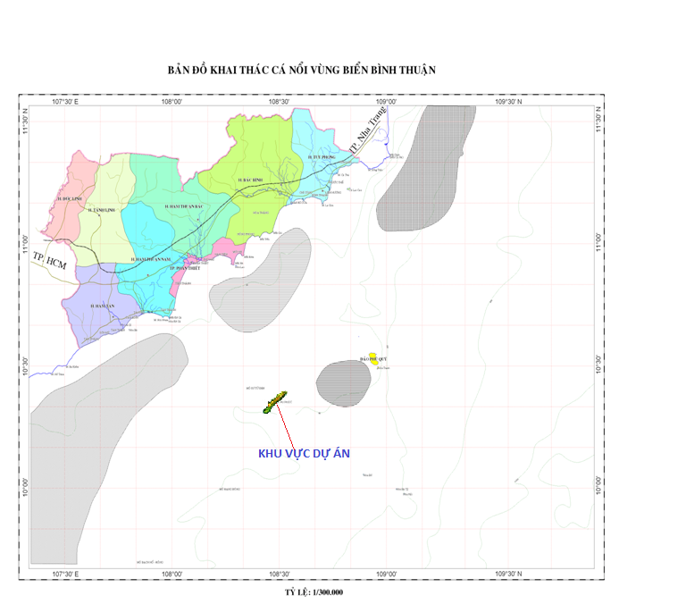**

**PROJECT AREA**

Figure 2.15 Map of pelagic fish distribution along Binh Thuan-Vung Tau sea area

Source: CPSE&CLJOC, 2015

**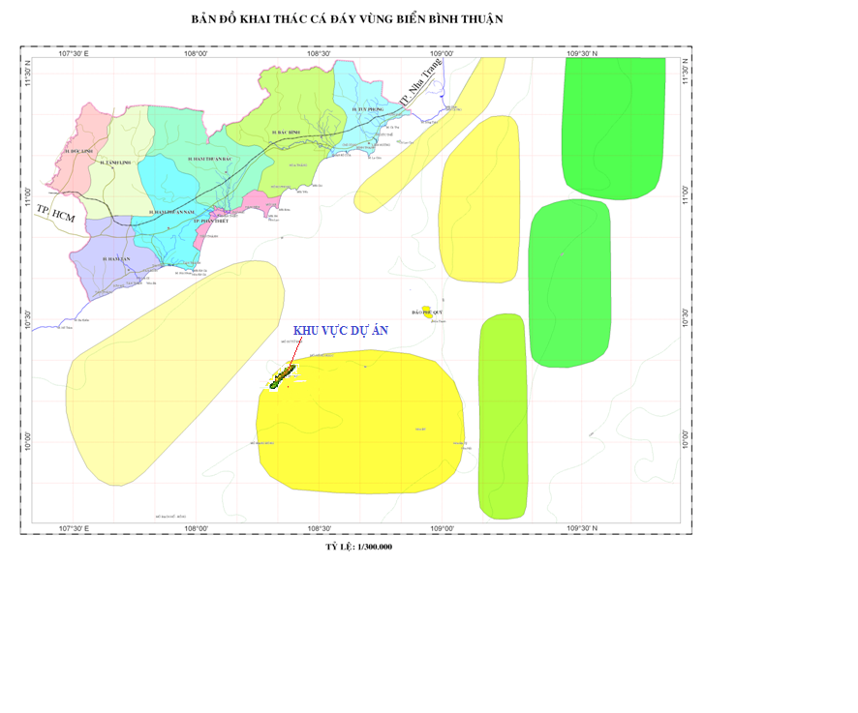**

**PROJECT AREA**

Figure 2.16 Map of Demersal fish distribution along sea of Binh Thuan-Vung Tau area

Source: CPSE&CLJOC, 2015

* **Spawning season**

Spawning season of pelagic fish in East Sea in general and Southeast Vietnam Sea in particular has typical characteristic of species living in the tropical sea areas. Most of species have long spawning season and many species spawn all year-round. Most of fish species spawn in the Southwest Monsoon coincident with the rainy season. The key spawning ground is in the coastal area, especially the area near large estuaries [11].

#### Shrimp resources

In Southeast Vietnam Sea, there are 4 key shrimp grounds including Cu Lao Thu isle, South of Vung Tau, Southwest of Con Dao and Cuu Long estuary(Figure 2.17).

* Shrimp ground at Cu Lao Thu isle: Wide distribution is at South of Cu Lao Thu isle with coordinate being 8o-12oN and 108o 5’-110oE and the production depth is from 50 to 100m. Almost of the shrimp produced here has commercial value.
* Shrimp ground at South of Vung Tau: The ground is about 2,750 km2 with the production depth of 5-35 m and the density of 63-98 kg/km2.
* Shrimp ground at Cuu Long estuary: about 5,145 km2, production depth of 5-32m and the density of 100 - 220 kg/km2.
* Shrimp ground at Southwest of Con Son: about 5,150 km2 with the production depth of 5-25m and the density of 35-67 kg/km2 [03].

In general, shrimp ground is far away from the project area (Figure 2.17).

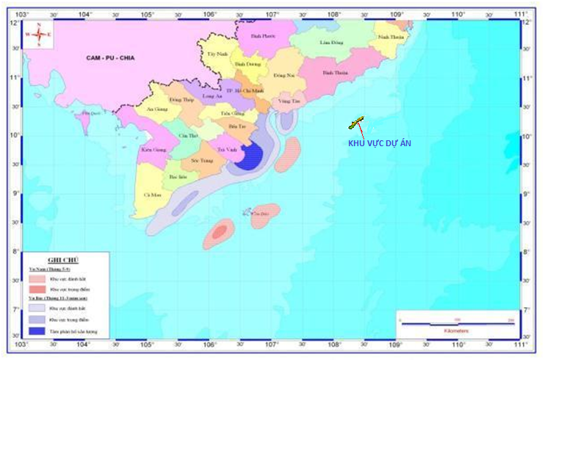

**PROJECT AREA**

Figure 2.17 Map of shrimp distribution at the southeast Vietnam sea

Source: CPSE&CLJOC, 2015

#### Cuttle-fish resource

The reserve of cuttle-fish of Binh Thuan Province is about 10,000 - 17,000 tons that distributes mainly at the coastal region from Ca Na to Ham Tan and the region surrounding Phu Quy Island [03]. Cuttlefish is available all year round and the main production season is the Northern monsoon season. Cuttle-fish is produced mainly in Southern monsoon season (about 80% capacity).

Key Cuttle-fish grounds are Phu Quy (from Ham Tan to Vung Tau), North-Northeast of Con Son and East-Southeast of Khoai Isle (Figure 2.18 & 2.19). At these grounds, squid can be caught all year round, for example the North crop is from December to April. South crop is from June to September, in which July, August and September producing the highest yield [11].

Cuttle -fish grounds distribute depending on season are as follows:

* In the Northeast monsoon season: mainly Cuttle fish distribute around Cu Lao Thu;
* In the southwest monsoon season: mainly Cuttle -fish distribute offshore Ham Tan - Binh Thuan and from Vung Tau to Eastern region of Con Dao Island.

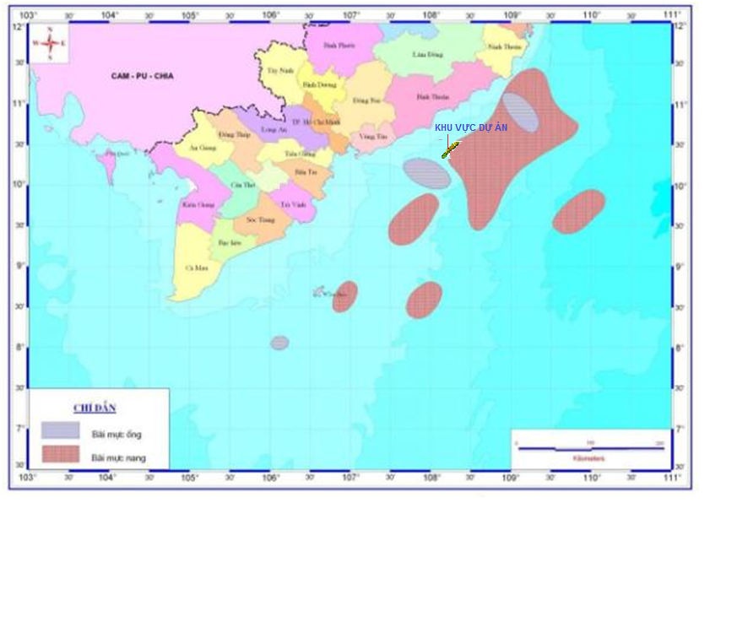

**PROJECT AREA**

Figure 2.18 Distribution of Cuttle fish Grounds in the Northeast Monsoon Season in the SE Vietnam Sea

Source: *CPSE&CLJOC, 2015*

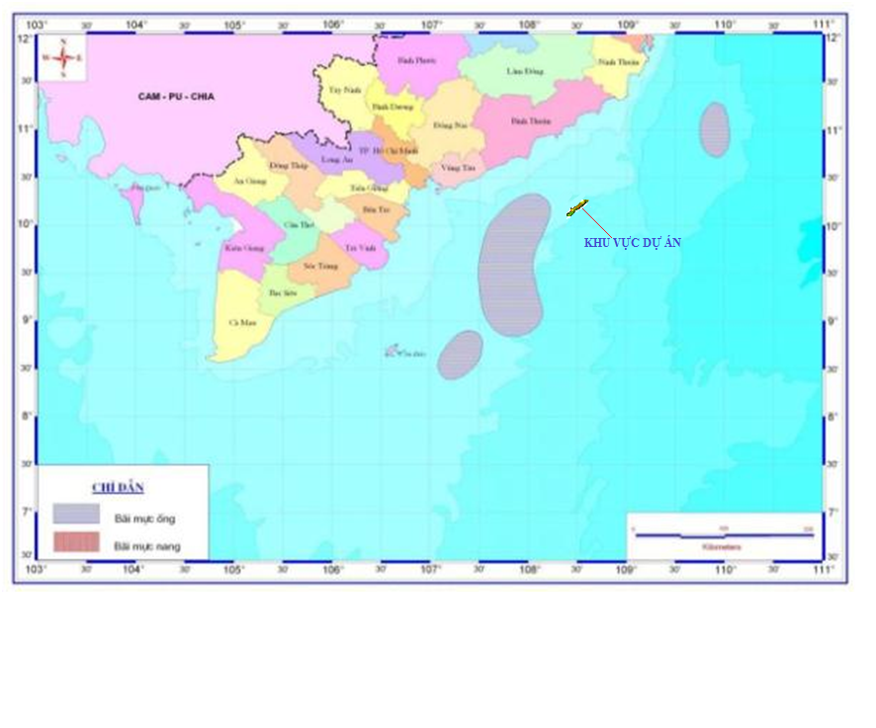

**PROJECT AREA**

Figure 2.19 Distribution of cuttle-fish grounds in the Southwest Monsoon Season in the SE Vietnam Sea

Source: *CPSE&CLJOC, 2015*

#### Mollusca resource

* **Binh Thuan province [10]**

Molluscs are special marine species which are strength of Binh Thuan. Because favorable natural conditions are suitable for growth and development of many mollusc species, Binh Thuan sea has concentrated a large number of special marine species with high economic value. It can be said that mollusca resource in Binh Thuan sea are most abundant in Vietnam sea. The bivalve are exploited mainly as scallops, ark shells, pen shells - *Pinna vexillum*, horse mussel, clams,...

* **Ba Ria - Vung Tau**

Mollusc resources are also plentiful in Ba Ria - Vung Tau sea. Bivalve class (Bivalvia): has 13 families including 26 bivalve species. In which, there are some species with large reserve and high economic value, such as Pearl oysters, clams, scallops, ark shells,... Besides, there are also some economic value species, such as *Sassia*, *Littorina littorea*, *Conus orbignyi*. In particular, species with high economic value are catching mainly, such as blood coackles, ark shells, scallops, clams. The areas focus mainly at Cua Lap and Loc An estuaries.

#### Other resources

* **Coral reefs**

Coral is one of the species which are very sensitive to spilled oil. In the study area, coral reefs mainly distribute in Hon Cau, Ca Na cape, Phu Quy island and Con Dao archipelago. In Ca Na Bay, there are about 134 species belonging to 48 genera of hard corals, 28 species of soft corals, 2 species of horn corals and 2 species of hydra corals, average coral cover is about 43%. Dominant species are *Montipor, Acropora, Hydnophora, Porites.*

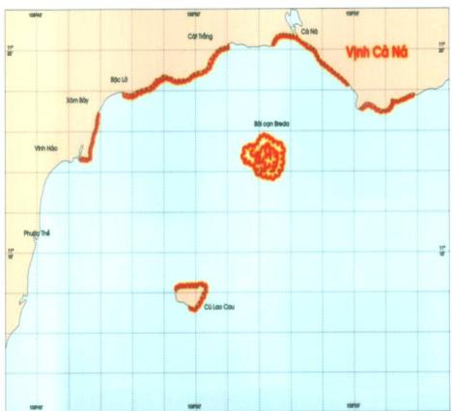

Figure 2.20 Distribution of coral reefs in Ca Na bay (Cu Lao Cau)

Source: *CPSE&CLJOC, 2015*

Hon Cau waters are considered to be an area of high biodiversity, the richness and diversity of coral reefs and sea grass has formed a favorable convergence system and development of biological marine resources. The fringing coral reefs distribute around the island and along the shore, while the platform coral reefs distribute on reefs. Coral reefs still preserve their original with high coral coverage of to 43%. They mainly distribute around the island, along the coastal Vinh Hao - Ca Na to Breda shallow isle. This area with high biological diversity of the coral reefs of Vietnam has more than 65 genera *including Acropora, Montipora, Porites* and *Goniopora Favia.*

Phu Quy island is an area which ​​coral reefs distribute in all four directions: North - South - East - West of the island. Coral reefs here are in form of island fringing reefs, their width is over 1000 m, especially, coral reefs’ width in the west of the island is about 2000 m. Due to transparency of seawater around Phu Quy island is high, so coral reefs here distribute to 42 m depth. The total number of recorded species is 192 species belonging to 56 genera of 15 families. In which, *Faviidae* family has number of genera highest with 15 genera (26.79%), next to *Fungiidae* family has 7 genera (12.50%). The other families have from 1 to 3 genera.

Also, in order to protect biodiversity in general and protect marine ecosystems in particular, in 2010 the Government has approved the master plan that Phu Quy island is planned to be Phu Quy Marine Conservation Area for protecting coral reefs and organisms living in coral reefs which are at risk of threatening. The planned distribution map of functional areas of Phu Quy Marine Conservation Area is shown in Figure 2.21.

**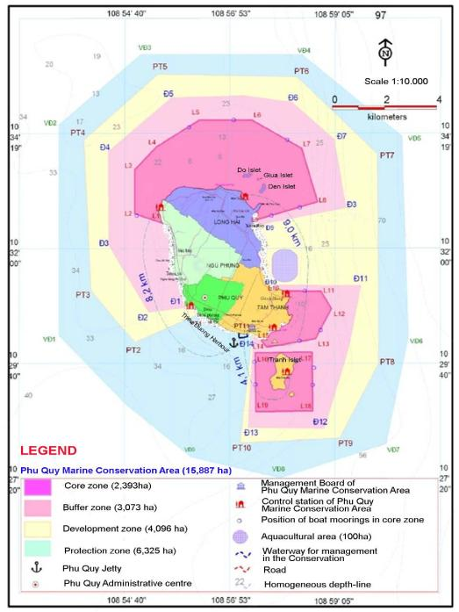**

Figure 2.21 Distribution Map of Functional Areas in Phu Quy Island

Source: *CPSE&CLJOC, 2015*

* **Coral reef fish**

In 148 identified species in Hon Cau island have 70 economic value species, of which more than 40 species have commercial values. Some commercial value species are such as *Serranidae*, *Scombridae*, mackerel, etc. and 26 ornamental value species of typical families such as *Pomacentridae, Holocentridae, Scorpaenidae.*

Ca Na Bay area has 211 species belonging to 87 genera, 35 families. Families concentrate mainly in the project area, including *Pomacentridae* (38 species)*, Chaetodontidae* (28 species), *Labridae* (27 species).

Phu Quy Island has identified 154 species belonging to 42 families, 10 orders. Of these, the order that has the number of families and species most is *Perciformes* with 28 families (66.7% of total orders) and 130 species (84.4% of total orders). The other orders of coral reeffishes have species less than 10% of total ones.

* **Algae** **and seagrass communities**

Hon Cau area is considered to have favorable conditions for the development of seaweed. A total of 163 species of seaweed and three species of seagrass have been identified. Composition of common algae belongs to gendres of *Turbinaria, Sargassum, Caulerpa, Chnoospora, Chamia and Halimeda*. The *Sargassum* has 14 species, distributed in shallow waters near the shore at the depths of 2-4 m and strongly develops in April when the water temperature is hig and then declines in July when the water temperature sharply decreases due to the upwelling effect and replace it with the dominance of *Caulerpa*.

Up to now, Binh Thuan Province has identified 300 ha of seagrass and mainly concentrated around Phu Quy island with six species, including *Thalassia hemprichii, Halophila ovalis, Halophila minor, Cymodoceae rotundatata, Halodule uninervis, Syringodium isoetifolium*. Seagrass distribute at five regions of the island, including Northern, Northeastern, Western, Southwestern of Phu Quy island (4 regions) and a region at the Western of Hon Tranh Island (Figure 2.22). Its coverage is from 10 to 80%.

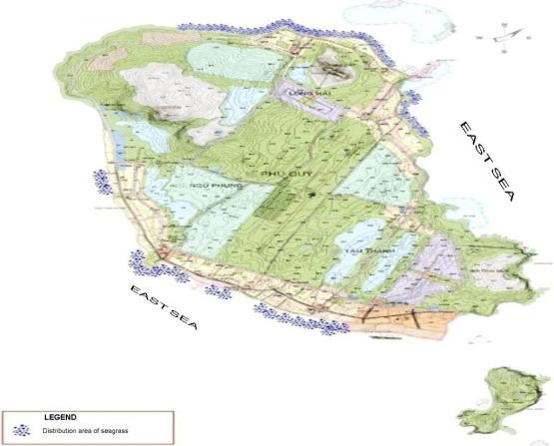

Figure 2.22 Distribution of Seagrass around Phu Quy Island - Binh Thuan

Source: *CPSE&CLJOC, 2015*

According to CLJOC’s surveys, seagrass is not found in the project area.

* **Sea-turtle**

Sandy Beaches around the Hon Cau island is spawning area of sea-turtle (*Eretmochelys imbricata*) and green turtle (Chelonia mydas). According to the fishermen, the sea turtle laid eggs on these beaches. But, recently it is not seen the turtle appear on the sand for spawning.

|  |  |
| --- | --- |
| Figure 2.23 A rare sea turtle species have been also found on the Phu Quy Island on June 11th 2011. This shows that this area also has natural beach for turtle spawning | 634562543384487500_rua-quy-hiem |

#### Rare, endangered or threatened aquatic species

In Hon Cau Island area, economic value species are such as sea cucumbers (*Actinopyga echinites*, *A. mauritiana, Microthele nobilis, Thelenota ananas*), sea-urchine (*Heterocentrotus mammillatus*); snails (*Trochus niloticus, Tectus pyramis, Nautilus pompilius, Charonia tritonis, Cymatium lotorium, Cypraea argus, Cypraea mappa), Cassis cornuta, Cypraecassis rufa and Melo Molo*). Abalones (Haliotis asinina, Haliotis ovina); Pen shells (*Atrina vexillum*); giant clams (*Tridacna gigas*), Oysters (Pinctada margaritifera, Pinctada maxima, Pteria penguin, Hippopus hippopus, Tridacna squamosa, Tridacna maxima); ... These above species are at risk of extinction due to indiscriminate exploitation habitat destruction.

The rare and valuable aquatic species also need to be protected in Binh Thuan province include *Dermochelys cortacea* and *Hippocampus sp.* [12].

### Environmental sensitivity and recovery potential at the project area

To assess the sensitivity of coastal areas, the environmental sensitivity map for coastal area from Da Nang to Cambodia border conducted by CPSE in 2010 (Fig. 2.24) has been refered as well as evaluated recovery potential at the vicinity of the project area as below: [13]:

* Oceanographic regime at the project area such as wave, wind and current are strong. Their patterns changed regularly in accordance with the monsoon regime;
* Project area has been affected by the warm and cold currents coming from somewhere and often be affected by tropical storms and typhoons;
* Project area has high solar radiation throughout the year which results a high production rate of primary phytoplankton, and leading to high production of other marine organism in aquatic food chain consequently.

With such natural conditions and high dispersion ability at the project area as well as basing on the basis of baseline survey (2007) and recent monitoring survey (3/2015) at Su Tu Trang field area shown that environment surrounding the project area can be considered to have good recovery potential.

### Suitability of project site selection with the surrounding environmental natural conditions

STT FFD Phase 1 Project locates in offshore area of SE Vietnam Sea, belongs to Cuulong Basin where has been occurring the many oil and gas production activities in Vietnam. It is quite suitable that the petroleum activities are implemented in the offshore area because there is no community in the vicinity area and less human activities in this area. Furthermore, when revising the previous oil and gas production activities in this area, it can be seen that the environmental impacts from these activities are available, but the impact magnitude is just minor. Therefore, it can be assume that the site selction in the offshore area for conducting petroleum activities is totally suitable.

*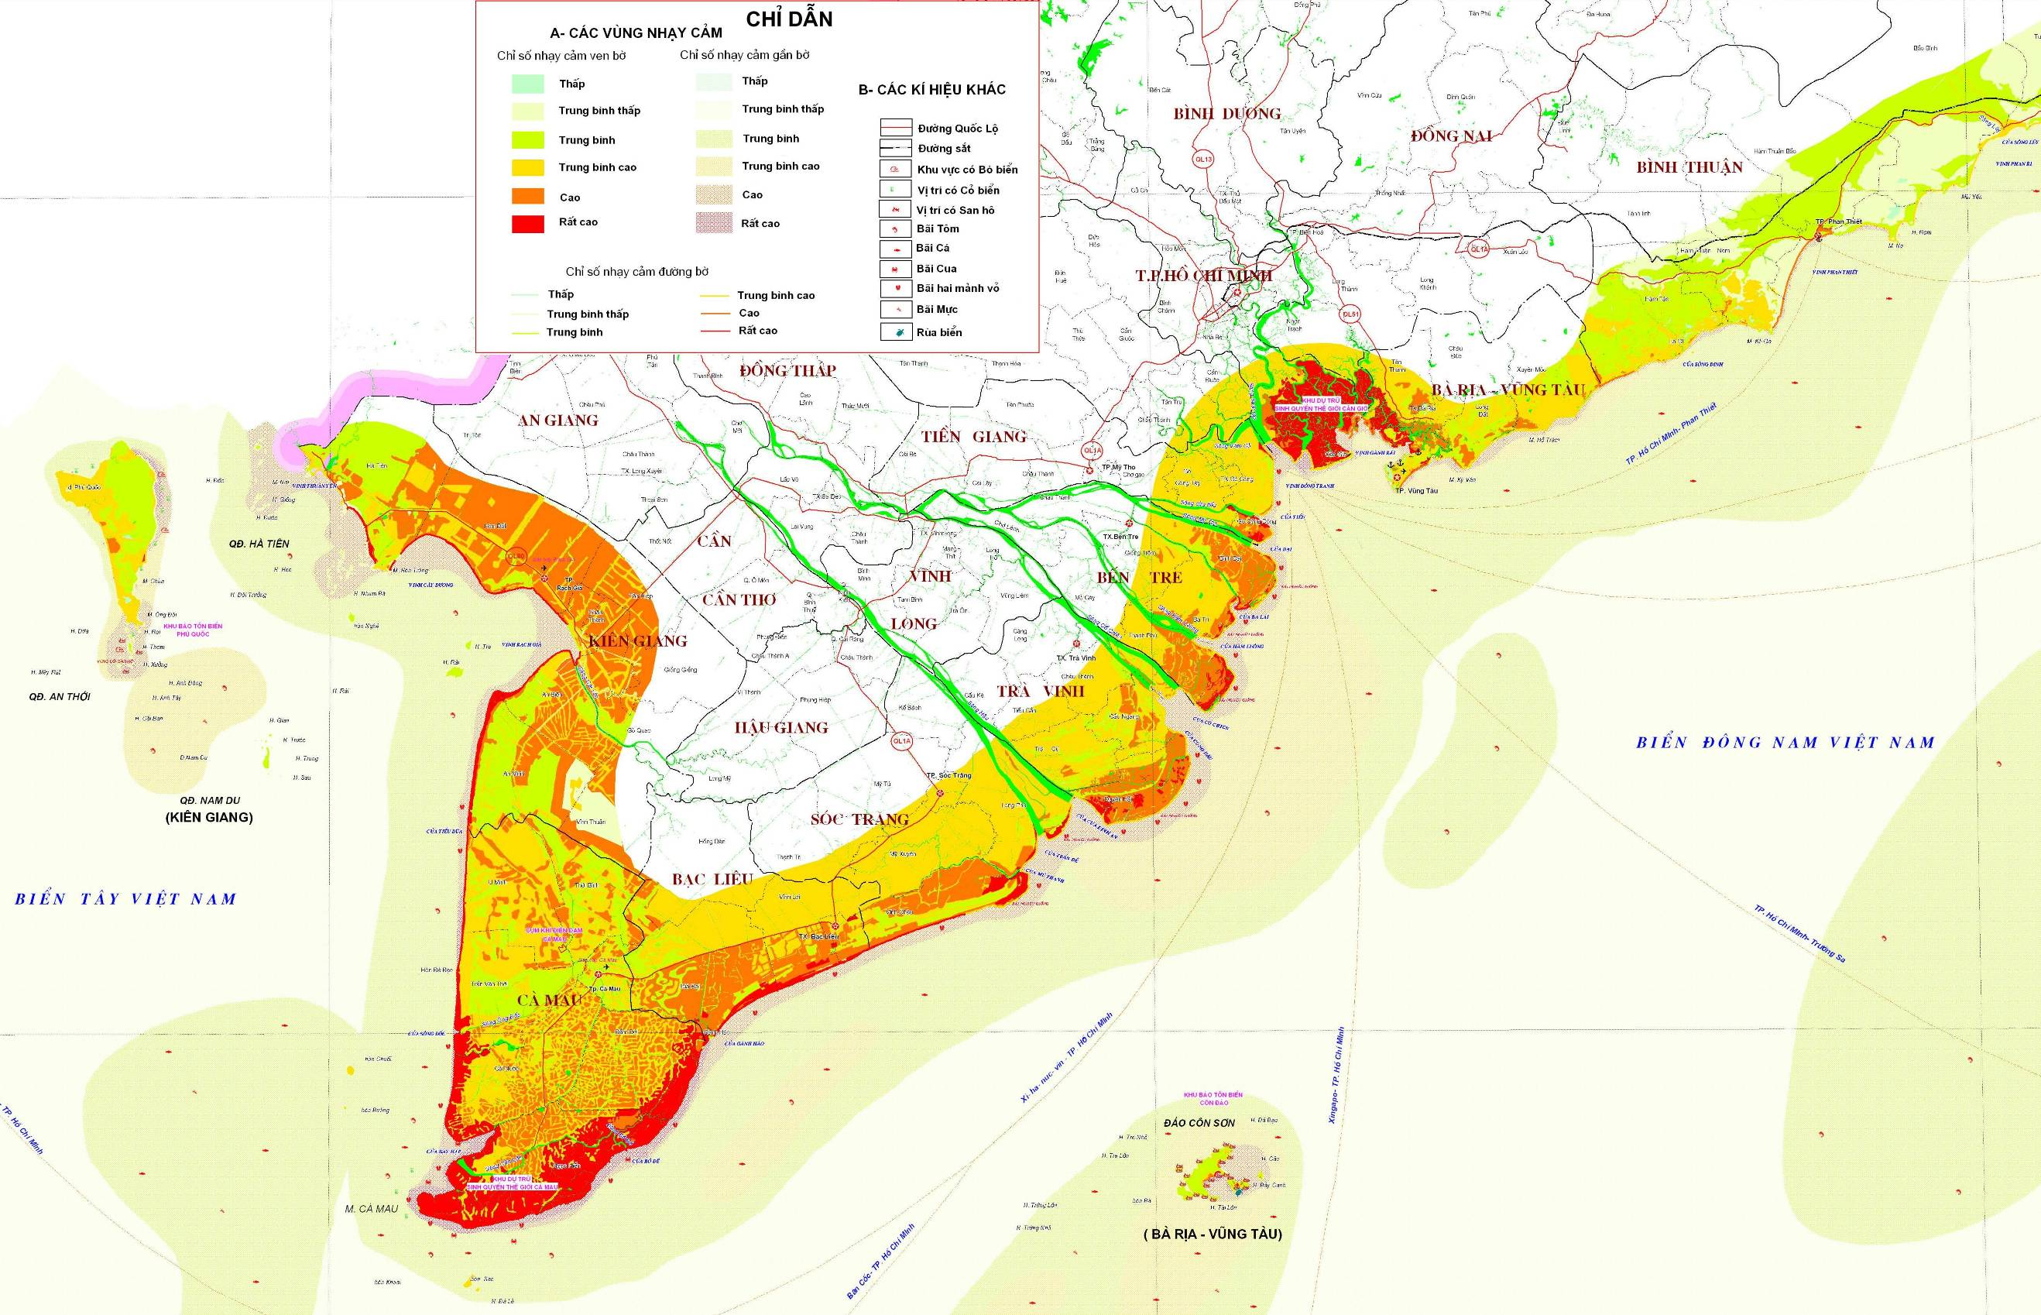*

Figure 2.24 The Environmental Sensitivity Map of project area

Source: *CPSE&CLJOC, 2015*

## SOCIO - ECONOMIC CONDITIONS

### Economic conditions

The economic activities in the coastal/offshore area of Binh Thuan Province can be affected by the project activities including fisheries, petroleum, maritime, tourism,...

#### Fishery activities

* **Fishing activities**

The field area locates closed to the fishery grounds (such as fish/ shrimp/ cuttle-fish grounds, etc. ), so there are the interaction between fishing activities and the petroleum activities. SE Vietnam Sea is one of the density fishing grounds of the South of Vietnam.

With the high fishing productivities of the coastal provinces from Khanh Hoa to Ca Mau in 2012 & 2013, it showed that the fishing industry occupied a high ratio in total fishery products, especially Ninh Thuan and Ba Ria-Vung Tau Provinces had upto 90% of the fishery products were catching products. The provincial catching productivities are presented in the Table 2.22.

Table 2.22 Catching fishery productivities of coastal provinces from Khanh Hoa to Ca Mau in 2012 & 2013

| **Provinces** | **Total fishery productivities in 2012** (thousand tons) | **Catching Productivities** (thousand tons) | | **Ratio of total fishery productivities in 2012** (%) |
| --- | --- | --- | --- | --- |
| **2012 (ha)** | **Preliminary in 2013 (ha)** |
| Khanh Hoa | 93.9 | 80.2 | 82.3 | 85.4 |
| Ninh Thuan | 75.5 | 63.7 | 64.2 | 84.4 |
| Binh Thuan | 194.6 | 180.3 | 187.0 | 92.7 |
| Ba Ria – Vung Tau | 285.4 | 273.0 | 285.7 | 95.7 |
| Ho Chi Minh City | 49.5 | 21.8 | 21.7 | 44.0 |
| Long An | 43.3 | 13.6 | 13.2 | 31.4 |
| Tien Giang | 220.0 | 84.8 | 92.2 | 38.5 |
| Ben Tre | 383.1 | 156.9 | 158.0 | 41.0 |
| Tra Vinh | 147.2 | 75.0 | 74.4 | 51.0 |
| Soc Trang | 181.0 | 56.1 | 56.6 | 31.0 |
| Bac Lieu | 258.0 | 99.6 | 100.4 | 38.6 |
| Ca Mau | 424.5 | 154.8 | 161.7 | 36.5 |

*Source: 2013 Statistical Yearbook*

The offshore fishing vessels of the coastal provinces are high and concentrate chiefly in BRVT, Binh Thuan, Ben Tre, Ca Mau and Ninh Thuan provinces. The statistical data of offshore fishing vessels in 2012 & 2013 were presented in below Table.

Table 2.23 Number of provincial offshore fishing vessels in 2012 &2013

| **Province** | **Number of vessels (pieces)** | |
| --- | --- | --- |
| **2012** | **Preliminary in 2013** |
| Khanh Hoa | 767 | 783 |
| Ninh Thuan | 1.003 | 1.056 |
| Binh Thuan | 2.456 | 2.701 |
| Ba Ria – Vung Tau | 3.103 | 3.167 |
| Ho Chi Minh City | 46 | 24 |
| Long An | 698 | 614 |
| Tien Giang | 1.752 | 1.745 |
| Ben Tre | 152 | 163 |
| Tra Vinh | 282 | 296 |
| Soc Trang | 451 | 487 |
| Bac Lieu | 1.346 | 1.434 |

*Source: 2013 Statistical Yearbook*

* **Aquacultural activities**

Ba Ria – Vung Tau and Binh Thuan provinces have large water area which is appropriated for aquaculture of high valuable sea food.

**Situation of aquacultural activity**

Most of coastal provinces from Khanh Hoa to Ca Mau have the coastal aquacultural activities with many types: tiger shrimp, *Penaeus vannamei*, crab, oyster, arca, fish, etc. Aquacuture is one of the key eonomics of the coastal provinces. Aquacultural forms are diversified, including extensive farming, improved extensive farming, semi-intensive farming and intensive farming. Besides, it is very popular with fishery casing farming, oyster/ tiger shrimp/carb... farming on the river and mangrove forests.

Fishery aquacutural activities bring high economic effects for the coastal provinces, however it also cause heavy pollution on the local environment. Moreover, the service and fishery processing companies locate along the beach and river mouthes. Less of them have the wastewater treatment systems or the old technology wastewater treatment systems. This is the main reason causing water source pollution.

Statistical data of fishery aquacultural areas and productivities of the coastal provinces from Khanh Hoa to Ca Mau were presented in below table:

Table 2.24 Statistical data of fishery aquacultural activities from Khanh Hoa to Ca Mau

| **Province** | **Area (ha)** | | **Productivities**  **(thousand tons)** | |
| --- | --- | --- | --- | --- |
| **2012** | **Preliminary in 2013** | **2012** | **Preliminary in 2013** |
| Khanh Hoa | 8.8 | 5.7 | 13.8 | 13.8 |
| Ninh Thuan | 1.2 | 1.0 | 11.8 | 12.4 |
| Binh Thuan | 2.5 | 3.0 | 14.3 | 13.7 |
| Ba Ria – Vung Tau | 7.0 | 7.1 | 12.4 | 13.5 |
| Ho Chi Minh City | 7.5 | 6.8 | 27.7 | 30.4 |
| Long An | 8.9 | 9.0 | 29.7 | 30.4 |
| Tien Giang | 14.4 | 15.4 | 135.2 | 136.6 |
| Ben Tre | 47.7 | 44.8 | 226.3 | 233.6 |
| Tra Vinh | 40.4 | 37.0 | 72.2 | 88.4 |
| Soc Trang | 64.8 | 68.2 | 124.9 | 138.6 |
| Bac Lieu | 117.8 | 127.9 | 158.4 | 170.4 |
| Khanh Hoa | 296.5 | 295.8 | 269.8 | 279.4 |

*Source: 2013 Statistical Yearbook*

#### Petroleum activities In the Vicinity area of Block 15-1

Up to now, in the area surrounding Block 15-1 there are oil and gas activities such as: Bach Ho and Rong, Tho Trang, Gau Trang fields produced by Vietsovpetro, Phuong Dong and Rang Dong fields produced by JVPC, Ruby, Pearl, Topaz fields produced by PCVL and Su Tu Den/Hai Su Trang field produced by CLJOC. Exploration and field development activities of other contractors are still ongoing here. These ones also contribute to the pollution of Cuu Long Basin. Petroleum Blocks are presented in Figure 2.25.

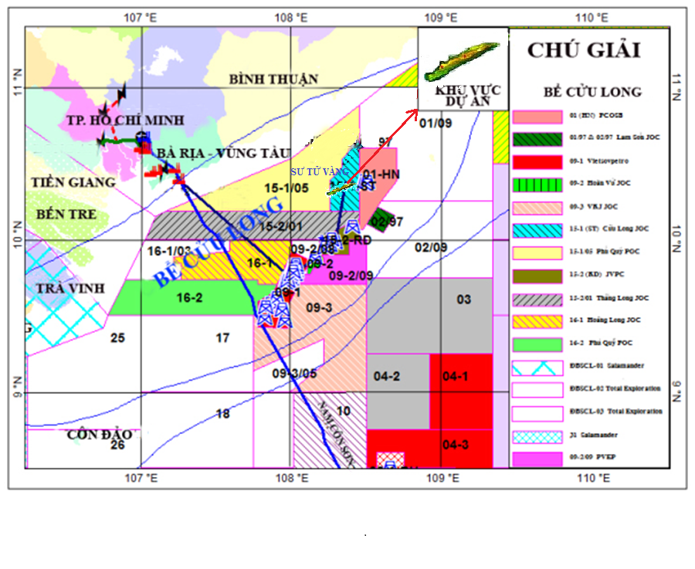

**PROJECT AREA**

Figure 2.25 Petroleum Operations in Cuu Long Basin

#### Maritime activities

There are many international maritime routes crossing the Block 15-1 such as: HCMC-Tokyo, HCMC-Hong Kong and HCMC-Singapore, etc. and the internal maritime routes such as HCMC–Hai Phong, Phan Thiet–Quy Nhon. These maritime routes and the offshore fishing activities cause the crowded maritime activities in this area.

Two maritime routes closest to the project area is the route from Ho Chi Minh City to Hai Phong and Ho Chi Minh City - Hong Kong (about 3 km). However, because the safety scope of the project is only a very small area of the large sea as well as the vessel density of maritime routes is not so many, only about 15-20 times/day, so the project has completely not interfered with maritime activities across the region.

Binh Thuan Province has 04 large ports, including Phan Ri Cua, Phan Thiet, La Gi and Phu Quy Ports. The maritime activities in the province are very crowded. The vessel capacity is variety, range from 20 HP to over 300 HP. As planned, from now to 2020, Binh Thuan province will continue to develop 2 ports, as Ke Ga Port and Vinh Tan Port. However, up to 2013 planning for Ke Ga port is pending now because it is unfeasible.

Ba Ria - Vung Tau province has been developping strongly seaport system. Ports system in Ba Ria - Vung Tau is a national and international integrated sea port system of Vietnam. Currently the province includes 4 port zones: Cai Mep - Sao Mai Ben Dinh port zone, Phu My – My Xuan port zone; Dinh river port zone, Ben Dam - Con Dao port zone. As planned, from now to 2020, Ba Ria - Vung Tau province will develop 2 port zones. First is Long Son terminals for using in petrochemical industry and the Sao Mai-Ben Dinh port zone for transporting passengers.

Figure 2.26 The Maritime Routes in Study Area

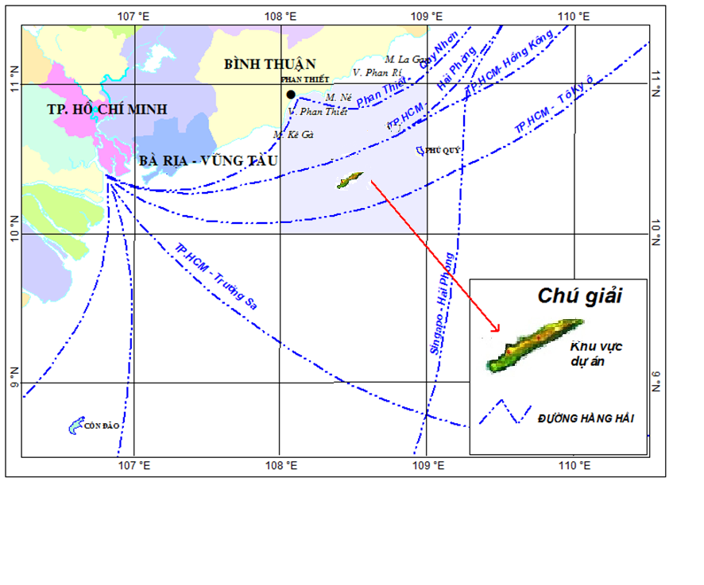

**Legend**

**Project area**

**Maritime route**

#### 

#### Tourism

Tourism activities in the study area from Binh Thuan to BR-VT are quite developed with resorts, beaches,... distributed along the coastal areas. The number of hotels and tourists to these provinces has increased steadily over the years from 2009 to 2012.

The number of hotels and tourists of two provinces are summarized in Table 2.25.

Table 2.25 Tourism Activities in Binh Thuan and BR-VT Provinces

from 2009 to 2012

|  |  |  |  |  |  |
| --- | --- | --- | --- | --- | --- |
|  | **Units** | **Year** | | | |
| **2009** | **2010** | **2011** | **2012** |
| **Binh Thuan Province** | | | | | |
| Accommodations | Unit | 456 | 478 | 518 | 622 |
| Tourists | Thousands of persons | 2,200 | 2,500 | 2,802 | 3,144 |
| **BR-VT Province** | | | | | |
| Accommodations | Unit | 720 | 828 | 638 | 756 |
| Tourists | Thousands of persons | 1,639 | 2,416 | 2,635 | 2,855 |

*Source: Statistical Yearbook of Ba Ria – Vung Tau and Binh Thuan, 2013*

### Social conditions

#### Population

Statistical data of the population of the coastal provinces from Binh Thuan to BR-VT in 2011 and 2012 is listed in Table 2.26.

Table 2.20 Statistical data on population of Binh Thuan and BR-VT Provinces in 2011-2012

|  |  |  |  |  |
| --- | --- | --- | --- | --- |
| **Province** | **Binh Thuan** | | **Ba Ria –Vung Tau** | |
|  | **2011** | **2012** | **2011** | **2012** |
| **Area** *(km2)* | 7,813 | | 1,989,5 | |
| **Total population**  *(thousand persons)* | 1,180,339 | 1,193,504 | 1,027,226 | 1,041,565 |
| **Density** *(person/km2)* | 151 | 153 | 516 | 524 |

*Source: Statistical Yearbook of Ba Ria – Vung Tau and Binh Thuan, 2013*

The local residents mainly concentrated for living in center areas of urbans, districts, communes and along coastal roads and areas. Workforce in the provinces lives by many different careers such as: tourism, agriculture, fishing and aquaculture. Specially, aquaculture and tourism are two strong forces of Binh Thuan and Ba Ria – Vung Tau provinces.

#### Health

Most of the coastal districts have health care centers for residents include: hospitals, health centers, clinics and maternities. The number of medical facilities of the coastal districts in the study area is summarized in Table 2.27.

Table 2.27 Number of health facilities of the coastal districts in the area from Binh Thuan to Ba Ria - Vung Tau in 2012

| **No.** | **District / City** | **Hospitals** | **Clinics** | **Maternities** | **Health centers** | **Total** |
| --- | --- | --- | --- | --- | --- | --- |
| **Ba Ria - Vung Tau** | | | | | | |
| 1 | Vung Tau city | 2 | 1 | - | 17 | **20** |
| 2 | Long Dien district | 1 | 2 | - | 7 | **10** |
| 3 | Dat do district | 1 | 1 | - | 8 | **10** |
| 4 | Xuyen Moc district | 1 | 2 | - | 13 | **16** |
| 5 | Con Dao district | 1 | 0 | - | 0 | **1** |
| **Total** | | **6** | **6** | **-** | **45** | **57** |
| **Binh Thuan** | | | | | | |
| 1 | Phan Thiet city | 6 | 1 | 2 | 18 | **27** |
| 2 | La Gi town | 1 | - | - | 9 | **10** |
| 3 | Tuy Phong district | 1 | 1 | 1 | 12 | **15** |
| 4 | Bac Binh district | 1 | - | - | 18 | **19** |
| 5 | Ham Thuan Nam district | 1 | 2 | - | 13 | **16** |
| 6 | Ham Tan distric | 1 | 1 | - | 10 | **12** |
| 7 | Phu Quy district | 1 | - | - | 3 | **4** |
| **Total** | | **12** | **5** | **4** | **83** | **104** |

*Source: Statistical Yearbook of Ba Ria – Vung Tau and Binh Thuan, 2013*

#### Education

The number of schools, teachers and pupils (including elementary, secondary and high school) in the coastal districts of the study area in 2011 are summarized in Table 2.28.

Table 2.21 Number of Schools, Teachers and Pupils of the Coastal in the Area from Binh Thuan to Ba Ria - Vung Tau in 2012

| **No.** | **District / City** | **Primary school** | | **Secondary school** | | **High school** | |
| --- | --- | --- | --- | --- | --- | --- | --- |
| **Teachers** | **Pupils** | **Teachers** | **Pupils** | **Teachers** | **Pupils** |
| **Ba Ria-Vung Tau** | | | | | | | |
| 1 | Vung Tau city | **22** | **1,054** | 14 | **841** | **7** | 572 |
| 2 | Long Dien district | 14 | 501 | **10** | 475 | 4 | 254 |
| 3 | Dat do district | 12 | 296 | 7 | 296 | 2 | 119 |
| 4 | Xuyen Moc district | 30 | 607 | 14 | 607 | 5 | 351 |
| 5 | Con Dao district | 1 | 23 | - |  | - |  |
| **Binh Thuan** | | | | | | | |
| 1 | Phan Thiet city | 31 | 713 | **13** | **711** | **6** | **611** |
| 2 | La Gi town | 22 | 436 | 7 | **355** | 3 | **322** |
| 3 | Tuy Phong district | 33 | 611 | 14 | **435** | 2 | **242** |
| 4 | Bac Binh district | 33 | 634 | 17 | **524** | 2 | **215** |
| 5 | Ham Thuan Nam district | 27 | 513 | 12 | **438** | 2 | **166** |
| 6 | Ham Tan distric | 17 | 331 | 9 | **311** | 2 | **108** |
| 7 | Phu Quy district | 6 | 139 | 3 | **111** | 1 | **51** |

*Source: Statistical Yearbook of Ba Ria – Vung Tau and Binh Thuan, 2013*

#### Conservation areas

In the study area, the important conservation areas need to pay attention are: Hon Cau – Vinh Hao, Phu Quy Marine Conservation Area in Binh Thuan Province, Mangrove forest in Can Gio of Ho Chi Minh City, Con Dao Marine Conservation Area in Ba Ria - Vung Tau province and Ca Mau National Garden Park in Ngoc Hien district, Ca Mau province.

The conservation areas in coastal South Vietnam are presented in Figure 2.27.

**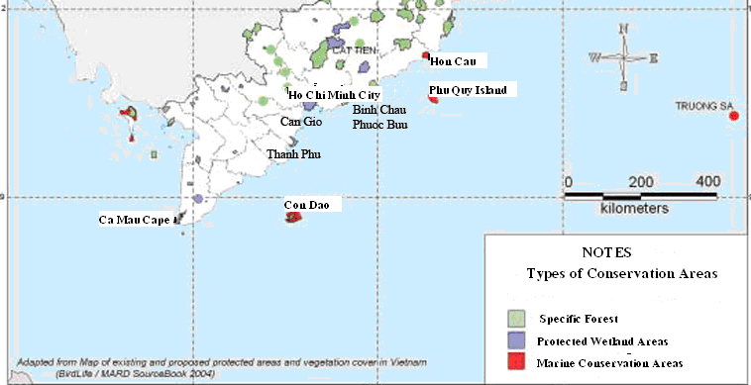**

Figure 2.27 Conservation Areas in the Southern of Vietnam Area

* **The Hon Cau – Vinh Hao Conservation Area [11]**

It is an area of 12,500 ha. This area was recommended as the reserve area by Hai Phong Institute of Aquatic Product in 1995. The topography of Hon Cau island is characterised by rocky outcrops, with sandy beaches on the north and south sides. Its topography has the highest point of 27 m and the lowest point of 17 m below sea level. The reserve area includes coral reefs of Hon Cau Isle and other subsea rocks. Native coral reefs are 43% of the whole isle, playing the role of preserving the coral biodiversity of Vietnam. Hon Cau Isle has 65 species of coral, mainly belonging to familles of *Acropora, Montipora, Porites, Favia and Goniopora*.The reserve area also has high bioproductivity. There has identified 175 species of phytoplanktons, 163 species of seagrass, 147 species of coral, 80 species of Mollusca, 46 species of Crustacean, 26 species of Echinodermata and 211 fish species in the reserve area.

* **Phu Quy Conservation Area [14]**

It locates about 100 km away from the shore with the surrounding area is strongly affected by up-swellings specific for the Central and Southern of Vietnam Sea. Preliminary researches has recorded about 70 species of flora, 72 species of seaweed, 134 species of solid corals and 15 species of mollusca. Among other kinds of coral, the most popular corals are *Acropora* and *Pocillopora*. At the Western of Phu Quy Island, there is a large coral reef (about 600m), locates closed to a lagoon covered by large coral reefs.

* **Mangrove forest in Can Gio [15]**

About mangrove flora, there are 72 mangrove species reported, 30 of which are true mangroves (species that can only grow in areas inundated regularly with tidal water, even if only once a year) and 42 associated mangrove species. Besides the mangrove flora, 95 species belonging to 42 families of inland plants dispersed by humans and animals have been found.

About fauna, Can Gio now provides habitats for:

* 127 species of fish belonging to 38 families
* 9 species of amphibians belonging to 4 families, including tree frogs (Racophorus leucomystax)
* 30 species of 14 families of reptiles
* 19 species of mammals belonging to 13 families
* 5 species of Chiropterans

Birds have an important role in the ecosystem, contributing actively to the enrichment of food sources and the soil. Besides waterfowl, migratory species from the north, such as *Numenius arquata, Tringa hypoleucos* and *Charadrius dubius*, appear in large numbers in winter. Many shore birds such as *Phalacrocorax carbo, Centropus sinensis, Egretta garzetta, Egretta alba, Threskiornis melanocephalus, Plegadis facinellus* and *Dendrocygna javanica* are present on the mudflats.

* **Con Dao National Park [16]**

It includes 16 large and small isles belong to Ba Ria – Vung Tau province, away from Vung Tau City about 180 km. Con Dao National Park locates from 80 34' to 80 49' N and from 1060 31' to 1060 45' E with the total area of 15,043 ha.

About marine ecosystem, Con Dao is very abundant and diversified with 1,321 marine species founded, in which tree in sand-marsh has 23 species, alga has 127 species, seaweed has 7 species, phytoplankton has 157 species, zooplankton has 115 species, coral has 219 species, marine animal and reptile has 5 species... Among them, 37 species is classified into Vietnam Red Book. There are many high economical species, such as fishery products, alga. The rare marine animals are: *Neophon phocaenoides*, *Orcaella brevirostric*, *Dugong Dugon*. Especially, Con Dao is the breeding ground of some marine turtles.

### Suitability of the project site selection with the socio-ecomomic conditions of the surrounding area

The project area locates in the area with many fishery activities and maritime activites in the SE Vietnam Sea. Besides, SE Vietnam Sea is oriented to be developed in oil and gas field. Therefore, there are interference between many different groups, but until now, these groups operate their jobs in the harmonious manner that creates less conflicts among them. So that, the STT FFD Phase 1 Project will occur in the SE Vietnam Sea is totally adequate with the provincial orientation as well as do not make conflicts with the other economic groups.

# ENVIRONMENTAL IMPACT ASSESSMENT

The main objective of this chapter is to focus on assessment of potentially significant impact associated with the development Su Tu Trang Full Field Development Project – Phase 1 (STT FFDP1).

This section is assessed in detailed according to each phase of the project such as installation and commissioning phase, drilling phase, production phase, onshore support activities, decommissioning activities and accidental events happening in all project life. The cumulative environmental impacts from neighbor production areas are also mentioned and discussed. The environmental impacts of decommissioning phase are assessed in qualitative level due to unavailable information on detail decommission plan at the moment of preparing this EIA. However, before decommissioning, CLJOC will completely implement regulations on environmental protection, Petroleum Law as well as other existing related regulations of Vietnam.

The EIA preparation process is complied with the Governmental Degree No.18/2015/NĐ-CP dated 14 February 2015 and Circular No.27/2015/TT-BTNMT dated 29 May 2015 of the Ministry of Natural Resources and Environment on "Guidelines for environmental protection planning, strategic environmental assessment, impact assessment environment and environmental protection plan" and current Vietnamese environmental protection regulations as well as the Health, Safety and Environment (HSE) policy of CLJOC.

To assess the level of the potential impacts on the environmental and socio-economic aspects, CLJOC has applied the following Impact Quantitative System (IQS) to identify the significance of impact.

**Impact Quantitative System (IQS)**

The IQS is based on the integration of EIA guidelines of E&P Forum, United Nations Environmental Program (UNEP), World Bank and CLJOC’s Hazard Risk ID Assessment Procedure (CLJOC – HSE-PRO-HS-0015a/b) and CLJOC HSE Management System (CLJOC-HSE-MSY-00-001). In IQS, each identified impact will be rated by the following characteristics:

|  |  |
| --- | --- |
| **Impact Aspects** | **Representative Parameters** |
| Physical, Chemical, Ecological Interactions | Magnitude, scale of effect, recovery time |
| Occurrence | Frequency |
| Management | Legislation, cost, public concern |

Each parameter then is defined based on ranking system listed in Table 3 .1.

Table 3.1 Ranking system of impact quantitative system (IQS)

|  | **Parameter** | **Ranking System** | | |
| --- | --- | --- | --- | --- |
| **Level** | **Definition** | **Score** |
| Interaction | Magnitude **(M)** | No Impact | No interaction generated | 0 |
| Minor | Changes within the natural variability scale, well below the regulatory permit, no effect on health | 1 |
| Moderate | Moderately change the ecosystem, have little potential effect on public health, close to regulatory permits | 2 |
| Major | Major change the ecosystem, likely cause effect on public health when over exposed to | 3 |
| Severe | Greatly change the ecosystem, harmful to public health | 4 |
| Interaction | Scale of Effect  **(S)** | No impact | No interaction generated | 0 |
| Site-specific | Impact on site only | 1 |
| Local | Impact on local area | 2 |
| Regional | Impact on regional area | 3 |
| International | Impact on international region | 4 |
| Recovery Time  **(R)** | No require | Impact reverse immediately | 0 |
| < 1 year | Recovery time less than 1 year | 1 |
| 1-2 years | Recovery time of 1-2 years | 2 |
| 2-5 years | Recovery time of 2-5 years | 3 |
| > 5 years | Recovery time greater than 5 years | 4 |
| Occurrence | Frequency **(F)** | Very Unlikely | Impact is very unlikely to occur | 1 |
| Unlikely | Impact is unlikely to occur | 2 |
| Occurrence | Impact will occur | 3 |
| Frequent | Impact will occur with high frequency | 4 |
| Management | Legislation  **(L)** | No Legislation | No legislation regulate the impact | 0 |
| General | Only general legislation regulate the impact without limits or standards | 1 |
| Specific | Specific legislation with certain standards or limits applied | 2 |
| Cost  **(C)** | Low | No or only low cost is required to control and/or remedy the impact | 1 |
| Medium | Cost to control and/or remedy the impact is considered medium | 2 |
| High | Cost to control and/or remedy the impact is considered high | 3 |
| Public Concern  **(P)** | Rare | Public concern or nuisance is rare or no available | 1 |
| Occasional | Possible to bring public nuisance, public concern arise occasionally | 2 |
| Frequent | Likely to bring public nuisance, public concern arise frequently | 3 |

The impacts will be analyzed and awarded a corresponding score based on each characteristic. The total score is calculated by the formula:

|  |
| --- |
| **Total Score (TS) = (M+S+R) X F X (L+C+P) = Total Significance Value** |

The values of each parameter are divided into five (5) subsets which are min, low, medium, high and max as presented in the below table. The relevant total score of each set is also given from the formula.

|  |  |  |  |  |  |  |  |  |
| --- | --- | --- | --- | --- | --- | --- | --- | --- |
| **Rank** | **M** | **S** | **R** | **F** | **L** | **C** | **P** | **TS** |
| **Min** | 0 | 0 | 0 | 1 | 0 | 1 | 1 | **0** |
| **Low** | 1 | 1 | 1 | 2 | 0 | 1 | 1 | **12** |
| **Medium** | 2 | 2 | 2 | 3 | 1 | 2 | 2 | **90** |
| **High** | 3 | 3 | 3 | 3 | 2 | 3 | 3 | **216** |
| **Max** | 4 | 4 | 4 | 4 | 2 | 3 | 3 | **384** |

With these results, the scale of impact significance is defined as presented in Figure 3.1.

|  |  |  |  |  |
| --- | --- | --- | --- | --- |
| **0** | **12** | **90** | **216** | **384** |
| **Negligible** | **Minor** | **Significant** | **Severe** |  |

Figure 3.1Significance scale of impact qualitative system

Based on this scale, the significance characteristic of an impact can be summarized as below:

**Severe environmental impacts:**

* Major change in ecosystem or activity leading to long term damage (i.e. lasting for 5 years and over)
* Likely to reach over to the regional and global scale
* Poor potential for recovery to background level
* Likely to affect on public health
* High cost for the company to control/mitigate, long term loss or change to public and economy

**Significant environmental impacts**

* Considerable change in ecosystem or activity in a localized or larger area for a medium time, with medium recovery potential (within 2-5 years)
* Potential effect on health
* Medium to high cost for the company to control/mitigate
* May cause nuisance to some users

**Minor environmental impacts**

* Partly change in ecosystem or activity in a localized or smaller area for a short time, with good recovery potential (within 1-2 year)
* Similar scale of effect to existing natural variability but may have cumulative implications
* Potential effect on health but unlikely
* May cause nuisance to some users

**Negligible environmental impacts (including No impact):**

* Changes are undetectable or only small variations are recorded but immediately restored to the background level
* No impact on health
* No nuisance to the public

Positive impacts which likely bring improvement to the ecosystem benefit local population in terms of health, living condition and economic are marked with sign ‘+’.

This IQS will be applied to assess potential impacts, which are categorized in according to main activities of the STT FFDP1.

## ENVIRONMENTAL ASPECTS AND IMPACT ASSESSMENT

### INSTALLATION AND COMMISSIONING PHASE

The main environmental aspects of the installation and commissioning phase for STT FFDP1 include:

* Air emissions from engine exhaust of the support vessels and installation barges;
* Discharge of drainage and domestic wastewater from support vessels and installation barges;
* Domestic and construction solid wastes; and
* Presence of support vessels, barges and facilities to be installed

The major potential environmental impacts caused by the installation and commissioning activities are identified as:

* Deterioration of seawater quality
* Impact on pelagic communities
* Disturb/re-distribution of seabed sediment
* Localized impact on benthic communities
* Interference with marine users

#### Impacts Relate to Air Emission

* **Air Emission Sources**

In installation and commissioning phase, exhaust gases are mainly generated from diesel generators, engine-driven machinery used for site work, welders/cutters, etc. on the installation barges and supply vessels, etc. Air emission sources and receptors in this phase are given in Table 3.2.

Table 3.2 Air emission sources in installation and commissioning phase

|  |  |  |  |
| --- | --- | --- | --- |
| **Emission Sources** | **Emission Gases** | **Receptors** | **Potential Impact** |
| * Gas exhaust from vessel/barge engines during transportation of jacket and topside facilities | Dust, CO, NOx, SOx, VOC, CH4 | * Offshore atmosphere | * Negative |
| * Gas exhaust from ship/barge engines, power generators, welding and metallic cutting machines during installation of ST-PIP, ST-LQ, bridges and WHP-C modification | Dust, COx, SOx, NOx, CH4, VOCs | * Offshore atmosphere | * Negative |

* **Estimation of Air Emission**

According to offshore installation and commissioning schedule of this Project, the number of barges and vessels required for transportation, installation, hook-up and commissioning activities is about 26 in which:

* 6 barges and vessels for ST-PIP Jacket transportation and installation
* 6 barges and vessels for ST-PIP topside, bridges and pipelines transportation and installation
* 6 barges and vessels for ST-LQ Jacket, topside and bridge installation
* 6 barges and vessels for WHP-C modification
* 2 barges and vessels for ST-PIP/ ST-LQ hookup and commissioning

Additionally, CLJOC will mobilize one hook-up vessel and one control/command vessel to direct all installation and commissioning activities on scene. As field experiences from CLJOC’s previous projects, each tugboat or transportation barge/vessel consumes about 5 tons of Diesel oil (DO) per day when operating offshore for ST-PIP area. Estimation of fuel volume to be used in the installation and commissioning phase is presented in Table 3.3.

Table 3.3 Estimation of diesel volume to be used in the installation and commissioning phase

| **Activities** | **Number of vessel and barge** | **Volume of Diesel oil/vessel/day (Ton)** | **Number of days** | **Fuel**  **(tones)** |
| --- | --- | --- | --- | --- |
| ST-PIP Jacket transportation and installation | 6 | 5 | 25 | 750 |
| ST-LQ jacket transportation and installation | 6 | 5 | 20 | 600 |
| ST-LQ & ST-PIP topsides transportation and Installation | 6 | 5 | 17 | 510 |
| WHP-C modification | 6 | 5 | 60 | 1,800 |
| ST-PIP/ ST-LQ hookup and commissioning | 2 | 5 | 60 | 600 |
| **Total** | **26** | **25** | **182** | **4,260** |

The air emission is estimated by using a method instructed in “Environmental Emissions Monitoring System” of the United Kingdom Offshore Operators Association (UKOOA), 1999 [18]. Estimations of generated emission is presented in Table 3.4.

Table 3.4 Estimated of air emission from the installation and commissioning phase

| **Activities** | **Fuel (tons)** | **CO2b (tons)** | **COc (tons)** | **NOxd (tons)** | **SO2a (tons)** | **CH4e (tons)** | **VOCf (tons)** |
| --- | --- | --- | --- | --- | --- | --- | --- |
| ST-PIP Jacket transportation and installation | 750 | 2,400 | 6.0 | 44.3 | 3.8 | 0.2 | 1.8 |
| ST-LQ jacket transportation and installation | 600 | 1,920 | 4.8 | 35.4 | 3.0 | 0.2 | 1.4 |
| ST-LQ & ST-PIP topsides transportation and Installation | 510 | 1,632 | 4,1 | 30,1 | 2,6 | 0,1 | 1,2 |
| WHP-C modification | 1800 | 5,760 | 14.4 | 106.2 | 9.0 | 0.5 | 4.3 |
| ST-PIP/ ST-LQ hookup and commissioning | 600 | 1,920 | 4.8 | 35.4 | 3.0 | 0.2 | 1.4 |
| **Total** | **4260** | 13,632 | 34.1 | 251.3 | 21.3 | 1.2 | 10.2 |

***Ghi chú***:

* *a: Sulfur content is 0.25% wt.*
* *b, c, d, e, f: Calculations are based on a Guide to Environmental Emissions Monitoring System of the United Kingdom Offshore Operators Association (UKOOA), apply emission coefficient of 3.2 for CO2, 0.008 for CO; 2S for SO2; 0.059 for NOx; 0.00027 for CH4 and 0.0024 for VOC [18].*
* **Potential Impacts of Air Emission**

Estimated quantity of air emission from transportation and installation activities of ST-PIP, ST-LQ and WHP-C modification in offshore are about 13,950 tons in which the highest pollutant is CO2 (13,632 tons) and subsequently NOx (251.3 tons). These emitted gases mainly generated from gas exhaust of engines on 26 vessels and barges in offshore, so they are well dispersed and only generated about more 6 months of whole installation and commissioning phase. Therefore, it is expected that the impact of emitted gases on atmospheric environment is considered as negligible and only restricted in working areas that does not cause any significant impact on the offshore air environment and workforce health as well as significant volume of emitted gases to impact on green house effect.

Based on the Impact Quantitative System (IQS), the impact magnitude of emitted gases on the environment during the installation and commissioning phase is summarized and tabulated in the Table 3.5.

Table 3.5 Impacts magnitude of air emission during installation and commissioning phase

|  |  |  |  |  |  |  |  |  |  |  |
| --- | --- | --- | --- | --- | --- | --- | --- | --- | --- | --- |
| **Source** | **Environmental Impact** | **Impact Quantitative System** | | | | | | | | |
| **M** | **S** | **R** | **F** | **L** | **C** | **P** | **SIG** | **Rank** |
| Air  emission | Deterioration of air quality | 1 | 2 | 0 | 2 | 0 | 1 | 1 | 12 | Minor |
| Health effects towards workers | 1 | 1 | 1 | 1 | 1 | 1 | 1 | 9 | Negligible |
| Global warming and climate change | 1 | 1 | 0 | 2 | 1 | 1 | 1 | 12 | Minor |

#### Impacts related to Effluent Discharges

* **Effluent sources**

The installation and commissioning activities of ST-FFDP1 will generate significant volume of domestic wastewater in installation vessels and barges. If the installation activities are undertaken in the rainy season, a significant volume of storm water runoff is also generated on the vessel/barge deck. In addition, a small quantity of used oil, paints, cleaning solvents, etc., also form hazardous effluent during installation and commissioning phase.The wastewater sources related to Installation and commissioning phase are listed in Table 3.6.

Table 3.6 Wastewater sources in Installation and commissioning phase

|  |  |  |  |
| --- | --- | --- | --- |
| **Effluent Sources** | **Wastewater Type** | **Receptors** | **Impact** |
| * Deck drainage | * Oily water | - Marine environment | -Negative |
| - Workforce living activities | - Domestic wastewater | -Marine environment | -Negative |

* **Effluent Load Estimation**
* ***Deck drainage wastewater***

Deck drainage wastewater consists of all water resulting from rainfall run-off from oily areas and non-oily areas on transportation and installation vessels. Drainage loads depend on deck surface areas of tug-boat, vessels /barges and rainfalls in the project area. This load only generates in the rainy season and much depends on the real rainfall, so it is difficult to estimate and be considered as negligible.

* ***Domestic wastewater***

The estimation of quantity of domestic wastewater is based on the number of working people and days for each activity. According to plan, there is about 120 persons working for installation jacket and topside of ST-PIP and ST-LQ, pipeline installation and WHP-C modification and ST-PIP/ ST-LQ hookup & commissioning. Total duration of installation and commissioning phase is about 182 days equivalent ~6 months. The estimated volume ofdomestic wastewater is given in Table 3.7.

Table 3.7 Estimation of domestic wastewater for the Installation and commissioning phase of ST-FFDP1

|  |  |  |  |
| --- | --- | --- | --- |
| **Activities** | **Duration (day)** | **Manpower**  **(person)** | **Volume**  **(m3)** |
| ST-PIP Jacket transportation and installation | 25 | 120 | 375 |
| ST-LQ jacket transportation and installation | 20 | 120 | 300 |
| ST-LQ & ST-PIP topsides transportation and Installation | 17 | 120 | 255 |
| WHP-C modification | 60 | 300 | 2,250 |
| ST-PIP/ ST-LQ hookup and commissioning | 60 | 400 | 3,000 |
| **Total** | **182** | **120 - 400** | **6,180** |

**Note***: Domestic wastewater rate is assumed 125 liters/person/day.*

* **Potential Environmental Impacts**

***Impacts of Deck Drainage Wastewater***

The drainage wastewater on each construction barge/vessel is gathered and routed to oily-water separating equipment to ensure that oil content in the effluent outlet is below 15 ppm (as required in Annex 1 MARPOL 73/78) before discharging to the sea. In practice, the drainage wastewater is generated in the rainy season only and volume is insignificant. Therefore, the potential impact on seawater quality is assessed as negligible.

***Impacts of Domestic Wastewater***

Total volume of domestic wastewater is about 6,180 m3 generated from different 26 installation barges and vessels (average 1.3 m3/day/vessel or barge) for the whole duration of installation and commissioning phase. On each installation barge/vessel, the domestic wastewater will be collected to septic tank system for treatment before discharging to the sea. Therefore, the impact level is assessed as negligible to marine environment due to the small discharge volume be quickly diluted in the open sea conditions.

In practice, all barges/vessels supporting for installation and commissioning activities must have licenses of the legal personality license; the registered certificate is accepted by Vietnamese Register Bureau and the International Pollution Prevention Certificate. The International Pollution Prevention Certificate of the vessels is required in Annex IV of MARPOL 73/78 Convention, which confirms installation and accepted operation of sewage equipment.

Assessing based on the Impact Quantitative System (IQS), the impact magnitude of aqueous discharges during the Installation and Commissioning Phase is summarized and tabulated in the Table 3.8.

Table 3.8 Impacts Magnitude of Aqueous Discharges during Installation and Commissioning Phase of ST-FFDP1

| **Aspect** | **Environmental Impact** | **Impact Quantitative System** | | | | | | | | |
| --- | --- | --- | --- | --- | --- | --- | --- | --- | --- | --- |
| **M** | **S** | **R** | **F** | **L** | **C** | **P** | **SIG** | **Rank** |
| Deck drainage wastewater | Deterioration of seawater quality | 1 | 1 | 0 | 1 | 2 | 2 | 1 | 10 | Negligible |
| Impact on pelagic communities | 1 | 1 | 0 | 1 | 2 | 2 | 1 | 10 | Negligible |
| Domestic wastewater | Deterioration of seawater quality | 1 | 1 | 0 | 1 | 1 | 2 | 1 | 8 | Negligible |
| Impact on pelagic communities | 1 | 1 | 0 | 1 | 1 | 2 | 1 | 8 | Negligible |

#### Impacts related to Solid Wastes

* **Solid Waste Sources**

Solid wastes generated from construction and installation activities include debris, packaging materials, scrap metals, etc. Besides, there is significant quantity of domestic wastes generated by project workers. Source of solid wastes in installation and commissioning phase is given in Table 3.9.

Table 3.9 Source of solid wastes from installation and commissioning phase

|  |  |  |  |
| --- | --- | --- | --- |
| **Sources** | **Solid Waste Type** | **Potential Receptors** | **Impact Type** |
| * Installation & commissioning activities | * Construction wastes * Wasted materials contaminated oil, grease, lubricant | * Seawater environment | * Negative |
| * Workforce living activities | * Domestic wastes: food wastes, galley wastes | * Seawater environment | * Negative |

* **Estimation of Solid Wastes**

Through CLJOC’s previous experience, solid wastes in installation and commissioning phase are calculated basing on following rate:

* Food waste rate is assumed at 0.58 kg/person/day;
* Galley rate is assumed at 0.85 kg/person/day;
* Scrap materials are assumed at 0.5 ton/week;
* Waste oil and grease are assumed at 0.5 ton/week

Estimation of solid wastes generated in installation and commissioning phase is given in Table 3.10.

Table 3.10 Estimated quantities of solid wastes in installation and commissioning phase

|  |  |  |  |  |  |  |
| --- | --- | --- | --- | --- | --- | --- |
| Solid Wastes (tons) | ST-PIP Jacket installation & transportation | ST-LQ Jacket installation & transportation | ST-LQ and ST-PIP topside transportation &Installation | WHP-C modification | ST-PIP/ ST-LQ hook-up & commissioning | Total |
| **Non-hazardous wastes** | | | | | | |
| Food waste | 1.7 | 1.4 | 1.4 | 10.4 | 13.9 | **28.9** |
| Galley waste | 2.6 | 2.0 | 2.0 | 15.3 | 20.4 | **42.3** |
| Scrap materials | 1.8 | 1.4 | 1.4 | 4.3 | 4.3 | **13.2** |
| **Hazardous wastes** | | | | | | |
| Waste oil and Grease | 1.8 | 1.4 | 1.4 | 4.3 | 4.3 | **13.2** |

* **Potential Environmental Impacts**

In offshore installation process, solid wastes generated are mainly non-hazardous wastes (including domestic wastes, scraps materials) and a small amount of hazardous wastes on barges/vessels. As calculated data of Table 3.10, total solid wastes generated in installation and commissioning phase of offshore facilities of STT-FFDP1 is about 97.6 tons in which they are mainly non-hazardous wastes (86.4%) and small amount of industrial and other wastes (13.6%).

Food waste (estimated 28.7 tons) generated in installation and commissioning phase of ST-PIP, ST-LQ and WHP-C modification will be ground to less than 25mm prior to disposal directly into sea in conformity with Annex V of MARPOL 73/78. They will be food source for marine organism or completely bio-disintegrated in the sea environment.

The other solid wastes are not allowed to discharge into the sea. Indecomposable wastes will be collected in appropriate bin, skips at the source and then will be transported by support vessels to the shore for further treatment and disposal at the stipulated disposal site. Therefore, the impact level of domestic wastes on marine environment is considered as negligible.

Scrap materials wastes generated will be both metallic and non-metallic materials as well as industrial waste types. These may be spent lubricants discarded or off-specification paint, thinner/solvents and coating products, plastic, paper and wooden materials, drums, ferrous and non-ferrous metals and welding rods. These construction wastes together with other wastes will be collected, segregated into non-hazardous waste and hazardous waste and stored in the appropriate skips or containers. The segregated wastes will be transported to ashore by PTSC Marine’s vessels. After arrival to PTSC’s solid waste storage yard at Vung Tau, hazardous wastes will be transferred to Holcim Cement Factory in Hon Chong, Kien Giang or Viet Xanh Company for final treatment. Non-hazardous wastes will be transferred to Gia Linh Construction and Services Company at Ba Ria-Vung Tau for properly buried /treated.

Besides, CLJOC will strictly supervise waste transportation of sub-contractor’s and implementation of waste treatment procedures for ensuring exact performance according to the articles of service contract between CLJOC and PTSC SB *(*Appendix 3). Thus, no harmful or significant impacts on the marine environment and minor impact on soil environment and underground water surrounding its treatment/disposal landfill is expected.

The impact magnitude of solid waste during Installation and Commissioning Phase are summarized and tabulated in the Table 3.11.

Table 3.11 Impacts Magnitude of Solid Waste during Installation and Commissioning Phase from STT FFDP1

|  |  |  |  |  |  |  |  |  |  |  |
| --- | --- | --- | --- | --- | --- | --- | --- | --- | --- | --- |
| **Aspect** | **Environmental Impact** | **Impact Quantitative System** | | | | | | | | |
| **M** | **S** | **R** | **F** | **L** | **C** | **P** | **SIG** | **Rank** |
| Solid wastes | Deterioration of seawater quality | 0 | 0 | 0 | 3 | 2 | 2 | 2 | 0 | No Impact |
| Impact on underground water & soil | 1 | 1 | 4 | 3 | 2 | 1 | 1 | 72 | Minor |

#### Physical Interaction Impacts (Unrelated to Wastes)

* **Impact Sources**

Non-waste impact sources in the installation and commissioning phase are mainly generated by:

* Transportation jacket and topside facilities of ST-PIP and ST-LQ by barges and vessels;
* Offshore jacket and topside installation;
* WHP-C modification;
* Anchoring activities of installation barges and supply vessels.

The movement and anchoring of the barges and supply vessels, installation and commissioning activities such as welding, cutting, ST-PIP and ST-LQ installation and WHP-C modification will cause effects as following:

* Deterioration of the seawater column quality;
* Disturbance on the sediments and localized impact on benthic organism;
* Generate noise, vibration and light;
* Interference in maritime activities;
* Interference in fishing activities.
* **Potential Environmental Impacts**

***Physical Disturbances***

When the jacket and transportation barge reach the installation site, the sea floor where the jacket will be set is clear all debris and any obstacles. As the jacket is placed to the sea floor, steel piles will be deeply driven below the mudline through each of the jacket legs to pin the jacket to the sea floor. Total seabed affected area is estimated about 6,000 m2 (approximately 4,000m2 for ST PIP and 2,000m2 for ST-LQ). Estimated weights for the topside and the jacket of ST-PIP are respectively 3,600 tons and 1,800 tons. The installation of the ST-PIP and ST-LQ jackets on the seabed will cause strong disturbance of the seabed sediments as well as obliteration of areas where the jacket system sit on the seabed. The presence of the jacket and leg mooring will result in sediment disturbance and redistribution around the structures. These impacts are expected to be minor, to reduce significantly after installation jacket systems are completed.

The anchoring of laying barge will cause strong disturbance to the seabed and organic matters, make temporary un-stability of bottom sedimentation loading, and increase considerably of the suspended solid and pollutants within some kilometers from construction site by sloughing seabed sediment. The impact level is considered as minor in the offshore during construction period (about 6 months).

In addition, operation of installation vessels/barges will also cause physical disturbance to the seabed. When anchoring, they will create “anchor scars” on the seabed inside the project area. Anchors raised out of a clay /mud substrate typically leave “craters” in the seabed surrounded by boulders and mounds of clay. The resettlement of sediments and effects of bottom currents in the areas will recover these physical disturbances. Sedimentation will fill up holes and anchor scars, while the current will gradually erode boulders and mounds.

***Disturb Fishery and Maritime Traffic***

Transportation of jackets and topside facilities of ST-PIP and ST-LQ platforms and barges/vessels presence will increase shipping traffic near the project area that may cause potential shipping collisions, occupying fishing grounds and interference of fishing activities in the region.

According to the plan of Department of Agricultural and Rural Development of Binh Thuan in 2012, the traditional activity of fish aggregating device (FAD) of local fishermen is typical fishing pattern at Binh Thuan sea. As planned, FAD activity would be developing in the areas from Ke Ga cape to Hon Lan cape and the surrounding of oil and gas fields. In practice, FAD activities are focused on the area with water depth lower 35 m, moreover due to implementation of strict regulation on safety zone radius around of oil and gas facilities, so there is not existing any FAD activity of Binh Thuan fishermen surrounding offshore fields in Block 15-1.

According to data of marine activities in Vietnam South East sea mentioned in Chapter 2, there are some international marine routes across the area of Block 15-1 such as Ho Chi Minh – Tokyo, Ho Chi Minh – Hongkong, Ho Chi Minh – Singapore…, and domestic marine navigations such as Ho Chi Minh – Hai Phong, Phan Thiet – Quy Nhon, etc. Among them, there are two routes lying nearest the project area including routes Ho Chi Minh – Hai Phong and Ho Chi Minh – Hongkong (away about 3 km). The traffic density of these lines are not high, estimated about 15-20 ships/day.

Beside, the offshore fishing routes in the area of Binh Thuan – Vung Tau is rather crowded. According to Department of Agriculture and Rural Development of Binh Thuan Province, up to now there are 8,720 fishing boats in the whole province of which there are 1,580 offshore fishing boats with capacity greater than 90 HP. According to Department of Agriculture and Rural Development of Ba Ria - Vung Tau Province, there are about 7,000 fishing boats in all provinces with total capacity greater than 700,000 HP in which about 4,500 fishing boats operate in Vung Tau waters.

Survey on fishing activities carried out by CLJOC in years of 2011 and 2012 indicated that main fishing grounds of Binh Thuan Province locate at surround of Phu Quy island and main fishing grounds of Ba Ria – Vung Tau Province locate at Con Dao island and estuary of Me Kong River which are located far away about 200 km from Block 15-1. In the installation and commissioning phase of STT FFDP1 (182 days), there are total of 26 tug boats/barges/ vessels will be mobilized for installation of jacket and ST-PIP and ST-LQ and their operations range takes only a small area in comparison with the vicinity waters. Hence, although this project is located within a region of marine and fishing activities, implementation of suitable mitigation measures will minimize the risks and effects of installation and commission activities on the environment. Therefore, the effect is considered to be minor.

The impact magnitude of physical interactions during installation and commissioning phase is summarized and tabulated in the Table 3.12.

Table 3.12Impacts magnitude of physical interactions during installation and commissioning phase of STFFDP1

|  |  |  |  |  |  |  |  |  |  |  |
| --- | --- | --- | --- | --- | --- | --- | --- | --- | --- | --- |
| **Aspect** | **Environmental Impact** | **Impact Quantitative System** | | | | | | | | |
| **M** | **S** | **R** | **F** | **L** | **C** | **P** | **SIG** | **Rank** |
| Physical Disturbance | Distribution of Sediment size | 1 | 1 | 3 | 3 | 0 | 1 | 1 | 30 | Minor |
| Changes in benthic communities | 1 | 1 | 1 | 3 | 0 | 1 | 1 | 18 | Minor |
| Physical disturbance due to appearance of vessels and facilities | Interference with marine users | 1 | 1 | 0 | 3 | 2 | 1 | 2 | 30 | Minor |

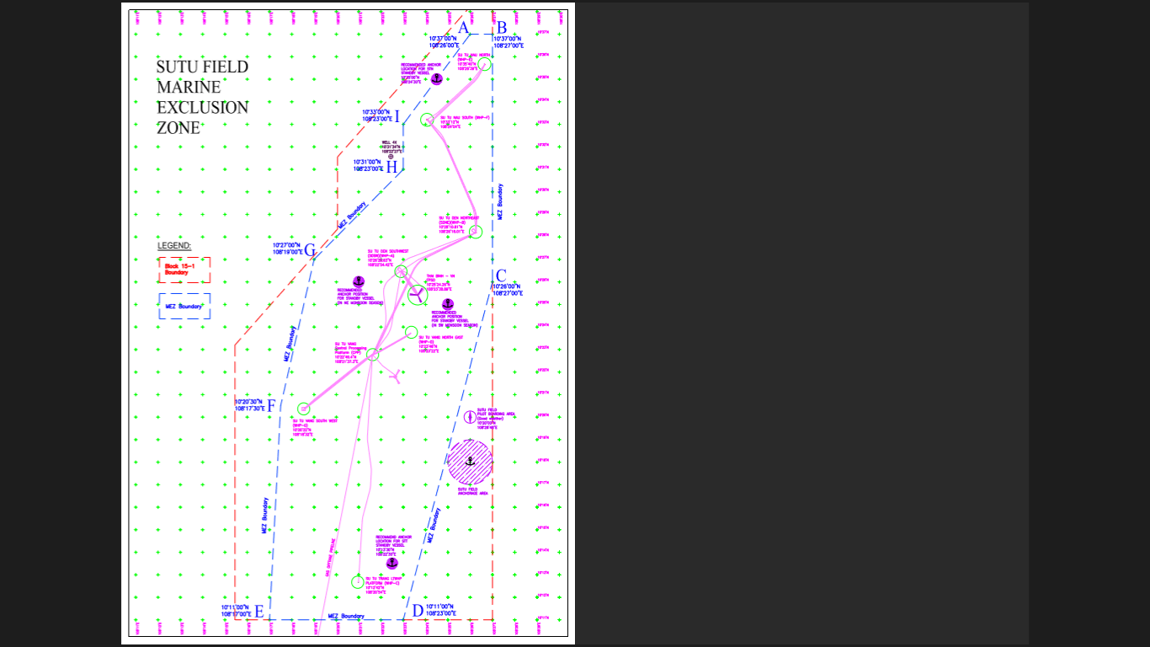

Figure 3.2Safe marine area surrounding Su Tu Fields at Block 15-1

### DRILLING PHASE

As plan of the STT-FFDP1, CLJOC will drill two (02) development wells (ST-5P & ST-6P) at the end of 2015. The drilling activity will occur within 150 days. CLJOC plans to use both water base mud (WBM) and synthetic base mud (SBM) for the drilling program. The potential sources of main environmental effects of drilling operations are showed in Figure 3.3.

**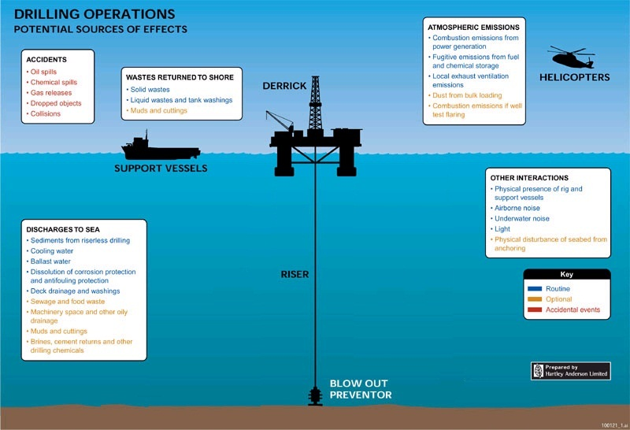**

Figure 3.3 Potential sources of main environmental effects in drilling operations

Main environmental aspects in drilling phase of ST-FFDP1 consist of:

* Air emissions: The main sources of gaseous emissions generated from the drilling operations will include exhausts from engines, generators on rig and on support vessels;
* Drilling discharges includes the used WBF, WBM drill cuttings, SBM drill cuttings;
* Effluence discharges includes domestic sewage and surface water run-off or deck drainage water and oily water;
* Solid wastes;
* Unplanned fuel /chemical spill;
* Positing and placement of the drilling rig.

#### Impacts relate to Air Emission

* **Air Emission Sources**

As illustrated in Figure 3.3, the main sources of air emission in the drilling phase of STT FFDP1 include fuel exhaust of power generators and engines on drilling rig and support vessels**.**

Table 3.13 Source of air emissions in drilling phase of STT FFDP1

|  |  |  |  |
| --- | --- | --- | --- |
| **Air Emission Sources** | **Emission Gases** | **Potential Receptors** | **Impact** |
| * Gas exhaust of power generator on drilling rig; | COx, SOx, NOx, CH4, VOC | * Offshore atmosphere * Health of workforces | * Negative |
| * Gas exhaust from engines on support vessels and helicopters | COx, SOx, NOx, CH4, VOC | * Offshore atmosphere | * Negative |

* + **Estimation of Air Emissions**

The estimation of air emissions of engines, generators on the rig and vessels in the drilling phase is based on emission factors of the guidelines of the UKOOA [18] (Table 3.14).

Table 3.14Emission factors by UKOOA

|  |  |  |  |
| --- | --- | --- | --- |
| **Emission Gas** | **Air Emission factor** | | |
| **Engine**  (*ton /ton DO)* | **Vessels**  (*ton /ton DO)* | **Helicopter**  *(ton /ton Jet A1)* |
| CO2 | 3.2 | 3.2 | 3.2 |
| CO | 0.0157 | 0.008 | 0.0052 |
| NOx | 0.0594 | 0.059 | 0.0125 |
| SO2 | 2 \* %S (wt.) | 2 \* %S (wt.) | 2 \* %S (wt.) |
| CH4 | 0.00018 | 0.00027 | 0.000087 |
| VOC | 0.002 | 0.0024 | 0.0008 |

The estimations of total emission loads from drilling activities are given in Table 3.15.

Table 3.15Estimated total loads of air emissions from drilling phase

|  |  |  |  |  |  |  |  |  |
| --- | --- | --- | --- | --- | --- | --- | --- | --- |
| **Sources** | **Drilling duration (days)** | **Fuel** | **Load of emissions** *(tons)* | | | | | |
| *(tons)* | **CO2b** | **COc** | **NOxd** | **SO2a** | **CH4e** | **VOCf** |
| Fuel exhaust of Engines and generator on drilling rig | 150 | 1,350 | 4,320 | 21.2 | 80.2 | 6.8 | 0.2 | 2.7 |
| Fuel exhaust of engines on Support Vessel | 150 | 750 | 2,400 | 6.0 | 44.3 | 3.8 | 0.2 | 1.8 |
| Fuel exhaust of engines on Helicopter | 150 | 35 | 112 | 0.2 | 0.4 | 0.2 | 0.0 | 0.0 |
| **Total in drilling phase** |  | **2,135** | **6,832** | **27.4** | **124.9** | **10.7** | **0.4** | **4.5** |

***Notes****: The estimation of air emissions from drilling phase is based on:*

* *Diesel consumption on drilling rig is assumed about 9 tons per day;*
* *Engines on drilling unit, which are considered as diesel engines.*
* *Fuel consumption of supply vessels is assumed 5 tons of DO /day /vessel;*
* *Actual Fuel for Helicopter operations at Block 15-1 is 6.26 tons /month;*
* *a: Sulfur content of fuel is taken of 0.25%wt;*
* *b, c, d, e, f: Calculations are based on emission coefficient in Table 3.14.*
  + **Potential Environmental Impacts**

Estimation results in Table 3.15 showed that air emission from drilling phase is highest of CO2 with 6,832 tons (occupying 98%). The emission of other pollutants (CO, NOx, SOx, CH4, VOC) is not much (2%) in comparison with CO2 emission. Daily air emission generated from the drilling activities and supporting vessel as well as helicopter is about 41.7 tons.

All air emissions from vessel, rig and helicopter will be dispersed quickly in the open offshore atmosphere due to the very short-lived nature of these activities (150 days). In addition, drilling rig and support vessels must comply with requirements from Annex VI of MARPOL about concentration limits of sulfur oxide (SOx) and nitrogen oxide (NOx) emissions from ship exhausts and prohibition from use of ozone-depleting substances including halons and chlorofluorocarbons (CFCs). Therefore, it is expected that atmospheric environment pollution of the air emission from the drilling phase would be negligible and adverse effects on the health of the rig and vessel personnel in the area are not anticipated.

Moreover, the emission of Green House Gas (Carbon Dioxide - CO2 and Methane - CH4) generated from the drilling operation and calculated as in Table 3.15 is considered as negligible which does not cause any significant impact on the Greenhouse Effect in the atmosphere.

Assessing based on the Impact Quantitative System (IQS), the impact magnitude of atmospheric emission during Drilling Phase is summarized and tabulated in the Table 3.16.

Table 3.16 Impacts magnitude of atmospheric emission during drilling phase

|  |  |  |  |  |  |  |  |  |  |  |
| --- | --- | --- | --- | --- | --- | --- | --- | --- | --- | --- |
| **Aspect** | **Environmental Impact** | **Impact Quantitative System** | | | | | | | | |
| **M** | **S** | **R** | **F** | **L** | **C** | **P** | **SIG** | **Rank** |
| Atmospheric Emissions | Deterioration of air quality | 1 | 2 | 0 | 2 | 0 | 1 | 1 | 12 | Minor |
| Health effects towards workers | 1 | 1 | 1 | 1 | 1 | 1 | 1 | 9 | Negligible |
| Global warming and climate change | 1 | 1 | 0 | 3 | 1 | 1 | 1 | 27 | Minor |

#### Impacts Relate to Effluent Discharge

* + **Effluent Sources**

The effluent waste generated during the drilling phase includes domestic wastewater and oily wastewater. Wastewater sources are listed in the Table 3.17.

Table 3.17 Effluent sources in drilling phase of STT FFDP1

|  |  |  |  |
| --- | --- | --- | --- |
| **Effluent Sources** | **Wastewater** | **Potential Receptors** | **Impact** |
| * Run-off rain water and deck drainage washing | * Oily water | * Sea water environment | * Negative |
| * Workforce living activities | * Domestic wastewater | * Marine living organisms in water column | * Negative |

* + **Estimation of Effluent Discharge Volume**

***Domestic Wastewater***

According to the plan of CLJOC, during the drilling phase, there are about 112 people working on the rig. The estimation of total volume of wastewater generated in this phase is given inTable 3.18.

Table 3.18 Estimated effluent discharge in drilling phase of ST-FFDP1

|  |  |  |  |  |  |
| --- | --- | --- | --- | --- | --- |
| **Source** | **Quantity /person/day (m3)** | **Drilling time (day)** | **Number of person** | **Total wastewater volume (m3)** | **Wastewater volume /day (m3)** |
| Domestic wastewater | 0.125 | 150 | 112 | 2,100 | 14 |

***Deck Drainage***

Assuming the top surface area of PVD1 rig is about 4,000m2 and a maximum monthly rainfall of about 400 mm (rainfall in July at Con Dao Island Station), the maximum monthly average deck drainage would be 1,600 m3. Besides, there is a small daily volume of deck drainage wastewater generated from the washing of floor cleaning and other facilities on the rig.

**Potential Environmental Impacts**

According to Table 3.18, the domestic wastewater in drilling activities is estimated about 2,100m3 or 14m3/day. All this wastewater volume is routed to domestic wastewater treatment system in drilling rig PDV1 for treatment so that pollutants in effluent will be handled thoroughly to meet requirements of Annex IV of MARPOL 73/78 before discharging into the marine environment. Thus, the impacts of domestic wastewater from PVD1 rig on water environment are assessed to be negligible due to rapid dispersion of offshore environment.

Deck drainage is often contaminated by run-off oil from deck surface, especially casing placement, drill tower and solids on the surface. Deck drainage water is collected to oily separating equipment to reach the oil content requirement at 15ppm before being discharged to the sea. This procedure conforms to requirement of Annex 1 of MARPOL Convention. Therefore, deck drainage discharge is expected to have no detectable effect on seawater.

Although impacts of treated wastewater are minimum and negligible, discharges may more or less cause effects on local aquatic species at receiving environment. However, above estimated figures shown that volume of wastewater are not much and discharged at offshore site with strong wave and current condition, so the remaining pollutants on the treated wastewater will be rapidly dispersed. Therefore, the impact of wastewater during the drilling phase on aquatic species is minor in short term.

The impact magnitude of wastewater during the Drilling Phase is summarized in Table 3.19.

Table 3.19Impacts magnitude of wastewater in the drilling phase of ST-FFDP1

| **Aspect** | **Environmental Impact** | **Impact Quantitative System** | | | | | | | | |
| --- | --- | --- | --- | --- | --- | --- | --- | --- | --- | --- |
| **M** | **S** | **R** | **F** | **L** | **C** | **P** | **SIG** | **Rank** |
| Domestic wastewater | Deterioration of seawater quality | 1 | 1 | 0 | 1 | 2 | 1 | 1 | 8 | Negligible |
| Impact on pelagic communities | 1 | 1 | 0 | 1 | 2 | 1 | 1 | 8 | Negligible |
| Desk drainage wastewater | Deterioration of seawater quality | 1 | 1 | 1 | 3 | 2 | 1 | 1 | 36 | Minor |
| Impact on pelagic communities | 1 | 1 | 1 | 3 | 2 | 1 | 1 | 36 | Minor |

#### Impacts relate to Drilling Discharge

As planned, the drilling program of the ST-FFDP1 will be similar to other development projects in Block 15-1. CLJOC plans to use two drilling mud systems: Water Base Mud (WBM) and Synthetic Base Mud (SBM) as follow as:

* Synthetic Based Fluid NEOFLO 1-58 will be used to drill 12.25”, 9.5” and 6” hole section for normal drilling operations;
* The Synthetic Based drilling Fluid of SARALINE 185V will be only used to drill 121/4” hole section in emergency cases when meeting the wells with difficulty and complexity of technology as well as the loss of drilling mud while using up the reserved source, leading to insufficient supply source and delay of drilling operation, which can significantly increase drilling cost.
* Water Base Mud (WBM) will be used for cleaning inside 30” conductor pipe and drilling 16” hole section respectively.

Estimation of the total volumes of WBF and SBF used on a typical STT FFDP1 well are 9,200 bbl and 11,300 bbl respectively. The rate utilization of WBF/SBF is about 9,200bbl/11,300bbl (or 0.814). Detailed drilling program for each well of STT FFDP1 is following:

|  |  |
| --- | --- |
| 1. 30” hole section: 3,400 bbls of Water Based fluid |  |
| 1. 16” hole section: 5,800 bbls of Water Based fluid 2. 12-1/4” hole section: 3,800 bbls of Synthetic Oil Based fluid 3. (Neoflo 1-58 or or Saraline 185V) 4. 9-1/2” hole section: 4,200 bbls of Synthetic Oil Based fluid (Neoflo 1-58) 5. 6” hole section: 3,300 bbls of Synthetic Oil Based fluid (Neoflo 1-58) |  |

* **Source of Drilling Wastes**

Drilling waste sources including spent WBF, WBM and treated SBM are given in Table 3.20.

Table 3.20 Drilling waste sources in drilling phase of ST-FFDP1

|  |  |  |  |
| --- | --- | --- | --- |
| **Activity** | **Waste Type** | **Potential Receptors** | **Impact** |
| * Drilling activities | * Spent WBF * WBM cuttings * SBM cuttings with less than 9.5% of wet weight | * Marine environment * Plankton * Sediment and benthos | * Negative |
| * Well completion and fixing of casings | * Excess cement | * Sediment and benthos | * Negative |

* + **Estimation of Drilling Mud and Cuttings Discharge**
* ***Spent WBMs and SBMs***

According to National Technical Regulation on Discharge of Drilling Fluids and Drill Cuttings for Offshore Oil and Gas Facilities (QCVN 36:2010/BTNMT), the spent WBM generated from the changeover mud program and refused WBM at the end of the section hole will be discharged to the sea without treatment.

For SBM, only that having the concentration of adherent SBF less than 9.5% in weight is allowed to discharge to the sea. Spent SBFs will be transported to shore for separating fine cuttings to recover the SBF. The fine cuttings with SBF higher than allowable limitation of 9.5% wet weight of the cuttings, which does not meet QCVN 36:2010/BTNMT shall be treated by burning in the cementing kiln.

* ***Estimation of WBM and SBM drilling Cuttings***

The rate of WBM drilling cuttings discharged will depend on the diameter of the hole sections and the drilling distance. Estimated quantities of water based cuttings generated by the drilling program of the ST-FFDP1 are summarized in Table 3.21.

Table 3.21 Estimation of discharge volume of WBM and SBM drilling cuttings from ST-FFDP1

| **Hole size** | **Drilling Depth (m)** | **Mud program** | **Cuttings Volume (Tons)** |
| --- | --- | --- | --- |
| **1- WBM cutting discharge** | | | |
| 30” | 250 | Sea water & Hi Viscosity Pills | 524.4 |
| 16” | 1,969 | Polymer KCL / Gel/Polymer | 881.1 |
| Total WBM cutting discharge /1 well | | | 1,405.6 |
| **Total WBM cutting volume /2 wells** | | | **2,811.2** |
| **2- SBM cutting discharge** | | | |
| 12.25 | ,375 | Neoflor 1-58 or Saraline 185V | 240.5 |
| 9.50 | 940 | Neoflor 1-58 | 98.9 |
| 6.00 | 190 | Neoflor 1-58 | 8.0 |
| Total SBM cutting discharge /1 well | | | 347.3 |
| **Total SBM cutting volume /2 wells** | | | **694.6** |

***Note****:(\*) Estimation of discharged cutting volume is based on volume of hole section with Wellbore Wash out Factors of 2.0; 1.5 and 1.0 respectively for 2 well with section of 30”, 16” and other well section and cuttings density of 2.3.*

The used SBM muds will be transported to shore for separate fine particles out of the muds. The recovered SBM muds will be used for the next drilling activities and the fine mud particles will be burned in the cement clinker cinerator.

***Estimation of Discharge of SBF adhering on SBM Drill Cuttings***

Volume of adhered SBF on the discharged cuttings is calculated by mass balance method (basing on used SBF volume, lost SBF volume and remained SBF volume at the end of drilling phase).

Estimated quantity of SBM drill cuttings generated from development drilling of ST-5P and ST-6P wells is summarized in Table 3.22.

Table 3.22Estimation of discharge quantity of SBF adhered on drilling cuttings from STT FFDP1

|  |  |  |  |  |  |
| --- | --- | --- | --- | --- | --- |
| **Hole Size** | **Drilled**  **Depth**  (m) | **Mud program** | **Adhered SBM in cuttings/1 km drilled** *(Ton)\** | **SBM on discharged Cuttings /Well**  (ton) | **Total SBM on Cuttings of 2 Wells** (ton) |
| 12.25” | 1375 | SBF (NEOFLO 1-58 / SARALINE 185V)\* | 53.14 | 73.1 | 146.1 |
| 9.5” | 940 | 53.14 | 50.0 | 99.9 |
| 6” | 190 | 53.14 | 10.1 | 20.2 |
| **Total** |  |  |  | **133.1** | **266.2** |

***Note:***

* *(\*) SARALINE 185V will be only used for drilling single well as a contingent plan if required.*
* *The content of SBF adhered in the discharged drilling cuttings is 5.9% w.t.*
  + **Fate of Drill Cuttings of STT FFDP1**

***WBM Drilling Cuttings***

As most of WBM additives are soluble substances, therefore, when entering the open sea, they will be dispersed and diluted rapidly down current from the discharge point. Only insoluble parts such as weighing and viscosity agents and cuttings rocks will sink to the seabed. Several field studies have shown that drilling mud discharged into the sea were diluted rapidly to very low concentrations, usually within 1.000 to 2.000m down current from the discharge and in less than an hour after the discharge. In areas where water current velocity is high, drilling mud and cuttings discharges is diluted very quickly. For example as discharges from the drilling rig were diluted by 10,000 folds within 100m radius of the rig [19]. In well-mixed seawater, drilling mud is diluted more than 100-fold within 10 m radius of the discharge point.

When discharged, most of solids in the lower plume will sink rapidly to the seabed with little horizontal displacement or dispersion by local currents. However, the fine particulates will be carried more far away by surface water currents.

***SBM Drilling Cuttings***

SBM drill cuttings is a mixture of SBF (less than or equal 9.5%) and cuttings rocks when discharged to the sea. It tends to clump together in larger particle than WBM cuttings and settle more rapidly to the seabed. Field studies have shown that highest concentrations of SBM drill cuttings usually are located in sediments within about 50-100m of discharge point. With this nature, the extent of impact from SBF cuttings discharged is much more limited than impacts from WBM cuttings discharged [19].

Once cuttings is deposited on the seabed, the physical persistence of the cuttings and elevated SBF levels will depend upon the natural energy of re-suspension and transport on the seafloor coupled with biodegradation of the base fluids. In addition, shale cuttings can weather naturally and disaggregate into silt/clay particles due to hydration upon exposure to seawater.

**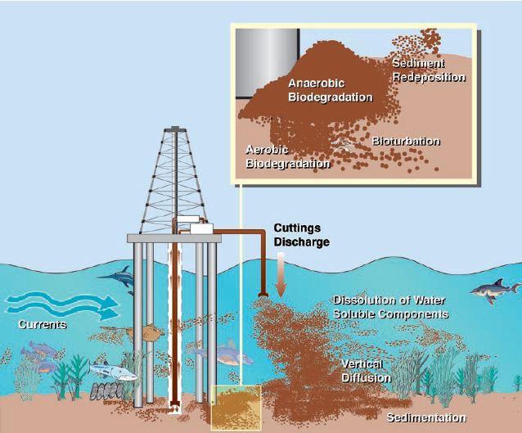**

*Figure 3.1 Fates of Discharged Cuttings at Sea*

*(****Source:*** *International Association of Oil and Gas Producers, 2003)*

* + **MUDMAP dispersion modeling**

***Input data of MUDMAP model***

In order to simulate effects of ST-5P and ST-6P well cuttings spreading on ST-PIP area after discharge to the sea, CLJOC in cooperation with CPSE used the model “MUDMAP” developed by ASA scientists and engineers that simulate dispersion process of discharged drilling mud at ST-PIP in the Northeast monsoon season from October to March.

MUDMAP modeling version 6.7.2 is an analytical software and modeling by Applied Science Associates, Inc (ASA) for computing, simulating the movement, spreading and resettling on the sea bottom of discharged drilling cuttings and drilling fluids as well as wastewater drifting.

MUDMAP is commercial software and worldwide applied with full data and terrain information via hydro-meteorological systems EDS data online. EDS is online database system of ASA provided data protection for hydrometeorology and marine areas on a global scale. EDS data are provided from reliable sources such as the U.S. Navy, Royal Australian Navy, NOAA, ... These data are measured through a system of large number of satellites continuously scan the range global scale in which 7 stations belongs to Vietnam Sea area (Do Son, Hon Gai, Cam Pha, Hon Nieu, Da Nang, Cam Ranh Bay and Vung Tau), in which:

* Seawater temperature:Average sea surface water temperature is taken from the National Oceanographic Data Centre, World Ocean Atlas (<www.metoc.gov.au>) and are seasonally collected from minimum of 27ºC to a maximum of 30ºC. Thus, a water temperature of 27oC is used as a worst case assumption, since the evaporative loss will be reduced with lower water temperatures.

* Current data:The current data is taken from the U.S. Navy Coastal Ocean Model (NCOM). NCOM Oceanographic is developed at the U.S Naval Research Laboratory (NRL) and is run operationally by the U.S. Naval Office (NAVO).
* Wind data: Local wind data are taken from the database of National Center for Environmental Predictions (NCEP) and provided by NOAA’s (National Oceanic and Atmospheric Administration) Climate Diagnostics Center.

MUDMAP may use all difference maps scale due to support from integration ability with GIS systems.

According to calculated results in Table 3.21, total WBM cuttings (2,811.2 ton) and SBM cuttings (694.6 tons) about 3,506 tons generated from two wells ST-5P & ST-6P at ST-PIP will be discharged into the sea during drilling phase (150 days)*.* Therefore, MUDMAP model is used to simulate the dispersion process of discharged drilling cuttings. The input data of MUDMAP is presented in Table 3.24.

Table 3.24 Input parameters of MUDMAP modeling

|  |  |  |
| --- | --- | --- |
| **Parameter** | **Value** | |
| **WBM and SBM cuttings discharge** | | |
|  | **WBM cutting discharge** | **SBM cutting discharge** |
| Discharge co-ordinate (ST-PIP platform) | 10.211395° - 108.349052° | |
| Discharge time | From October to March | |
| Discharge duration | 150 days | |
| Total discharged volume | 2,811 tons | 695 tons |

***Results of MUDMAP dispersion modeling***

**For the discharge of WBM and SBM drilling cuttings**: The MUDMAP modeling results for drilling phase at ST-PIP showed that after being discharged in to the sea, discharged drilling cuttings tend to be dispersed to South-West direction in the area within the radius of 180-600m from ST-PIP platform (**Figure 3.6**). The main reason is that the discharge of drilling cuttings of two wells ST-5P và ST-6P is implemented in North-East monsoon season (from October 2015 to March 2016).

The maximum distance of drilling cuttings movement is up to 600m. Total sedimentation area of drilling cuttings is about 0.07 km2. There may be a point with maximum concentration of cuttings up to 100 kg/m2. Most affected area has concentration less than 10 kg/m2.

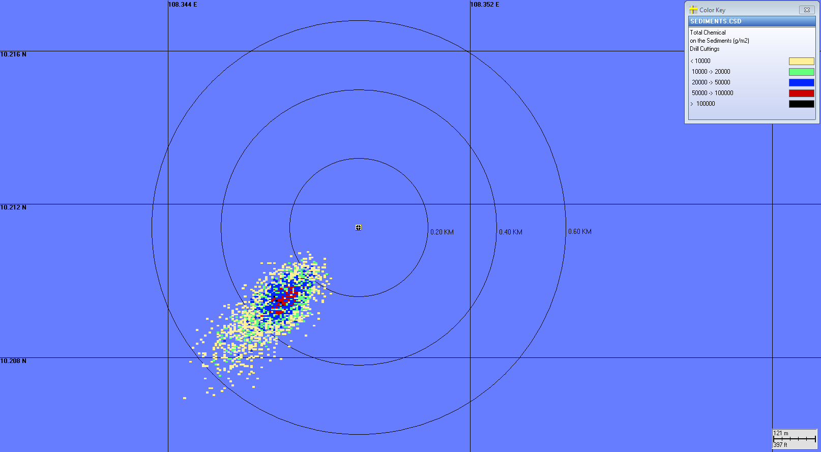

Figure 3.4 Dispersal direction of discharged WBM and SBM drilling cuttings at ST-PIP

The discharging cuttings will cause localized physical impact on the seabed such as changing in the sediment grain size and creating the cuttings piles. The discharge process may change in the physic – chemical characteristic of sediment including increasing in the total hydrocarbon, heavy metals (Ba, Hg, V, etc.) and cause temporary impacts on the benthic communities in the vicinities of the ST-PIP.

* + **Drilling Mud Toxicity**

***Toxicity of WBM***

The typical composition of WBM consists of seawater (76%), barite (15%), bentonnite (7%) clay and others (2%) including caustic soda, water-soluble polymers and low concentration of additive chemicals such as ammonium bisulfite and soda ash [20]. Toxicity information of the most used additives of WBM is presented in Table 3.25.

Table 3.25 OCNS toxicity rating of WBM additives

|  |  |  |
| --- | --- | --- |
| **Additives** | **Application** | **OCNS Category** |
| Barite | Weighting Agent | PLONOR |
| Betonnite | Viscosifier | PLONOR |
| Guar Gum | Viscosifier | PLONOR |
| Caustic Soda | pH control | Group E |
| Ammonium Bisulfite | Biocide | PLONOR |
| Soda ash | Calcium Remover | PLONOR |

***Note****s: United Kingdom Offshore Chemical Notification Scheme (OCNS)*

1. *PLONOR are preparations used and discharged offshore which are deemed to Pose Little or NO Risk to the marine environment.*
2. *Chemicals that cannot be calculated with ‘CHARM’ model are classified into five OCNS groups A-E, and Categories D & E are the least hazardous to the environment.*
3. *Chemicals that can be calculated with ‘CHARM’ model are classified into three HOCNF bands and Gold & Silver bands are the least hazardous to the environment.*

Experiment results from Environmental Protection Agency of USA (USA-EPA) in 1992 indicated that the WBF has lowest toxicity on environment. Most testing (99%) on LC50 toxicity of WBF within 96 hours in suspended phase with ratio of 1:9 between WBF and sea water always fall outside toxic threshold (>30,000ppm) of drilling solution (US standard on toxic threshold of drilling solution).

***Eco-toxicity of SBMs***

Many eco-toxicity studies on the synthesis base fluid (SBFs) had been undertaken globally. The results of studies show that eco-toxicity of SBFs is low and passes acceptance criteria in different countries in the world. The toxicity of SBF in soluble phase is very low, in most case acute toxicity of the SBFs is well above 1,000mg/Kg dry sediment. The toxicity of the SBF in insoluble phase test is always higher and varies from low to moderate toxicity subject to SBF types due to poorly soluble properly of SBFs [19 & 21].

* + ***Potential environmental Impacts***

As above mentioned, only spent drilling WBF and its cuttings are allowed to be directly discharged into the sea. SBM cuttings will only be discharged into the sea when they have SBF adhered on drilling cutting less than 9.5% of the wet weight of cuttings after treating to meet QCVN 36:2010/BTNMT. In reality, CLJOC always maintains SBFs adhered to discharged drilling cuttings at level of 5.9%, therefore, the oil content adhered to discharged drilling cuttings is always less than 32% in comparison with allowable threshold.

According to results of drilling cuttings discharge modeling for two wells ST-5P và ST-6P (Figure 3.6), drilling cuttings discharged in Northeast monsoon period (October to March) tends to be dispersed on South-West direction within radius 180-600m from ST-PIP platform. Total sedimentation drill cuttings area is about 0.07 km2. Most affected area has concentration less than 10 kg/m2 and maximum up to 100 kg/m2.

Based on the field studies in the North Sea and other regions indicated that the discharge of the SBM drill cuttings had resulted main following impacts on marine environment:

* Localized physical impact on the seabed such as changing in the sediment grain size and creating the cuttings piles;
* Change in the physic–chemical characteristic of sediment including increasing in the total hydrocarbon, heavy metals (Ba, Hg, V, etc.) and;
* Cause temporary impacts on the benthic communities in the vicinities of the discharge points.

The environmental impacts, therefore, generated from drilling activities of STT FFDP1 are considered as minor in scale, locally magnitude and a short period (about 5 months).

Based on above mentioned assessment, the physical and chemical characteristics of the WBM and SBMs (NEOFLO 1-58 or SARALINE 185V as a contingency plan) and the quantity of discharged SBM cuttings (695 tons) and WBM cuttings (2,811 tons), uncontinuously discharge (from 2015 to 2016) in combination with a high receiving capacity environment found in study area, it can be concluded as follows:

* Drilling cuttings generated from drilling activities of STT FFDP1 will result in significant change of sediment size distribution. The increase in hydrocarbon in short term and heavy metals (Barium for instance) concentrations in sediment will be localized within in the rings 180 to 600m from the discharge point. However, the impact will be in short-term due to enhanced physical and biological degradation of the contaminants and decolonization by opportunistic benthic species may occur within a few months or maximum one year after the drilling activities end;
* The impacts of NEOFLO 1-58 drilling cuttings discharge on the benthic community will be significant and localized around the discharge point particularly in the area of the prevailing current. The affected areas will be greatly reduced within 1 years with total recovery expected within 2 years after ceasing discharge of cuttings;
* Localized changes in the benthic community as a result of drilling discharges of the ST-FFDP1 will have minimal effects on the ecosystem of the Southeast Vietnam Sea due to the minor affected area and metocean characteristics of the region.
* The utilization of SARALINE 185V to drill the ST-5P and ST-6P wells as the contingent option will cause minor environmental impact and localized in a short time. The environment of affected area would recover within 1 year after stopping discharge due to the volume of cuttings discharge from ST-5P and ST-6P well is small and SARALINE 185V is ready biodegradation.
* ***Impacts caused by Cementing activity***

The cementing program for production wells at ST-PIP will be similar to that utilized in the pre-drilled wells at ST-1P to ST-4P. During the cementing activities, the volume of cement slurry will be calculated and pumped accordingly to fill up the annulus behind the casing and zones isolation. No excess cements are pumped into the sea. However, in some cases due to the cement channeling then a very minor of cement contamination with the drilling mud might be observed in the returns. The discharge of cement contamination will be within the limit and negligible, so the impact of cement discharge on the environment would be negligible.

Based on the Impact Quantitative System (IQS), the impact magnitude of drilling waste discharges during Drilling Phase is summarized and tabulated in the Table 3.27.

Table 3.27 Environmental impact of drilling waste discharges of STT FFDP1

| **Aspect** | **Environmental Impact** | **Impact Quantitative System** | | | | | | | | |
| --- | --- | --- | --- | --- | --- | --- | --- | --- | --- | --- |
| **M** | **S** | **R** | **F** | **L** | **C** | **P** | **SIG** | **Rank** |
| Discharge WBM cuttings | Changes in sediment quality | 1 | 2 | 3 | 3 | 2 | 1 | 1 | 72 | Minor |
| Changes in benthic communities | 2 | 2 | 2 | 3 | 2 | 1 | 1 | 72 | Minor |
| Deterioration of seawater quality | 1 | 2 | 1 | 3 | 2 | 1 | 1 | 48 | Minor |
| Impact on pelagic communities | 1 | 1 | 1 | 3 | 2 | 1 | 2 | 45 | Minor |
| Discharge of SBM cuttings | Changes in sediment quality | 3 | 2 | 3 | 3 | 2 | 3 | 1 | 144 | Significant |
| Changes in benthic communities | 2 | 2 | 2 | 3 | 2 | 3 | 1 | 108 | Significant |
| Deterioration of seawater quality | 1 | 1 | 1 | 3 | 2 | 3 | 2 | 63 | Minor |
| Impact on pelagic communities | 1 | 1 | 1 | 3 | 2 | 3 | 2 | 63 | Minor |

#### Environmental Impacts Related to Solid Wastes

* ***Solid Waste Sources***

Solid wastes generated from drilling operations, supporting services and workforce living on the rig. Solid wastes arising from drilling phase include hazardous wastes mostly fine SBM sludge with SBF adhered higher than 9.5% of cuttings weight, grease, oily wastes, used chemical bags and sacks, used chemicals (not met technical requirement) or paint containers/drum/ paint/ used batteries/ rags/ medical wastes etc) and non-hazardous wastes such as food wastes, galley wastes*,* paper, carton, wood, plastic, glasses, metal scrap, cans. Table 3.28 is summary of the solid waste sources from the drilling operations.

Table 3.28 Sources of Solid Waste in Drilling Phase

| **Solid Waste Sources** | **Waste Type** | **Potential Receptors** | **Impact** |
| --- | --- | --- | --- |
| Drilling activities | * Oily wastes * Used chemical bags and sacks * SBM sludge * Used chemicals, oil, paint drums/containers * Barite, cement | * Offshore air environment (indirect) | * Negative |
| * Workforce living activities | * Medical wastes * Other non- combustible non-hazardous wastes (glass, plastic and metal scraps) * Combustible non-hazardous * Food wastes * Galley wastes | * Underground water and soil | * Negative |

* + **Solid Waste Load Estimation**

Estimation of solid wastes from the STT drilling phase is based on 112 persons working on the jack-up rig within 150 days and actual quantity of solid wastes generated from the drilling operations in Block 15-1of CLJOC (Table 3.29) in which:

* Combustible rubbish: 4.85 kg/person/day
* Non-combustible rubbish: 2.5 kg/person/day
* Chemical bags, drums/rig: 21 kg/well/day
* Barite, cement etc.: 6.725 kg/well/day
* Oil & Grease Waste: 12 kg/day/WHP
* Oily Waste: 93 kg/day/WHP

The SBM sludge with SBF adhered more than 9.5% of weight cuttings is calculated, based on actual quantity of SBM Sludge generated from ST-4P in 2014 in the range of 230 - 250 tons/well.

Table 3.29 Estimated average quantity of solid waste in the drilling phase

| **Solid Wastes** | **Daily Average Quantity** *(Kg)\** | **Total quantity**  **for the Drilling Phase** *(tons)* |
| --- | --- | --- |
| 1. **Hazardous wastes** | | |
| * Oily Wastes | 93 | ~14 |
| * Spent Oil and grease | 12 | 1.8 |
| * SBM Sludge per well (ton/well) | 2,976.2 | 500 ( for 2 wells) |
| * Barite, Cement etc | 13 | ~2 |
| * Chemical Bags, Drums | 42 | 6.3 |
| **Total hazardous wastes** | **3,081.2** | **~524** |
| 1. **Non-hazardous wastes** | | |
| * Food waste | 95.2 | 14.3 |
| * Non- Combustible rubbish | 280 | 42 |
| * Combustible Rubbish | 543 | 81.5 |
| **Total Non-hazardous wastes** | **918.2** | **137.8** |

* **Potential Environmental Impacts**

***Hazardous wastes***

Hazardous wastes generated in the drilling phase include:

* Oily and grease wastes
* SBM Sludge
* Barite, Cement
* Chemical contaminated bags and drums

The drilling activities generates largest of volume hazardous solid wastes among difference phases of STT FFDP1. Estimated hazardous solid waste from the drilling activities is about 524tons of the whole the drilling phase which is equal about 3.08 tons of daily average solid wastes.

CLJOC has agreement with PTSC Supply Base for treatment and disposal all of wastes generated from the operations in the whole Block 15-1 in general including STT-FFDP1. CLJOC accepts Holcim or Viet Xanh as a waste treatment sub-contractor of PTSC Supply Base.

The hazardous wastes will be segregated and stored in appropriate bins, skips or containers, which will be fully labeled before transporting to onshore by vessels of PTSC Marine to temporary store at Vung Tau Yard of PTSC Supply Base. Then, hazardous wastes will be transferred to Holcim Cement Factory or Viet Xanh Company for suitable final treatment. So the solid waste treatment cause no effect on marine environment.

At the Holcim factory, almost hazardous wastes will be burnt at 2,000-3,000oC in cementing kiln. No disposal ashes to the environment because the ashes will be used as an additive to produce cement material. Gases emitted to air will be monitored to meet the applicable standard by Holcim Factory.

Practically, CLJOC always applies the appropriate waste management procedure and strictly supervises treatment and disposal of hazardous wastes and non-hazardous from the waste treatment Contractor and Sub-contractor. Hence, the impact of hazardous solid waste treatment and disposal on ground water and soil would be minimized. It would be concluded that the environmental impact from the hazardous solid waste treatment and disposal on the groundwater and soil will be minor. Further mitigation measures taken to minimize the impact of hazardous solid waste disposal and treatment are detailed in Section 4 of this EIA.

**Non-hazardous solid wastes**

Non-hazardous solid wastes generated in the drilling phase include:

* Low- combustible /non- combustible wastes (plastic and metals)
* Combustible rubbish (paper, hard carton …)
* Food wastes

The amount of non-hazardous solid wastes generated in the drilling phase of STT FFDP1 Project is not much and estimated about 138 tons, equivalent 0.9 tons/day.

The daily food wastes will be ground in to less than 25 mm in size to meet regulation in Annex V of MARPOL 73/78 Convention before discharging to the sea. They will be fed for marine creatures. In addition, oxidation processes of organic matters of food waste will increase the turbidity and reduce the quantity of dissolved oxygen in water around the discharge point. However, these impacts are negligible and only occur locally in the vicinity of the discharge point.

The non-hazardous wastes generated on rig will be segregated and stored in appropriate bins, skips or containers, which will be fully labeled before transporting to onshore by vessels of PTSC Marine to temporary store at Vung Tau Yard of PTSC Supply Base. Then, non-hazardous wastes will be transferred to Gia Linh Urban Company of Ba Ria-Vung Tau for final treatment. The non-hazardous solid waste (such as used papers, hard carton, plastic and metals) will be recycled and reused. Therefore, environmental impact of non-hazardous wastes is considered as negligible to soil and ground environment.

Based on the Impact Quantitative System (IQS), the impact magnitude of solid waste discharges during Drilling Phase is summarized and tabulated in the Table 3.30.

Table 3.30 Impacts of Solid Waste during Drilling Phase

|  |  |  |  |  |  |  |  |  |  |  |
| --- | --- | --- | --- | --- | --- | --- | --- | --- | --- | --- |
| **Aspect** | **Environmental Impact** | **Impact Quantitative System** | | | | | | | | |
| **M** | **S** | **R** | **F** | **L** | **C** | **P** | **SIG** | **Rank** |
| Solid wastes | Deterioration of seawater quality | 0 | 0 | 0 | 3 | 2 | 2 | 2 | 0 | No impact |
| Impact on underground water and soil | 1 | 1 | 4 | 3 | 2 | 1 | 1 | 72 | Minor |

#### Impacts related to radioactive use

Used radioactive sources (low radioactivity) will be used and transported oversea by a legal contractor for re-activation or be transported to store at safety place. Therefore, there is no radioactivity wastes risen from the drilling activities.

#### Impacts unrelated to wastes (physical interaction)

* **Impact Sources**

Seabed physical disturbances from offshore drilling operations are considered to be unrelated to wasteeffect, which include:

* Anchoring of support vessels,
* Noise and light,
* Physical presence of the drilling rig and the support vessels will also affect the marine traffic movements as well as the fishing activities near drilling area.
* **Potential Impacts**

***Seabed disturbance***

During drilling phase, the drilling rig will be moved in/out production platforms when required. Each time of moving and resettling, the rig legs will cause physical disturbance to the seabed. These potential disturbances will be similar to those occurring during installation and commissioning activities such as change in distribution of the sediment particles size which may cause localized disturbance in benthic community. However, these disturbances will be temporary and localized due to the positioning and occupation of the drilling rig in short time, small affected area and the high capacity of the rehabilitation of the area. These activities will re-suspend bottom sediments, crush benthic organisms and produce turbidity.

***Presence of drilling rig (including Noise and Lights)***

The presence of drilling rig, vessels and the associated noise and lights are a source of impacts in the marine environment. These immediate impacts at operational time will come to the end as drilling phase completed.

The physical presence of the drilling rig and the associated facilities will also interfere with marine traffic as well as fishing activities near the project area.

The physical presence of the drilling rig and the associated facilities will cause impacts to marine traffic routes as well as limiting fishing activities immediately near the drilling operations area. However, this area is small in comparison with the whole fishing ground in the region and is therefore will not cause significant economic loss.

Interaction with fishing boats may occur as they pass through the area to fish at other locations. Although there will be a 500 m safety zone around drilling rig, other measures are liable to be required to reduce the risk of interaction with this traffic. CLJOC will take full account of this hazard wherever possible and the operating procedures is being developed which seek to mitigate associated risk. The drilling rig and support vessels will be clearly marked and identifiable both during daytime and the hours of darkness.

Based on the Impact Quantitative System (IQS), the impact magnitude of physical Interaction during Drilling Phase is summarized and tabulated in the Table 3.31.

Table 3.31 Impacts magnitude of physical interaction during drilling phase

|  |  |  |  |  |  |  |  |  |  |  |
| --- | --- | --- | --- | --- | --- | --- | --- | --- | --- | --- |
| **Aspect** | **Environmental Impact** | **Impact Quantitative System** | | | | | | | | |
| **M** | **S** | **R** | **F** | **L** | **C** | **P** | **SIG** | **Rank** |
| Physical Disturbance | Distribution of seabed sediment size | 1 | 1 | 4 | 3 | 0 | 1 | 1 | 15 | Minor |
| Changes in benthic communities | 1 | 1 | 1 | 3 | 0 | 1 | 1 | 18 | Minor |
| Physical appearance of vessels & drilling rig | Interference with marine users | 1 | 1 | 0 | 3 | 2 | 1 | 2 | 30 | Minor |
| Fishing activities | 1 | 1 | 1 | 3 | 2 | 1 | 3 | 54 | Minor |

### PRODUCTION PHASE

Thus, the main environmental impact from the production activities of STT FFDP1 includes:

* Air emission from ST-PIP;
* Discharge of produced water from STV-CPP;
* Discharge of drainage water from ST-PIP ;
* Discharge of domestic wastewater from ST-LQ
* Solid waste treatment and disposal;
* Presence of ST-PIP and ST-LQ;
* Operations of support vessel; and
* Environmental incidents

#### Impacts Related to Air Emissions

* **Air Emission Sources**

ST-PIP will be equipped with the main production systems including production separator, centrifugal compressors driven by gas turbine, wellhead control panel (Hydraulic); common gas injection compression suction; heating, ventilation and air conditioning (HVAC), etc. The utility systems envisaged in ST-PIP includes fuel gas system, HP and LP flares and main power generation systems.

Most gas separated on ST-PIP will be routed to gas compression station and then exported by export pipeline. Production effluent (condensate and water) will be routed to existing WHP-C, combined with production effluent in here, then routed to central processing platform of Su Tu Vang (STV –CPP) for treatment and export to FPSO TBVN. A part of gas separated will be used as fuel gas for ST-PIP and maintaining gas for flare system.

Major and regular emissions in the production phase are summarized in Table 3.32.

Table 3.32 Sources of air emission in production phase

| **Emission Sources** | **Pollutants** | **Potential Receptors** | **Impact** |
| --- | --- | --- | --- |
| * Flaring on ST-PIP | * Hydrocarbon | Air environment | Negative |
| * Fuel gas exhaust of generators and engines on ST-PIP | * COx, SOx, NOx, CH4, VOC | Air environment | Negative |
| * Fuel exhaust for supply vessel operation | * COx, SOx, NOx, CH4, VOC | * Air environment | * Negative |
| * Fuel exhaust for Helicopter operation | * COx, SOx, NOx, CH4, VOC | * Air environment | * Negative |
| * Pilot gas at ST-PIP Flare | * COx, SOx, NOx, CH4, VOC | * Air environment | * Negative |
| * Emission when flaring gas in emergency cases | * COx, SOx, NOx, CH4, VOC | * Air environment | * Negative |

* **Estimation of Air Emission**

During STT FFDP1, almost production gas will be used for injection to wells ST-1P & ST-2P, fuel gas and for exporting to a shore for commercial purpose. The production forecasted daily gas production within 13 year of STT FFDP1 (2016 – 2028) is about 142.96 MMscfd.

Load of gas and fuel (diesel) used in production phase include:

* The treated gas from STT FFDP1 is used for re-injection, export and fuel, in which:
  + Re-injection and fuel gas: 65% (92.96 MMscfd)
  + Exporting to ashore for sale gas: 35% (50 MMscfd).
* Atmospheric local vent line from open drainage tank is routed and terminated at a safe location. The open drain vent shall not be connected to other vents and not be fitted with a flame arrestor. Estimation of vent volume from the open drain system is negligible with approximately 1 m3/day.
* Frequency of supply vessel operation is two (2) days/week/ST-PIP, equal 104 days a year (2 days/week x 52 weeks). Diesel fuel for supply vessel is 5 tons/day;
* Actual fuel consumption for helicopter in Block 15-1 is about 75.16 tons/year.

In emergency cases such as there are leakage or fire in the compressor turbine enclosure, it must be shut-down all process system. Then, a depression must be done within less than 15 minutes that about 2.54 mmscf gas should be led to flare for burning (which is equivalent to flare the gas stream at the maximum production rate of 244 mmscfd during 15 minutes). Daily of production phase, a continuous gas volume of 150 scf/h will be flared to prevent the oxygen penetration into the flaring/venting system as well as keep the pilot ignition.

Estimation of air emission from gas engines, equipment and vessels in the production phase is based on the guidelines of the UKOOA [18] in which the emission coefficient are listed in Table 3.33.

Table 3.23Air Emission Coefficient of UKOOA

| **Emissions** | **Gas Engine**  *(ton /gas fuel ton)* | **Aircraft**  *(ton /Jet A1fuel ton)* | **Vessels**  *(ton /DO fuel ton)* | **Associated gas flaring** *(ton /gas fuel ton)* |
| --- | --- | --- | --- | --- |
| CO2 | 2.86 | 3.2 | 3.2 | 2.8 |
| CO | 0.0076 | 0.0052 | 0.008 | 0.0067 |
| NOx | 0.0576 | 0.0125 | 0.059 | 0.0012 |
| SO2 | 2 \* %S (wt.) | 2 \* %S (wt.) | 2 \* %S (wt.) | 2 \* %S (wt.) |
| CH4 | 0.0198 | 0.000087 | 0.00027 | 0.01 |
| VOC | 0.0032 | 0.0008 | 0.0024 | 0.01 |

Load of used gas fuel/fuel and air emission load in the production phase is given in Tables 3.34, 3.35 and 3.36.

Table 3.34 Volume of gas and fuel used in the production phase

|  |  |  |  |
| --- | --- | --- | --- |
| **Activities** | **Frequency (time)/week** | **Fuel gas (mmscfd)** | **Volume of fuel (tons)/year** |
| Fuel gas for equipment on ST-PIP | Daily | 6 | 44,448 |
| Supply vessel for ST-PIP: | 2 days/week |  | 3,250 |
| Helicopter for ST-PIP | 1 time/week |  | 75 |
| Pilot gas at ST-PIP Flare | Daily | 3.6 x 10^-3 | 74.1 |

Table 3.35 Estimation of Air Emission of the Production Phase – STT FFDP1

|  |  |  |  |  |  |  |  |
| --- | --- | --- | --- | --- | --- | --- | --- |
| **Activities** | **Gas fuel**  **(ton)** | **CO2**  **(ton)** | **CO**  **(ton)** | **NOx**  **(ton)** | **SO2 (ton)** | **CH4**  **(ton)** | **VOC (ton)** |
| Fuel gas for equipment on  ST-PIP | 44,448 | 142,234 | 337.8 | 2.560 | 222.2 | 18.7 | 22.7 |
| Supply vessel  for ST-PIP | 3,249.8 | 10,399 | 26.0 | 191.7 | 16.2 | 0.9 | 7.8 |
| Helicopter  for ST-PIP | 75.2 | 215 | 0.4 | 0.9 | 0.4 | 0.01 | 0.06 |
| Pilot gas at ST-PIP Flare | 74.1 | 193.53 | 0.65 | 0.11 | 0.00 | 2.60 | 1.11 |
| **Yearly Total** |  | 153,042 | 364.8 | 2753.0 | 238.9 | 22.1 | 31.6 |
| **Total production phase (13 years)** |  | 1,989,550 | 4,743 | 35,789 | 3,105 | 288 | 411 |

*Note: GOR is 7486 Rscf/stb and Oil Gravity is 0.716*

Table 3.36 Estimation of Air Emission from Gas Flaring in emergency cases of ST FFDP1

| **Activities** | **Gas fuel**  **(ton)** | **CO2**  **(ton)** | **CO**  **(ton)** | **NOx**  **(ton)** | **SO2 (ton)** | **CH4**  **(ton)** | **VOC (ton)** |
| --- | --- | --- | --- | --- | --- | --- | --- |
| * Emission when flaring gas in emergency cases | 143.3 | 374.10 | 1.25 | 0.22 | 0.00 | 5.02 | 2.15 |

*Note: - total volume of flaring gas during 15 minutes is 2.54 mmscf*

*- GOR is 7486 Rscf/stb and Oil Gravity is 0.716.*

* **Potential Environmental Impacts**

Air emission from the production phase of ST-FFDP1 is about 2,033,887 tons within 13 production years, equal 428.6 tons/day in which CO2 emission occupies up to 97.8% mainly.

According to inventory results of green house gas of Viet Nam in 2010, total absorption and emission of national green house gas is 246.8 millions tons CO2 in which emission of green house gas from energy field makes up 53.1% total emitted gas [23]. Thus, compared to national total emission, the emission load of CO2 due to gas flaring of the project takes a very small part (~1%) and will not cause significant increase of green house effect as well as not cause significant increase potential risk on global warming and climate change.

Moreover, ST-FFDP1 is a small project of Block 15-1 (with 1 manned WHP, living quarter platform and 2 production wells). In practice, the re-injection gas method of phase 1 not only aims at maximum increase of production fluid recovery coefficient at STT field, but also brings about flexibility for the whole STT FFDP1. Nevertheless, CLJOC has applied Clean Technology for CLJOC petroleum projects, which are displayed via CLJOC’s efforts to install fuel gas system and gas compression system to use almost associated gas and natural gas as fuel gas and the gas export ashore for all project in Block 15-1 including STT FFDP1.

In emergency case of over pressure in the process system, CLJOC has to flare an amount of gas stream to keep the system pressure. The emission from gas flaring in this case is quite low (about 383 tons/time). Therefore, it can be concluded that the emissions volume generated from flaring gas in emergency case is quite small and the frequency of emergency is rare, so the impact from emergency case to the environment is expected insignificant.

Impact of Hydrogen Sulfide (H2S) and Hg in STT condensate and gas

Refer to analytical results of condensate and gas composition of ST-2P well by Core Lab Australia PTY LTD, the Hydrogen Sulfide (H2S) content on STT condensate is in the range of 50 to 174 ppm by weight. Maximum concentration of Hg in production fluid of STT field varies in the range 21-136 ppm by weight (Table 3.37).

Table 37 Concentration of H2S and Hg in STT condensate and gas

|  |  |
| --- | --- |
| **Parameter** | **Value** |
| **H2S** |  |
| Gas Phase | 50ppmv |
| Liquid Phase | 50 – 175 ppm wt |
| **Mercury** |  |
| Gas Phase | 296-361 micrograms / Nm3 |
| Condensate Phase | 21-136 ppb (wt) |

Source: CLJOC, March 2015

With very small amount of H2S (maximum 50 ppmv) and Hg (296-361 Microgams/Nm3) on STT gas, so the STT gas can be considered as a clean fuel, promising a direct use for facilities of the project on site without any significant impact on environment.

Assessing based on the Impact Quantitative System (IQS), the impact magnitude of atmospheric emission during the Operation Phase is summarized and tabulated in the Tables 3.38 and 3.39.

Table 3.38Impacts magnitude of atmospheric emission during production phase

|  |  |  |  |  |  |  |  |  |  |  |
| --- | --- | --- | --- | --- | --- | --- | --- | --- | --- | --- |
| **Aspect** | **Environmental Impact** | **Impact Quantitative System** | | | | | | | | |
| M | S | R | F | L | C | P | SIG | Rank |
| Atmospheric Emissions | Deterioration of air quality | 1 | 2 | 0 | 2 | 0 | 1 | 1 | 12 | Negligible |
| Health effects towards workers | 2 | 1 | 1 | 1 | 1 | 1 | 1 | 12 | Negligible |
| Global warming and climate change | 1 | 1 | 0 | 2 | 1 | 1 | 1 | 12 | Negligible |

Table 3.39 Impacts magnitude of atmospheric emission during emergency case

|  |  |  |  |  |  |  |  |  |  |  |
| --- | --- | --- | --- | --- | --- | --- | --- | --- | --- | --- |
| **Aspect** | **Environmental Impact** | **Impact Quantitative System** | | | | | | | | |
| M | S | R | F | L | C | P | SIG | Rank |
| Atmospheric Emissions | Deterioration of air quality | 1 | 1 | 0 | 1 | 0 | 1 | 1 | 4 | Negligible |
| Health effects towards workers | 1 | 1 | 0 | 1 | 1 | 1 | 1 | 6 | Negligible |
| Global warming and climate change | 1 | 1 | 0 | 2 | 1 | 1 | 1 | 6 | Negligible |

#### Impacts Related to Effluent Discharge

* + ***Effluent Sources***

ST-PIP is designed as a manned processing and wellhead platform bridge linked to the WHP-C and ST-LQ. Manpower working on ST-PIP is about 20 persons and stay in ST-LQ. Because the WHP-C is un-manned platform, thus, there will be no domestic wastewater. Therefore, the wastewater of ST-FFDP1 in production phase will consist of produced water, deck drainage water and domestic wastewater (Table 3.40) as follows:

* Produced water of ST-FFDP1 will be treated and discharged via produced water system on STV-CPP;
* Deck drainage consists of all water resulting from rainfall, platform washing on ST-PIP, etc.
* Domestic wastewater from ST-LQ and STV-CPP

Table 3.40Wastewater sources in production phase

|  |  |  |  |
| --- | --- | --- | --- |
| **Sources** | **Pollutants** | **Potential Receptors** | **Impact** |
| * Treated Produced water on STV-CPP | * Produced water (hydrocarbon) | * Sea water environment * Marine organisms living in water column | * Negative |
| * Deck drainage water on ST-PIP | * Oily water | * Sea water environment * Marine organisms living in water column | * Negative |
| * Domestic wastewater at STV-CPP and ST-LQ | * Organic compouds | * Sea water environment | * Negative |

* + ***Wastewater Estimation***

***Produced Water***

According to National Technical Regulations on Discharged Produced Water for the Offshore Oil and Gas Facilities (QCVN 35:2010/BTNMT), maximum allowable limit of oil content in the discharged produced water is 40mg/l. The estimated produced water generated from STT FFDP1 is given in Table 3.41.

Table 3.41 Estimated Produced Water of ST-FFDP1

| **Year** | **Total Produced Water** *(barrels/day)* | **Daily Discharged Oil** *(kg/day)* | **Yearly Discharged Oil (tone/year)** |
| --- | --- | --- | --- |
| 2016 | 437 | 2.8 | 1.0 |
| 2017 | 707 | 4.5 | 1.6 |
| 2018 | 785 | 5.0 | 1.8 |
| 2019 | 921 | 5.9 | 2.1 |
| 2020 | 1054 | 6.7 | 2.4 |
| 2021 | 1070 | 6.8 | 2.5 |
| 2022 | 1069 | 6.8 | 2.5 |
| 2023 | 1052 | 6.7 | 2.4 |
| 2024 | 1031 | 6.6 | 2.4 |
| 2025 | 1009 | 6.4 | 2.3 |
| 2026 | 965 | 6.1 | 2.2 |
| 2027 | 901 | 5.7 | 2.1 |
| 2028 | 833 | 5.3 | 1.9 |
| Average | **910** | **5.8** | **2.1** |
| **The whole of production phase** | **2,856,599** |  | **25.1** |

***Deck drainage water***

According to the design, ST-PIP has size 71.32 m in length x 63.4m in width, the area of ST-PIP platform is estimated about 4,521 m2. Thus, the maximum load of desk drainage water is about 1,808 m3.

***Domestic Wastewater***

Domestic wastewater from STV-CPP and ST-LQ is estimated based on maximum number of person working on STV-CPP of 131 persons (not calculated separately for STT FFDP1, but for all different projects in Block 15-1) and number of person in ST-LQ of 20 person and standard of 125 liters of wastewater/person/day (Table 3.42). In addition, there is a small volume of domestic wastewater generated from service boats in the area surrounding ST-PIP and ST-LQ.

Table 3.42 Estimation of domestic wastewater in the production phase of STT FFDP1

|  |  |  |  |  |
| --- | --- | --- | --- | --- |
| **Wastewater** | **Wastewater volume/person/day (m3)** | **Manpower**  **(person)** | **Wastewater volume/day (m3)** | **Wastewater volume/year (m3)** |
| Domestic waster on STV-CPP | 0.125 | 131 | 16.4 | 5,977 |
| Domestic wastewater on ST-LQ | 0.125 | 20 | 2.5 | 912.5 |
| **Total in production phase** |  |  | **18.9** | **6,889.5** |

* **Potential Impacts**

***Impacts of Produced Water discharge***

As STT FFDP1 production profile forecasted, the produced water rate on the STT production stream is small, daily average of produced water is about 910 bbl per day. After mixing with the production fluid of WHP-C, the production stream (condensate and produced water) after separating gas at ST-PIP, will be routed to STV-CPP for further treatment by the produced water treatment system.

During the production phase from 2016 to 2018, estimation of produced water volume is in the range of 437 to 1070 BWPD, with the peak is in 2018. The average daily produced water volume during the STT-FFDP1 will be about 910 BWPD. Total volume of produced water for the whole production phase will be about 2,856,599barrels (or 471,339 m3).

With the maximum allowable oil limit in discharged produced water of 40 ppm (QCVN 35:2010/BTNMT), the average oil in discharged produced water during the production phase will be about 3.97 kg/day or 1.45 tons/year. In reality, CLJOC always maintains oil content in treated produced water at the output not to be higher 35 ppm. Therefore, the oil content in discharged produced water is always less than 1.45 tons/year.

Consideration of capacity of production water treatment system on STV-CPP after receiving more produced water originated from ST-FFDP1 showed that the produced water treatment system on STV-CPP is designed with treatment capacity of 130.000 barrels/day. Presently, this system is treating all produced water (65,000 barrels/day) generated from existing fields as STV, SVNE, SVSW, STDNE, STN, STT,…, but this only takes about 50% of designed capacity of the treatment system. After receiving maximum produced water of 1070 barrels/day from ST-FFDP1, total volume of produced water required for treatment will be increased up to 66,070 barrels/day, and treatment efficiency of the existing water treatment system on STV-CPP will only take 50.8% of practice capacity of the system (Table 3.43). Such, the produced water treatment system on STV-CPP can completely have sufficient capacity for treatment after receiving the produced water generated from STT FFDP1 as well as other coming phases of the project in the future.

Table 3.43 Capacity and efficiency of produced water treatment system on STV– CPP in the production phase- ST-FFDP1

| **System** | **Designed Capacity** | **Production yield/Total produced water from existing production wells (\*)** | **Production yield /produced water from STT FFDP1** | **Production yield/ Total produced water after having STT FFDP1** | **Treatment capacity (%)** |
| --- | --- | --- | --- | --- | --- |
| Total Production stream (BFPD) | 175,000 | 126,920 | 19,452 | 146,372 | 83.6 |
| Total Capacity of Produced Water Treatment System(BWPD) | 130,000 | 65,000 | 1070 | 66,070 | 50.8 |

*Notes: (\*) consist of STV, SVNE, SVSW, STD/STN & STT LTPTP*

According the International Association of Oil and Gas Producers (OGP), produced water dilutes rapidly after discharging and dilution rate depends on receiver’s environment. Normally, dilution rates of 30 to 100 folds occur within the first few tens of meters from the discharge point and dilution rates is about 1,000 to 100,000 times at distances 500 – 1,000 meters from the release point [24].

The OGP report has also concluded that:

* Most organic constituents are rapidly decomposed in seawater. Many constituents in produced water will precipitate on discharge, or in the cue of trace metals and higher molecular weight hydrocarbons such as PAHs, will be adhered onto particulate matters.
* Irrespective of the variations in the chemical composition of water, they have very low intrinsic toxicity.
* Similar results are found at the Gulf of Mexico, where it was concluded that there was no indication of significant bioaccumulation of produced water-derived contaminants into marine organisms. Comprehensive field monitoring programs had been carried-out over the last 10 years in areas with the highest density of offshore installations and with the largest volumes of produced water discharged. These monitoring programs confirmed the presence of produced water constituents around the offshore installations, but they have not been able to identify any negative environmental effects. For example, in the North Sea, comprehensive surveys of contaminants in fish tissue have not revealed elevated levels of contaminants arising from produced water.
* The exposure times of organisms to key contaminants are too short to induce a significant threat to marine ecosystems from the produced water discharges. Sophisticated models that have been developed during the last decade, and which consistently demonstrate that Predicted No Effect Concentrations (PNEG) are quickly attained in the water column support these results.

Furthermore, the studies on produced water discharges from the oil and gas production activities of different fields in Block 15-1 (STD, STV and STT) and other nearby fields such as Bach Ho, Rong, Rang Dong, Phuong Dong and Ruby fields have revealed the following:

* No change in quality of seawater column in vicinities of discharge point
* Total hydrocarbon content varied in the range of 16.59 - 36 mg/l in which Benzene, Toluene and Xylene (BTX) occupied about 90-95% of total aromatic hydrocarbon content.
* Phenol varied in the range of 0.5 – 0.99 mg/l;
* Salinity was lower than that of seawater;
* Only Ba and Zn metal contents were higher than that of seawater;
* The toxicity of produced water of these fields were very low, for example, the EC50 value ranged from 24,000 - 43,000 mg/l and no impact of the discharged produced water on the plankton and pelagic communities.

Briefly, both the international and Vietnamese studies shown that the pollutants in produced water will be rapidly diluted in open sea environment so that treated produced water discharge is expected to cause only minor direct and immediate impacts on the seawater column and pelagic community in a short term.

***Impacts of Chemical storage and injection***

Chemicals used in the production phase will have functions of control/inhibition on operations of microorganisms (biocides), corrosion inhibition, scale inhibition and prevention of hydrate formation. Chemicals used in production operation are stored mainly at WHP-C and ST-PIP.

In the production phase, following chemicals are envisaged for the project’s operation:

• Scale Inhibitor

• Corrosion Inhibitor

• H2S Scavenger

• Hypochlorite

• Methanol

Most these chemicals are stored on WHP-C rig and supplied for ST-PIP from the WHP-C. Chemical quantity used in the production phase is presented in Table 3.44.

Table 3.44 Estimated quantity of usage chemicals in the production phase- STT-FFDP1

| **Type of chemical** | **Process** | **Target Concentration** | **OCNS Group/OSPAR**  **Rank** | **Injection Rate/total volume (L/year or kg/year)** | **Total Discharged amount (tons)** |  |
| --- | --- | --- | --- | --- | --- | --- |
|  |  |
| Corrosion Inhibitor | Production stream (Gas/Condensate) | 0.25 L / MMSCF gas | NA;  no discharge to the sea | 4,563 | 0 |  |
| H2S Scavenger | Production stream (Gas/Condensate) | 0.26 L / MMSCF gas / 1 ppm H2S reduction | HQ ranging group: Gold;  no discharge to the sea | 189,800 | 0 |  |
| Hypochlorite | Seawater system | 2 ppm | NA | 1,752 | 0 |  |
| Methanol | Production stream (Gas/Condensate) | 500 L/ well/ cold start | OCNS Group: E;  no discharge to the sea | 8,000 | 0 |  |
| Scale Inhibitor | Production stream (Gas/Condensate) | 5% of H2S scavenger rate | HQ ranging group: Gold; no discharge to the sea | 9,490 | 0 |  |
| Oxygen Scavenger | Fresh Water (as cooling medium) | 100 ppm | OCNS Group: E;  no discharge to the sea | 2,000 | 0 |  |

*Source: CLJOC, 2015*

*Notes: NA: without information*

Refer to Table 3.44, it shows that:

* Corrosion Inhibitor, H2S Scavenger and Scale Inhibitor have been applied for production stream sent to CPP only and do not discharge to the sea environment.
* Hypochlorite is generated onsite by Electro-generator package and do not discharge to the sea.
* Methanol is used for injection into upstream choke during cold start of a production well and do not discharge to the sea.
* Oxygen Scavenger is limited used in a closed circulated cooling water system and do not discharge to the sea.

These chemicals are organic compound which are high soluble in oil but insoluble in water. In the separation process of production stream into condensate, gas, water streams, these chemicals will be in condensate stream. Therefore, the produced water to be discharged into environment will not contain above mentioned chemicals due to no discharge them into the environment.

According to plan, CLJOC will not store chemicals in great amount at offshore works of Block 15-1. When there is a demand of use, chemicals wil be directly transported by suppliers from their chemical storage to service boats of CLJOC at PTSC port in Vung Tau and then these service boats will transport chemicals to productions platforms. In addition, due to limited space on offshore production works as well as in order to get initiative in production in case that chemicals transportation to the platform is late, CLJOC will also store a chemical amount that is sufficiently used for production facilities during a certain time.

***Impacts of Drainage Wastewater on ST-PIP***

Deck drainage wastewater from oily contaminated area on ST-PIP with the main component is oil adhered into the wastewater will be collected and routed to the hazardous open drainage tank for separating oil-water before routing to open drainage system to the sea. This system principle is the same as oily separator that is designed to have the oil content in treated wastewater lower than 15 mg/l in compliance with regulation of Annex I MARPOL 73/78.

Deck wastewater from non-hazardous area on ST-PIP will be collected into non-hazardous open drain system and directly routed to open drain caisson.

The treated wastewater discharge is expected to be rapidly diluted in the seawater column. So the impact would likely be undetectable beyond tens of meters from the discharge point [24].

***Domestic wastewater***

According to field development plan of ST-FFDP1, the labor force in STV-CPP is maximum of 131 persons/day (working for STV/STT/STN/SVNE&SVSW). The generated wastewater in STV-CPP is about 5,977 m3/year, equivalent to16.4 m3/day. The components of domestic wastewater consist of BOD, TSS and Ecoli bacteria. Si that domestic wastewater should be treated before discharged overboard.

All the domestic wastewater are collected and treated in STV-CPP before being discharged to the sea in compliance with regulation of Annex IV MARPOL 73/78 and meet the requirements of Circular No. 22/2015/TT-BTNMT dated on 28/5/2015 about the regulations on environmental protection during using drilling muds, waste management and monitoring for offshore petroleum operations. The existing wastewater treatment system on STV-CPP has been certified for sufficient performance all regulations of environmental protection as mentioned in Decision No.974/TCMT of 25th June 2009.

According to calculation results in Table 3.42, the volume of wastewater generated in ST-LQ is not much and only about 912.5 m3/year, equivalent to 2.5 m3/day. There is a sanitation system on ST-LQ for wastewater collection and treatment as requirements from Annex IV, MARPOL 73/78 and the Circular No. 22/2015/TT-BTNMT before being discharged to the sea. This system includes collection pipeline for entire accommodation living quarter, treatment system and drainage tank of wastewater. Therefore, the impacts to the sea environment is considered as negligible.

Assessing based on the Impact Quantitative System (IQS), the impact magnitude of effluent discharge during the production phase is summarized and tabulated in the Table 3.45.

Table 3.45 Impacts magnitude of effluent discharge during operation phase – STT FFDP1

| **Aspect** | **Environmental Impact** | **Impact Quantitative System** | | | | | | | | |
| --- | --- | --- | --- | --- | --- | --- | --- | --- | --- | --- |
| M | S | R | F | L | C | P | SIG | Rank |
| Produced Water discharge | Deterioration of seawater quality | 2 | 2 | 1 | 3 | 2 | 2 | 1 | 75 | Minor |
| Impact on pelagic communities | 1 | 2 | 1 | 3 | 2 | 1 | 2 | 60 | Minor |
| Desk wastewater discharge | Deterioration of seawater quality | 0 | 1 | 0 | 2 | 2 | 1 | 1 | 8 | Negligible |
| Impact on pelagic communities | 0 | 1 | 0 | 2 | 2 | 1 | 1 | 8 | Negligible |
| Domestic wastewater discharge | Deterioration of seawater quality | 0 | 1 | 0 | 2 | 2 | 1 | 1 | 8 | Negligible |
| Impact on pelagic communities | 0 | 1 | 0 | 2 | 2 | 1 | 1 | 8 | Negligible |

#### Impacts Related to Solid Wastes

**Solid waste sources**

Solid waste sources in the production phase at ST-PIP, ST-LQ and WHP-C are presented in Table 3.46.

Table 3.24 Solid waste sources in production phase

| **Solid waste Sources** | **Waste type** | **Potential Receptors** | **Impact** |
| --- | --- | --- | --- |
| * Production operations * Maintenance of equipment and facilities | * Hazardous waste: oily wastes, painting, chemical drum/ can * Non-hazardous waste: Glass, plastic and metal scraps, paper or cotton boxes | * Underground water and soil | * Negative |
| * Workforce living activities | * Food wastes, galley wastes, office waste | * Seawater environment * Marine biological resources * Underground water and soil | * Negative |

**Estimation of Solid Waste**

Generally, the solid wastes generated from the production phase are small. The production solid wastes includes hazardous wastes (oily wastes, spent lubricant oil, paint, spent chemicals drum and can; Non-hazardous wastes (domestic solid waste, galley waste, plastic, glasses, paper, cotton, metal scrap…) and the others.

The solid wastes estimation are based on actual production waste data of CLJOC generated from existing facilities on WHP as follows:

* Daily hazardous wastes (oily wastes, chemicals) rate on ST-PIP and ST-LQ are assumed approximately 23 kg/day/platform and about 10 kg/day on WHP-C;
* Domestic waste is assumed approximate 0.85 kg/person/day. Number of person working on ST-LQ is 20 persons, but there is no person working on WHP- C;
* Daily non-hazardous on ST-PIP and ST-LQ is assumed of 91.8kg/day and daily non-hazardous on WHP-C is approximately 15 kg/day;

The estimation of solid wastes in production phase is given in Table 3.47.

Table 3.25Quantity of Solid wastes in production phase of STT FFDP1

|  |  |  |  |  |  |  |  |
| --- | --- | --- | --- | --- | --- | --- | --- |
| **Solid Wastes** | **ST-PIP and ST-LQ** | | **WHP-C** | | **Total STT FFD Phase 1** | |  |
| **Daily Average Quantity *(kg)*** | **Yearly Average Quantity *(ton)*** | **Daily Average Quantity *(kg)*** | **Yearly Average Quantity *(ton)*** | **Daily Average Quantity *(kg)*** | **Yearly Average Quantity *(ton)*** |
| **1.Hazardous wastes** | | | | | | |
| Oily and chemical contaminated wastes | 23 | 8.40 | 10 | 3.6 | 33 | 12.00 |
| **2.Non-hazardous wastes** | | | | | | |
| Domestic waste | 17 | 6.2 | 0.0 | 0.0 | 17 | 6.2 |
| Other non-hazardous wastes | 91.8 | 33.5 | 15 | 5.4 | 106.8 | 38.9 |  |
| **Total** | **131.80** | **48.1** | **25.0** | **9.0** | **156.8** | **57.1** |  |

* **Potential Environmental Impacts**

**Impacts of hazardous wastes**

The hazardous wastes generated in production activities at STT FFDP1 includes mainly oily and chemical contaminated wastes…The list of hazardous solid wastes generated in the production phase of ST-FFDP1 includes:

* Chemical containers and bags …
* Paint and solvents containers and bags…
* Oily pads and oil sorbents
* Residue oil, used lubricant and grease
* Oily sludge from equipment maintenance activities
* Used batteries
* Chipping and corrosion wastes
* Used fluorescence lamps

In the production phase, the quantity of daily hazardous solid wastes generated from WHP-C is small only about 10 kg/day, equivalent 3.6 tons/year, while the quantity of daily hazardous solid wastes generated from ST-PIP and ST-LQ is about 23 kg/day, equivalent 8.4 tons/year. Total hazardous solid waste quantity in the production phase of STFFDP1 is about 33 kg/day, equivalent 12 tons/year.

Hazardous solid wastes will be segregated at onboard and kept in appropriated bins or skips with proper label and cap, then will be transported to a shore by PTSC Marine supply vessel for further treatment under the articles of signed service contract between CLJOC and PTSC Marine for all CLJOC’s offshore projects in Block 15-1.

All hazardous wastes from this phase will be transferred to Holcim Factory, in which the hazardous waste will be burnt at very high temperature (2000oC – 3000oC) in the cementing kiln. This is very advantage technology because the hazardous waste will be completely burnt at high temperature. Ashes production will be used as material for producing cement. Smoke and gaseous emission will be monitored by the Cement Holcim Factory. CLJOC applies the appropriate waste management procedure and CLJOC will strictly control and regularly audit as well as outstanding performance of waste treatment contractors such as PTSC Marine and Cement Holcim Factory.

The implementation of waste management and treatment process of contractors, regular monitoring by CLJOC and relevant authorities will significantly reduce impacts on the soil and underground water environment. Hence, the treatment and disposal of small quantity of hazardous solid wastes and other solid wastes generated in production phase will not cause any impact to the offshore marine environment.

So with the small volume of hazardous solid wastes and associated the above mentioned, it could be expected that the hazardous impact of solid waste disposal and treatment from the production phase on the ground water and soil would be insignificant.

**Impacts of non-hazardous wastes**

In the production phase, the daily amount of non-hazardous solid wastes generated from WHP-C is very small about 15 kg/day, equivalent 5.4 tons/year. The non-hazardous solid wastes generated from ST-PIP and ST-LQ are about 91.8kg/day equivalent 33.5 tons/year.

Domestic wastes only generated in ST-PIP and ST-LQ is about 17 kg/day, equivalent 6.2 tons/year because WHP-C is an unmanned platform.

Non-hazardous solid wastes will be segregated on platform and kept in appropriated bins or skips with proper label and cap before transporting to a shore by PTSC Marine supply vessel. At ashore, non-hazardous solid wastes will be transferred to Gia Linh Construction and Services Company (Sub-Contractor of PTSC Supply Base) for treatment and burial landfill. The non-hazardous wastes such as paper, cotton, plastic and metals will be recycled or re-used.

Based on the Impact Quantitative System (IQS), the impact magnitude of solid wastes discharge during the production Phase is summarized and tabulated in the Table 3.48.

Table 3.48 Impacts magnitude of solid waste during operation phase

|  |  |  |  |  |  |  |  |  |  |  |
| --- | --- | --- | --- | --- | --- | --- | --- | --- | --- | --- |
| **Aspect** | **Environmental Impact** | **Impact Quantitative System** | | | | | | | | |
| M | S | R | F | L | C | P | SIG | Rank |
| Solid wastes | Deterioration of seawater quality | 0 | 0 | 0 | 3 | 2 | 2 | 2 | 0 | No impact |
| Impact on groundwater & soil | 1 | 1 | 4 | 3 | 2 | 1 | 1 | 72 | Minor |

#### Impacts of physical interaction (unrelated to wastes)

The presence of the project facilities does not only interfere with marine traffic in the field development area but also occupies a small part of the fishing zone. Specially, many fishing-grounds of Vietnam Southern region focus on close by Block 15-1 (See Figure 2.17 and Figure 2.19 of Chapter 2 of this Report).

According to the Safety Regulation for Offshore Petroleum Facilities, a 500m safety zone around the offshore facilities is established and all of maritime and fishery activities will be prohibited in this zone. In fact, the zone is very small in comparison with the fishing area around ST-PIP, ST-LQ and WHP-C, so the implementation of ST-FFDP1 will not affect significantly the fishing activities of Binh Thuan province in comparison with profit gained by the CLJOC production activities.

According to the Impact Quantitative System (IQS), the impact magnitude of physical interaction during the production Phase is summarized and tabulated in the Table 3.49.

Table 3.26 Impacts magnitude of physical interaction during operation phase

|  |  |  |  |  |  |  |  |  |  |  |
| --- | --- | --- | --- | --- | --- | --- | --- | --- | --- | --- |
| **Aspect** | **Environmental Impact** | **Impact Quantitative System** | | | | | | | | |
| M | S | R | F | L | C | P | SIG | Rank |
| Physical interaction of vessels and facilities | Interference with marine users | 1 | 2 | 0 | 3 | 2 | 1 | 1 | 36 | Minor |
| Fishing activities | 1 | 1 | 2 | 3 | 2 | 2 | 2 | 72 | Minor |

### ENVIRONMENTAL ASPECTS AND IMPACTS FROM ONSHORE SUPPORT

In order to support the ST-FFDP1 in offshore installation and supplying materials, facilities and foods, CLJOC continues using the logistic support from PTSC’s onshore supply bases, vessels and services.

The onshore Supply Base at Vung Tau is approximately 141 km from the CLJOC’s offshore facilities. Moreover, CLJOC audits regularly on Safety and Environment performance at the Supply Base for ensuring all activities in conformity with existing Vietnam legal regulations.

* **Potential Impacts of Supply Vessel Operations**

***Impacts to marine navigation***

Based on shipping data provided by Oil and Gas Companies to PetroVietnam in 2010, the quantity of supply boats from petroleum service base of Vung Tau going to offshore drilling platforms in the South East Sea is mainly to Bach Ho/Rong, Su Tu Den/ Su Tu Vang and Rang Dong fields. It is in the range from 21-30 vessels/month/field. Total of supply vessels going to drilling platform in the South East sea is about 1,040 -1,273 vessels/year.

Table 3.50 Quantity of supply vessels from petroleum service base of Vung Tau going to drilling platforms in the South East Sea in period of 2006-2011

|  |  |  |  |  |  |  |
| --- | --- | --- | --- | --- | --- | --- |
| **Month** | **Year** | | | | | |
| **2006** | **2007** | **2008** | **2009** | **2010** | **2011** |
| 1 | 103 | 85 | 126 | 96 | 83 | 83 |
| 2 | 103 | 85 | 98 | 91 | 83 | 83 |
| 3 | 104 | 96 | 99 | 93 | 88 | 88 |
| 4 | 103 | 109 | 107 | 102 | 88 | 88 |
| 5 | 107 | 109 | 102 | 102 | 88 | 88 |
| 6 | 109 | 94 | 103 | 90 | 88 | 88 |
| 7 | 107 | 101 | 105 | 78 | 88 | 88 |
| 8 | 113 | 100 | 110 | 86 | 88 | 88 |
| 9 | 113 | 103 | 97 | 89 | 88 | 88 |
| 10 | 112 | 104 | 106 | 91 | 88 | 88 |
| 11 | 105 | 102 | 105 | 91 | 86 | 86 |
| 12 | 94 | 103 | 105 | 57 | 84 | 84 |
| **Total** | **1,273** | **1,191** | **1,263** | **1,066** | **1,040** | **1,040** |

Most of oil fields in the Viet Nam South East Sea concentrate in the area of Binh Thuan – Vung Tau waters. Especially, the waters of Vung Tau is a place where there are many international navigation routes connecting Viet Nam with Hong Kong, Taiwan, Far East, Japan, Singapore, Philippines and Indonesia. Every year, there are about 10,000 ships/vessels coming into ports of Sai Gon, Dong Nai and Vung Tau through Ganh Rai bay in which there are more than 2,000 ocean going vessels. In addition, every year there are about 4,500 fishing boats operating in the waters of Vung Tau. This means that, the density of moving ships/vessels in the sea of Vung Tau before starting Project is rather crowded.

Based on statistic data of shipping frequency, vessels at oil fields and navigation activities in the region and data about real accidents in offshore production oil fields in the South East Viet Nam Sea, there have not been any oil blowout incident or serious accidents happening within 24 years from 1986-2014. Especially, there is not any accident happening at Block 15-1 (STD, STT, STV) of CLJOC.

When STT FFDP1 comes into production phase, the frequency of supply boat of PTSC marine to area of SVSW field is only 1 trip/week, equivalent to 4 trips/month or 52 trips/year. In comparison with current shipping activities in Vung Tau waters in general and STT field especially, the shipping density generated from STT FFDP1 is very small and the potential risk between service vessel and existing vessel traffic in the region are considered highly unlikely as collisions.

***Impacts to marine environment***

Operation of support vessels will generate a small amount of air emission, wastewater and solid wastes. However, quantity of these wastes is insignificant due to number of onboard employees is not much (just few persons). Furthermore, all supply vessels of PTSC Marine are equipped wastewater treatment system as required of Vietnam regulation and MARPOL 73/78. Wastewater treatment system on the vessel is certified by the international or Vietnam Registers. The supply vessels have valid International Prevention Pollution Certification per required in MARPOL 73/78 Annex IV. Wastewaters from vessel operations will be treated to meet relevant Vietnamese regulation and per requirement in Annex IV MARPOL 73/78 Convention before being discharge into sea. All solid wastes generated on vessels will be handled and treated to meet the Vietnamese Regulation and per requirement in Annex V MARPOL 73/78 Convention. In the other hand, CLJOC closely supervises the vessel operations, so it would conclude that the impact of the supply vessel operations on the environment of the STT FFDP1 would be very minor.

***Impacts from helicopter services***

In order to mobilize employees to the offshore platform, CLJOC usually uses helicopter service from Vung Tau airport. Normally, the Southern Vietnam Helicopter Company (Ministry of Defense) will use a helicopter in combination for different facilities in Block 15-1 with short air-route in the range of 45-60 minutes for nearshore platforms and longer air-route with maximum 2 hours to offshore platforms. Due to the low frequency of flight and short flight duration, helicopter operations do not cause significant impact to national air-route. Air emission from the helicopter operations is considered and assessed in each phase of STT FFDP1.

***Impacts to Local Society and Economy***

The presence of ST-FFDP1 in special and other CLJOC’s oil and gas projects increase surely income of Binh Thuan and Vung Tau province by commercial services as well as creating jobs and increasing living standards for the local community. In general, the implementation of project will bring large socio-economic benefits throughout taxes, national incomes, and clean energy source (associated gas) in comparison with temporary environmental effects caused by project operations.

According to the Impact Quantitative System (IQS), the impact magnitude of onshore support during the production Phase is summarized and tabulated in the Table 3.51.

Table 3.51 Impacts magnitude of onshore support during production phase

|  |  |  |  |  |  |  |  |  |  |  |
| --- | --- | --- | --- | --- | --- | --- | --- | --- | --- | --- |
| **Aspect** | **Environmental Impact** | **Impact Quantitative System** | | | | | | | | |
| M | S | R | F | L | C | P | SIG | Rank |
| Solid waste offloading and management | Deterioration of seawater quality | 0 | 0 | 0 | 3 | 2 | 2 | 2 | 0 | No impact |
| Local Society & Economy (+) | 2 | 1 | 0 | 3 | 1 | 1 | 3 | 45 | Minor |
| Vessel & Helicopter operation | Obstruct marine users | 1 | 1 | 1 | 1 | 1 | 2 | 2 | 15 | Minor |

### DECOMMISSION PHASE

The project decommission phase cannot be discussed in detail at this stage due to lacking of project information. According to the Government Decision No. 40/2007/QD-TTg on “Decommissioning Fix Facilities in Oil and Gas Facilities”, CLJOC will comply with the requirements specified in Chapter 2 of this Decision.

The decommissioning plan including an environmental management plan and detail environmental impact assessment for this phase which will be submitted to appropriate authorities (i.e. MONRE, MOIT) for approval before decommissioning per the legal required. Safety and environmental protection in this phase will be also completely performed lawfully.

The main activities involved in decommission/demolition of the marine facilities is abandonment of topside, Jacket, pipelines, equipment demolition and removal and reinstatement of sites where facilities have been removed.

In general, the decommissioning activities will be similar to the installation and commissioning activities in reverse orders. Thus, effects of this phase on the environment will be the same as that of installation phase but in shorter period. A primary potential impact of the decommissioning phase is briefed below.

**Potential Environmental Impacts**

During the decommissioning phase, chemicals and oily wastes from pipes may be released into the sea and cause adverse effects to the seawater environment. The physical characteristics of the seabed will be disturbed by most of the operations during the decommissioning process. Corrosion/degradation of subsea pipelines will occur if subsea pipelines are abandoned in-situ.

* If the marine facilities are completely removed, the effects to the environment are:
* Physical disturbance to the seabed sediments at locations requiring the decommissioning/demolition and removal of facilities;
* Physical disturbance to the sea water due to ships/vessels movements;
* Potential contamination of the environment due to hazardous waste disposal.
* If the marine facilities are partly removed, the following impacts may result:
* Physical disturbance to the seabed sediments and water quality during the recovery and decommission/demolition process;
* Disposal of contaminated materials and rubble.
* **Environmental Impacts of Air Emission**

Air emission in the decommissioning activities of STT FFDP1 is mainly emission from service vessels and drilling rig. Drilling rig is only used for plugging well, so the emission load in these activities is smaller than the one in the drilling development activities. On the other hand, air emission from drilling rig in the decommissioning phase is very limited due to short duration of the phase so that air emission impacts on atmosphere are negligible.

* **Environmental Impacts of Effluent Discharges**

Effluent discharges during the decommissioning phase include domestic wastewater from workforce living activities onboard, and oily water from cleaning equipment, pipelines and chemicals remaining on WHP-C and ST-PIP. Except of a small quantity of effluent leakage dropped into the sea, the others are treated to meet existing regulations prior to disposal.

Domestic wastewater is treated via the treatment equipment onboard of vessels as well as drilling rig before discharge overboard. Lubricant, oil and remaining chemicals are collected, and transported ashore for proper treatment. Hence, it can be assumed that the effluent discharges are expected as minor and temporary on seawater environment.

* **Environmental Impacts of Solid wastes**

Solid wastes generating from decommission phase include removed structures, used equipment, oily materials and chemicals, etc. are transported ashore for reasonable treatment. Metal wastes (removed structures, used equipment) will be recycled or re-used. Therefore, except of waste leakages, the solid wastes will not cause effect on marine environment.

* **Impacts of Physically Interaction**

With the presence of the vessels and drilling unit during decommissioning phase, it is certainly to affect to maritime and fishery activities as well as to disturb the seabed sediment and benthic communities. However, the activities of drilling unit and service vessels only occur in the project’s area in a short period. Therefore, the impact scale is considered as minor and the seabed sediment and marine activities will also recover quickly.

* **Conclusions**

Decommissioning phase of ST-FFDP1 is predicted to cause short-term and insignificant impact on the offshore atmosphere, seawater, sediment, and biological resources. The presence and operation of service vessels will not contribute significant increase of shipping density in the region. Finally, fishing activities will resume as soon as safety areas are removed at the end of the decommission phase.

As we mentioned, the environmental protection will be fully performed in compliance with Vietnam legal regulations before commencing the Phase. At this time, CLJOC will not tabulate the impact magnitude as the Impact Quantitative System (IQS).

### ACCUMULATIVE ENVIRONMENTAL IMPACTS FROM PETROLEUM OPERATIONS IN THE VICINITY

As mentioned in Section 1, neighbor petroleum fields toward Southeast and East directions of STT of CLJOC include Rang Dong Field, Block 15-2 of JVPC and Ruby Field, Blocks 01 & 02 of Petronas Vietnam (PCVL). In Block 15-1, CLJOC has been being operated some fields close to STT including Su Tu fields (STD, STV, STN).

Cumulative impacts are those that may result from the combined or incremental effects of past, present or future activities. While a single activity may result in an insignificant impact, but when combined with other impacts (insignificant or significant) in the same geographical area and occurring at the same or similar time, it results in a cumulative impact that may have a detrimental effect on environment. However, based on different EIA reports and distance between oil and gas fields in the vicinity, the existing facilities of the STV, STD, SVSE, SVSW and STN field are located in the range of 7.5 Km to 25 Km, so that the accumulative environmental impact of the operations of the offshore fields in Block 15-1 as well as other neighbor blocks cannot happen.

At the present, STV, STD, SVSE, SVSW and STN fields are in production phase. Therefore, in this section, only typical emission loads and cumulative impacts of the the fields sited inside Block 15-1 are assessed and mentioned.

* **Potential Cumulative Impacts of Air Emission**

Air emissions from offshore facilities are expected to be rapidly diluted and dispersed in the offshore atmosphere. Several studies indicate that, there may be some decrease in air quality within several hundred meters around these emission sites. In addition to offshore platforms and vessels must comply with 73/78 Annex VI of MARPOL Convention which sets limits on sulfur oxides and nitrogen oxides emissions from ship exhausts and prohibits deliberate emissions of ozone-depleting substances including Halons and Chlorofluorocarbons (CFCs). Moreover, due to large distance from shore and between offshore petroleum platforms/rigs in the offshore environment, there should be no cumulative effect from air emission of fields in Block 15-1 .

Table 3.52 Loads of air emissions in Block 15-1

| **Field** | **STV (\*)** | **STĐ(\*)** | **STT LTPTP(\*)** | **STN (\*\*)** | **SVNE (\*\*)** | **SVSW(\*\*)** | **STT-FFDP1** | **Total** |
| --- | --- | --- | --- | --- | --- | --- | --- | --- |
| Air Emission Load (ton/month) | 25,690 | 19,402 | 756 | 945 | 284 | 284 | 13037.7 | 60398.7 |
| Air Emission Load (ton/day) | 856.3 | 646.8 | 25.2 | 31.5 | 9.5 | 9.5 | 428.6 | 2007.4 |

***Note****: (\*) – Real statistic figure; (\*\*) - The figure taken from approved EIA*.

The comparison between air emission load from ST-FFDP1 with that generated from other fileds in Block 15.1 showed that air emission load generated from ST-FFDP1 takes about 21.5% of total air emission load generated from fields in Block 15.1 (Table 3.50). Main reason is due to gas flaring activities on ST-PIP to maintain production pressure of the field. Assumed that air emission load from 2 fields STV and STD is not changed and the fields of STT, STN and SVNE are in production phase, the daily emission load of Block 15.1 is estimated about 2007 tons. Therefore, cumulative impacts will be negligible due to distances among fileds of Block 15-1.

* **Potential Cumulative impacts of Effluent Discharges**

Treated wastewater during routine offshore petroleum operations of STT FFDP1 include mainly produced water and small amount of deck drainage. Comparison volume of produced water generated from STT field with other fields in Block 15-1 is given in Table 3.53.

Table 3.53 Produced water load at Block 15-1

|  |  |  |  |  |  |  |  |  |
| --- | --- | --- | --- | --- | --- | --- | --- | --- |
| **Field** | **STV** | **STD** | **STT LTPTP(\*)** | **STN** | **SVNE** | **SVSW** | **ST-FFDP1** | **Total** |
| Monthly produced water (m3/month) | 195,600 | 378,437 | 4,401 | 47,000 | 23,269 | 7,427 | 3,021.4 | **648.646** |
| Daily produced water (m3/day) | 6,520 | 12,615 | 144,7 | 1,567 | 776 | 248 | 77.96 | **15,108.5** |

The results in Table 3.53 shows that produced water generated from ST-FFDP1 is smallest and occupies a very small rate (0.95%) in comparison with total volume of produced water of Block 15-1. As discussed in item 3.1.3.2, produced water will be rapidly diluted after being discharged into marine environment. Produced water will be diluted from 30 to 100 folds within the first few tens of meters from the discharge point and about 1,000 to 10,000 times at distances 500 – 1,000 meters from the discharge point. So cumulative impact of produced water discharges does not occur to other petroleum operations in the Block 15.1 and the other oil fields in the vicinities.

* **Potential Cumulative impacts of Drilling Discharge**

Drilling cuttings discharge, especially SBM’s cuttings arises from this development drilling campaign in the vicinity. There may be a cumulative impact on seabed sediments and benthic communities around discharge point.

As conclusion of drilling discharge effects mentioned above, the drilling discharge will cause locally and short-term impacts to marine environment due to enhanced physical and biological degradation of the contaminants. The impacts of drill cuttings discharge on the benthic community will be moderate and localized around the discharge point (within 50–250m) particularly in the area of the prevailing current, The affected areas will be greatly reduced within 1 years with total recovery expected within 2 years after ceasing discharge of cuttings. Because ST-PIP, ST-LQ and WHP-C are located far away from STV-CPP about 19.5 km, thus, the accumulative environmental impact of the discharged cuttings among those fields in Block 15-1 can not happen.

Moreover, CLJOC has applied effective drilling mud treatment and SBF content adhered to discharged drilling mud is at 35 ppm level, lower than allowable limit of Viet Nam (40 ppm) before discharging, thus, the environmental impact of discharge drilling mud is very small.

* **Potential Cumulative impacts of Solid Wastes**

With not large scale of ST-FFDP1, the solid waste quantity generated from ST-PIP, ST-LQ and WHP-C would take smallest rate in comparison with other CLJOC’s offshore projects (see Table 3.52). They occupy 27.6% and 20.33% of total non hazardous wastes and hazardous wastes of Block 15-1. All generated solid wastes will be regularly collected, stored, labeled and transported to shore together with wastes from other CLJOC’s offshore projects for treatment and disposal in compliance with the existing requirements of Viet Nam. Therefore, solids wastes generated from STT FFDP1 do not cause any cumulative effect to other projects in Blocks 15-1 of CLJOC.

Table 3.54 Loads of solid wastes during production phase in Block 15-1

|  |  |  |  |  |  |  |  |  |
| --- | --- | --- | --- | --- | --- | --- | --- | --- |
| **Year** | **STD**  **(Tons)** | | **STV**  **(Tons)** | | **STT\***  **(Tons)** | | **Block 15.1**  **(Tons)** | |
| **Non-Hazardous** | **Hazardous** | **Non-Hazardous** | **Hazardous** | **Non-Hazardous** | **Hazardous** | **Non-Hazardous** | **Hazardous** |
| 2014 | 52.2 | 30.9 | 66.1 | 16.14 | 45,11 | 12 | 163,41 | 59,04 |
| **Monthly average of 2014** | **4.35** | **2.56** | **5.51** | **1.35** | **3,76** | **1,0** | **13,62** | **4,91** |

Source: CLJOC-March, 2015

*Notes:\* According to calculation for ST-FFDP1*

* **Potential Cumulative impacts on Marine Traffic and Fishing Activities**

As calculated, STT FFDP1 will use 01 supply base vessel with frequency 1time (2 days)/week that means 52 times/year. Therefore, the impact of the project on marine traffic and fishing activities is considered as minor. However, the combined effect of this project and others in the region may increase the overall vessels. The increased traffic will increase incremental impact, and so their cumulative effect may affect significant traffic and activities.

### ACCIDENTAL EVENTS

#### Accident sources

During the Installation, drilling and production phases of the ST-FFDP1, accidental events might occur, which caused negative impacts to the environment. The accidents and impacted receptors can be listed in Table 3.55.

Table 3.55Potential accidental events in ST-FFDP1

| **Events** | **Consequence** | **Potential Receptors** |
| --- | --- | --- |
| Well blow-out | Condensate spill, fire and explosion, facility structure failure, human harm | Sea water, atmosphere, marine biota (the creatures in the water column and benthos) |
| Pipeline interruption | Gas leakage, Condensate spill | Sea water, atmosphere and marine biota |
| Ship Collision | Fuel oil spill, facility structure failure, human harm | Sea water, atmosphere and marine biota |
| Dropped Objects / Debris | Equipment loss, fishing and maritime interference, seabed facility failure, oil spill, seabed disturbance and human harm | Bottom sediment, fisherman, sailor, marine biota |
| Structure corrosion | Gas leakage, structure failure | Sea water, atmosphere and marine biota |
| Nature Disaster | Facility structure failure, oil spill, fire and explosion, human harm | Sea water, atmosphere and marine biota |

In order to ready response to any potential accidents, CLJOC developed the Crisis Management and Emergency Response Plan and Onshore and Offshore Oil Spill Response Plans. These plans identified all incident scenarios based on the CLJOC operations, CLJOC also provide guidelines how to response the incident and CLJOC and provides the emergency training to relevant staff as well as conduct regular drill and exercise. Therefore the incidents risks and consequences of the incident will be minimized (Refer to Section 4 for more details).

#### Condensate/Fuel Oil spill accident

* **Scenarios of oil spill modeling**

Based on results of risk assessment of Block 15.1, CLJOC selected three (3) typical scenarios of condensate/fuel oil spill for ST-FFDP1 (Table 3.56 and Figure 3.6) for determination of oil propagation direction, duration and area of shore receiving oil spill:

* Scenario 1- Blow-out of production well at ST- PIP: the accident causes spilling 1,272 m3 condensate to the sea during continuous 4 hours and is simulated for 5 days after accident occurred.
* Scenario 2 – Breakdown of pipeline transporting production stream from WHP-C to STV-CPP: the accident causes spilling 515.5 m3 condensate to the sea during 4 continuous hours and is simulated for 5 days after accident occurred.
* Scenario 3 – collision accident between supply vessels providing Diesel oil for ST-PIP: the accident causes spilling 693 m3. Diesel oil to the sea and is simulated for 30 days after accident occurred.

Table 3.56 Information of oil spill scenarios

| **Information** | **Scenario 1:**  Blow-out of production well at ST-PIP | **Scenario 2:**  Breakdown of pipeline transporting production stream from  WHP-C to STV-CPP | **Scenario 3:**  Collision between supply vessels to provide Diesel oil for ST-PIP |
| --- | --- | --- | --- |
| Co-ordinates | 10o12’41,40”N  108o20’56,63”E | 10o29’36”N  108o36’24”E | 10o12’41,40”N  108o20’56,63”E |
| Total oil spill volume | 1.272 m3 | 515,5 m3 | 693 m3 |
| Type of spill oil | Condensate | Condensate | Diesel |
| Spill rate | 1,272 m3/day | 515.5 m3/day | Immediate |
| Spill duration | 4 hours | 4 hours | Immediate |
| Simulation duration | 5 days | 5 days | 30 days |
| Times for modelling | * North-East monsoon (November – March) * South-West monsoon (May – September) * Transition period (April & October) | | |

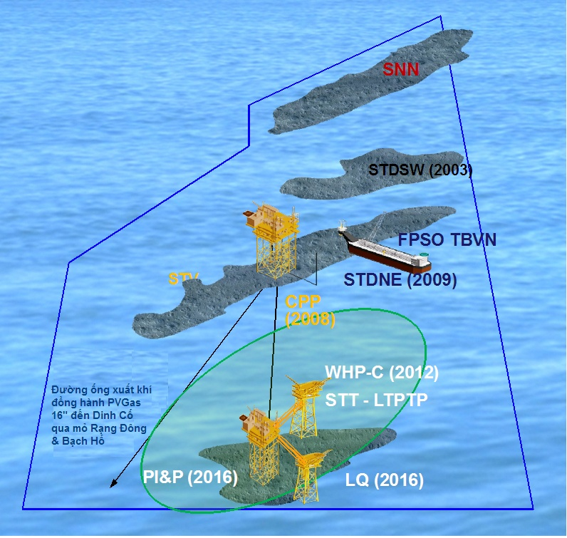

Figure 3.6 Location proposed for condensate/fuel oil spill modeling

* **Model simulating**

In order to compute drifting possibility of an assumed oil spill accident, CLJOC has cooperated with CPSE to use “OILMAP” software of USA.

* Software: OILMAP version 6.4, 2009
* Producer: Applied Science Associates, Inc. (ASA)
* Data for modeling: Online database system (EDS)

The online database system (EDS) made by ASA aims at serving for searching and responding to the accident of oil/chemicals spill and has been applied worldwide. ASA is an organization with 20 years of experiences on development and exploitation of environmental and geographic databases.

Input database of OILMAP includes:

* **Sea water temperature**: Data about average temperature of sea water is taken from database of Australian National Oceanography Center ([www.metoc.gov.au](http://www.metoc.gov.au)) and collected by seasons with lowest and highest temperature of 27oC and 30oC.

* **Current data:** Current data of STT field is taken from online database of USA Navy (NCOM). NCOM is developed at the Laboratory of USA Navy (NRL) and executed by Oceanography Office of USA Navy. In addition, real current data measured at STT field has been also referred for verifiable running in cases of oil spill at ST-PIP and pipeline transporting production stream from WHP-C to STV-CPP.
* **Wind data:** wind data is taken from database of National Center for Environment Prediction of USA (NCEP), provided by USA National Ocean amd Atmosphere Management Agency (NOAA)
* **Simulated location**: Simulated location for running oil spill modeling is presented in Figure 3.6 with corresponding co-ordinates in Table 3.56.
* **Modeling results:**

Main spreading direction of oil slick and affected area by chosen 3 scenarios at the Project area of ST-FFDP1 and pipeline transporting production stream from WHP-C to STV-CPP is summarized as follows:

1. ***Scenario 1: Blow-out of production well at ST-PIP***

According to Scenario 1, with being capable of quick evaporation in offshore environment , condensate only exists in a short time and does not cause any impact on coastal area. Seasonal detailed output is presented in Table 3.57.

Table 3.57 Summary of spreading direction and affected area following Scenario 1- Blow-out of production well at ST-PIP

| **Times** | **Spreading direction and affected area** |  |
| --- | --- | --- |
| North-East monsoon | Condensates move primarily toward southwest direction and possible longest distance of about 150km, but it doesn’t spread to any coastal place | NE-days.png |
| South-West monsoon | Condensates primarily move toward northeast and possible longest distance of about 140 km. Condensates may have possible drift close to coast of Phu Quy Island, but no risk of approaching the Phu Quy Island | SW-days.png |
| October (transition) | Condensates drift primarily toward southwest direction and possible longest distance of about 135km, but it doesn’t spread to any coastal area | 10-days.png |
| April (transition) | Spilled condensates will primarily drift toward North direction and a small part (<10%) of condensate will move toward northwest direction. Condensates will drift with longest distance of about 120km toward northwest direction and does not cause any impact on coastal area. | 4-days.png |

1. ***Scenario 2: Breakdown of pipeline transporting production stream from***

***WHP-C to STV-CPP***

According to Scenario 2, if this accident happens, condensate will be spilled over the sea. However, due to quick evaporation of condensate in offshore environment, condensate exists in the sea only for a short time and is no capable of spreading to the coastal area. Detailed results of seasonal propagation direction are summarized in Table 3.58.

Table 3.58 Summary of spreading direction and affected areas according to Scenario 2: Breakdown of pipeline transporting production stream from WHP-C to STV-CPP

| **Time** | **Spreading direction and affected areas** |
| --- | --- |
| Northeast monsoon | Condensate primarily spreads toward southwest direction with possible longest distance of about 110km and does not cause any impact on coastal area. |
| Southwest monsoon | Condensate primarily drifts toward northeast direction with possible longest drifting distance of about 95km. Condensate can be capable of drifting close to Phu Quy Island area but without approaching the island. |
| October (transition) | Condensate primarily drifts toward southwest direction with possible longest drifting distance of about 100km and doesn’t cause any impact on coastal areas. |
| April (transition) | Condensate primarily spreads toward North direction and a small part of spilled condensate (<10%) will moves toward northwest direction with possible longest drifting distance of about 80km and doesn’t cause any impact on coastal area. |

1. ***Scenario 3: Collision between supply vessels to provide Diesel oil for ST-PIP***

According to Scenario 3, if the event happens, spilled oil can cause impact on coastal area with probability in the range 43-97%. Spilled oil can spread to the shore in shortest time from 1-4 days, depending on monsoon season (Table 3.59), to cause impact on sensitive areas such as Phu Quy Island right after first day in months of July, August and September, Con Dao Island after 4 days of accident occurred in January and coastal areas of Mekong Delta in northeast monsoon season and coastal areas of central provinces in the southwest monsoon. Details of spreading ditrections and affected areas of spilled oil are presented in Table 3.59 and Table 3.60.

Table 3.59 Effect probability and shortest time of oil drifting to the shore according to Scenario 3: Collision between supply vessels to provide Diesel oil for ST-PIP

|  |  |  |  |
| --- | --- | --- | --- |
| **Time** | **Effect probability on coastal area (%)** | **Shortest time for oil to reach the shore (hour)(day)** | **Total oil volume spilled to the shore (ton)** |
| Northeast monsoon (November-March) | 60% | 92 (> 3 days) | 150 |
| Southwest monsoon (May-September) | 60% | 20 (< 1 day) | 320 |
| April (transition) | 97% | 101 (> 4 days) | 260 |
| October (transition) | 43% | 72 (> 2 days) | 200 |

Table 3.60 Summary of spreading direction and affected area according to Scenario 3- Collision between service vessels supplying Diesel for ST-PIP service vessels supplying Diesel for ST-PIP

| **Time** | **Spreading direction and affected areas** |  |
| --- | --- | --- |
| January | Oil primarily spreads toward Southwest direction and reaches Con Dao area after more than 4 days of accident occurred. Spilled oil can drift to shoreline area of the Mekong Delta provinces from Tra Vinh (after 5 days), Soc Trang (after 6 days) and Ca Mau (after 9 days). Spilled oil possible drifts toward Southwest direction with longest drifting distance about 780 km. | 1-days.png |
| February | Spilled oil primarily drifts toward Southwest direction with longest drifting distance about 500 km. Spilled oil can hit coastal areas of the Mekong Delta provinces from Ben Tre to Soc Trang (after 6 days) and from Bac Lieu to Ca Mau (after 9-10 days of accident occurred) | |
| March | Oil primarily drifts toward Southwest direction with longest drifting distance about 500 km. Spilled oil can spread to coastal area from Binh Thuan to Soc Trang (after 5-6 days) and from Bac Lieu to Ca Mau (8-9 days after accident occurred). | |
| April | Oil primarily drifts toward Southwest direction with longest drifting distance of about 350 km. Spilled oil can affect coastal areas of Binh Thuan (after 4 days), Vung Tau (after 4 days), HCM City and Tien Giang (after 7 days), Ben Tre (after 8 days), Tra Vinh (after 10 days) and Soc Trang (after 12 days after accident occurred). | |
| May | Oil primarily moves toward Northeast with longest drifting distance of about 800 km. Spilled oil can affect coastal areas of Binh Thuan (after 3 days), South of Ninh Thuan (after 8 days). A part of spilled oil can drift toward the coastal area of Ba Ria- Vung Tau after 9 days of accident occurred. . | |
| June | Oil primarily moves toward Northeast with longest drifting distance of about 1,100km. Spilled oil can affect shoreline area such as Cam Ranh Bay of Khanh Hoa (more than 4 days), south of Phu Yen (after 5 days) and Hoang Sa Archipelago (after more than 8 days). | |
| July | Oil primarily spreads toward Northeast with longest drifting distance of about 1,100 km. Spilled oil can affect shoreline areas such as Phu Quy Island (first day), Ninh Thuan (over 2 days), Cam Ranh Bay (over 3 days), south of Phu Yen (after more than 4 days) and Hoang Sa Archipelago (after more than 10 days). | 7-days.png |
| August | Oil primarily moves toward North direction with longest distance of about 860 days. Spilled oil can affect shoreline areas such as Phu Quy Island (first day), Binh Thuan (after 4th day), Ninh Thuan (over 4 days), Cam Ranh Bay (over 4 days). In addition, oil has ability to move to the area near the Hoang Sa Archipelago after 20 days of the incident. | |
| September | Oil primarily moves toward North direction with longest distance of about 800 km. Due to the effect of flow, oil will straight moves to the north Binh Thuan and Ninh Thuan after 3 days. In addition, oil has ability to affect shoreline areas such as Phu Quy Island (more than 1 day), Cam Ranh Bay (over 4 days), Phu Yen 11 days), Binh Dinh (10 days), Quang Ngai (over 17 days). Oil also has ability to move to the area near the Hoang Sa Archipelago after 20 days of the incident. | |
| October | Oil primarily drifts toward Southwest direction with longest distance of about 650 km. Spilled oil can affect Phu Quy Island after 2 days and Con Dao after more than 4 days occurring the accident. | |
| November | Oil primarily moves toward Southwest direction with longest distance of about 650 km. Oil can affect Phu Quy Island after 9 days. | |
| December | Oil primarily moves toward Southwest direction with longest distance of about 650 km. Spilled oil can affect Phu Quy Island after 3 days occurring accident. | |

Details of spreading directions and affected areas of above mentioned 3 scenarios are presented in **Appendix 4.**

* **Potential impacts of oil spill**

When oil enters the sea, it spreads out because of wind, current, waves and tides, as a slick on the surface, under the combined action of gravity and surface tension, until its thickness is reduced to 0.1-0.01 mm [26]. During the time of an oil slick spreading, there will be a natural reduction in size due to weathering processes, such as evaporation, biodegradation and natural dispersion by waves.

The impact of an offshore oil spill depends on the quantity and type of oil discharge, the prevailing meteorological and hydrological conditions, and the sensitivity of the receiving environment and the geographical location of the spill. Oil spill occurred in the sea area closed to the shore may cause severe environmental impacts because the oil spill can drift to the coastal areas where there are a great number of sensitive ecological zones and intensive economic activities.

For condensate spill incident of scenarios 1 and 2, spilled condensate will not cause impacts on coastal areas and islands due to quick evaporation capacity of condensate.

According to Scenario 3 of fuel oil spill incident, spilled oil has risk to spread most coastal areas from Nha Trang to Ca Mau Cape and islands depending on monsoon seasons. In the Northeast monsoon season, spilled oil will primarily moves toward Southwest direction and reach coastal areas of sprovinces in the south from Vung Tau to Ca Mau. Polluted oil has high risk to Marine Protection Area of Con Dao (MPA) after 4 days of incident occurring in January. This is what shoul be of particular concern if oil spills occur in the Northeast monsoon season (from November to March next year). The Con Dao Island is far away from the field and spilled oil should be certainly significantly dispersed before reaching the shoreline. In worst case, polluted oil has risk of reaching the Con Dao Island after 92 hours (> 3 days). Therefore, there would be enough time to deploy either measures diverting oil drift direction or offshore response measures to mitigate oil pollution and damages caused by this incident.

In the Southwest monsoon season (May to September), the Phu Quy Island is most at risk from shoreline oiling due to its proximity to the area of ST-PIP. Drifting time of oil to Phu Quy island is approximately 1-1.5 days after occurring oil spill incident. In this period, coastal area from Binh Thuan to Nha Trang is also at high risk of oil pollution caused by fuel oil spill incident.

The coastal areas from Vung Tau to Ca Mau and some island as Phu Quy and Con Dao contain marine resources, coral species (at Phu Quy), fishing grounds and human-use activities. These areas are also high tourism potential where there are many beautiful resorts and beaches. Thus, these resources and the local economy can be strongly affected if oil spill occurs.

***Potential effects on air quality***

A diesel fuel or crude oil spill would affect air quality in the vicinity of the oil slick by introducing volatile organic compounds through evaporation. The polluted wastes would not long exist due to rapid evaporation of volatile organic compounds in spilled oil. Evaporation is greatest within the first 24 hours. The extent and persistence of impacts would depend on the meteorological and oceanographic conditions at the time of incident.

***Potential effects on water quality***

Spilled diesel would form a slick on the water and temporarily increase hydrocarbon concentrations. Most crude oil components are not soluble in water and have densities higher than that of seawater while diesel contains hydrocarbons which have densities lighter than that of sea water and can dissolve in it. Therefore, the decomposition of diesel in water column will be faster than that of crude oil when both are drifted and weathered in marine environment.

***Potential Effects on Plankton***

Oil pollution may change directly various kinds of plankton due to the different sensitivities to oil of individual species, or indirectly by effects on groups of particular plankton organisms, which may subsequently affect other parts of the ecosystem. Some species show growth when they are exposed to oil, while other species will migrate away from the contaminated area.

Spilled oil will cause direct impacts on plankton in affected area. The impact may last for weeks, but in general, it will only be evident for several days. However, if using chemical dispersant, the impacts on plankton may be higher. The oil concentration in water less than 100μg/liter will not result in significant impact [18].

***Potential Effects on Fish and Larvae*** [25 & 26]

Experiments show that an oil concentration of 50-100mg/liter can cause an immediate mortality for fish. This is a very high concentration that only appears in limited areas as a result of a big oil spill accident.

Fish may not be killed by very low oil concentrations in water, which however can cause oil accumulation in the fish. In contrast to adult fish, eggs and larvae are easily vulnerable to the spilled oil. Experiments have shown that an oil concentration of 50μg/liter will cause vulnerability and deformation of fish eggs and larvae.

In addition, shrimp eggs and young shrimps that is very sensitive to crude oil, would suffer a high mortality. Aquaculture activities will be directly affected due to the severe shortage of larvae.

Near shore from Vung Tau to Ca Mau cape has a high density of fish eggs and larvae, especially Dat Mui area. Therefore, an oil spill drifting into this area, could severely affect the local economy and aquatic resources.

***Potential Effects on Corals*** *[25, 26]*

Corals are highly sensitive to sedimentation and contamination by oil and other toxic wastes, and because of their dependency on photosynthesis, they are susceptible to increased turbidity. In the Project area, there are existing many corals at Phu Quy Island, in offshore of Southeast Phan Thiet.

***Potential Effects on Sea Grasses***

Sea-grasses play an important role in marine biodiversity. They not only prevent sediment disturbances, but also serve as a food source for Dugong, supporting and habitat for young fish, shrimps, prawns, crabs and other creatures.

Oil spills can affect sea grasses in many ways. Toxic materials in the spilled oil are introduced into sediments, the water, and ultimately benthic living organisms. Oil can also block sunlight from reaching the plants. During oil weathering, heavy oil compositions sink and mix with sediment and can coat sea grasses. When these grasses are damaged or killed, organisms that depend upon them as a food source or for habitat are also adversely affected.

***Potential Effects on Sea Birds***

Oiled birds commonly experience hypothermia and/or the effects of ingested oil as a result of feather preening. Moreover, if oil touches bird’s eggs, hatching success can be much reduced. Evidence also suggests that oil pollution can have a direct effect on reproduction. It is therefore important to protect bird habitats. Should the oil spill occur in an area where many seabirds live in, the directed impact might be the possibility of a mass-death of seabirds and the undirected impact is due to decrease of food resource.

***Effects on Marine Mammals*** [26]

Whales rarely appear in the Eastern Vietnam Sea. Dolphins are sometimes found in the Bach Ho and Rong fields (the southern of Block 15-1). If spilled oil were to drift to shore, Otters living in the river mouths and mangroves would be affected. Oil may stick to them and obstruct their river mouths and mangroves would be affected. Oil may stick to them, obstruct their activities and cause poisoning. The indirect effect would be a decrease of their food resources.

***Impacts on Fishing Activities***

Fishing is a main activity of coastal provinces. From Binh Thuan to Ca Mau, main fishing grounds are focused on Vung Tau, Phan Thiet, Phu Quy Island, Con Dao, Cuu Long estuary, etc. In the Southeast Vietnam Sea from Vung Tau to Ca Mau, fishing activities operate all year round and focus on both offshore and coastal area from 20 nautical miles to the shore.

The impacts on coastal fishing grounds, fishing nets, floating tools and traps depend on the season that spill occurs and the location of oil spill incident. In oil spill with larger tier, the impacts on fishing activities may be very severely to extend to fishing activities along the coastal areas from Vung Tau to Ca Mau. All fishing activities may be stopped, or even if fishes are caught they seems oily smell and unusable.

The actual economic damages on fishing activities will be verified by field survey and economic investigation after oil spill incident.

***Potential Effects on Mangrove*** *[26]*

Like sea grasses, mangrove forests also play an important role in marine biodiversity. Mangroves not only protect coasts, but also serve as feeding sites and nurseries for fish, shrimps, crabs and other creatures.

Oil slicks enter mangrove forests when the tide is high, and deposited on the aerial roots and sediment surface as the tide recedes. This process commonly leads to a patchy distribution of the oil within the forests.

Mangroves can be killed by heavy or viscous oil that covers the trees’ breathing pores thereby causes lack of oxygen for subsurface roots. Mangroves can also be killed through the toxicity of substances in the oil, especially lighter aromatic compounds, which damage cell membranes in the subsurface roots. This in turn impairs the normal salt excretion process of plants, leading to increase of salt accumulation and inhibition plant’s growth.

The creatures living around or in the mangroves are affected in two ways. First, there may be heavy mortalities as a direct result of the oil. For example, oil may penetrate burrows in the sediments, killing crabs and worms, or coat mollusca on the sediment surface and aerial roots. Second, dead trees rot quickly, leading to loss of habitat for organisms living in the branches and canopy of the trees, and in the aerial root systems and then gradual their death.

Great spilled oil can seriously damage mangroves and their habitats and this damage is likely to be long term. Although the weather in the South Vietnam is conducive to rapid oil degradation, however, if spilled oil is buried in the mangrove system, it can persist in the fine mud and cause impacts for decades. Therefore, if spilled oil reach the coastal area, their impact will be considered as severe magnitude.

***Potential Effects on Aquaculture***

As mentioned in Section 2, floating fish cages are well developing in coastal provinces, especially Phu Quy, Vung Tau, etc. Many local people use natural and intensive aquaculture patterns for growing shrimp (tiger shrimp – Tom Su) and crabs in ponds inside salinity prevention dike system and mussel grounds along the shoreline from Binh Thuan to Ca Mau.

A caution should be taken into account that all above-mentioned aquacultural ponds and coastal grounds have high environmental sensitivities (low terrain, many estuaries and canals, alluvial grounds and mangroves running along the shoreline). Therefore, when oil spill incident happens, the aquacultural areas are always exposed to potential risk because aquaculture households don’t have any technique on prevention, protection and response to apply for.

Mussels are developed in mixture mud and clay beach. They are sensitive and easily affected at low tide by spilled oil persistent in the ground. Mussels cannot open mouth to eat, because their mouth is covered by oil.

Aquaculture is one of key economic sectors of the coastal provinces from Binh Thuan to Ca Mau. Aquaculture farming is very diverse such as extensive, intensive farming…. Besides, raising of caging fish on river and oysters, prawns, crabs on artificial ponds have been developed alongside the rivers and in the mangrove forest. Generally, aquaculture areas usually locate on estuaries and littorals polluted easily by oil spill.

Oil pollution can affect hundreds of thousands hectares of aquaculture and many of families. This damage not only causes immediate impact but also long-term impact on aqua cultural activities of coastal provinces from Binh Thuan to Ca Mau.

However, the probability of large spill from CLJOC’s operations seems very low. The project will be implemented in the most safety and efficient way, with all possibilities of incidents reduced as much as possible through mitigation and control measures. In reality, no spill incident has occurred while drilling the exploration, appraisal and development wells as well as production activities in Block 15-1. Furthermore, by having suitable equipment and oil spill contingency response plan, CLJOC will actively respond rapidly by available response equipment on platform to avoid as much as possible any oil leakage into marine environment. Therefore the actual risk of oil spill occurred in the STT field and effects on offshore sensitive areas are considered as small.

***Impacts on Tourist Activities***

There are many beautiful and famous beaches along shoreline from Nha Trang to Vung Tau. These beaches are very attractive places to tourists in the summer season.

Spilled oil drift to these beaches not only creates disordering scene and unsafe environment but also damages existent tranquility of the famous travel beaches. Although oil collecting responses will be taken immediately, a significant quantity of oil may penetrate into the sand and cause oil smell and rainbow-color films in the following days.

In the case of large fuel oil spill, entertainment activities at beaches will be almost stopped for days after the oil spill incident occurs. Oil spill not only damages the beauty of the tourist areas, but also causes significant economic losses for the tourism industries.

#### Potential impacts relate to gas leakage

Gas release can be caused by production process on platform or from the subsea pipeline system, flow lines or production risers due to well blow-out occurrence.

Gas leakage will make bubbles moving upward and diffusing into the water column. The hydrocarbon dissolves into the water column with very low concentration because bubbles only exist very short-term in the water column.

CLJOC will comply with the company’s maintenance and anti-corrosion process to ensure the pipeline integrity. So, the risk of gas release in offshore pipeline is insignificant.

Additionally, to promptly and effectively response to the incident, CLJOC also developed the Crisis Management and Emergency Response Plans which cover the gas leak to provide detailed guidance how to response with this incident.

#### Potential impacts related to dropped objects and materials

All project activities and particularly, the transportation of equipment, materials and wastes supporting to activities have always potential incident for objects and wastes dropped into the sea. Effects of this issue are predicted as follows:

* Effects on marine ecosystem: contaminated materials may interfere with activities of feeding and then reduce food sources (sea grass, algae) or directly impact on marine animals;
* Water pollution: decomposition of waste and degradable material leads to polluting seawater. Polluted water in turn affects directly or indirectly on ecosystem and human-being.
* Interference of fishing activities.

To deal with this, CLJOC and their contractors/sub-contractors have developed a procedure to deal with this incident (details in the emergency response plans). In case of dangerous materials falling into the sea, CLJOC will immediately report to the relevant authorities and take necessary actions/response measures. Hence, the environmental impacts of this incident are likely to be from negligible to minor.

#### Potential impacts relate to the structure corrosion

The equipment/facilities of project placed in offshore environment, therefore, could be corroded by external environment. The pipelines for transferring multiphase fluid mixture contain produced water, therefore, internal corrosion can be occurred. These corrosion processes have been controlled by several measures such as: equipping anticorrosion anodes and rust-resistant paint outside the structures; pumping chemicals of corrosive inhibition and launching pig while doing the hydro-testing.

The drilling contractor has had measures controlling corrosion of rig structures as well as complying with maintenance procedures of manufacturers.

In short, the facility structures of project will be insignificant failure from corrosion.

Table 3.61 Summary of Impacts of incidents

| **Aspect** | **Environmental Impact** | **Impact Quantitative System** | | | | | | | | |
| --- | --- | --- | --- | --- | --- | --- | --- | --- | --- | --- |
| M | S | R | F | L | C | P | SIG | Rank |
| Vessel & Helicopter operation | Interference with marine users | 1 | 1 | 1 | 1 | 1 | 2 | 2 | 15 | Minor |
| Solid waste transportation and management | Deterioration of seawater quality | 0 | 0 | 0 | 3 | 2 | 2 | 2 | 0 | No impact |
| Local Society and Economy (+) | 2 | 1 | 0 | 3 | 1 | 1 | 3 | 45 | Minor |
| Fuel Oil Spill | Impact on pelagic communities | 4 | 4 | 4 | 3 | 2 | 3 | 3 | 288 | Severe |
| Impact on coastal mangroves | 4 | 4 | 4 | 3 | 2 | 3 | 3 | 288 | Severe |
| Fishery | 3 | 3 | 2 | 3 | 2 | 3 | 3 | 192 | Significant |
| Tourism | 3 | 3 | 2 | 3 | 2 | 3 | 3 | 192 | Significant |
| Fire and Explosion | Deterioration of air quality | 2 | 1 | 0 | 2 | 2 | 3 | 3 | 48 | Minor |
| Impact on health and safety of man | 3 | 2 | 2 | 2 | 2 | 3 | 3 | 112 | Significant |
| Shipping Collision | Impact on health and safety of man | 3 | 2 | 2 | 2 | 2 | 3 | 3 | 112 | Significant |
| Impact of fuel spill | 3 | 2 | 3 | 2 | 2 | 3 | 3 | 128 | Significant |
| Dropped Objects/Debris | Deterioration of seawater quality | 1 | 1 | 1 | 2 | 2 | 2 | 1 | 30 | Minor |
| Impact on pelagic communities | 1 | 1 | 1 | 2 | 2 | 2 | 1 | 30 | Minor |

*Notes: (\*) The assessment is conducted for the worst scenario (largest oil spill)*

*(\*\*) Suppose that the incident probability is 2.*

### SOCIAL AND ECONOMIC IMPACTS

The operation of STT FFDP1 will bring positive impacts to the socio-economy through selling condensate and natural gas and gains of taxes. The ST-FFDP1 will use local services and industrial materials. Moreover, the project will bring higher incomes for its worker/staff and contribute profits to local budget. However, almost contractors and staffs are living at Vung Tau so that these impacts are only local character in Ba Ria - Vung Tau province.

On the other hand, the project activities also cause several impacts on socio-economic coastal areas as follows:

* ***Local community***

The STT FFDP1 will be undertaken offshore Southeast Vietnam Sea. Therefore, project’s activities would not cause any impact on coastal inhabitant communities.

The CLJOC base is mainly located in integrated base of PTSC SB at Vung Tau. This base is far away from residential area, thus, there is no significant impact on local inhabitants.

CLJOC’s Supply Base and PTSC base were also located on industrial yards far away from the residential area for which the EIA reports has been approved.

The processes of hazardous wastes transportation, treatment and disposal onshore can cause impacts on local inhabitants surrounding the area of wastes treatment and disposal. CLJOC will be responsible to frequently supervise contractor of transportation (PTSC Marine) and sub-contractors of waste treatment strictly according to procedure of wastes transportation and treatment which has been approved by authorized agency to minimize these impacts to local community.

* ***Local Economy***

The activities of STT FFDP1 are taken place in the sea area of Binh Thuan Province (offshore activities) and Ba Ria- Vung Tau (onshore base), thus causing impacts to local economy on fishery and tourism sections.

There will be a 500m exclusive safety zone surrounding each offshore facility of the ST-PIP, ST-PQ and WHP-C, where all fishing activities are strictly prohibited. However, the prohibited area is very small, thus its impact on Binh Thuan fishery is negligible.

The tourism service from coastal area from Nha Trang to Vung Tau has been rapidly developed with a large number of recreational beaches. If large oil spill accident occurred, spilled oil might reach to beaches and cause severe damages. However, there is small probability of oil spill, additionally CLJOC already prepared oil spill response plan to minimize the adverse affects so that the risk of oil spill on the coast is very small.

In general, CLJOC ensures that its operations will minimize the potential adverse impacts on local socio-economic condition during the implementation of the project.

Table 3.27 Summary of Impacts on local society and economy caused by STT FFDP1 activities (exception of accidental events)

|  |  |  |  |  |  |  |  |  |  |  |
| --- | --- | --- | --- | --- | --- | --- | --- | --- | --- | --- |
| **Aspect** | **Environmental Impact** | **Impact Quantitative System** | | | | | | | | |
| M | S | R | F | L | C | P | SIG | Rank |
| Socio-Economy | Labour distribution | 1 | 0 | 0 | 1 | 1 | 1 | 3 | 5 | Negligible |
| Cultural Conflict | 1 | 0 | 0 | 1 | 1 | 1 | 3 | 5 | Negligible |
| Industry (+) | 4 | 3 | 0 | 3 | 1 | 1 | 3 | 105 | Significant |

## DETAIL AND RELIABILITY OF ASSESSMENT METHODOLOGY

### Details of the EIA

Potential environmental aspect and impacts are identified and assessed in accordance with each phase of project. The assessment complies with detailed requirements of **Decree No.**18/2015/NĐ-CPdated 14/2/2015 **and Circular No.** 27/2015/TT-BTNMT dated 29/05/2015 of the Ministry of Natural Resources and Environment on “Guidance on making **Strategic Environmental Assessment, Environmental Impact Assessment and Environmental Protection Commitment” as follows:**

* Identify key environmental aspects arising from each phase of project and logistic support activities between the onshore and the offshore;
* Identify potential risks/accidents that may occur during project implementation;
* Predict dispersion ability of discharged drill cutting and discharged drilling fluid by drill cutting dispersion model “MUDMAP”;
* Predict oil drift ability from 3 scenarios of oil spill by oil spreading model “OILMAP”;
* Identity potential receptors;
* Quantify environmental impacts, and
* Assess effect levels on environment, society and economy

### Reliability of the environmental impact assessment

The reliability of the assessments is proven through:

* Comprehensiveness and reliability of the EIA methodology;
* Baseline environmental monitoring data are measured by CLJOC in the study area and the vicinity; use the repeat sampling method to reduce error;
* Updating existing environment data collected from related agencies of Binh Thuan and Ba Ria - Vung Tau provinces and Research Centers and Institutes;
* CLJOC’s experience in petroleum exploration and production activities;
* CLJOC's environmental management system is established and implemented in compliance with international standards with the contribution from its partners, especially, the HSE specialists; and
* CPSE has experiences in environmental impact assessment for offshore petroleum projects.

# MITIGATION, PREPAREDNESS & EMERGENCY RESPONSE MEASURES

## INTRODUCTION

The aim of this chapter is to provide mitigation, preparedness and emergency response measures, as well as the environmental practices and standards, which will be incorporated into the design and operational phases of Su Tu Trang Full Field Development Phase 1 Project (STT FFDP1 Project), strictly complying with applicable legal requirements and consistent with policy of Health, Safety and Environment from CLJOC to mitigate impacts identified for the project. The objectives of these mitigations are to:

* Reduce the volume of waste;
* Treat all wastes to meet the Vietnamese standards and other international standards before discharging;
* Reduce impacts that are not related to wastes such as physical disturbance, noise and vibration.

Mitigation measures are discussed in the following phases:

* Installation and commissioning phase
* Drilling phase
* Production phase
* Decommissioning phase

Impact mitigation measures are developed based on the best methods of integrating the project into the environment to offset short, medium and long-term environmental and social effects. Mitigation measures will be applied as appropriate to each Project phase including installation and commissioning, drilling, production and decommissioning phases. Specific actions including infrastructure and procedures will be defined to eliminate, reduce or correct negative impacts or improve positive impacts. Mitigation measures are vital for the environmental protection program. This environmental protection program will be an element of an overall HSE Management System that will be developed by CLJOC for different offshore field development projects in Block 15-1.

## MITIGATION MEASURES TO REDUCE AND PREVENT THE NEGATIVE IMPACTS OF PROJECT TO THE ENVIRONMENT

### INSTALLATION AND COMMISSIONING PHASE

The jacket, topside (including equipment) of the Su Tu Trang Injection Platform (ST PIP), Su Tu Trang Living Quarter (ST-LQ), Bridges to be linked ST-PIP to ST-QT and existing WHP-C will be constructed at the of PTSC M&C at PTSC BS Port in Vung Tau by PTSC M&C prior to towing to the offshore STT FFDP1 Project location for installing, hook up and commissioning. Modification of WHP-C will be conducted in site. Therefore, the mitigation measures for environmental impacts of the wastes generated during onshore construction shall be followed by the construction Contractor (PTSC M&C) mitigation measures mentioned in EIA report for PTSC SB. So, this item only calculates and proposes measures for shipping activities and offshore installation and commissioning activities.

The topside of ST-PIP and facilities on ST-LQ WHP will be mainly pre-commissioned on the shore before towing to site and assembled in place, so there will be minimum work requirements at offshore construction site, thereby ensuring minimal waste generation. Installation of the ST-PIP, ST-LQ and linked bridges will be undertaken in a short period (182 days) so that impacts on the surrounding environment are already minimized. Hence, mitigation measures will mainly focus on issues such as waste management, air emissions reduction, physical disturbance and restriction of the development to the defined project area.

All equipment and facilities of STT FFDP1 Project is designed to meet usual Vietnamese Standard and international industrial standards (API AISC, ASTM, AWS…). These equipment will be inspected and certificated by Vietnam’s registration agency according to requirement of Vietnam or international regulations. Constructions of ST-PIP, ST-LQ, WHP-C modification will be the connection of modern technology/equipment and subjective/objective controlling system to limit the probability of incident. Factors about safety, durability and stamina in sea environment also be calculated during designed process.

Besides, CLJOC already has expertise in developing oil fields at Block 15-1 area such as Su Tu Den, Su Tu Vang, Su Tu Vang Northeast, Su Tu Vang Southwest in particular Su Tu Trang Long Term Testing Production project. Therefore, during installation and commissioning phase of the STT FFDP1 Project, CLJOC will strictly manage and supervise the implementation of measures to minimize impacts to environment.

#### Mitigation Measures for Air Emissions

A.1 Select contractors that have experiences in installing oil field construction and have good machinery that consume little fuel to reduce air emission;

A.2 Service/tug boats and construction barges/vessels must follow regulations of Annex VI of MARPOL 73/78 about the Prevention of Air Pollution from Ships and other regulations of Vietnam (QCVN 26:2010/BGTVT - Rules for Marine Pollution Prevention Systems of Ships and QCVN 1:2009/BKHCN - Gasoline and diesel fuel);

A.3 Commissioning timing and procedures will be reviewed and followed to minimize venting during processes of commissioning and start-up;

A.4 Minimize the exhaust emissions from the generators and engines on the service boats and construction barges/vessels by reducing volume of fuel and reasonably controlling operation of boats and vessels during installation activities;

A.5 Carry out good ventilation for working areas that create dust and exhaust gas and supply individual protective facilities suitable for workers;

A.6 Cold venting during commissioning and process start-up will be minimized;

#### Mitigation Measures for Effluents

Offshore installation and commissioning activities will generate water, deck drainage and domestic wastewater. *STT FFDP1 Project will use the existing 3 phase pipeline to transfer the production stream form WHP-C to CPP, so that there will be no hydrotesting activities and no discharge of the hydrotesting waste water during installation of facilities the STT FFDP1 Project.* In order to mitigate impact of other effluents to sea environment, CLJOC will perform following mitigation measures:

B1. Select Contractors and sub-contractor have good environmental performance and be able to provide barges, tug barge, vessels to supporting the offshore installation of STT FFDP1 facilities that are equipped the waste water treatment system and pollution control certificates;

B2. CLJOC’s supervisors will cooperate with Personnel In Charge of the Contractors and sub-contractor to supervise implement mitigation measurements to ensure the barge and vessels operations meet the Vietnamese and international environmental legislation requirements and standards;

B3. Maximize onshore pre-commissioning of equipment;

**Oily deck drainage**

B5. Supporting barges, vessel and board reduce oily wastewater volume by limiting the use of oil detergent, solvent and lubricant, collecting spillage oil and other polluted material before cleaning floor and working area;

B6. Oily effluents generated from barges/vessels/boats will be treated on board, to ensure oil contents meeting within requirements of MARPOL 73/78, Annex I, Regulation 5/15 (the International Convention for the Prevention of Pollution from Ships) in order to prevent pollution caused by oil, sewage and waste discharge from the vessel. The CPI (Corrugated Plate Interceptor) equipment can be used for wastewater treatment before discharging to the environment;

B7. Barges/vessels/supply boats will regularly monitor the content of oil in wastewater according to regulations of rule 5/15 of Annex 1, MARPOL 73/78.

**Domestic Wastewaters**

B8. Domestic wastewater arising from construction barges/vessels and supply boats will be collected and treated to ensure that quality of discharging water always meets the requirement of MARPOL 73/78 Annex IV (the International Convention for the Prevention of Pollution from Ships);

B9. The domestic treatment system will be maintained and inspected regularly;

B10. Main content of domestic wastewater are organic materials that are easily biodegradable and good nutrient for microorganisms. Therefore, suitable treatment method for this type of wastewater is biological oxidation. The oxidation process will be performed by using aerobic bacteria that exists in form of activated sludge. During disturbing, this bacteria will contact with organic material and decompose them.

#### Mitigation measures for solid waste disposal

All solid waste arising from the barges/vessels supporting the facilities of STT FFD Phase installation will be managed according to regulations of Annex V of MARPOL 73/78, Vietnamese Regulations (Circular 36/2015/TT-BTNMT dated on June 30th, 2015 of MONRE about hazardous waste management, Decree 38/2015/NĐ-CP dated on April 24th, 2015 of government about solid waste and scrap management) and CLJOC’s waste management procedures. The Marine Construction Contractor will be responsible for collecting and treating the waste generated from the construction and installation of platform and infield flow-lines. In addition, CLJOC will supervise wastes handling and management of the construction contractor to ensure all wastes treatment to meet the Vietnamese regulation. Mitigation measures that will be implemented according to regulation of Vietnam by the construction and installation CLJOC’s Contactors are:

C1. Food wastes on tug barges, derrick barges, transportation barges and service vessels will be crushed to less than 25mm before discharging to the sea;

C2. Solid wastes on construction barges/vessels will be separated hazardous and non-hazardous wastes at source into different bins/skips with proper design to avoid spilling large articles from the platform to the sea;

C3. **Non –hazardous wastes** (papers, packings, domestic materials, etc.) are separated into defer groups (recycle, non-recycle) and stored in the separated bins and skips with label before transferring to a shore for treatment.

C4. **Hazardous waste** (oily wastes, oil and paint cans, container, residue paint, etc.)**:** Waste generators (PTSC M&C, CLJOC) are responsible for the followings:

* Hazardous wastes will be collected, segregated into groups, then stored in the suitable bins, skips with label according to Regulation of circular 36/2015/TT-BTNMT and CLJOC hazardous waste management procedures;
* Segregated hazardous wastes will be stored will be stored in hazardous waste bins/skips with proper label and then transported ashore for further treatment;
* The hazardous wastes will be manifested and inventoried before transporting ashore and transferring to the waste treatment and disposal contractors.

Beside solid waste management, the CLJOC’s Construction Contractors (PTSC M&C) will undertake the waste reduction measures including:

* Using equipment, material and chemical with sufficient quantity to reduce the residual waste;
* Reusing materials when possible;
* Preferring contractor that performs waste recycling and recovery measures.

C5. Beside solid waste management, the CLJOC’s Construction Contractors (PTSC M&C) will undertake the waste reduction measures including:

* Using equipment, material and chemical with sufficient quantity to reduce the residual waste;
* Reusing materials when possible;
* Preferring contractor that performs waste recycling and recovery measures.

C6. Any use of radioactive materials in the NDT testing shall comply with the provisions of radiation safety and Vietnamese Standards (TCVN 4397-87) and Regulation on Safe Transportation of Radioactive and Vietnamese Standards (TCVN 6867-2001), Regulation on Safety of Ionizing Radiation and CLJOC. Use of radioactive source for NDT testing shall be strictly controlled, stored in the specific container with clear lable and keep in isolated area with safety warning barriers. After using, the radiation resource will be transferred back to suppliers after completion ***(see item J2 to J5 page 4-18 for more detail procedures);***

#### Mitigation Measures for Physical Interactions and Fishing Activities

The following mitigation measures will be implemented to reduce physical interactions and impacts on fishing activities:

D1. Reducing seabed disturbance during construction phase:

* Prepare a good installation and hook up plan and close cooperate between the Contractor and CLJOC supervisors when the facilities being installed to avoid extend installation time;
* Notify to local authorities and marine users about transporting and installation schedule before transportation of the jackets and topsides of the ST-PIP and ST-LQ;
* Reasonably mooring or anchoring ships during constructing;

D2. Barge emergency procedures will also act to control potential interactions and will be implemented prior to sail-away;

D3. Notify and consult with related local authorities (e.g. Province People Committee, Department of Natural Resources and Environment (DONRE) and Department of Agriculture and Rural Development (DARD) of both Binh Thuan and Ba Ria-Vung Tau Provinces) as well as marine users (through the People Committee of coastal provinces, maritime notice) detailing precise location of offshore structures, subsea wells, infield pipelines of the Su Tu Trang FFD Field;

D4. Carry out timely communication and good liaison with the various fishing and maritime organizations to indicate the presence and duration of vessels participating in installation activities;

D5. Establish a restricted area for the working site and along the pipeline route and hide navy boats to manage and control the installation area as well as set up execution zone to allow fishing boats to enter in this working zone;

D6. Coordinate with local authority, frontier commander, maritime police, and other enforcement authorities to ensure marine security;

D7. Provide navigation and safety lighting to ensure that any shipping or recreational activities are able to clearly identify the presence of project’s construction activities;

### DRILLING PHASE

CLJOC will use PVD1 rig of PVD Drilling Company to drill 02 new production wells (ST-5P/ST-6P) of the STT FFDP1 Project. In this phase, a large volume of spent WBM drilling fluids and drill cuttings will be generated and as well as be treated by solid control system on the PVD 1 rig. The drilling rig also will be equipped pollution prevention systems and procedures complied with the MARPOL 73/78 as well as satisfied CLJOC’s requirements.

The selection of suitable drilling rig will ensure the CLJOC’s capacity for sound environmental management of drilling operations. In this project, CLJOC has already proposed some criteria for rig selection including:

* The drilling rig are equipped adequate safety systems such as blow out preventer, alarms and automated shutdown devices, which meet regulatory and industrial standards;
* Contractors shall set up safety operating procedures for all equipment on drilling rig which meet regulatory and industry standards of CLJOC and Vietnam including chemicals and waste management aspects, etc;
* The drilling rig is provided efficient solid control and mud circulation systems which maximize recycling of drilling fluids;
* The drilling rig must have adequate drainage (open and closed) system to collect and treat aqueous wastes and monitoring system to prevent overboard discharges of unpermitted effluents (e.g. oil, or chemical contaminated effluents, whole food scraps and sewage, etc.). The treatment equipment meets MARPOL standards and certificated by the relevant international organizations **(*attached Appendix 1 showing related certificates of PVD 1);***

CLJOC will apply special mitigation measures to reduce negative environmental impacts during drilling phase as described below.

#### Mitigation Measures for Air Emissions

1. Technical solutions:

* Using equipment and machines that have good combustion ability to reduce volume of air emission;
* Using high quality fuel in which content of sulfur is low (below 0.25%) to reduce volume of SO2 discharge into air;
* Halon will not be used for fire fighting and sub-contractors will be instructed on this subject;

1. Management solutions:

* The operation time of machinery and equipment on the rig is always recorded and maintained on time to ensure operation efficiency and minimize air emissions from diesel engines and generators;
* All relevant staff will be trained about engines operation knowledge before working;
* Setting up suitable working schedule and limiting the operation of many machines at the same time;

#### Measures to minimize the impact of Drilling Discharges

As planned both of WBM and SBM will be used to drill 02 development wells during implementation of the STT FFDP1 Project. Spent WBM, WBM cuttings and SBM drill cuttings discharges are main wastes generated from drilling operations. In concern of environmental issues, CLJOC and the relevant contractors will be performing the specific mitigation measures in order to control and minimize the impact of the drilling discharges on the environment.

F1. Use of efficient solid control system that includes VSM 300 Shale Shaker system (Figure 4.1), two high capacity Big Bowl Centrifuges (maximum processing capacity 757 Liter/minute and maximum centrifugal speed 4000 rpm) and Cuttings Vacuum Dryer Unit with treatment capacity of 8 tons/h. This system has enough capacity to treat the synthetic drill cuttings meet allowable limitation (9.5%) before discharging ***(volume of WBM and SBM have already calculated in table 3.26 and 3.27)***. The use of above effective systems will increase effective of the drilling fluid circuiting. Efficiency of this system was proven throughout of the drilling operations of STDSW/STDNE/STV/STT LTP wells. The synthetic based drilling fluid (SBF) on discharged cuttings (SOC) was significantly reduced from 9.5% in 2002 to 6.0% weight of cutting in 2014. For the STT Wells, the SOC were 5.9% weigh of cutting.

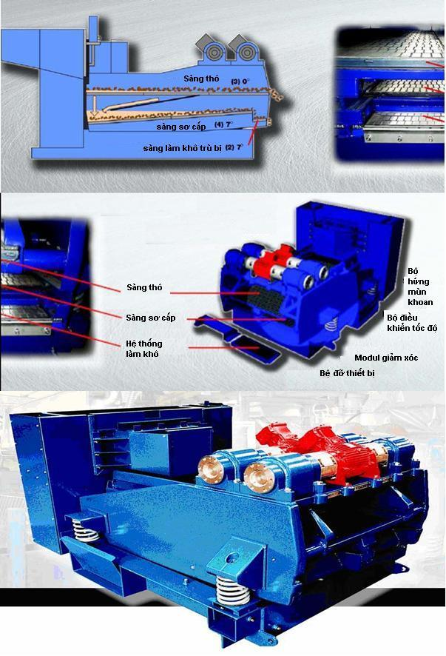

Figure 4.1 VSM 300 Shale Shakers System on Rig

The operating principle of the solid control system ***(Figure 4.2)*** is summarized below:

* Mixed SBM and cuttings from well hole flow to VSM 300 shakers system (Figure 4.1) for preliminary separation into drill cuttings and drilling mud. After preliminary separating, the drilling mud will be routed to settling tank to remove remaining solid before returning to mud pit for pumping back to the well hole. Periodically, fine cuttings from settling tank will be pumped to high capacity big bowl centrifuges to dry before discharging into sea. Drilling fluids recovered from centrifuges are reused by routing into drilling fluids storage tank;
* After preliminary treating at shale shaker wet cuttings fall from shale shaker onto a rotating screen, which draws SBM from the cuttings. Processed cuttings from the Vacuum Dryer ***(Figure 4.3)*** are discharged to the sea. Especially for SBM, the recovered SBM is removed back by vacuum sucking and then pumped to a decanting centrifuge to remove solids, then back to the Mud Pit;
* CLJOC ensures that above mentioned efficient solid control system on rig can treat the synthetic based drilling mud (SBM) on cuttings is less than or equal to allowable limitation (9.5% by weight) to comply with QCVN 36:2010/BTNMT - National Technical Regulation on discharge of drilling fluids and drilling cuttings for offshore oil and gas facilities;

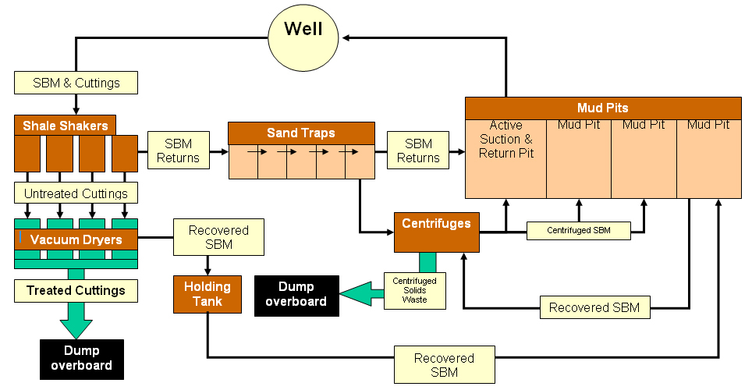

Figure 4.2 Diagram of solid control system operation

**Shale shaker**

**Rotary Screen**

**Cuttings fall from shale shaker to the Rotary Vacuum Dryer screen**

**High vacuum draws the liquids off the cuttings surface and SBM is returned to the tank**

**Processed cuttings are then discharged**

Figure 4.3 Simple concept of the rotary cutting vacuum dryer

After completing drilling campaign, spent WBM is allowed to discharge to the sea but spent SBM is kept in drilling fluid tank before transferring to ashore by supply vessel in order to transfer to the MI Vietnam supplier at Vung Tau where SBM are centrifuged to separate fine cuttings and recover SBM for using the next drilling campaign.

Besides, these following mitigation measures will also be implemented to reduce quantity of drilling fluids and cuttings:

F2. Conducting rig survey prior to drilling commencement to ensure the rig meets environmental standards;

F3. Chemicals which are selected for adding to the drilling fluids or for the well testing and clean-up will be low toxicity and high biodegradable; Minimize the total quantity of chemical utilization and discharge (Group E, D by the standards of OCNS);

F4. Careful calculation of cement quantity required for cementing jobs to avoid excess cement;

F5. In order to prevent drilling cuttings forming dunes near discharging point, CLJOC will use shaker with suitable pore size to ensure that particle size of cutting is not large enough to settling near discharging point (within 250m ring). In practice, SBM drilling cuttings (695 tons/ 2 wells) is not much and will be discharged in a short period of use of SBM for drilling 02 STT wells (10 -15 days/well). So, it is concluded that discharge of SBM drilling cuttings in short period and with strong current and sea water depth 56 m would not form pile on the discharge area. This conclusion is also proven through the results of distribution of cuttings and drilling mud model (Chapter 3- section 3.1.1.3 Impacts of drilling wastes), the greatest thickness of the cutting layer is 0.01m and 99.99% of the drilling cutting deposited in the range of 30m – 600m around the discharge point;

F6. Reducing volume of using and discharging chemicals and Enhancing cycling and reusing drilling fluids;

F7. During operation process, solid control systems (mud and cuttings handling systems) shall be frequently monitored and maintained (e.g. visual routine inspection of shale shaker screens) to reduce spillage of chemical and fluid;

F8. Cooperation with MI to manage the recovered spent SBM and separated SBM fine sludge at the MI yard to avoid leak SBM and sludge to environment. The SBM fine sludge will be stored in place that is designed meet the Vietnamese Standard. The SBM fine sludge shall be transferred to the Holcim for treating. Remain ashes will be used as material to product cement;

***For use of water based drilling mud (WBM)***

F9. Minimize WBM discharge by optimizing the useful life of drilling fluids by effective liquids/ solids separation, and wherever possible water based drilling fluid (WBM) will be recovered and recycled;

F10. WBM Cuttings and used/spent WBM (WBM are not recovered at the end of drilling phase) shall be discharged directly into the sea through discharge pipe above the sea surface in order to maximize dispersion and scatter of the cuttings;

***For use of Synthetic based drilling mud (SBM)***

To mitigate the potential impacts of SBM cutting discharged on the marine environment, the following efforts shall be conducted:

F11. Good procedures (check SBM line, valves, and carefully accounting chemicals, maintenance of equipment) for handling SBM will be in place and actively continue to follow, and if possible improve upon, the stringent self-imposed procedures and guidelines designed to eliminate and minimize the risk of accidental discharges of synthetic fluids. A proper bunkering procedure, lock out and tag out procedure for mud pit dump valves shall be in place and properly implemented;

F12. Spent SBM will be collected, transported to shore and then transferred to supplier (MI). The spent SBM will be stored in the tanks that are isolated by bundling system to prevent SBM spilling to the environment. The spent SBM will be re-cycled before returned to the rig for re-using in next drilling campaign;

F13. SBM cuttings shall be treated to meet the allowable discharge limit of MONRE before discharging (9.5% by weight of cuttings) of QCVN 36:2010/BTNMT - National Technical Regulation on discharge of drilling fluids and drilling cuttings for offshore oil and gas facilities;

F14. In conjunction with CPSE, CLJOC will continue to closely monitor and accurately report the weight percent of Synthetic retention on cuttings (SOC), by testing synthetic base fluid retention on shale shaker and centrifuge cuttings twice (2) daily during period of using synthetic based drilling fluid by Retort equipment in order to ensure that SBM on discharge cuttings is always less than 9.5%;

F15. The records of discharged synthetic on cuttings and analytical results of SBM on cuttings shall be maintained; the analytical results will be reported to CLJOC daily, quarterly and annually to PVN and Binh Thuan and Ba Ria-Vung Tau DONREs; and,

F16. A suitable comprehensive environmental monitoring program in the vicinity of WHP-C will be conducted to assess the status of impacts of synthetic based fluid cuttings discharge on the marine environment;

#### Mitigation measures for effluents

All kinds of wastewater arising during drilling phase will be collected and treated to meet the allowable standards before discharging.

* **Domestic wastewater**

G1. The PVD1 Rig is equipped with a sewage treatment system IMO MEPC 2(VI) by Hamworthy production in 2005 (Figure 4.4). The equipment has been examined and satisfactory tested in accordance with the International Maritime Organization Resolution MEPC2 (VI) to meet the operational requirements referred to in regulation 3(1)(a)(ii) of Annex IV of the International Convention for the Prevention of Pollution from Ships, 1973/1978;

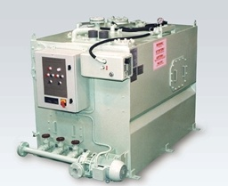

Figure 4.4 Domestic wastewater treatment system Hamworthy ST6A Super Trident IMO MEPC 2(VI)

G.2 Operating principle of IMO MEPC 2(VI) systems is aerobic oxidization, precipitation and disinfection before discharging. This system (Figure 4.5) has treatment capacity of 15m3/day meeting demand for domestic wastewater treatment of 120 people on rig using electric catalysis method. By this equipment, the wastewater can be effectively treated obtaining feacal coliform of 250 MPN/100ml and Total Suspended Solids (TSS) of 50 mg/l without impacts on environment;

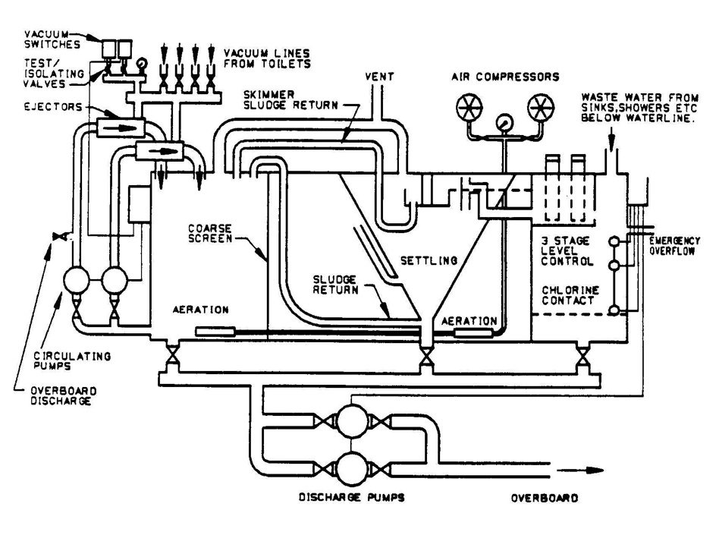

Figure 4.5 Diagram of domestic wastewater treatment system IMO MEPC 2(VI)

* Aeration compartment: Sewage enters this compartment via the soil inlets and a coarse screen before being thoroughly mixed and aerated by the aerators located at the bottom of the tank. The aerobic bacteria and microorganisms break down the organic waste material into mainly carbon dioxide, water and inert material and produce new bacteria cells and organisms. This mixture is displaced by incoming sewage into the settling compartment. Air, which provides the oxygen for the bacteria and microorganisms is supplied by a rotary compressor to the fine bubble aerators which are easily removable through the side or end of the tank for maintenance;
* Settling compartment: This section is designed to precipitate all solid material to the bottom of the hopper as activated sludge which is then returned by air lift back to the aeration compartment where it is mixed with the incoming raw sewage. The clear supernatant liquid is then displaced into the disinfection compartment via a flow through type disinfector. A combined surface skimmer and outlet weir is situated at the center of the settling compartment. This removes any floating debris from the surface of the settling compartment and controls the flow of supernatant into the disinfector;
* Disinfection compartment: This section allows time for the disinfectant absorbed by the effluent, to kill any remaining bacteria. The discharge of the resulting effluent is controlled by float switches connected to the discharge pump;
* **Oily water**

G3. PVD1 Rig is equipped a Hamworthy HS0.5-M Oily Water Separator by Hamworthy production in 2005 to IMO MEPC 107(49)treating the remaining oil content in wastewater lower than 15ppm in accordance with Annex 1 MARPOL 73/78 (***Figure 4.6).***



Figure 4.6 Oily water treatment system Hamworthy HS0.5-M

* HS-M equipment can directly draw oily water from ship’s bilges or a common collection tank. Treatment processing includes first stage and second stage, based on floatable sifting principle;
* First stage treatment: the HS-M equipment relies on buoyancy differential between water and oil to effect separation. To minimize the shear which the bilge water undergoes during transfer from sludge tank to the HS-M, the feed pump is mounted downstream of the first stage and draws bilge water in under vacuum. A strainer mounted upstream of the feed pump prevents ingress of solids. The first stage has two modes: Normal Running Mode and Bulk Oil Discharge Mode;
* In Normal Running Mode, valve AV1 opens when the feed pump runs and closes when the feed pump stops. Assuming the HS-M is initially full of clean water, as the bilge water enters the first stage, the reparation will occur: oil will float to the top of the upper chamber, displacing water. As the bilge water is drawn through the lower chamber, oil globules will coalescence on the oleophylic plates (oil sucking). As they increase in size, so their buoyancy increases and they will raise to upper chamber;
* The feed pump is controlled by the liquid level in the second stage emulsion tank, measured by transducer L1. On L1= E2 the feed pump stops. It starts again on L1=E3. On L1=E1, an alarm annunciates and the plants shuts down. The feed pump also responds to level in ship’s bilge water collection tank: stopping on low level (BLL) emergence and starting on high level (BHL) submergence;

In addition, following mitigation measures will be implemented to ensure that the drainage discharge meets the relevant legislation and regulations of Vietnam:

G4. All decks and wash-down areas on the rig will be secured by retaining walls to contain and direct water runoff to specific drainage collection areas and will be treated to meet current standards before discharging;

G5. A variety of absorbents and containers will be available on the rig to clean up small accumulations of oil, grease, solvents around decks and working areas;

G6. Accumulations of oil, grease and other contaminants will be collected and removed whenever possible prior to any washing down of decks and work areas;

G7. Use of degreasers, solvents and lubricants will be kept at minimum;

G8. Washed water will be directed to/through the on-board oily water separator prior to discharge over board;

G9. Discharged effluent samples will be regularly taken and tested to ensure the effluent water meet MARPOL73/38 Annex 1, Regulation 13b;

#### Mitigation Measures for Solid Waste Disposal

Solid wastes generated from the drilling operation will significantly contribute in among of all solid waste generated from the development process of STT FFDP Phase 1. Solid wastes generated from drilling activities will be collected, classified and treated following Vietnamese regulation (Circular 36/2015/TT-BTNMT - Rules on solid waste management) and other related international conventions (Annex V of MARPOL 73/78). To minimize the impact of solid waste disposal on environment, CLJOC, drilling contractor and relevant contractors will implement the following mitigation measures:

* **Waste Management Responsibility**

H1. Drilling Contractor is responsible for handling and treating their wastes to meet the relevant Vietnamese Waste Management Regulation and CLJOC Waste Management Procedures;

H2. CLJOC will sign the contact with the competency waste treatment Contractor and only accept the Sub-Contractor that will be able to treat the wastes meeting the Relevant Vietnamese Regulation on the Waste Management;

In order to treat solid wastes for all activities at Block 15-1 that include STT FFDP Phase 1, CLJOC has already signed triple contract with PetroVietnam Technical Service Supply Base (PTSC SB) and its sub-contractors (Holcim Vietnam Joint Venture Company, Viet Xanh Environment Company) for collecting, transferring, storing, and treating hazardous wastes (Appendix 3). PTSC SB also signs contract with Construction and Service Gia Linh Ltd Company to treat non-hazardous wastes of CLJOC. According to this contract, waste handling contractor (PTSC SB) and its sub-contractors (Holcim Vietnam Joint Venture Company, Viet Xanh Environment Company and Construction & Services Gia linh Ltd Company) will be responsible for transporting, treatment and disposal of hazardous wastes properly and in compliance with Vietnam legislative requirements. Besides, the waste handling contract of CLJOC also requires PTSC SB to closely supervise and regularly check/audit the wastes treatment of their sub-Contractors such as Holcim, Viet Xanh and Service Gia Linh Company to ensure the wastes treatment meets Vietnamese regulation (Circular 36/2015/TT-BTNMT - Rules on solid waste management).

Beside waste management measures, following specific waste handling measures will be implemented:

* **Treatment of Food wastes**

Drilling Jack up rig is equipped a food grinder as Hobart FP-300 (Figure 4.7) to grind food wastes to 25 mm particles size before discharging to the sea.

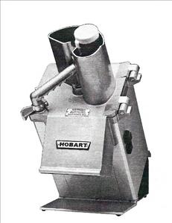

Figure 4.7 Typical Food Grinder HOBART FP-300

* **Treatment of other solid wastes**

Except for food waste, other solid wastes will be collected and stored on rig before transferred to the treating facility onshore (Figure 4.8).

H3. As much as possible wastes will be collected and segregated into distinctive waste streams: non-hazardous waste (recycle waste, general waste) and hazardous wastes (e.g. spent chemicals, chemical bags/sacks, industrial waste, batteries etc.) and stored in suitable bins and skips or containers with cover and appropriate label before transporting ashore for further treatment;

H4. The non- hazardous wastes will be labeled and stored on the skip or container appropriately for transporting ashore where disposal at landfill, or if possible reuse, recycling or recovery will take place;

H5. Hazardous wastes will be collected, classified, labeled and stored in different skips or container according to regulation of Circular No. 36/2015/TT-BTNMT. After being collected, these wastes will be stored at hazardous waste storage on-board;

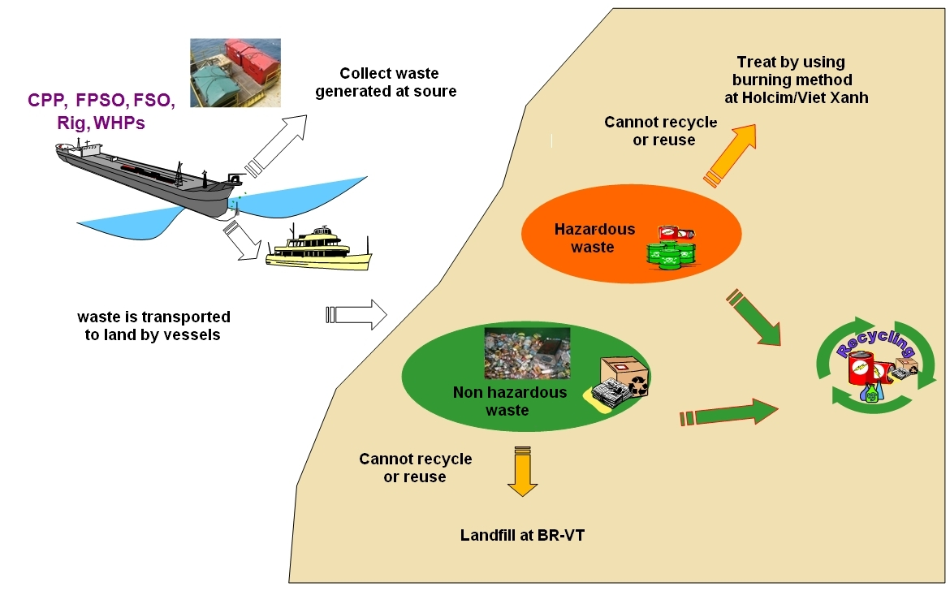

Figure 4.8 Solid Waste Collecting, Transferring and Treating Process

H6. Hazardous and used chemical wastes shall be clearly labeled and appropriately stored to prevent inappropriate disposal, accidental discharge or release, or mixing of incompatible liquid or solid chemical wastes;

H7. Hazardous wastes will be manifested correctly at the waste generation sources per legal requirements;

H8. All wastes generated from the drilling activities will be inventoried and waste log book will be maintained in place for convenient management;

H9. In order to ensure waste treatment process of contractor always meet all applicable regulations and CLJOC’s HSE policy, CLJOC will regularly conduct Contractor (including both PTSC SB and Sub-contractor Holcim, Viet Xanh) waste management audit and waste management inspection when necessary (CLJOC’s reserved right as defined in the contract);

H10. Personnel shall be appropriately trained to understand the nature and impacts of waste on the environment and their associated health and waste safety collecting and treating processes;

#### Measures to Control Physical Interactions

I1. Notification of the appropriate authorities prior to rig moving and positioning to prevent disruption to other marine users and reduce collision risk;

I2. Rig fitted with navigation lights that satisfy SOLAS safety standards;

I3. Continuous 24-hour monitoring of shipping traffic and fishing activity will be taken by the standby vessels;

I4. Establish a restricted area for the project site where fishing boats are not to enter. Strictly control local fishing boats nearby the safety area of the project facilities;

#### Storage and Usage of Radioactive Materials on the Rig

J1. Any use of Radioactive materials in the logging activities shall comply with the provisions of radiation safety from TCVN 4397-87 and Regulation on Safe Transportation of Radioactive - TCVN 6867-2001, Regulation on Safety of Ionizing Radiation. No radioactive waste generated. The radioactive materials are returned with the logging equipment to the logging contractor;

J2. Radioactive materials under unused status are stored in suitable protective receptacle and situated in a safe place reserved solely for such materials and far away from residential area;

J3. Control of hazards associated with potentially pyrophoric materials and safe disposal of radioactive materials;

J4. Strictly comply with all procedures related to use of radioactive materials (work permit and other procedures);

J5. In the event of dropping radioactive materials into well during the logging process, CLJOC, joined by relevant contractors, will implement possible action to recover dropped material. If radioactive materials could not be recovered, CLJOC will report to PVN and Vietnamese authorities administrating radioactive operations, to ask for guidance on well abandonment, as well as to apply all necessary actions to prevent the distribution of radioactive material to the ambient environment in line with authorities’ requests. In reality, such incident is very unlikely. In addition, in selecting contractor performing radioactive-related operations, CLJOC also requires contractors to utilize proper practices, to comply with procedures for preventing such incident, and to have emergency plan in place for response readiness;

### PRODUCTION PHASE

STT FFDP1 is a gas project. In production phase, environmental impacts mostly are caused of production process, air emission, discharge of produced water and collection, transportation and treatment of solid wastes. For air emission, about 50MMCFD of production gas will be injected to the 2 wells (ST-1P/ST-2P) and used as fuel gas and commercial purpose. So the air emission to atmosphere will be significantly reduced.

For wastewater, beside the installation of the production process equipment, STT- PIP, ST-LQ, WHP –C will be equipped wastewater treatment systems (open and closed drain system) and solid waste container. Wastewater treatment systems will be designed to treat wastewater to meet the allowable standard of MARPOL 73/78 Annex I and IV. Joined production stream of STT FFDP1 with very low produced water rate shall be routed to STV-CPP for treatment. STV - CPP is equipped the produced water treatment system with capacity of 130,000 barrels per day. The STV-CPP capacity will be enough to treat whole volume of produced water generating from existing oil and gas STV/STDNE/STVNE/ STVNE and STT FFDP1 fields (65,000 barrels/day) and STT FFDP1 Project produced water is very small (maximum about 1070 barrels per day) meet QCVN 35:2010/BTNMT – National Technical Regulation of Discharged Produced Water for Offshore Oil and Gas Facilities.

Detailing of all mitigation measures for production phase is detail described below:

#### Mitigation Measures for Air Emissions

The following mitigation measures shall be taken to reduce the air emission quantity.

K1. Minimize flaring production gas. From 2016 to 2024, estimation of 86.7 MMscf of treated gas will be injected to the wells ST-5P & St-6P per day. So during STT FFDP1 project estimated about 65% production gas is used as injection gas and fuel gas and about 35% production gas is used as exporting gas;

K2. Flare systems have been designed with super-sonic flaring tip to avoid gas loss and to give combustion efficiencies of greater than 99%. Glycol regeneration off-gas shall be routed to the low pressure flare;

K3. All engines, power generators will be maintained and operated under manufacturer’s standards to ensure operational efficiency;

K4. Minimize required pigging frequency through the implementation of adequate flow assurance measures, including increased pipeline insulation, favorable operating conditions, turndown provisions, etc.; Hydrates control philosophy will be developed in order to reduce the need to fully depressurize the infield pipeline system prior to start-up;

K5. Specify the use of high performance graphite valve or equivalent for reducing fugitive emissions; select soft and elastomeric valves or equivalent; minimize the number of flanged connections;

K6. All production and processing equipment will be daily monitored for leak detection and appropriate operating practices will be in place to minimize emissions;

K7. Isolators will be used to minimize the gas volume from equipment or lines to be blown-down for maintenance purposes;

K8. In order to prevent gas leakage from pipeline during routine activities, CLJOC will install a gas and smoke detector systems working 24 hours per day on WHP-C, ST-PIP, ST-LQ and STV - CPP. Further, helicopter and standby vessels will also support to monitor leakage through observing the sea surface (if bubbles appear). Moreover, CLJOC also controls regularly the input pressure of gas on the WHP – C, ST-PIP, STV - CPP and the output pressure at the end of gas pipeline;

K9. Halon, CFCs or HCFCs shall not be used; only products with zero ozone depletion potential and low global warming potential shall be used;

K10. Notify international maritime originations of about the specific location of the pipelines for updating the international nautical chart, and minimizing the anchoring of vessels in the project area;

K11. Iron frame is designated to cover tie-in module system of gas pipeline to isolate the valve and tie-in module system from fishing and maritime traffic activities;

#### Mitigation Measures for Effluents

* **Produced Water Treatment**

As mentioned in Section 1.4.3.1, Joined three (3) phase produced stream (gas, condensate and produced water of STT FFDP1) will be routed to STV - CPP via 12” pipeline of WHP-C for separating gas, condensate and produced water. After separating, combined produced water shall be routed to the produced water treatment system for meeting the allowable limitation before discharging to the sea.

The produced water treating system on STV - CPP includes two hydro cyclones and flotation cell, an online oil contact monitor. This system is produced by SIEMENS PTE Ltd. in 2007. This system is designed to process maximum 130,000 MBWPD which is sufficient for treatment of produced water of existing STVs/STTLPT fields and prospective STT FFDP1 Project. In reality, the produced water treatment system on STV - CPP for STV, STT LLP, STDNE, SVNE/SVSW Fields and STT FFDP1 Project are just used about 50% designed capacity (Table 4.1). This system can reduce the oil content in exploited water from 1,000 ppm down to less than 35ppm. This system was certified by MONRE in 2009 (***see Appendix* *1***).

Table 4.1 Designed capacity of produced water treatment system on STV - CPP before and after starting STT FFDP1 Project

|  |  |  |  |  |  |
| --- | --- | --- | --- | --- | --- |
| **Design items** | **Designed capacity (barrel/day)** | **Existing capacity in use (STV/STT /SDNE/SVNE/SVSW) prior to having STT FFDP1**  **(barrel/day)** | **Production Rate of STT FFDP1**  **(barrel/day)\*** | **Total used capacity after having STT FFDP1 (barrel/day)** | **% capacity will be in use compared to designed capacity** |
| Rate of production oil | 100,000 | 74,200 | 13,000 | 87,200 | 87.2 |
| Total volume of produced fluid | 175,000 | 126,920 | 19,452 | 146,372 | 83.6 |
| PW water treatment capacity | 130,000 | 65,000 | 1,070 | 65,070 | 50.8 |

*Note: Maximum of STT FFDP1 Project including STT LTP production rate (production profile Rev. October 2013*

Produced water treatment process on STV - CPP is summarized below:

L1. Produced water from the HP Production Separator on the STV- CPP is routed to the Production Hydro-cyclones for initial treating. The cyclones, which operate at an inlet pressure of 8.6 bar reduce the oil in water content of the produced water stream to approximately 75ppm. From the hydro-cyclones, the produced water will enter the Flotation Cell for final treating where the oil content will be reduced to less than 40ppm at outlet, which meets the regulatory standard of QCVN 35:2010/BTNMT – National Technical Regulation of Discharged Produced Water for Offshore Oil and Gas Facilities.

Treated produced water that met allowable limit (less than 40 ppm) will be discharged overboard and skimmed oil will flow to the Closed Drain Header before being returned to the main production process. The diagram of produced water treatment system is presented in ***Figure 4.9.***

To ensure that the STV - CPP Produced Water treatment system works efficiently and achieves a consistent allowable discharge limit (40ppm according to QCVN 35:2010/BTNMT – National Technical Regulation of Discharged Produced Water for Offshore Oil and Gas Facilities) the following mitigation measures will be implemented:

L2. The overboard stream will be monitored via online monitoring system for oil content;

L3. Manual treated produced water samples will be obtained periodically (4 times per day) and taken to the lab to check concentration of oil in water to ensure that the produced water is treated and meet allowable limitation (40ppm);

L4. Produced water after being treated is collected and analyzed at high technical laboratory onshore once every 3 months to promptly detect and adjust unusual situation (if any);

L5. The chemical with lowest OCNS category (E, D) or lowest Hazardous Quotient (Gold or Silver Brand) (e.g. chemicals have low toxicity and bioaccumulation and high biodegradability) will be considered to use for activities of STT FFDP Phase 1.

Figure 4.9 Produced Water Treatment Process on STV - CPP

* **Domestic Waste Water**

As mentioned above, WHP-C and ST-PIP was designed as an unmanned platform and installed in 2011. The ST-LQ shall be designed as the manned platform. During STT FFDP1, the all operations and maintenance on ST-PIP and WHP-C will be supported by 20 personnel attendance on ST-LQ. Thus, there is no domestic wastewater generating from ST-PIP and WHP-C. The man-power of STT FFDP1 will stay on the ST-LQ that is equipped the sewage treatment.

To minimize the impacts of domestic waste water, the following measures will be implemented.

M1. The ST-LQ will be equipped with a marine sewage treatment system. Due to EIA is prepared early stage of project, in this time equipment contract procurement is in progress so information on the sewage treatment system (Producer, equipment name) on the ST-LQ is not available. But this sewage treatment system will be designed to fulfill the requirements of IMO MARPOL (International Maritime Organization - the International Convention for the Prevention of Pollution from Ships) 73/78 Annex IV and USCG 33 CFR Part 159 for inspected vessels which specify discharge waste water from the sewage treatment plants. Besides, this sewage treatment plant is fully adapted with the Circular No. 22/2015/TT-BTNMT dated on 28/5/2015 about the regulations on environmental protection during using drilling muds, waste management and monitoring for offshore petroleum operations. The typical sewage treatment shown in the Figure 4.10.

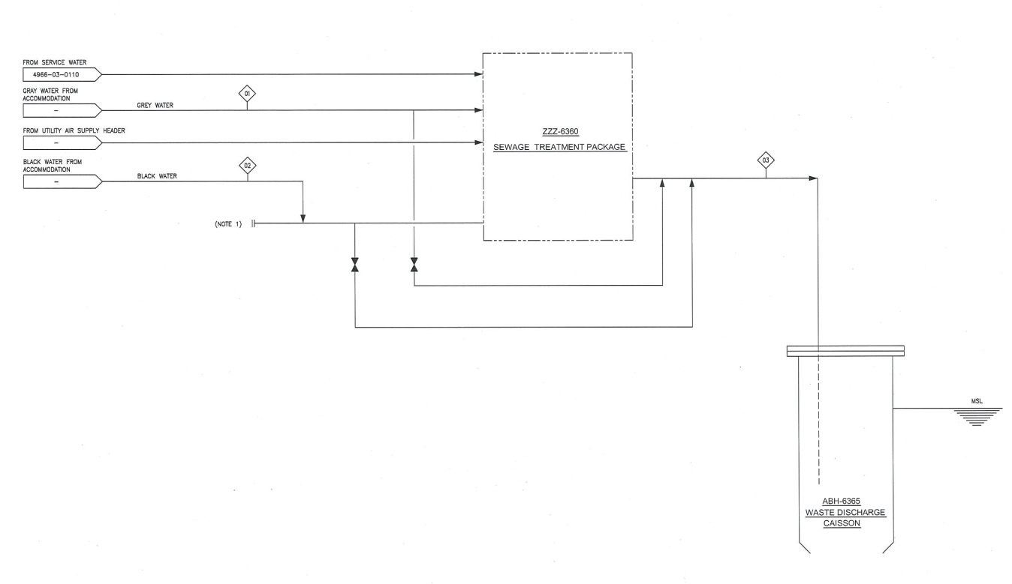

Figure 4.10 Process diagram of sewage treatment plant on ST-LQ

M.2 The sewage treatment plant on ST-LQ will be environmental friendly unit using biological treatment process. The aerobic process of the treatment plant’s bio-population convert organic substances existing in waste water to carbon dioxide and water without danger of methane gas production. All wastewaters, both black water (toilets, urinals, hospital) and grey water (galley, showers and sinks) can be treated in this plant. The treatment plan can operate in all vessels, which are sailing in salt, brackish or fresh water areas.

This system has treatment capacity of 20m3/day meeting demand for domestic wastewater treatment of 60 people on ST-LQ using electric catalysis method.

* **Drainage and Wastewater Discharges**

During the STT FFDP1 Project, drain wastewater will generate from operations of production facilities such as WHP-C and ST-PIP and ST-LQ. The WHP-C was provided the Open Drain System and Closed Drain System. Those systems were certified by MoNRE on 03 March 2014 (see attached document No. 333/TNMT in Appendix 1).

For ship’s floor water drainage, ST-PIP will be provided with appropriate drainage systems for pollution control of the wastewater as required by MARPOL 73/78 Annex I, which are:

***Closed Drain System*** *(see Chapter 1, Section 1.4.3.1, Figure 1.8a/1.8b)*

Closed drain system on ST-PIP consists of varies closed drain lines, deck sub header, main header, closed drain vessel with volume of 10 m3, two (2) closed drain transfer pumps with capacity of 5 m3/h.

Closed drain lines will collect wastewater from various sources such as hydrocarbon handling equipment piping during maintenance, inventory blow-down operator and from pressure relief. The Closed drain lines from various sources are routed to downstream isolation valve before joining the deck sub-header or main headers. Collected wastewater from closed headers are routed to the closed drain vessel in which liquid and flashed vapors in wastewater are separated. An electric heater is also provided at the vessel bottom to maintain the fluid temperature in vessel at around 65oC to avoid fluid gelling as well as formation of wax. Collected liquid (mainly oil) will be transferred to the production fluid stream pipeline by the closed drain transfer pumps. The wastewater drained from the closed drain vessel will be routed to the open drain tank for oil decanting before discharging.

***Hazardous Open Drain System (****see Chapter 1, Section 1.4.3.1 Figure 1.7a/1.7b)*

Hazardous Open Drain System is designed to collect the wastewater from the various processes, rainwater, desk water, utility equipment from open decks of the platform. There are 2 open drain headers, open drain tank with 34.8 m3 volume, design capacity 4 m3 and 2 open drain pumps with capacity 2 m3/h (one on duty, one standby). To prevent hazardous vapor from one to other decks and from hazardous area to other non-hazardous and hazardous areas, each collection header will be closed by a liquid seal arrangement.

Hazardous Open Drain Tank is designed to operate in atmospheric temperature and pressures. An electric heater (20 Kw) is provided at the bottom of the oil compartment on the open drain tank. The heater shall maintain the oil temperature 65oC to prevent fluid from gelling as well as prevent wax formation.

Wastewater from the all hazardous sources will be collected by the open drain headers will subsequently be routed to the open drain tank for recovery of hydrocarbon by gravity settling. The recovered hydrocarbon liquid in the open drain tank will be pumped to the closed drain vessel for recycle to the main process. Treated waste water (clean water) will be discharged to sea via open caisson with design 1600mm.

This system is active at all times and the heaters and pump will be automatically running on rising water level. If the level reaches the highest level of ST-PIP surface, the process shutdown will be initiated.

The diagrams of open drain systems are presented in the **Figure 1.9a/1.9b/1.10a/1.10b, Chapter 1**. Moreover, the CLJOC will implement following mitigation measures:

L1. Hazardous open drain system shall be designed (oil skim pumps is sized sufficiently to handle diesel spill) to prevent potential loading of open drain tank leading to diesel and oil spill to open drain caisson;

L2. Oily water from the machinery area and deck washing will be treated when passing through the open drain tank to reduce the oil content below 15 ppm before discharging to the sea (meet MARPOL Annex 1 and Circular 395/1998/QD-BKHCNMT - Regulations for Environmental Protection in Petroleum Search, Exploration, Field Development, Production, Storage, Transportation, Processing and Related Services).

Non Hazardous Open Drain:

The washing deck water and the rainy water at the non-hazardous areas will be routed through the non-hazardous open drain system to discharge into the sea without any treatment.

#### Mitigation Measures for Solid Waste

The ST-PIP will be designed to be manned, linked and supported by ST-LQ and WHP-C for operations and maintenance personnel attendance on the LQ when necessary. An amount of solid wastes generated from maintenance process of ST-PIP, ST-LQ and WHP – C will be collected and transported to ashore for further treating. CLJOC signed the Contract with PTSC-PTSC Marine to transport the waste generated from operations in Block 15-1 to a shore for treatment. In order to ensure handling and disposal of solid wastes, CLJOC has already signed a triple contract on solid waste treatment with PTSC - PTSC Supply Base and Holcim Vietnam Ltd. ***(see Contract No. CLJOC -2014-OPE-1607 dated 15 Dec. 2014 in Appendix 3)***. According to this contract, waste handling contractor (PTSC-PTSC SB) and its sub-contractors will be responsible for treating all waste generated during operation of CLJOC at Block 15-1 that includes waste from the operation of STT FFDP1 Project in compliance with Vietnam legislative requirements for the waste management and CLJOC waste management procedures.

CLJOC also has hazardous waste registration book that issued by DONRE’s Binh Thuan in 03 April 2013 **(see attached document in Appendix 3).**

Solid wastes on the CLJOC’s production facilities will be handled as follows:

* **Collecting, classifying and storing solid waste at the sources**

N1. Food waste on ST-LQ: including food scraps and rotten vegetation shall be macerated to less than 25mm in size prior to discharge to sea;

N2. Solid waste storing bin/skips are designed with cover and appropriately label according to requirements in Circular 36/2015/TT-BTNMT to prevent waste leakage to the environment.

N3. CLJOC applies color code for waste segregation. All wastes at the production facilities will be collected and segregated at the sources in accordance with color code system (recycled waste and non-hazardous general waste will be stored on Green bin/skip and Blue Bins/skips, Hazardous wastes will be stored on Red bin/skip, special hazardous waste such as medical waste, Hg waste, used batteries will be stored on yellow bins/skips);

N4. **Non-hazardous wastes: Non –hazardous wastes** with possibility of recycle and reuse including paper scraps, plastic bags, glass bottles wood… will be collected and stored in Green suitable bin/skip with proper label;

N5. General non-hazardous wastes (mixed domestic waste, kitchen wastes, un-recycle wastes) will be stored on the Blue bins/skips with proper label;

N6. **Hazardous wastes**: including cell, batteries, oily cloths and gloves, lubricant oil from machinery maintenance, damaged electronic components, chemical container, painting drum/can will be collected, segregated according Segregation Color Code System and stored on the proper bin/skips with cover and suitable label at the waste source to prevent leakage and mixing wastes during transportation and storage of wastes.

N7. As contract between CLJOC and PTSC-PTSC SB, all segregated solid waste will be transported to ashore by supply vessels of PTSC Marine for temporarily storing at PTSC Supply Base before transferring to PTSC Sub-contractors for treatment as follow as:

* Non-hazardous waste will be buried at permitted landfill area by the Construction and Service Gia Linh Ltd. Company (PTSC’s Sub- Contactor).
* Most Hazardous wastes will be transferred to Holcim’s factory at Hon Chong (Kien Giang) where they are burnt at very high temperature by using cementing kiln. Remained hazardous wastes (paint drum/container, spent chemical, Hg waste) will be transferred to Viet Xanh for specific treatment. PTSC SB has to closely supervise and regularly check/audit the wastes.

N8. Moreover, CLJOC will also audit and inspect the solid waste transportation and treatment implemented by contractors when necessary (CLJOC’s reserved right as defined in the contract) to ensure all applicable regulations and CLJOC’s requirements upon solid waste management are met.

* **Other Mitigation Measures**

Beside the implementation of all requirements of Vietnam’s law and other related international regulations, CLJOC will implement the following measures:

N9. Waste Management Procedure shall be in place. All wastes shall be handled treated, disposed in compliance with the CLJOC’s relevant procedures;

N10 All type of hazardous waste types will be registered and manifested at the waste sources (at facilities, ST-PIP, ST-LQ, WHP–C, STV - CPP, FPSO-TBVN, Rig and Vung Tau Base including SBM fine sludge generated from MI yard during spent SBM centrifugation..). Strictly follow procedures on documentation of hazardous wastes.

N11 The hazardous waste treatment contractors will be audited prior to signing contracts. The Project Owner ensure that all hazardous waste treatment contractors have operation permit meeting legislative requirements on treating wastes generated from project activities. CLJOC only uses the Contractor and Sub-contractor having waste treatment and transportation permits those were issued by appropriate authority and strong environmental commitment and complete waste treatment which will not pollute environment;

N12. Periodically report (every 6 months) to Department of natural resource and environment (DONRE) of Provinces about status of storing and transferring hazardous waste according to guidance of Circular 36/2015/TT-BTNMT.

N13. Provide appropriate waste handle and waste management training to the relevant staff to ensure they understand the nature and impacts of using chemical, collection and treatment of waste on the environment and their associated health and safety implications;

N14. Select chemicals and store in returnable/refillable containers that can be returned to suppliers wherever possible; material safety data sheets will be available; appropriate measures for storage, handling and disposal shall be strictly followed;

N15. A record book on wastes treatment and disposal shall be maintained and available for inspection.

#### Mitigation Measures of Noise to Labour Health

O1. Make sure the lighting conditions and ventilation in working areas meet the related standards of Vietnam;

O2. Provide appropriate noise barrier/insulation for the control of noise pollution equipment such as gas turbine and air compressor;

O3. Install noise and vibration sensors at zones with high noise and high vibration such as air compressor and turbines;

O4. Provide Personal Protection facilities including hearing protection for employees working in noisy areas. The use of hearing protection should be enforced when the equivalent sound level over eight hours reaches 85 (dBA)

O5. Develop a periodic Maintenance Plan for equipment to minimize noise and vibration;

O6. Perform medical hearing checks for workers exposed to high noise levels;

O7. Monitor the working environment in accordance with Vietnam Regulations.

#### Mitigation measures for impacts caused by ships activities during STT FFDP1 Project

A 500m safety zone will be maintained around the facilities (WHP-C, ST-PIP, ST-LQ, STV-CPP, drilling rig…) and no vessels are allowed to enter or anchor within the zone without the permission.

To reduce the risk of collision with vessels in the area, fisheries and shipping will be warned of the presence of facilities, pipelines by appropriate navigation marker lights.

During STT FFDP1 Project, the CLJOC will carry out following mitigation measures to all shipping and vessel serving for the project:

P1. Vietnam authorities, International Marine Users and Vietnamese Fishing organizations shall be notified of major marine movements and location of facilities;

P2. Surrounding offshore facilities of STT FFDP1 Project will have a safety zone, in which all fishing activities and merchant vessels are strictly prohibited. Appropriate navigational aids shall be operational at all times;

The vessel power generation shall comply with international good practice for NOx and SOx emissions; diesel fuel with low sulfur content (0.25 %) will be selected to reduce NOx and SOx emission. All reasonable measures shall be taken to ensure that temporary power generation has a high-energy efficiency and low fuel consumption;

P3. All chemical and liquid hydrocarbons (oil, diesel and aviation fuel tanks & drums other than hull storage’s for vessel propulsion) storage areas will be designed to prevent spillage of chemicals to marine waters. Chemical and hydrocarbon shall be storage on lower deck or on the main deck, providing the area is approved, in accordance with best practice regulations for flammable/hazardous materials and in areas where drainage is directed to a treatment/storage facility prior to discharge to environment ;

P4. Wastewater from drainage systems and machinery space will be routed to oil water separation system; the oil concentration of discharge will set at 15mg/l or less in accordance with MARPOL Annex 1 and Vietnamese Regulations for Environmental Protection in Petroleum Search, Exploration, Field Development, Production, Storage, Transportation, Processing and Related Services. Oily water discharges shall not be permitted within 12 nautical miles of the Vietnam coastline;

P5. All food waste will be macerated to < 25 mm prior to discharge;

P6. Disposal of solid wastes will be collected and treated in accordance with Regulations for Environmental Protection in Petroleum Search, Exploration, Field Development, Production, Storage, Transportation, Processing and Related Services and Rules for the Prevention of Maritime Pollution from Ships, Construction and Equipment from Ships;

P7. Solid waste disposal will be minimized by:

* Substitution (use a product that does not generate waste, specify packaging that minimizes waste);
* Recycle (use materials and components again wherever possible).

P8. Hazardous wastes will be segregated, treated and disposed in accordance with Circular No. 36/2015/TT-BTNMT that regulates on hazardous waste management and Regulations for Environmental Protection in Petroleum Search, Exploration, Field Development, Production, Storage, Transportation, Processing and Related Services and Rules for the Prevention of Maritime Pollution from Ships, Construction and Equipment from Ships.

### DECOMMISSIONING ACTIVITIES

In general, activities of phase decommissioning are similar to those of construction phase but follow the reverse process. So, mitigation measures for these stages are not much different. The procedures of decommissioning will comply with Decision No. 40/2007/QD-TTg, ratified on 21 March, 2007 by the Prime Minister regarding *“Decommissioning of fixed installations, equipment and facilities used for petroleum operations”*. This plan consists of procedure and environmental protection measures for decommissioning activities. The mitigation measures of this phase will include:

1. Establish proper decommissioning procedures;

2. Minimize decommissioning time;

3. Before and post-closure environmental monitoring will be conducted;

The decommission activities of STT FFDP Phase 1 is a part of the STT Full Field Decommission Plan which will be updated by CLJOC and resubmitted to MoIT for getting approval.

## PREVENTION MEASURES AND RESPONSE TO POTENTIAL RISK AND INCIDENTS

Throughout the life of the STT FFDP1 project, construction, drilling, production and decommissioning activities always have potentials about occupational accidents, environmental accidents that can affect to life, environment and property. Although probability of incidents is very low, damage might be serious if it happens. Therefore, incidents management and prevention is necessary, mitigation measures are proposed based on the following principles:

* Identifying and assessing risks and risks management based on implementation of hazard identification and operability (HAZID and HAZOP studies);
* Setting up operation procedures following safety standards;
* Eliminating high risk activities;
* In case risks cannot be eliminated:
* Reducing the probability of incidents;
* Limiting damages (if any) by using management and technical solutions;
* Development of the Emergency Contingency Plan;
* Development and implementation of the periodic maintenance programs;

The specific measures for each phase of the project are described below:

### INSTALLATION AND CONSTRUCTION PHASE

In order to control risk and prevent the incident during installation & construction phase of STT Phase 1 Project, CLJOC will implement following measures:

U1. Select contractors that have sufficient equipment and good experience and expert in the construction and installation of the facility in the offshore as well the good safety performance;

U2 Before starting installation of STT Phase 1 facilities in the offshore, CLJOC will inform Maritime Administration Department, Department of Natural Resources and Environment, Department of Agriculture and Rural Development, Department of Transportation, Department of Police and Frontier Board of Binh Thuan and Ba Ria - Vung Tau Province of the installation schedule and location of the facilities, etc.

U3. Area under installation and constructions will be zoned by buoy system and signal lights (at night) to limit ship collision;

U4. Strictly comply with construction procedures that have been proposed;

U5. In case having problem cause by anglers, local people or other bad element, CLJOC will perform following measures:

* Chartering border protection ship to chase these facilities and protect machinery and equipment under construction process;
* Strictly cooperate with the local authorities to quickly solve emergency situation caused by vandalism or prevention.
* %),In our ability, CLJOC will quickly review and expedite special cases when local people need to support about education or public welfare;

### DRILLING PHASE

U6. Notify to relevant Vietnamese authorities and local authorities of transporting and positioning rig to prevent influence to operation of other agencies and minimize risk collision;

U7. Rig will be equipped lighting system according to SOLAS safety standards;

U8. Arrange support vessels 24/24 in surrounding area of rig to monitor fishing activities and cargo ship crossing this area.

U9. Prevention of fire and explosion:

* Rig is equipped safety systems such as: valve system, anti-rusting device, leakage and fire detectors, auto-signal light, safety switching valve system, fire prevention and firefighting devices, emergency shutdown system … All devices operate automatically or are operated by controlling center;
* All staff on rig is trained about firefighting knowledge and usually practice periodically.
* Establish the emergency response plan for incidents and frequently maneuver.

U10. Prevention of oil blowout incidents:

During drilling phase, special interest is always given to controlling well to prevent blowout incidents. Following measures will be implemented to minimize and prevent blowout incident:

* Blowout prevention measures begin from well design activities: estimation of reservoir pressure, choosing the depth of casing base, selection of casing (grades, thickness, connector…). After that, selection of density of drilling fluid is to satisfy demand of controlling pressure in the wellbore;
* Setting up blowout preventor (BOP) system on PVD1 Rig:
* Blow Out Preventor (BOP) is used to control well, preventing blowout situation. This system can be closed rapidly in the event of an uncontrolled influx of formation fluids which allow the well to be circulated to safety by venting the gas at surface and routing oil so that it may be contained.
* Drilling techniques supervising system is always active to monitor the circulatory status, early detect oil intrusion, and prevent eruption.
* Rig always has strictly rules that details actions of each staff during well control process. Drilling team and related members usually practice well control operation periodically. Well control is always interesting problem during drilling phase.
* When well cannot be controlled, leading to blowout situation, the first thing must be done is evacuating all staff from the rig. After that, overcoming operation is implemented basing on emergency response process.

### PRODUCTION PHASES

U11. Prevention and reduction of incidents and occupational accidents:

* Ensure all lighting system on WHP – C, STT-PIP, ST-LQ , STV - CPP and FPSO-TBVN meeting the allowable standard of TCVN 3743-83 - lighting standards in the workplace;
* Provide sufficient and appropriate PPE for each employee;
* All employees will be trained and obtain HSE certificate before working in project area.

U12. Prevention of leakage and rupture of pipelines:

* Design and use good material suitable with marine water resistant to erosion for producing pipe
* Monitor the potential erosion to prevent or to protect the pipeline system structures;
* Regularly monitor the pipeline pressure to detect possible leakage;
* Combine the ship collision prevention methods, which are mentioned in Item U15 below.

U13. Prevention of fire and explosion incidents:

* Install safety valves in well holes (valve is located inside well bore and lie in appropriated deep below seabed), well head valve assemblies (valves that are installed on surface) and anti-spray system when finishing or repair well.
* Set up combination of automatic and manual fire alarm and firefighting systems on offshore facilities.
* Provide air ventilation system to prevent the backlog of explosive gases;
* Set up ventilation system to avoid accumulation of explosive gases;
* All fire systems (for example, firewater pumps or control room) are located in a safe area of the facility, protected from the fire by distance or by fire walls. If the system or item is located within a fire area, fire preventing and fighting measures will not be effective and unsafe;
* Develop and carry out the yearly maintenance program based on the recommendation of the manufacturer and international advising companies to ensure that all operation equipment is in good conditions;
* Accommodation areas are located far from operation area of machinery or at least protected by fire walls;
* Firefighting system is set up at automatically system operation area.

U14. Ensure safety in personnel transfer: Personnel transfer to and from offshore facilities is typically by helicopter or boat. Specific safety procedures for helicopter and vessel transport of personnel are described below:

* Helicopter deck (helideck) onboard offshore facilities is set up according to the requirements of the International Civil Aviation Organization (ICAO);
* Personnel transfer from ship to rig must be implemented under good weather conditions to avoid incidents or collision between ship and rig;
* If personnel is transferred from the boat to the facility by crane, only cranes, cables, and baskets certified for personnel transfer should be used.

U15. Ship collision incidents:

* WHP-C, ST-PIP, ST-LQ, STV - CPP and other facilities in Block 15-1 are equipped lighting system that meet the allowable standard of SOLAS;
* Arrange vessels in surrounding area of rig 24/24 to monitor fishing activities and cargo ship crossing this area;
* Cooperate with local government (People's Committee, Department of Natural Resources and Environment, Department of Agriculture and Rural Development ...) to perform communication and dissemination activities about exploitation activities of the project, location of project, permitted operation area around the project ...
* Implement precautionary shutdown procedures if a specific collision is recognized. Ensure surveillance of the 500m safety zone around the facilities (WHP – C, ST-PIP, ST-LQ, STV - CPP..), and equip vessels supporting STT FFDP1 Facilities , STV – CPP and FPSO-TBVN with navigational aids and lights;

**Other mitigation measures will be taken as follows:**

* Ensure that timely notice is given to the relevant authorities, mariners and relevant fishing organizations for non-routine events;
* Log, recover and report any fabric lost when practical.
* Review and update Oil Spill Contingency Plan (OSCP) and submit to PVN and National Committee of Search and Rescue (VINASARCOM) as regulated at Governmental Decision No. 02/2013/QĐ-TTg of Prime Minister and the Decision No. 63/2014/QĐ-TTg of Prime Minister ratified on 11 Nov. 2014 about the adjusting and supplementing some articles of Oil Spill Response Process which mentioned in the Decision No. 02/2013/QĐ-TTg;
* Develop and practice Emergency Response Plan (including oil spill contingency plan and oil and gas blowout response);
* Provide emergency training to relevant personnel (including exercised regularly about the emergency response plan).

### Decommissioning phase

In this STT FFDP1, safety issues should be paid more attention because after being use for long time, constructions and equipment would be degraded and may fail to ensure the safety for handling as in the beginning phase.

In order to absolutely ensure safety during decommissioning phase, beside similar measures to other phase, project owner will implement additional measures below:

* Assessing the status of all system to select appropriate measure for decommissioning process and ensure safety for workers;
* Contract with contractor that have experience in oil field decommissioning, request contractors equip labor protection for all employees;
* Transfer, collect all residual chemical and waste before implementing.

### Emergency response procedure

CLJOC’s HSE goals set for all offshore field development projects in Block 15-1 will be zero Lost Workday Case and zero incident of oil spill. During design and development, extensive measures such as well-engineered design works, simple operating programs, adequate equipment maintenance and adherence to proper operational procedures will be followed to reduce the risk of accidents. However, since accidents cannot be completely eliminated, emergency response actions for emergency situations must be considered and prepared.

CLJOC established a Emergency Management Plan Tier 2/3 Response, Offshore Emergency Response Plan and Offshore and Onshore Oil Spill Contingency Plans to outline procedures to respond to any foreseeable emergency, preventing or minimizing of any losses of people, environmental damage, property damage and the company’s reputation ensuring that prompt and suitable actions are taken. Those Plans covers for drilling, production, office, logistics and any business activities under CLJOC management.

The Emergency Management Plan Tier II/III and Offshore Emergency Response Plans will address the following:

1. Classification and determination of all potential accidents that could occur from operating STT FFDP1 Project;
2. Implementation steps of Emergency Management Plan

* Isolate all system and equipment;
* Mobilize the response force immediately on site;
* Communicate with emergency response and management center and other response organization;
* Emergency treatment and evacuation of victims.

1. Identification the role and responsibilities of organizations and personals in implementing the Emergency Management Plan and Offshore Emergency response plan:

* Developing the Emergency Response Procedures to assist personnel in responding effectively during any emergency, including the establishment of effective communication linkages between parties affected by, or who need to be informed of, any emergency. Emergency Response Action Procedures is compiled in detail and outlines the various procedures to be followed, in the event of any form of Emergency Offshore.
* Training and periodic drilling in “emergency response”, basic first aid and training courses in safety from accidents:
* Emergency Management Plan and Offshore Emergency Response will be evaluated and appraised on conformity by maneuver of emergency response. Such maneuver will not only prove whether procedures are appropriate, but also will improve the employees’ ability to effectively respond if a real emergency occurs. The extent and frequency of training will depend on involvement of each employee in emergency response. Training will include interaction with external personnel who will also be involved with emergency response.
* The Emergency Management Plan define responsibility and authority for handling and investigating the non-conformances, taking mitigation measures of any impacts and for initiating and completing corrective and preventive action. Any corrective or preventive action taken to eliminate the causes of actual and potential non-conformance shall be appropriate to the magnitude of problems and commensurate with the environmental impact encountered.

### Oil Spill Contingency Plans

The CLJOC Oil Spill Contingency Plan, which is a part of CLJOC Integrated Emergency Plans (but for specific oil spill incident), is summarized as below:

#### Purpose and Scope

Offshore Oil Spill Contingency Plan and Onshore Oil Spill Contingency Plan (OSCPs) have been developed to provide Offshore Emergency Commanding Team in offshore and Emergency Command Team in onshore with guidance and the information they need to respond to an oil spill incident in a safe, rapid and effective manner.

Offshore and Onshore Oil Spill Contingency Plans covers CLJOC onshore bases and all offshore facilities (STV - CPP, FPSO TBVN, PVD1 and WHPs, ST-PIP and ST-LQ) in Block 15-1. Those plans were developed based on the legal requirements for the petroleum activities (Petroleum Law, Environmental Protection Law of Vietnam) and comply with the Decree No. 02/2013/QĐ-TTg on the Responsibility to Response Oil Spill of Prime Minister and CLJOC HSE Policy. The Oil Spill Response Plan for Development, Drilling and Production in Block 15-1 were approved by VINASARCOM in the Decision No. 341/ QĐ-UB dated October 1, 2014 (see attached document in Appendix 1).

#### Tiered Response System

CLJOC has adopted the internationally recognized tiered response system to categories, assess the severity of an oil spill scenario, and respond appropriately. CLJOC’s tiered response system does not have the same spill tier as PVN or the nation. However, this system is consistent with tiered response system the mobilization of equipment resources on the spot and from Offshore Petroleum Technique Service Company (PVD offshore) (as provisions signed with CLJOC), response resources can be mobilized from the region, from Viet Nam and from international organizations.

This system is also consistent with definition of the responsibility to response oil Spill addressing in Decision No.02/2013/QĐ-TTG on the Responsibility to Response Oil Spill. Oil spill tier and responsibility on response coordination is presented in Table 4.2 and summary of oil spill response tier and cooperation responsibility based on regulations of CLJOC is presented in Figure 4.10.

Table 4.2 Tired Response Cooperation and Mobilization Resources

| **CLJOC oil spill response Tier (Ton)** | | **National response Tier** | **Leading Response** | **Response Cooperation and Mobilization Resource** |
| --- | --- | --- | --- | --- |
| Tier 1 | **< 20 tons** | **Unit level <500 tons** | CLJOC on site Incident Commander (OIM of facility) | * ***Unit Level*:** In event of oil spill less than 20 tons (oil spill arises from a disruption to the routine operations, typically resulting in small volumes of oil being spilled, within the confines of the facility and having a relatively minor impact). On-site resources (STV - CPP, TBVN), ST-PIP supplying vessel shall be capable of dealing with oil spill. |
| Tier 2 | **20 to 100 tons** | **Unit level <500 tons** | CLJOC’ Emergency Response Commanding Team (ECT) will direct the oil spill incident response | * ***Unit Level*:** Oil spill incident exceeds response capacity of equipment on site and continues increasing (spilled oil greater than 20 tones up to 500 tons), CLJOC will mobilize resources from PVD Offshore based on the contractual conditions signed between CLJOC & PVD Offshore * CLJOC will notify to PVN for consideration of support from PVN grass root resources |
| Tier 3 | **> 100 tons** | **(Unit level) <500 tons** | CLJOC’ Emergency Response Commanding Team (ECT) will direct |
| **Regional Level**  **500 to 1000 tons** | CLJOC’ Emergency Response Commanding Team (ECT) will direct to manage the oil spill incident response  Or combine with Provincial People Council (PPC) may take over command to response the oil spill and appoint the on-seen Incident Commander for shoreline response | * ***Regional Level:*** in the case of oil spill from 500 – 1000 tons, beside CLJOC’s resources, CLJOC will notify PVN and requires support of PVN grass root resources. * In event of oil spill incident over CLJOC’s capacity response resource (1000 tons escalation)/or the spilt oil drifted to the shoreline, and impacted sensitivities areas, CLJOC will notify Provincial People Council (PPC) to request support and mobilize the provincial resources and regional resources (NASOS). * CLJOC also requires the support of other resource such as OSRL, Singapore via Perenco |
| **National Level**  **> 1000 tons** | VINASACOM will directly coordinate the relevant organizations to response the oil spill  VINASACOM/  Prime Minster | * ***National Level:*** In the case of large oil spill occurs (>1000 tons), oil spill exceeds the regional response capability, PPC (where oil spill occurred) shall notify to VINASARCOM. Beside the Company resources (including the PVD Offshore, PVN Grass Root resources) and Regional resources (NASOS, provincial resources), VINASACOM shall mobilize other resources in Vietnam to response the spilt oil * In the case of the spill continues to grow in very lager scale or very severity (>2000 tons), extensive range of sensitivities is at risk and national response resources is insufficient to response effectively, VINASACOM will report to Prime Minister to consider and make decision for requesting international supports to response the oil spill. |

#### CLJOC Response Organization (RO)

1. **CLJOC *Tier 1 Incident Command Structure***

CLJOC maintains and trains an offshore Emergency Response Team (OST or ERT) who are capable of initiating an appropriate response to any emergency in the immediate vicinity of the operations in Block 15-1 (rigs, STV - CPP and ST-LQ/ ST-PIP/ WHP-C). On Site Team capability can be limited by resources, however at a minimum, response teams should be able to provide:

* Initial alarm, make notifications and direct immediate safe evacuation of personnel
* Basic first aid
* Basic fire fighting
* Initiation emergency shutdown of operating facilities
* Containment and recovery of small spills (<20 tons)

They will report to their OST Leader, who is assigned by the Offshore IC.

In event of oil spill occurred during the drilling operations, CLJOC is responsible for commanding the response activities and follow the Offshore and Onshore Response Plans. PVD and PIC on PVD1 Rig shall cooperate to CLJOC to response the incident under the CLJOC instruction an requirements.

The drilling rig PVD1 has a Simultaneous Operations Drilling and Productions Procedure (SIMOP), which contains procedures for notifying and informing the CLJOC Senior Drilling Supervisor (SDS). So, when the rig is on site and attached to platforms, the PVD1 Rig shall follow CLJOC notification procedures. If the oil spill incident occurred, the OIM of the PVD 1 Rig should immediately notify the SDS and coordinate with the SDS for actions. The SDS will notify the OIM of STV - CPP and discuss the response actions required. OIM/SDS shall inform the other facilities in Block 15-1 via the CLJOC’s representative on the rig (Drilling Supervisor), because the incident may cause danger to facilities nearby.

The diagram below will show organizational to command and control during mobilization of an oil spill incident tier I (Figure 4.13):

Oil spill Incident Area

**CLJOC-IMC**

**OSC (OIMs)**

PVD offshore

Other CLJOC Facilities

Unit Level

(< 20 – up to 500 tons

**CLJOC- CMC**

Perenco

OSRL

Other International Resources

PPC/ Local authorities (DoNRE)

(Preside over)

PVN Emergency Board

Provincial

Original resources

MoNRE/MOIT

P*V*N’ Grass Root Units (VSP…)

Other Operators

Figure 4.11 Oil Spill Response Cooperation Organization

National Committee of Search & Rescue (VINASARCOM)

Instruct/command

National Steering Board of Flood & Storm Control

Other Ministries & Government Organizations

Prime Minister

**International Oil Spill Response Organizations**

Instruction line

Liaison, notification & report line

National Level > 1000 tons

Regional Level 500 – 1000 Tons



Figure 4.124 Tier 1 Command and Control

1. ***CLJOC Tier 2/3 Incident Command Structure***

If the oil spill incident is exceeded the capacity of the Tier 1 then the Offshore IC will handover command and control to the Onshore Incident Commander (IC) or DM. Onshore Incident Commander (IC) or DM (the DM may become the Onshore IC) shall make all the necessary mobilizations to response the oil spill incident. The Onshore IC will decide upon response strategies or if they have already been implemented, they will evaluate their effectiveness.

1. ***Alert/Notification Procedures***

All oil spill incident at any of the project’s facilities would trigger both internal and external notification procedures.

***Offshore notification and Key Actions***

Offshore, the OIM will notify the OST and the rest of the personnel at the facility by sounding an alarm and passing information via the radio. The OST will muster upon hearing this alarm and await instructions from the OST Leader.

The rig has a simultaneous operations drilling and productions procedure (SIMOP) which contains procedures for notifying and informing the CLJOC Senior Drilling Supervisor (SDS) of an oil spill. The OIM should immediately notify the SDS and wait for actions. The SDS will notify the affected platform’s OIM and discuss the response actions required.

OIM of facility (the Offshore IC) shall notify to Operations Manager and Onshore DM of any oil spill. The onshore DM will make the necessary notifications to the authorities, as required.

***Notifications and Reporting Tier 2/3***

In event of oil spill from tier 2, Onshore Incident Commander (IC) or On Duty Manager (DM) will ask Deputy Incident Commander to activate the on duty members of the Emergency Commanding Team (ECT). This will be conducted by the following message:

**EMERGENCY – REPORT TO THE ECR, THIS IS NOT A DRILL**

Once the whole ECT has arrived at the ECR, they will receive a brief from the DM.

The following notifications will need to be made by the IC, or their delegate:

**Tier 1**

**Tier 2**

**Tier 3**





Figure 4.135 Tier 2 and Tier 3 Notifications

1. ***Reporting process***

***Internal Reporting for CLJOC***

Any oil spill incident shall be reported to CLJOC Representative (OIMs on the ST-LQ and ST-PIP, FPSO-TBVN, STV - CPP, SDR on PVD1 rig, VT Base Superintendent). The commander of facility with spill incident shall report the spill to the Operations Manager within 24 hours of the incident occurring.

The following oil spills require a written report within 24 hours to the General Manager:

* Oil, oily waste, SBM or product releases from primary containment greater than 100 barrels
* Category A- greater than 100 barrels
* Category B- 10-100 barrels
* Category C- <10 barrels

**External *Reporting for management agencies***

In the event an oil spill occurs, CLJOC shall report the incident to the relevant authorities (PVN, MONRE) per legal requirements. A report shall be submitted that is not subjective, but simply describes the spill scenario. It shall not include how the incident occurred or who is responsible, as this report can be used in a court of law. The oil incidents shall be reported as follow as:

* The event of oil spill less than 2 tons: Report PVN within 24 hours
* The event of oil spill less than 2 tons: Report PVN immediately. Detail written report shall be submitted to PVN and local authorities within 15 days.

1. ***Response Facilities and Equipment***

Oil spill equipment for responding Tier 1 (<20 tons) oil spill are provided on facilities in Block 15-1 (ST-PIP, Rig, STV - CPP, FPSO -TBVN). CLJOC has already signed agreement with PVD Offshore Services Company Ltd. in which PVD Offshore will stand by 24/7 provide oil spill combating equipment and personnel to response any oil spill incident. In case of oil spill exceeds the response capacity of CLJOC and PVD Offshore, CLJOC can mobilize the oil spill response resources of PVN grass root via PVN and provincial and regional resources (NASOS) via People Councils of provinces (Binh Thuan/or BR-VT) and from the Oil Spill Response in Singapore via Perenco. List of chemicals and response equipment for Tier 1 on production platform and supply boats are as follows:

* Oil super dispersant 25 - 5 drums - 1000Litter.
* Oil spill prevention kits on ST-PIP & STV - CPP: 8 sets (See detail list in Appendix 3).

In addition, CLJOC had signed contract with PVD Offshore for Oil Spill Response Services in order to mobilize response equipment and materials of Tier 2 which is attached in Appendix 3.

1. ***Response Strategies***

 Based on the result of oil spill ricks assessment, CLJOC identify the response strategies for offshore oil spill incidents:

***Offshore Response Strategies***

**Spill oil Tier 1**

**< 20 tons**

Spill Observer

Control Room

Offshore Installation Manager (On-Scene Commander – OSC)

Alert Control Room

Log information – injuries, hazards, location, quantity, type of oil, cause of spill,etc.

Alert IC on duty in Offshore

Initial oil size and tier level assessment

Transmit Oil Report Form

Mobilize Offshore strike Team

Deploy equipment as required

Onshore IC on duty

Alert IMT

Alert Tier 2 or Tier 3 provider for advice and assistance

Allocate tier level using information form the oil spill report form in communication with On-Scene Commander

Alert PVN who inform D necessary authorities

Mobilize IMT for Tier 2 or Tier 3

If out of IMT’s control than CMC is formed with supports from PVN and Perenco

Tier 1

**Tier 2**

**Tier 3**

1 - 2

2-3

Alert OIM – become On-Scene Commander

Alert ERT and Offshore Strike Team and select a Leader

Figure 4.146 CLJOC Tier 1 Response decision flow chart

The Tier 1 response strategies available to the Offshore Strike Team are:

* Site Safety
* Monitor and Evaluate
* Physical Break Up
* Containment and Recovery
* Deck Spill Kits
* Chemical Dispersant Application
* Deploy equipment to deflect oil slick and protect sensitive area;
* Perform shoreline cleaning operation;

Waste collecting and treating management plan. Offshore incident commander must perform the initial steps of Figure 4.16.

***Response Strategies for tier 2/3 – (onshore IC)***

Offshore IC must perform initial steps of Figure 4.16 if spilled oil may reach shoreline or level of oil spill is considered up to tier 2 or 3, onshore IC will take command and perform response process base on this diagram. Beside, onshore IC can refer Offshore oil Spill Response Plan for information about offshore oil spill response strategies have been applied.

After having defined probable spill scenarios and considered the likely behavior of the spilt oil and the resources under threat, consideration should be given to viable response strategies.

It is important for the Onshore IC to be aware of the response strategies that have already been implemented offshore as these can affect the track, volume and shoreline response strategies that can be selected. For further information the Offshore OSCP should be referred to. The response strategies available to the Onshore Response Teams for Tier 2 or 3 spills are as follows:

* Monitor and evaluate;
* Chemical dispersant application;
* In situ burning;
* Shoreline protection and deflection;
* Shoreline containment and recovery;
* Near-shore containment and recovery.

Due to Block 15-1 located offshore, the first line of response is an offshore strategy. However, CLJOC should be prepared for the oil reaching the Vietnamese coastline.

Note: oil spill incidents are different to each other, so all response approaches should be planned and practiced to ensure each member of response team can response with any situation.

Monitoring and evaluation of drifted direction and volume of spilled oil can be based on actual information (volume of oil spills, sea conditions, wind, currents) or oil spill model to predict the drift direction of oil slick.

* Consider using dispersant or not;
* Consider in situ burning plan;
* Deploying equipment, deflecting, enclosing and collecting the spilled oil.

***Near shore response strategies***



Figure 4.157 CLJOC Tier 2/3 Response decision flow chart

***Dispersant Application***

One of the most important strategies in oil spill response is the use of chemical dispersant to improve the process of natural dispersion. Dispersant break down the oil in small droplets which are suspended in the water column, this greatly increases the surface area of the spill and allows the process of bio-degradation of the oil to proceed rapidly. This layer of dispersed oil is generally in the upper 5m of the water column, where natural aerial spreading is easy and very beneficial.

At present, supporting vessels of CLJOC always store Super-dispersant 25 in drums, which was approved by MONRE *(See* ***MSDS of Super dispersant 25*** *in Appendix 2)*.

Use of dispersant shall comply with Decree No. 02/2013/QĐ-TTg dated 14 January 2013 - Regulation for Response Oil Spill Incidents.

|  |
| --- |
| A decision to use of dispersants or not should be based upon weather condition, analyzing of sensitive factors in this area and also the actual benefits of using dispersant |
| Only use the dispersants that were approved by MoNRE and comply with the MoNRE requirements |
| not should be based upon weather condition, analyzing of sensitive factors in this area and also the actual benefits of using dispersant (mouth of driver and the area have depth water less than 20 m or far from coastal line 1 Nautical mile) |

Leader of emergency response board will decide to use dispersant based on the consultant and coordination with OST.



Figure 4.168 Dispersant decision making process

## METHODS AND ORGANIZATION OF IMPLEMENTING THE ENVIRONMENTAL PROTECTION FACILITIES

| **Phase** | **Activities** | **Impacts** | **Environmental protection facilities** | **Budget for environmental protection facilities** | **Responsibility of conducting environmental protection facilities** |
| --- | --- | --- | --- | --- | --- |
| Installation and commission | Operation of barges, vessels for transporting and installing the platforms and the pipelines | Generate the emissions: CO2, CO, NOx, SO2, CH4 and VOC. | Equip no more emission treatment facilities | - | - |
|  |  | Generate the waste waters:   * Rainy water; * Sewage; * Oily water. | Barges and vessels were equipped the sewage treatment systems and oily water separators on board. | In the installation expenditure: 7645.4 billion VND (355.6 million USD) | Construction contractor |
|  |  | Generate the solid wastes: food wastes, hazardous and non-hazardous wastes. | No treatment facilities on-board.  All solid wastes will be collected, segregated and transported to onshore for treatment. | In the installation expenditure: 7645.4 billion VND (355.6 million USD) | Construction contractor |
| Drilling | * Operation of power generator; * Operation of vessels/ helicopter’s engines; * Gas flaring during well testing/ well completion | Generate the emissions: CO2, CO, NOx, SO2, CH4 and VOC. | Equip no more emission treatment facilities | - | - |
|  | * Drilling; * well completion; * Casing. | WBM and SBM cuttings | Equip the cutting vacuum dryer on the drilling rig | 8.57 billion VND/ 2 wells (~398,575 USD)/  150 days | Drilling contractor |
|  | Use environmental friendly SBM Neoflo 1-58 for drilling activities | 7.5 billion VND/02 wells (~348,872 USD) | Drilling contractor |
|  | * Operation of workers on the drilling rig | Generate sewage | Equipped ST6A Super Trident Sewage Treatment Unit on rig | In the rig hiring expenditure:  8.57 billion VND/2 wells (398,573 USD/150 days) | Drilling contractor |
|  | * Rainy water/ washing water at the machinery compartment | Generate the oily water | Equipped the oily water separator on rig (Hamworth HS0.5-M Oily Water Separator) | In the rig hiring expenditure:  8.57 billion VND/2 wells (398,573 USD/150 days) | Drilling contractor |
|  | * Operation of workers in rig; * Equipment maintenance | Generate the solid wastes:   * Food waste; * Galley wastes and office wastes (used paper, plastic, cans, glasses, wool, rubber, etc.). | Food wastes will be grinded by the FP-300 food grinder on the rig.  All solid wastes will be collected, segregated and transported to onshore for treatment. | In the rig hiring expenditure:  8.57 billion VND/2 wells (398,573 USD/150 days) | Drilling contractor |
| Production | * Flaring system; * Gas venting from open and close venting system in case of emergency. * Fuel gas exhaust of generators and engines on ST-PIP/ ST-LQ & WHP-C; | Generate the emissions: CO2, CO, NOx, SO2, CH4, H2S and VOC. | Equip the high efficient flaring system, gas fuel system and gas injection system on platform to enhance the oil recovery rate, minimize the flaring duration, and can flare completely flaring if needed. | CAPEX of flaring system, gas fuel system of this STT FFDP1 project is 45.2 billion VND (~ 2.2 million USD)  Budget for environmental protection of this project is 19.5 billion VND (0.906 million USD) | CLJOC |
|  | * Production activities and separation of well fluids; * Operation of workers on ST-LQ | * Oily water; * Produced water; * Sewage. | Equipped the produced water treatment system on STV-CPP (belongs to the STD/STV FFDP);  Equip the open and close drain system on ST-PIP;  Equip the sewage treatment system on ST-LQ. | * CAPEX for the produced water treatment system on STV-CPP is in the CAPEX of STD/STV FFDP. * CAPEX for the sewage treatment system on ST-LQ: 8.6 billion VND (400,000 USD) * CAPEX for the open and close drain system on ST-PIP: 17.2 billion VND (800,000 USD) | CLJOC |
|  | * Use the chemical during the production activities; * Operation of workers on ST-LQ, STV-CPP and FPSO. | Generate the solid wastes:   * Food wastes and galley wastes; * Hazardous wastes: oily wastes, battery, pin, solvent, painting… * Non-hazardous wastes: wood, paper, metal and plastics … | Food wastes will be grind by the food grinder on ST-LQ.  All solid wastes will be collected, segregated and transported to onshore for treatment. | * Expenditure for solid waste treatment is ~ 5.1 billion VND (232.200 USD)/10 years. * Expenditure for environmental protection is 19.5 billion VND (0.906 million USD) | CLJOC |
| Decommission phase: nearly the same as the installation and commission phase which will be estimated and assessed detailed in the Decommission Plan that will be resubmitted to MoIT for getting approval. | | | | | |

# ENVIRONMENTAL MANAGEMENT AND MONITORING PROGRAMS

## ENVIRONMENTAL MANAGEMENT PROGRAM (EMP)

Cuu Long Joint Operating Company (CLJOC) started oil and gas exploration in Block 15-1 since 1999. In the course of activities, Cuu Long JOC always pays attention to Safety, Health and Environment (HSE) and considers the HSE Policy of the company as the guideline for all activities to control and prevent all risks that can occur in all activities of the company. Environmental management plans and environmental monitoring program for STT FFD Phase1 Project is a part of HSE Management System and overall monitoring programs that CLJOC established for series Su Tu oil and gas Fields such as Su Tu Den (STD) field, Su Tu Vang Field and Su Tu Trang long term Production, gas project started in 2012). The environmental management plan and Environmental Monitoring Program will comply with the applicable legal regulation of Viet Nam and CLJOC HSE policy.

### CLJOC Policy on Health, Safety & Environment

The HSE Policy is supplemented by 15 HSE MS elements that provide a high-level overall plan embracing the general goals of the HSE Management System. Procedures supplement the Policies by specifying detailed requirements and setting standards for the control of actions, work and processes that are considered instrument to the HSE Management System.

**CLJOC HSE Policy states**

We will conduct our business in a manner that protects the safety, health and well being of our employees, contractors and neighbors, and with respect and the care for the environment. To accomplish this, we will:

**Minimize the negative impacts of our activities by**

* Ensuring all employees and contractors recognize that safe working is a condition of employment, and that they are accountable for their own safety and the safety of those around them.
* Operating in a manner, which reduces the risk of spills, leaks, and accidental discharges.
* Assessing the environmental impact of our operations.
* Limiting physical disturbances to the environment and employing appropriate and remediation practices.
* Ensuring responsible and efficient use of energy and natural resources.
* Limiting waste generation, discharges and emissions, and handling wastes in a responsible manner.

**Systematically manage performance by:**

* Establishing a goal of zero incidents, which includes no injuries, equipment damage, spills, leaks or accidental discharges;
* Management demonstrating commitment to, and accountability for, the safety, health and environmental performance;
* Addressing safety, health and environmental concerns in all phases of our activities;
* Committing appropriate means and resources to meet stated goals and standards;
* Committing to strictly comply with Vietnamese Law regarding the environment, the safety of personnel and the protection of property;
* Utilizing effective performance measures;
* Encouraging contractors and suppliers to conduct their business in an environmentally responsible manner;
* Ensuring that audits and follow-up actions are planned and completed.

**Provide the means to achieve our goals by:**

* Developing standards and ensuring responsibilities are assigned and understood;
* Assessing and managing the risks associated with our operations;
* Ensuring that all employees and contractors are trained to perform their jobs safely and in an environmentally responsible manner;
* Maintaining and regularly testing emergency preparedness plans and capabilities;
* Thoroughly investigating and communicating all incidents to identify contributing factors, lessons learned and needed improvements in ongoing prevention efforts;
* Promoting off‑the‑job safety to extend and reinforce safety, health and environmental consciousness;
* Being responsive to the concerns of employees, contractors, suppliers and the public;
* Working with government and other interested parties to develop balanced environmental standards and expectations.

**Continuously improve our health, safety and environmental performance through:**

* Technology innovation and application;
* Organizational development;
* Commitment.

### CLJOC’s Health, Safety and Environmental Management System

#### Environmental Management System and Procedures

Environmental management system within CLJOC is integrated into CLJOC’s HSE Management system (HSEMS) that is built around CLJOC’s process to ensure that business activities are conducted in safe, healthy and environmentally friendly manner. CLJOC has established and implemented the environmental management system that aligns with the environmental management system ISO 14001-2004. The Environmental Management system consists of 15 elements as presented in Figure 5.1.

These elements of the HSEMS shall be applied through the Project Stages including Planning, Design, Fabrication and Construction, Drilling Operations, facilities Installation and commissioning, Production Activities and Decommissioning.

CLJOC has developed the following critical procedures, working instructions, action plans and guidelines that specify detailed requirements, set standards for the control of actions and work and processes to describe how environmental expectation and requirements are going to be met at an operational level.

**1. HSE Policy**

**& Leadership**

**ADJUST**

**PLAN**

**DO**

**ASSESS**

***Planning Elements***

2. Risk Assessment (including Env. Aspect & Impact Assessment

3. Legislative Compliance & Operating standards

1. Strategic Planning, Goals & Objectives (including Environmental objectives, Goals

***Adjusting Elements***

15. Review

***DO (Implementation) Element***

5. Structure & Responsibility

6. Program and procedure

7. Assess and Operation Integrity Management (Operation Control)

8. Emergency Preparedness & Response

9. Training, Awareness and Competence

10. Non Conformance, Investigation and Corrective Action

11. Communication and workforce involvement

12. Documentation and Document Record.

***Assessing Elements***

13. Measuring and measurement

14. Audit

Figure 5.1 Elements of CLJOC HSE Management Plan

The following main procedures are instruments for implementing the environmental management systems for Su Tu Trang FFD Phase 1 Project:

|  |  |
| --- | --- |
| **Document No** | **Document Title** |
| CLJOC-HSE-POL-HS-0001 | Health, Safety & Environment Policy |
| CLJOC-HSE-MSY-00-0001 | HSE Management System |
| CLJOC-HSE-ERP-40-0001 | CLJOC OFFSHORE OPERATIONS EMERGENCY RESPONSE PLAN |
| CLJOC-HSE-ERP-HS-0001 | Emergency Management Plan & Offshore Emergency Response Plan |
| CLJOC-HSE-PLN-00-0004A | ONSHORE OIL SPILL CONTINGENCY PLAN |
| CLJOC-HSE-PLN-00-0004B | OFFSHORE OIL SPILL CONTINGENCY PLAN |
| CLJOC-HSE-PRO-HE-0004 | Waste Management Procedure |
| CLJOC-HSE-PRO-HS-0006 | Management of Hazardous Substances Procedure |
| CLJOC-HSE-PRO-HE-0007 | Overboard Discharge Procedure |
| CLJOC-HSE-PRO-HS-0008 | Accident Incident Reporting Investigation |
| CLJOC-HSE-GDL-HS-0010 | Control of Mercury Procedure |
| CLJOC-HSE-PRO-HS-0015a | Hazard ID Risk Assessment Vol 1 |
| CLJOC-HSE-PRO-HS-0015b | Hazard ID Risk Assessment Vol 2 |
| CLJOC-HSE-PRO-HS-0017 | HSE Auditing Procedure |
| CLJOC-HSE-PRO-HS-0018 | Naturally Occurring Radioactive Material (NORM) Safety Handling and Disposal Procedure |
| CLJOC-HSE-PRO-HS-0027 | Noise Exposure Hearing Protection |
| CLJOC-HSE-PRO-HS-0035 | Radiation Safety Procedure |

In compliance with applicable legal requirements for environmental performance, CLJOC reports the quarter and annual environmental management performance in Block 15-1 (including STT FFD Phase 1 Project to PVN, DoNREs of Ba Ria-Vung Tau and Binh Thuan Provinces).

In case of environmental incidents occurred in Block 15-1, based the incident level, CLJOC shall report the relevant authorities (MoNRE, DoNREs of Ba Ria Vung Tau and Binh Thuan Provinces and others) per existing Vietnamese Regulations. If the environmental incident has potential affects to the provinces (Binh Thuan, Ba Ria Vung Tau…), CLJOC also directly report provincial authorities to cooperate response the incident (refer Item 4.3.6.1- Section 4, page 4-39 to 4-42 for more details of notification and reporting the incident of CLJOC).

#### Environmental Aspect and Environmental Risk Assessment

CLJOC has established, maintained and implemented procedures to identify the environmental aspects of its activities that it can control and over which it can be expected to have influence, in order to determine those, which have or can have significant impacts on the environment. CLJOC shall ensure that the aspects are considered in setting its environmental objectives. CLJOC shall keep this information up-to-date.

Environmental aspects have been identified and addressed throughout all stages of the STT FFD Phase 1 Project and objectives and targets will be set. Management programs will be implemented to ensure continuous improvement is achieved.

Environmental impact/risk assessment and minimization measures are an essential element of overall safety and environmental management. It shall be an ongoing process throughout the life of all processing operations, including planning and design, construction and commissioning, Operations and maintenance, and Decommissioning.

In the planning phase, the process may involve:

* Establishing a knowledge and understanding of the existing natural socio-economics, environment and identification of its particular values and sensitivities (e.g. bio-diversity areas, endangered flora/fauna, aboriginal heritage sites, or valuable agricultural or pastoral land, etc.);
* Identification of hazards through conducting HAZID and HAZOP;
* Identifying and addressing environmental research needs;
* Carry out Environmental Impact Assessment to identifying the sources of impact on the environment from the project (e.g. physical disturbance, discharges, emissions);
* Evaluating the effects and significance (severity, frequency) of impacts on the environment;
* Identification and implementation of measures to control and monitor environmental impacts.

In the construction/installation and commissioning, and operations and maintenance phases, the process may involve continuous reassessment of environmental impacts and risks by:

* Monitoring sources of impact, identifying and addressing any changes in discharge or emission types;
* Monitoring effects on the environment, identifying and addressing any unforeseen adverse environmental changes;
* Maintaining and improving knowledge and understanding of the existing environment, values and sensitivities.

#### Set up Environmental Objectives and Target

Based on legal requirements, actual CLJOC operations and activities, audit results and HSE management review, CLJOC set up annual environmental objectives and targers. Environmental objectives and targets are communicated to the all CLJOC departments and relevant contractors. Main annual main environmental objectives of CLJOC are as follow as:

* + - No discharge of produced water with oil content exceeding allowable limitation 40ppm;
    - Zero oil spill incidents category A, B (Category B>100bbls, Category A>10bbls;
    - Synthetic on cuttings discharge less than 8% weight of cuttings);
    - Zero mixed waste incident;
    - Conduct environmental audit facilities (at least one time/year).

#### Contractor HSE Management

Managing contractors will be a major part of CLJOC’s business. It has been recognized that CLJOC as the operator of the project is primarily responsible for ensuring that the contractor’s safety programs are developed and implemented on each CLJOC’s work site. Accordingly, pre-qualification, monitoring, frequent communications and periodic auditing of these contractors will be essential.

These principles of HSE management, will apply to all contractors for the STT FFD Phase 1 Project:

* Contractor selection will be based on commitment and past satisfactory safety performance.
* Documentation of an existing HSE program by the contractor in the tendering process.
* Development of job-specific HSE plan.
* Detailed planning to minimize hazardous situations.
* Preparation and implementation of effective emergency response plans.
* Detailed ongoing monitoring and regular verification of the contractor’s performance.
* Review and follow-up on HSE performance at the close out of the contract.
* Recognition of outstanding safety performance and commitment.
* Quick and appropriate response in case of unacceptable safety performance.

The principles of management control commonly applied to cost, schedule, quality and productivity will equally apply to safety throughout the development and will provide improved performance overall.

According to the above mentioned requirements, the main contractors shall prepare project HSE management plans, for their specific operations. In fact, the main contractors in cooperation with CLJOC HSE staff develop the Waste Management Plan, Oil Spill Response Plan, and Production Operation Plan for Production Operation for STT FFDP Phase 1.

### Establishment and implementation of Environmental management plan and program

To obtain objective and target of environmental protection, environmental management plan and program for this project are proposed as follows:

#### Waste management plan (WMP)

CLJOC will have no discharges to the environment of gaseous, liquid or solid waste exceeding limits allowed by the applicable Vietnamese standards and international treaties of which Vietnam is a signatory or participant. The CLJOC will implement the Waste Management Program and will ensure that all site employees are trained in waste management.

Waste Management Principles of CLJOC that will be applicable to STT FFD Phase 1 Project:

* Waste will be properly identified, categorized and segregated;
* Implement waste minimization strategy; waste minimization is the key to reduce cost and risks of waste handling;
* All applicable Vietnamese laws and regulations governing waste disposal and MARPOL Annex V requirements will be understood and followed;
* Waste management procedure will be place and strictly followed;
* Monitoring waste at sources;
* Each employee and contractor will be made aware to ensure they understand the waste handling practices;
* Waste management and disposal by contractors will be closely supervised and audited for correct separation, storage, transportation, treatment and disposal;

The WMP is established to apply to all wastes which are generated from operations in Block 15-1 of CLJOC including STT FFD Phase 1 Project. Key components of the WMP are showed in Figure 5.2.

Waste Inventory and Characterization

Development of Specific Waste Management Plan

and Waste Management Procedure

Segregation, Storage, Transport, Treatment and Disposal of Wastes; and Documentation

Audit/Inspection

Review Site Waste Management (Rig, ST-PIP, ST-LQ, WHP-C and STV-CPP) and Shore Based Office Documentation

Identification of

More Efficient Procedure

and Technology

Discussion of WMP Related to

Non-conformance and Development of

More Efficient Procedures

HSE Policy and Goals (Including Waste Management Goals)

Organization, Responsibilities, Resources,

Documents and Standards

Figure 5.2 Diagram of CLJOC Waste Management Plan

Besides, Figure 5.3 depicts the decision flow chart of waste management strategy for mitigation, handling and disposal decision of wastes of CLJOC.

**Wastes**

**Characterize**

**SegregatE WASTE**

**NORMAL DISPOSAL**

Yes

**TREATMENT (S)**

No

**Reduce Or Prevention at Sources whenever**:

* Process design, modification or design change
* Inventory control and management (buy & use less)
* Material substitution
* Improved Housekeeping
* Reduce oil, solvent in water wastes by limiting the usage of grease cleaner, solvent and lube oil
* Use chemicals are low toxicity & accumulation, and good biodegradable

**REUSE:**

* Chemical containers Material elimination
* Return of synthetic based fluid to the vendor for reprocessing and reuse

**RECYCLE OR RECOVERY**

* Recycle refused materials (scrap metals, wood, plastic and paper)
* Recycle drilling mud
* Recover oil from tank bottoms, produced waste and drilling mud

Yes

Yes

No

Can waste be reused or recycled?

Yes

**STOP**

Does it require special treatment/disposal?

Is there a residue?

No

Figure 5.3 Waste Mitigation, Handling and Disposal Decision Chart

#### Chemical Management Plan

The management of chemicals used for offshore petroleum operation will be implemented in compliance with the relevant legal regulations and The “*Guidelines on the Implementation of Requirements on Use and Discharge of Chemicals and Drilling Fluids in Petroleum Operations Offshore Vietnam*” which is issued by PVN in June 2005. A simplified diagram of CLJOC Chemical Management Strategy is presented in Figure 5.4.

**Chemical Management Plan**

Chemical List and Inventory

For each chemical, is there sufficient information available to evaluate and classify chemical’s eco-toxicity impact on the environment?

Yes

No

Classify

Chemicals

Environmental Hazardous

Environmental Non-Hazardous

No

Does the use of the chemical pose an unacceptable risk to the environment?

Yes

Develop and implement procedures for Environmental Protection

with respect to the particular chemical, including safeguards for:

- Transportation - Site location

- Handling - Use

- Storage - Disposal

Chemical managed safety and environmental impacts is minimized

Document chemical management procedures and train personnel

Audit practices against site chemical Management Plan

Review and update plan and practices in line with

changing standards and technologies

Evaluate alternative chemical and risk management strategies

Obtain more information from company specialists, supplier and/or manufacturer

Figure 5.4 Diagram of CLJOC Chemical Management Strategy

For STT Phase 1 Development Project, chemical managment plan will be applied for all project stages in particular for chemical purchage and selection of chemical supplyer for drilling and production.

To manage the chemical utilization, CLJOC also developed Hazardous Substance Management Procedure. This procedure reflects all legal requirement and define role and responsibilities for each positions (line manager, supervisor and chemical hanling personnel) as well as provide guideline for what need to do and how to handle and manage chemical to relevant CLJOC staff and Contractors that supply services to CLJOC. The specific training for each relevant positon also are identified and provided to the personnel in charge and handle of chemicals.

#### Audit Program

CLJOC has developed and implemented a HSE audit procedure for the operations in Block 15-1 including STT FFD Phase 1 Project. An annual HSE audit plan shall be established for the all project phases basing on annual objective and goal, audit finding, as well as result of review of HSE management performance. A specific audit plan may be conducted that focus on the non-conformity.

The HSE audit will include self–assessment by site personnel and a business level audit by top management and external assessment by unbiased and independent parties. The findings from the audit shall be documented. At minimum, the audit of project activities shall cover the following:

* Auditing implementation of the Environmental Management System and Environmental Procedures;
* Inspections and investigations to identify sources and causes of non-compliance with environmental legislative limits and deviations from environmental management procedures;
* Verification of all environmental mitigation measures and waste handling procedures are properly and effectively implemented; a review of the adequacy of the implemented measures should also be carried out;
* Verification and validation of all the environmental monitoring results;
* An analysis and interpretation of the monitoring results in order to establish the environmental profile of the project at the time of the audit;
* Verification of whether the results of the environmental monitoring complies with or exceeds the defined environmental legislative and CLJOC policy;
* Recommendation for improvement;
* Identification of HSE risks at facilities and operations for which standards do not currently exist;
* An audit report then will be presented to the relevant departments (operations, project..) and CLJOC Management and follow-up actions and recommendations will monitored the adopted;

For STT FFD Phase 1, environmental audit plan will be established. This audit plan includes:

* In section of contractors, conduct pre-environmental audit to evaluate the environmental performances and facilities that Contractors will be used to support the CLJOC’s activities;
* Environmental audit at the fabrication and construction sites of the Contractor; scope audit will focus on waste managements and handle;
* May Conduct inspection of facilities of the STT FFD Phase 1 before starting productions;
* For drilling and production stage: environmental audit for the STT FFD Phase 1 facilities will be conducted as a part of annual audit plan of CLJOC;

### Summary of Environmental Management Plan for all phases of project

In order to minimize environmental impacts of STT FFD Phase 1 Project, CLJOC have already set up the environmental management program for each stages of project and perform thoroughly from the feasibility study phase to decommissioning phase.

Details of all environmental management plan content are shown in Table 5.1.

Table 5.1 Environmental Management Plan of STT FFDP Phase 1

| **Phase** | **Activities** | **Environmental impacts** | **Protection measures** | **Implementation Budget** | **Time to perform** | **Responsibility for implementation** | **Responsibility for supervising** |
| --- | --- | --- | --- | --- | --- | --- | --- |
| 1. **Drilling phase: Use a Jack-up drilling Rig PVD1 to drill two (2) new production wells: ST-5P & ST-6P** | | | | | | | |
| I.1 | * Power generator on drilling rig; * Engines on service vessels and helicopters; * Production fluid combustion in well testing /cleaning well; | Air emit exhaust gas CO2, CO, NOx, SO2, CH4, and VOC in to atmospheric,  Negligible impact on the atmospheric and contribution of green house gas | Rig PVD1 was provided the effective solid control system and SBM drill cuttings treatment system (Vacuum Dryer)  **Mitigation of Air Emission from using fuel**   * Using machine that have good combustion ability; * Using fuel which sulfur content below 0,25%. * Halon will not be used for firefighting; * The operation time of machinery and equipment on the rig is always recorded and maintained on time to ensure operation efficiency and minimize air emissions from diesel engines and generators; * All relevant staff will be trained about engines operation knowledge before working; * Setting up suitable working schedule and limiting the operation of many machines at the same time ; | The facilities are available on the rig, vessels. The environmental budget is included in the cost of the hiding rig and ship and helicopter:  210.7 Billions VND (~ 98 MM USD) | * Start drilling on 15 Oct. 2015 * 150 days during drilling 02 STT wells (ST-5P & ST-6P) | CLJOC have chosen a suitable contractors and setting up drilling plan.  Contractors will perform all protection measures according to agreement in contracts. | CLJOC is responsible for supervising contractors |
| I.2 | * Drilling activities * Well completion * Fixing of casings in holes | Discharge drilling cuttings and cement to sea.  Moderate impact on the seabed sediment, benthic communities in 250 m ring from the discharge point. Impact duration is within 1 year | * **Reduce volume of WBM drilling fluids and cuttings:** * The rig survey prior to drilling commencement will be conducted to ensure the rig meets environmental standards; * The selection of chemicals, which are added to the drilling fluids, or used for the well testing and clean-up will be low toxicity and biodegradable; Minimize the total quantity of chemical utilization and discharge; * Careful calculation of cement volume required for cementing jobs to avoid excess cement; * Use efficient solid control system and cutting drier to minimize the Synthetic on discharged cuttings; * Reducing volume of using and discharging chemical. Enhancing cycling and reusing drilling fluids; * Mud and cuttings handling systems shall be monitored and maintained to reduce spillage; * Quantities of spent WBM drilling mud discharge will be minimized, wherever possible water based drilling fluid (WBM) will be recovered and recycled; * WBM Cuttings and used/spent WBM those are not recovered at the end of drilling phase shall be discharged directly into the sea surface in order to maximize dispersion and scatter of the cuttings;   **Mitigate the potential impacts of SBM cutting**   * Use efficient Solid Control System and SBM drill cutting treatment (Vaccum Dryer to treat SBM drill cuttings to to meet QCVN 36:2010/BTNMT * Good procedures for handling SBM will be in place and actively continue to follow, and if possible improve upon, the stringent self-imposed procedures and guidelines designed to eliminate and minimize the risk of accidental discharges of synthetic fluids. A proper bunkering procedure, lock out and tag out procedure for mud pit dump valves shall be in place and properly implemented. * Spent SBM shall be transported to ashore for recycling and re-used for next drilling campaign * Synthetic based drill cuttings shall be treated to meet allowable limitation ( 9.5% of weight cuttings) before discharging (QCVN 36:2010/BTNMT) * CLJOC will routine monitor a, record & report the weight percent of Synthetic retention on cuttings (SOC), by testing synthetic base fluid retention on shale shaker and centrifuge cuttings twice daily. * The record of discharge and analytical results shall be maintained; the analytical results will be reported to CLJOC daily and annually to PVN. * A suitable comprehensive environmental monitoring program to assess the state of the impacts of synthetic based fluid cuttings discharged on the marine environment in the vicinity of relevant offshore platforms will be conducted. | Cost for installing solid control system and SBF drill cuttings treatment 8,57 billions/2 wells (398,573 USD/150 days )  Additional costs for the use of environmentally friendly Drilling Fluid (Neoflo 1-58):  7.5 billion VND/02 wells (~348,872 USD)   * + - Additional costs for the use ofs | * + - Ditto- | CLJOC is responsible for choosing suitable drilling fluid using in this phase.  Drilling Contractors will perform all protection measures according to agreement in contracts. | CLJOC is responsible for supervising contractors  When SBM is used, CPSE will collect SBM cuttings to check oil on cuttings and report results to PVN and CLJOC |
| I.3 | * Workforce living activities | Discharge sewage water to sea resulting negligible impact quality of sea water column in short term | * Equip sewage treatment system ST6A Super Trident Sewage Treatment Unit IMO MEPC 2(VI) which has capacity 15m3/day for treating sewage waste water generated form 120 labors on the rig; | The equipment was installed on the rig as part of hiding cost of the rig 8,57 billion/2 wells (398,573 USD/150 days ) | -ditto- | Drilling contractor is responsible for operating sewage treatment system and ensure the system work properly, | CLJOC is responsible for supervising contractors |
| I.4 | Run-off water and washing | Hydrocarbon that escape from flare combustion and ending up in the sea. resulting negligible impact quality of sea water column in short term | * Equip oily water treatment system (Hamworth HS0.5-M Oily Water Separator to IMO MEPC 107(49) that have capacity (15m3) to be enough to treat volume of waste water generated from the drilling and oil content in water and ensure oil in discharging water always below 15 ppm per requirements of Annex I, MARPOL73/78; * Contain and direct water runoff to specific drainage collection areas and treat them to meet current standards before discharging; * A variety of absorbents and containers will be available on the rig to clean up small accumulations of oil, grease, solvents around decks and working areas; * Accumulations of oil, grease and other contaminants will be collected and removed whenever possible prior to any washing down of decks and work areas; * Use of degreasers, solvents and lubricants will be kept at minimum; * Wash water will be directed to/through the on-board oily water separator prior to discharge over board.   Discharged effluent samples will be regularly taken and tested to ensure the relevant provision 13b, Annex I MARPOL 73/78 standards are met; | The equipment was installed on the rig. Environmental budget is included in the hiding rig and drilling 8,57 billion/2 wells (398,573 USD/150 days ) | * Start drilling on 15 Oct. 2015 * 150 days during drilling 02 STT wells (ST-5P & ST-6P) | Drilling contractors is responsible for operating wastewater treatment system on rig and supporting vessels | CLJOC is responsible for supervising contractors |
| I.5 | * Living of staff on rig * Maintaining machinery and equipment on rig   Drilling operation | Discharge solid waste including:   * Food wastes; * Generate galley wastes, office waste (used paper, plastic, cans, glasses, wool, rubber etc.**)** | **Waste Managemen responsibility**   * Drilling Contractor is responsible for handling and treating their wastes; * CLJOC will sign the contact with PTSC SB and PTSC’s Sub-Contractors (Holcim & Viet Xanh) which organizations have the competency and valid permit to treat the wastes generated from CLJOC operations. PTSC SB & their Sub-contractors shall treat the wastes meet the relevant Vietnamese Regulation on the Waste Management and CLJOC’s Waste Management Procedure   **Treatment of Food wastes**   * Drilling Jack up rig is equipped a food grinder (typical food grinder Hobart FP-300) to grind these solid wastes to 25 mm particles size before discharging to the sea   **Treatment of Other solid wastes**   * Wastes will be collected and segregated into distinctive waste streams. Non-hazardous waste and hazardous wastes and stored in suitable bins and skips with cover and appropriate label before transporting to a shore for further treatment; * The Non- hazardous wastes will be labeled appropriately for return to shore where disposal at landfill, or if possible reuse, recycling or recovery will take place; * Hazardous waste: are collected, classified, labeled and stored in different container according to regulation of Circular No 36/2015/TT-BTNMT. After being collected, these wastes will be stored at hazardous waste storage onboard; * All waste disposal and treatment will be inventoried and waste log book will be maintained in place; * CLJOC will regularly audit waste management and treatment of the PTSC SB and Holcim, Viet Xanh when **n**ecessary to ensure all applicable regulations and CLJOC’s requirements upon solid waste management are met; * Personnel shall be appropriately trained to understand the nature and impacts of waste on the environment and also the waste safety collection and treatment process. | The equipment was installed on the rig. Environmental budget is included in the hiding rig and drilling operations : 1.352 Billion VND (~ 62.2 MM USD) | * Start drilling on 15 Oct. 2015 * 150 days during drilling 02 STT wells (ST-5P & ST-6P) | * Drilling contractor take responsibility in collecting and storing waste. * Solid waste treatment contractor will perform transportation and treatment. | CLJOC is responsible for supervising contractors and send solid waste management report to DONRE twice a year according to Circular No. 12/2011/TT-BTNMT |
| I.6 | * Movement and anchoring of the drilling rig; * Occupation of the drilling rig, and * Deposition and distribution processes of drilling cuttings on the seabed | Cause physical Interactions,  resulting negligible impact quality of sea water column in short term | * Notification of the appropriate authorities prior to rig moving and positioning; * Rig fitted with navigation lights that satisfy SOLAS standards; * Continuous 24 hours monitoring of shipping traffic and fishing activity;   Establish a restricted area for the project site; | - As above | * Start drilling on 15 Oct. 2015 * 150 days during drilling 02 STT wells (ST-5P & ST-6P) | * CLJOC takes responsibility in notifying to authority * Drilling contractor will perform others measures. | CLJOC is responsible for supervising contractors. |
| * **Installation and Commissioning of ST-PIP & ST-LQ of STT FFD Phase 1** | | | | | | | |
| II.1 | * Ship/barge operation for jacket and topside facilities transportation; * Power generators and engines on the barges and supply vessels during installation and Infield pipeline installation; | Emit exhaust gaseous of CO2, CO, NOx, SO2, CH4, and VOC in atmospheric  Negligible impact on the atmospheric and contribution of green house gas | * Contract with contractors that have experiences in installing oil field construction. * Tug boat and construction ship must follow regulations of Annex IV of Marpol 73/78 and others regulations of Vietnam * Commissioning timing and procedures will be reviewed to minimize flaring or venting during process commissioning and process start up; * Minimize the exhaust emissions from the generator and engine. * Good ventilation for working areas that create dust and exhaust gas and supply individual protective equipment suitable for workers. * Cold venting during commissioning and process start-up will be minimized; | Cost used to perform all environmental protection in this phase includes in cost of facilities (ST-PIP , ST-LQ) construction contract and contractors (PTSC M&C) will perform all mitigation measurements  7645 .4 billion VND (355.6 MM USD) | Total 182 days  ST- PIP Jacket: 25 days Aug. 2015  ST-LQ jacket: 20 day, start July 2016  ST-PIP ST-LQ Topside : 17 days start July 2016  Hook up & commissioning: 60 days from October to November 2016 | * CLJOC will require environmental protection content in contract with contractors. * Contractors will perform all environmental protection measures during installation and construction process. | CLJOC is responsible for supervising contractors |
| II.2 | * Deck drainage; * Workforce living activities. | Discharge wastewater and pollute sea:   * Drainage and Domestic * Wastewater   Negligible impact quality of sea water column in short term | **Oily deck drainage**  Offshore installation and commissioning activities will generate water, deck drainage and domestic wastewater. *STT FFD Phase 1 Project will the existing 3 phase pipeline to transfer the production stream form WHP-C to CPP, so that there will be no hydrotesting activities and no discharge of the hydrotesting waste water during installation of facilities the STT FFD phase 1 Project.* In order to mitigate impact of other effluents to sea environment, CLJOC will perform following mitigation measures:   * Select Contractors and sub-contractor have good environmental performance and be able to provide barges, tug barge, vessels to supporting the offshore installation of STT FFD Phase 1 facilities that are equipped the waste water treatment system and pollution control certificates; * CLJOC’s supervisors will cooperate with Personnel In Charge of the Contractors and sub-contractor to supervise implement mitigation measurements to ensure the barge and vessels operations meet the Vietnamese and international environmental legislation requirements and standards; * Maximize onshore pre-commissioning of equipment; * Reduce oily wastewater volume by limiting the use of detergent oil, solvent and lubricant; collect spillage oil and other polluted material before cleaning floor and working area. * Oily effluents will be treated on board, to ensure oil contents are within requirements of Annex I MARPOL 73/78 by CPI equipment before discharging to the offshore. * Monitor the content of oil in wastewater according to regulations of rule 5/15 of Annex 1, MARPOL 73/78.   **Domestic Wastewaters**   * Domestic wastewater will be collected, treated and ensured quality of discharging water always meet the requirement of Annex IV MARPOL 73/78 ; * Treatment system will be maintained and inspected regularly; * Treatment method for this type of wastewater is biological oxidation. The oxidation process will perform by using micro-aerobic that exists in form of activated sludge. | Cost used to perform all environmental protection in this phase includes in cost of facilities (ST-PIP , ST-LQ) construction contract and contractors (PTSC M&C) will perform all mitigation measurements  7645 .4 billion VND (355.6 MM USD) | Total 182 days  ST- PIP Jacket: 25 days Aug. 2015  ST-LQ jacket: 20 day, start July 2016  ST-PIP ST-LQ Topside : 17 days start July 2016  Hook up & commissioning: 60 days from October to November 2016 | Contractors will perform all environmental protection measures during installation and construction process. | CLJOC is responsible for supervising contractors |
| II.3 | * ST-PIP /ST-LQ Jacket and topside installation, WHP-C modification and commissioning activities; * Workforce living activities. | Discharge solid waste including:   * Domestic wastes: galley wastes, food wastes, office wastes; * Construction wastes (rubbish and trash);   Lubricant /grease /oily wastes, etc. | * Food wastes will be ground to less than 25mm before discharging to the sea; * Solid wastes on construction barges/vessels will be separated hazardous and non-hazardous wastes at source into different skips before transferring to waste treatment collector; * Hazardous waste:   + Hazardous waste will be collected, classified and labeled according to Regulation on the Hazardous Waste Management’s of the Circular 36/2015/TT-BTNMT;   + Hazardous wastes will be stored in hazardous waste storage of vessel and transferred to hazardous waste treatment contractors when landed;   + The hazardous wastes will be manifested and inventoried before transporting to ashore and transferring to the waste treatment and disposal contractors. * Using equipment, material and chemical with enough volume to reduce the residual waste; * Reusing materials when possible; * Preferring contractor that perform waste recycling and recovery measures;   Any use of Radioactive materials in the logging activities shall comply with TCVN 4397-87 and TCVN 6867-2001 | Cost used to perform all environmental protection in this phase includes in cost of facilities (ST-PIP , ST-LQ) construction contract and contractors (PTSC M&C) will perform all mitigation measurements  7645 .4 billion VND (355.6 MM USD) | Total 182 days  ST- PIP Jacket: 25 days Aug. 2015  ST-LQ jacket: 20 day, start July 2016  ST-PIP ST-LQ Topside : 17 days start July 2016  Hook up & commissioning: 60 days from October to November 2016 | Contractors will collect, classify and store all solid waste before transfer to solid waste treatment contractor.  Solid waste treatment contractor will perform treatment process. | CLJOC is responsible for supervising installation contractors and solid waste treatment contractor if necessary.  Installation contractors will supervise their waste treatment contractor |
| II.4 | * ST-PIP /ST-LQ Jacket and topside Installed activities | * Disturbances to the seabed sediments and marine organism; * Interference to maritime activities   Interference to fishing activities  (minor impact in short term) | Reducing seabed disturbance during construction phase:   * Prepare a good installation and hook up plan and close cooperate between the Contractor and CLJOC supervisors when the facilities being installed to avoid extend installation time * Notify to local authorities and marine users about transporting and installation schedule before transportation of the jackets and topsides of the ST-PIP and ST-LQ; * Reasonably mooring or anchoring ships during constructing; * Barge, vessels emergency procedures will also act to control potential interactions; * Notification and consultation with related local authorities as well as marine users detailing precise location of offshore structures, subsea wells and infield flowlines; * Establish a restricted area for the working site and along the pipeline route; do not allow fishing boats to enter in the working zone; * Coordinate with local authority, maritime police, and other enforcement authorities to ensure marine security; * Provided navigation and safety lighting to ensure that any shipping or recreational activities are able to clearly identify the presence of activities; | Cost used to perform all environmental protection in this phase includes in cost of facilities (ST-PIP , ST-LQ) construction contract and contractors (PTSC M&C) will perform all mitigation measurements  7645 .4 billion VND (355.6 MM USD) | Total 182 days  ST- PIP Jacket: 25 days Aug. 2015  ST-LQ jacket: 20 day, start July 2016  ST-PIP ST-LQ Topside : 17 days start July 2016  Hook up & commissioning: 60 days from October to November 2016 | Contractors will perform all protection measures according to agreement in contracts. | CLJOC is responsible for supervising contractors |
| **III. Production Phase** | | | | | | | |
| III.1 | * Gas flare * Gas venting from open and close venting system in case of emergency shut-down (small load); * Fuel gas exhaust of generator and engines on ST-PIP/ST-LQ & WHP-C; * Diesel consumption of generator and gas engines on ST-PIP/ST-LQ & WHP-C in equipment maintenance cases; * Fuel exhaust for supply vessel operation; * Fuel exhaust for Helicopter operation | * Gas flaring to maintain production pressure * Emit exhaust gases CO2, CO, NOx, SO2, CH4, H2S and VOC content in atmospheric.   Negligible impact on the atmospheric and contribution of green house gas | Minimize flaring and air emission by installing fuel gas system, gas compression, gas injection.   * Flare systems have been designed with super-sonic flaring tip to avoid gas loss and to give combustion efficiencies of greater than 99%. Glycol regeneration off-gas shall be routed to the low pressure flare; * All engines, power generators will be maintained and operated under manufacturer’s standards to ensure operational efficiency; * Hydrates control philosophy will be developed in order to reduce the need to fully depressurize the infield pipeline system prior to start-up; * Specify the use of high performance graphite valve packing or equivalent for reducing fugitive emissions, and the selection of soft elastomeric valve seats or equivalent; the number of flanged connections shall be minimized; * All production and processing equipment will be monitored for leak detection and appropriate operating practices will be in place to minimize emissions; * Isolations are used to minimize the volume or line to be blown-down for maintenance purposes; * Install a gas and smoke detector system working 24 hour per day on ST-PIP, ST-LQ, WHP -C & STV-CPP. * Halon, CFCs or HCFCs shall not be used; only products with zero ozone depletion potential and low global warming potential shall be used; * Metal frame which will protect the valve and tie-in module system from anchoring activities of ship and from drop – bottom net of offshore fishing activities; * Monitoring the evolution of H2S contain in gas every 3 months. | Investment Cost for flare system, fuel gas system of STT FFD Phase 1 is about 45.2 billion VND (~ 2.2 MM USD)  Budget for environmental protection management of  STT FFD Phase 1 Project is 19.5 billion VND (0.906 MM USD) | Within 10 years  Start December 2016 | CLJOC take responsibility in performing all protection measures | CLJOC is responsible for supervising this operation |
| III.2 | * Separation of gas, condensate from the STT FFD Phase 1 production stream | * Discharge produced water to sea * Negligible impact , in short term on the sea water column in the discharge point | * STT FFD Phase 1 production stream will be routed into multiphase 12” pipeline from WHP-C to STV-CPP for separating condensate, gas and produced water. * The produced water rate of STT production stream will be very small. Maximum produced water is about 1070 bbls/day. * Combined produced water the separated from the separators on STV-CPP will be flowed to the produced water system on STV-CPP for treatment. Capacity of this produced water system was designed to be able treat whole produced water generated from STV field and STT FFD Phase 1 Project and it has already been certificated by MoNRE. * The overboard discharge of the treated produced water will be monitored via online monitoring system on STV-CPP for oil content; * Manual (04 time per year) treated produced water samples will be obtained periodically and taken to the lab to check concentration of oil in water to meet allowable standard (40ppm-QCVN 35:2010/BTNMT); * Every quarter, the treated produced water is collected and send to high technical laboratory in onshore to analysis to promptly detect and adjust unusual situation (if any); * The chemical with lowest OCNS category (E, D) or lowest Hazardous Quotient (Gold or Silver Brand) e.g will be consider to use for processing production that lead to discharge remain chemical to marine environment; | CAPEX for produced water treatment system on STV-CPP is in the CAPEX of STD/STV FFDP | Within 10 years  Start December 2016 |  |  |
| III.3 | * Rain falling on the decks and superstructure of the ST-PIP & Non hazardous open drain on ST-LQ | * Rain water may come into contact with a number of contaminants such as chemicals and oil before discharging to sea. | Design appropriate drain systems on ST-PIP for pollution control as required by Regulation 16 of Annex I MARPOL: 73/78 including:   * Close rain header; * Hazardous Area Open Drain System; * Non-Hazardous Area Open Drain System.   Moreover, the following mitigation measures will be applied   * Hazardous Open Drain system shall be designed to prevent potential loading of open drain tank leading to diesel and oil spill to the environment * Oily water from the machinery area and deck washing will be routed to the open drain tank to treat the oil content below 15 ppm meet Annex 1 MARPOL 73/78 an Vietnamese Regulations before discharged to the sea; | CAPEX for the open and close drain system on ST-PIP is 17.2 billion VND (800,000 USD) | Within 10 years  Start December 2016 | CLJOC is responsible for operating and maintaining this treatment system. | CLJOC (HSE) will supervise this operation. |
| III.4 | * Workforce living activities on ST-LQ and platforms (STV-CPP) | * Discharge sewage water to sea * Negligible impact , in short term on the sea water column in the discharge point | Sewage treatment system on STV-CPP was certified by MoNRE  For ST-LQ: the anaerobic biological sewage treatment system will be installed to treat sanitary water (sewage) to meet Annex IV MARPOL 73/78 standards before discharged. | CAPEX for the sewage treatment system on ST-LQ is 8.6 billion VND (400,000 USD) | Within 10 years  Start December 2016  Sewage water treatment system will be operated 24/24 during production phase. | CLJOC is responsible for operating and maintaining this treatment system. | CLJOC (HSE) will supervise this operation. |
| III.5 | * Maintain machinery and equipment; * Using of chemical in production; * Living of staffs STV-CPP, FPSO-TBVN | Discharge solid waste including:   * Hazardous waste: oily wastes, painting, chemical drum/ can * Non-hazardous waste: Glass, plastic and metal scraps paper or cotton boxes * Food wastes, galley wastes, office waste | In order to treat waste generated from operation of block 15-1 (this include all waste generated from operation of STT FFDP Phase 1) CLJOC has already signed waste treatment contract with PTSC-PTSC SB and their sub-contractor Holcim, Vietxanh to according to current regulation of Vietnam and waste treatment process of CLJOC.   * Strictly follow waste management strategy to minimize waste where is impossible * Implement the waste management plan and follow Waste management procedure   **Collecting, classifying and storing solid waste**   * Food waste on ST-LQ will be macerated to less than 25mm in size prior to discharge to sea * Waste bin/skips with cover will be designed and appropriately labeled according to hazardous waste in Circular 36/2015/TT-BTNMT to prevent waste leakage to the environment; * CLJOC apply color code for waste segregation. All wastes at the production facilities will be collected and segregated at the facility according to color code system (recycle waste and non-hazardous general waste will be stored on Green bin/skip and Blue Bin/skips, Hazardous wastes will be stored on Red bin/skip, special hazardous waste (medical waste, Hg waste, used batteries) will be stored on yellow bin/skips; * Non-hazardous wastes will be collected and segregated into recycle waste : including paper scraps, plastic bags, glass bottles wood … and stored in Green suitable bin/skip with proper label; * General non-hazardous wastes (mixed domestic waste, kitchen wastes, un-recycle wastes) will be stored on the Green Container with label * Hazardous wastes will be collected, segregated according Segregation Color Code System and stored on the proper bin/skips with cover and suitable label at the waste source to prevent leakage and mixing wastes during transportation and storage of wastes; * All segregated solid waste will be transported to ashore to temporary store at PTSC Supply Base before transferring to PTSC Sub-contractor; * Moreover, CLJOC will also audit and inspect the waste management contractors when necessary to ensure all applicable regulations and CLJOC’s requirements upon solid waste management are met.   **Other solution**   * Waste Management Procedure shall be in place. All wastes shall be handled treated, disposed in compliance with the CLJOC’s relevant procedures; * Registration book for hazardous waste generator and manifest of hazardous waste at the waste sources; * CLJOC will inspect and access the capability of contractor before sign contract and only use the Contractor and sub-contractor have waste treatment and transportation license that was issued by appropriate authority and strong environmental commitment and good environmental performance; * Periodically report to Department of natural resource and environment (DONRE) of Provinces about status of storing and transferring hazardous waste according to guidance of circular 36/2015/TT-BTNMT; * Provide appropriate waste handle and waste management training to the relevant staff to ensure they understand the nature and impacts of using chemical, collection and treatment of waste on the environment and their associated health and safety implications; * Chemicals shall be purchased in returnable/refillable containers and these containers returned to suppliers wherever possible; material safety data sheets will be available; appropriate measures for storage, handling and disposal shall be strictly followed; * A waste record book shall be maintained and documents available for inspection. | - Solid waste treatment cost is ~ 5.1 Billion VND (232.2 USD) /10 years.  Budget for environmental protection management of  STT FFD Phase 1 Project is 19.5 billion (0.906 MM USD) | Within 10 years  Start December 2016  Waste collecting and classifying will be performed  Periodically (about once a month) PTSC marine will collect and transfer these wastes to Holcim VN Ltd. | CLJOC is responsible for collecting and storing waste.  Solid waste treatment contractor will perform transportation and treatment process. | * CLJOC will supervise contractor according to agreement in contract. * CLJOC (HSE) will supervise treatment process of contractor and report annually to DONRE and PVN if required. |
| III.6 | Presence of the offshore petroleum installations | Cause physical interactions to fishing, other user.  (Negligible impact) | * Set up 500m safety zone around constructions; * Notify to Vietnamese authorities, International Marine Users and Vietnamese Fishing organizations; | Cost for performing these measures are included in operation cost during 10 years routine production is 2119 billion VND (~98.6 MM USD) | December 2016 | CLJOC will perform all notification measures.  Contractor will protect the safety zone around constructions. | CLJOC will supervise operation of contractor. |
| IV. **Decommissioning phase** | | | | | | | |
| IV.1 | Operation of supporting vessel and equipment | Emit CO2, CO, NOx, SO2, CH4, and VOC content in atmospheric  (Negligible impact on the atmospheric & contribution of green house gases | * Use efficiency combustion engines during process; * Inspect and routine maintain equipment and machinery on ST-PIP, ST-LQ WHP-C STV-CPP, FPSO-TBVN-TBVN and supporting vessels. * Only use low sulfur content fuel for equipment and machinery | Cost for this phase is estimated about 27 billion VND (~1.3 million USD) for each facilities | Mitigation measures will be performed during operation of this phase | Decommissioning contractor will perform all mitigation measures. CLJOC is responsible for ensuring environmental protection condition in decommissioning contract. | CLJOC will supervise treatment process of contractor according to agreement in contract and report to DONRE and PVN if required. |
| IV.2 | Living of staffs on vessels | Discharge wastewater to sea:   * Sewage water * Oily water * (Negligible impact on sea water quality in short term | * The waste contaminated by oil and surplus chemicals, spent chemical; will be collected transported onshore and treated at permitted locations by the appropriate process; * Vessel and barge have to valid International Pollution Prevention Certificate per required by MARPOL 73/78 Annex I/V& IV. | As above | Mitigation measures will be performed during operation of this phase | Decommissioning contractor will perform all mitigation measures. CLJOC is responsible for ensuring environmental protection condition in decommissioning contract. |  |
| IV.3 | * Remove topsides and the onboard equipment; * Remove under sea pipeline; * Cut base of construction under sea; | * Generate large amount of solid waste; * Part of constructions base also exit under sea; * Leakage problem during transportation of residual chemical. | * All component will be transported to onshore to reuse, recycle or discharge according to related regulation; * The piles for holding jackets will be cut below the seabed to ensure not impact to transportation and fishery; * All production wells will be plugged and abandoned; the surface casings will be cut below the mud level and recovered in compliance with the “*Regulations for petroleum well maintenance and abandonment”;* * The infield pipelines will be completely emptied, cleaned thoroughly for complete removal of hydrocarbons from the pipelines; * Before decommissioning the STT FFDP Phase 1 facilities, CLJOC will collect and treat the solid and liquid wastes on ST-PIP & ST-LQ; * Toxic chemicals will be labeled and stored in a suitable container to prevent leakage and spill to environment during transporting process. | As above | Mitigation measures will be performed during operation of this phase | CLJOC is responsible for choosing suitable contractor to treat these solid wastes.  Contractor will perform waste treatment process | CLJOC will supervise contractor according to agreement in contract and report to DONRE, MONRE and PVN as required in decision 40/2007/QĐ-TTg. |
| IV.4 | * Transport of vessels and other ship in this area | * Ship collision; * Affect to maritime and fishery activities; * Disturb the seabed sediment and benthic communities   (Minor impact on sea bed, fishing, other marine user in short term | * The decommissioning of fixed constructions process complies with current regulations of Vietnam laws and related regulations in oil and gas contracts; * The location, depth and dimensions of the retained construction must be shown on maritime map; * Notify the Ministry of Transport and Ministry of Defense about fixed and retained constructions 45 days before beginning time. * Notify about time and scope of decommissioning process to fishermen through People's Committees, Department of Fisheries of local areas to ensure all fishermen don’t operate in this area during decommissioning process | As above | Mitigation measures will be performed during operation of this phase | Decommissioning contractor will perform all mitigation measures. CLJOC is responsible for ensuring environmental protection condition in decommissioning contract. | CLJOC will supervise contractor according to agreement in contract. |

## ENVIRONMENTAL MONITORING PROGRAM

### Basis of the environmental monitoring program (EMP)

CLJOC will establish and carry out an EMP complying with the Vietnamese relevant legal requirements to monitor and mitigate the possible environmental impacts from STT FFDP Phase 1.

Environmental monitoring program will be implemented throughout the project implementation phases such as: installation and construction phase, drilling phase, operation phase and decommissioning phase. This is one of important part of the environmental management plan with the following purposes:

* Monitoring the discharged effluents, and wastes to ensure that activities are compliant with the relevant legislation requirements;
* Checking on operating procedures, monitor and inspect installation and equipment in respect of pollution prevention and control;
* Implementation of corrective actions non-conformity recorded during the monitoring program implementation.

The establishment of the EMP is based on:

* The type of facilities and types of waste discharges expected from petroleum operations in the STT FFDP Phase 1;
* The latest monitoring data conducted by CLJOC, and combined with the environmental monitoring data in Block 15-1 and the available documents and data;
* The *"Guideline of PVN on Monitoring the Marine Environment in the vicinity of Offshore Petroleum Installations" ratified on 12 March, 2014*.

The EMP for STT FFDP Phase 1 includes the following:

* Waste Source Monitoring; and
* Field (Offshore) Environmental Monitoring

As presented in Section 1.5, total of budget estimation for the environmental monitoring of this project is about 2.84 billion VND (2843 MM VND/ year). The detail budget for each kind of environmental monitoring are as follow as:

|  |  |  |  |
| --- | --- | --- | --- |
| **Environmental Monitoring** | **STT FFD Phase 1 Budget (USD)** | **STT FFD Phase 1 Budget (MM VND)** | **Yearly STT FFD Phase 1 Budget (MM VND)** |
| Aqueous waste environmental monitoring | 20,000 | 430 | 43 |
| Oil on cuttings monitoring | 12,240 | 263 | 26 |
| Field Environmental Monitoring | 100,000 | 2,150 | 215 |
| **Total** | 132,240 | 2,843 | 284 |

### Periodical waste source monitoring program

Besides wastes monitoring (synthetic drill cuttings, produced water and sewage), a periodical waste source monitoring program is proposed by CLJOC to ensure the quality of the discharged wastes must meet the related regulations (Circular No. 22/2015/TT-BTNMT and Circular No. 36/2015/TT-BTNMT).

#### Objective and Scope

The objective of periodical discharge monitoring at the source is to ensure the waste treatment to meet the specified quality standards before being discharged to the environment. This is an effective solution because if the analytical results indicate that the wastes do not meet allowable limitation, CLJOC will quickly propose mitigation measures.

ST-PIP will be unmanned platform so there is no domestic waste water discharge. The 3 phase production stream from ST-PIP will be joined to 3 phase WHP-C production stream, then it will be flowed to STV-CPP for segregating gas, condensate and produced water. Another hand, STT field is gas and condensate field, produced water rate on the production stream is very low (maximum is 576 bbl/day). So the main discharge from the STT FFD Phase 1 Project to the sea will be WBM drill cuttings, spent WBM, SBM drill cuttings generate from the drilling 2 wells. The small produced water volume of STT field will be treated by the produced water treatment system on STV-CPP. Therefore, routine produced waste discharge monitoring will be carried out. Additional quality of the produced waster monitoring is also monitored periodicaly on STV-CPP during the production phase.

Besides, ST-LQ is a living quarter platform which is equipped by a sewage treatment system on the deck. As the Annex IV of MARPOL 73/73 Convention, the sewage can be discharge overboard at the distance over 12 nautical from shore if it is ground before discharge. So, CLJOC will not monitor the sewage water.

The wastes will be monitored quarterly are:

* SBM on the drill cuttings when using SBM for during 2 wells on ST-PIP;
* Oil content on the produced water on STV-CPP;

An analyst will be on the drilling rig to collect representative bulk samples of the cuttings to perform the required analyses before discharge. The analytical results will be reported to CLJOC daily, to PVN and Ba Ria-Vung Tau and Binh Thuan DONREs annually.

Total Hydrocarbon in produced water will be monitored by the online monitor. As part of routine operations the treated produced water will also be checked four times daily for Total Hydrocarbon Content (THC) according to QCVN 35:2010/BTNMT. In addition as part of this Source Discharge Monitoring Program, quarterly samples of the produced water will be obtained for more extensive analytical testing. The results of this testing will be provided in an annual report that will be submitted to MONRE, PVN and Ba Ria -Vung Tau and Binh Thuan DONREs.

#### Frequency of periodical monitoring and waste source sampling

**Sampling frequency**

The frequency of source discharge monitoring shall be as follows unless significant changes are observed in the analytical results (Table 5.2).

**Sampling location and Number of Samples**

The sampling locations will be as close to the discharge point as possible. The sampling locations shall not be changed unless changes are made in the process.

Table 5.2 Sampling location & frequency in waste source monitoring program

|  |  |  |  |
| --- | --- | --- | --- |
| **Waste type** | **Location** | **Frequency** | **Number of samples** |
| SBM on drill cuttings | Shaker system and centrifuge system on rig | Two times per day while SBM is being used | 2 samples/day |
| Produced water | Out let of the produced water system on STV-CPP (discharging point) | On site testing 04 times per day;  Quarterly, take samples and transfer them to third party’s lab to test. | Two samples for each analysis parameters at sampling time. |

#### Monitoring parameters and analytical procedures

The parameters and analytical procedures shall be as in following **Table 5.3**.

Table 5.3 Analytical parameters in waste source monitoring

| **Wastes**  **Parameters** | **Drilling cutting\*** | **Produces water** |
| --- | --- | --- |
| Total hydrocarbon (THC) | ✓ | ✓ |
| Chemical oxygen demand (COD) | - | ✓ |
| Total suspended solid | - | ✓ |
| Metal (Pb, As, Hg, Cd) | - | ✓ |

*Note: (\*) The drill cutting samples will be taken by Third party to analysis Synthetic Based at the laboratory on the rig.*

**Analysis method**

The corresponding analysis method is performed in the laboratory as follows:

* THC (Synthetic Drill Based Fluid) on drill cutting: Weighted Average Oil On Cuttings Retort Procedure (OOP);
* THC in wastewater: UV Absorption Spectrometry;
* COD: Oxidation Titration Procedure (Potassium Permanganate Method);
* TSS: Filtration and Measuring gravity;
* Heavy Metals: Atomic Absorption Spectrometry for all metals (Hg is treated with specific method) and Differential Pulse Polarography to quantify traces of Pb, Cd, As.

### Field Environmental Monitoring Program in the Development and Production Phases

Due to ST-PIP locates only 80 meters far from the existing WHP-C in STT Field, so the EMP Program for STT Field when the STT FFDP Phase 1 gets into production will be the same as which is carrying out in STT Field without any addition stations.

Since 2007, CLJOC has established ​​periodic environmental monitoring program for the existing WHP-C which is approved by MoNRE in the EIA report for STT LTPTP.

Environmental Monitoring Program for STT LTPTP will be set up to comply with "*Guideline of PVN on Monitoring the Marine Environment in the vicinity of Offshore Petroleum Installations*" promulgated by PVN and enclosed with the Decision No. 4613/QD-KHCNMT on November 15th, 2000 and updated in accordance with “*Guideline of PVN on Monitoring the Marine Environment in the vicinity of Offshore Petroleum Installations in Vietnam*” promulgated by PVN on March 12th 2014. And this monitoring sampling grid is totally adequate with the regulations of Circular No. 22/2015/TT-BTNMT dated on 28/5/2015 about the regulations on environmental protection during using drilling muds, waste management and monitoring for offshore petroleum operations.

The parameters measurement shall be in accordance with the parameters specified in Vietnamese regulations (QCVN 43:2012/BTNMT on sediment quality and QCVN 44:2012/BTNMT on water quality). Analytical results of monitoring parameters shall be compared with the values ​​specified in above mentioned standards.

1. ***Objective and Scope***

Drilling discharge (cuttings) and produced water are the main wastes generated from the production activities of STT Field. In order to assess impacts and mitigate impacts of drilling discharge and discharge of produced water from STT production activities on marine environment, CLJOC proposes a monitoring program including:

* Monitoring of seabed sediment and seawater in the vicinity of the WHP-C where the synthetic based fluid drill cuttings will be discharged;
* Monitoring of seabed sediment and seawater at reference stations as well as the stations along the pipeline connecting STT to STV;

1. **Frequency of Environmental Monitoring Program**

The frequency of this EMP is the same as the frequency of EMP which is mentioned in the approved EIA report for STT LTPTP (it means that CLJOC will conduct the EMP per each 3 years after finishing drilling activities or production activities of STT in stabilize).

**c) Proposed Sampling Station Grid**

The co-ordinate of the sampling stations is presented in Table 5.4 and Figure 5.5.

Table 5.4 Co-ordinates of proposed sampling stations

| **Station No.** | **Easting** | **Northing** | **Distance to**  **EPS-WHP** |
| --- | --- | --- | --- |
| **WHP-C** | **867000** | **1130700** |  |
| 60 | 867177 | 1130877 | 250 |
| 61 | 866823 | 1130877 | 250 |
| 62 | 866823 | 1130523 | 250 |
| 63 | 867177 | 1130523 | 250 |
| 64 | 867354 | 1131054 | 500 |
| 65 | 866646 | 1131054 | 500 |
| 66 | 866646 | 1130346 | 500 |
| 67 | 867354 | 1130346 | 500 |
| 68 | 867707 | 1131407 | 1,000 |
| 69 | 866293 | 1131407 | 1,000 |
| 70 | 866293 | 1129993 | 1,000 |
| 71 | 867707 | 1129993 | 1,000 |
| 72 | 868414 | 1132114 | 2,000 |
| 73 | 865586 | 1129286 | 2,000 |
| 74 | 869828 | 1133528 | 4,000 |
| R75 | 859929 | 1123629 | 10,000 |
| R76 | 874071 | 1123629 | 10,000 |
| P-77 | 867561 | 1140684 | 10,000 |

*Note: Reference Stations: R75 & R 76; Pipeline station: P77*

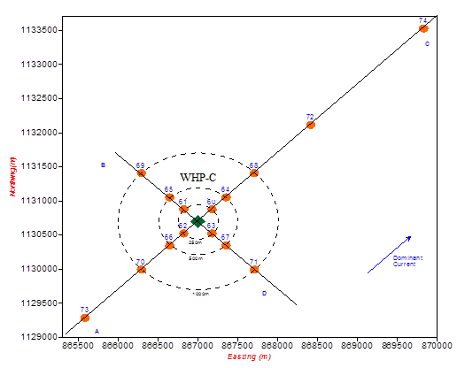

Figure 5.5 Sampling Grid

**d) Monitoring Parameters and Analytical Procedures**

|  |  |  |  |  |  |  |  |  |  |  |  |  |  |  |  |
| --- | --- | --- | --- | --- | --- | --- | --- | --- | --- | --- | --- | --- | --- | --- | --- |
| T**able 5.5 Analytical Parameter & Procedure Of Seawater** | **Analytical Instrument** | Water quality logger YSI-3800 | Water quality logger YSI-3800 | Water quality logger YSI-3800 | Oxygen meter WTW -OXI-197 Germany Temperature incubator – I.S.Co - Italia | - | Oxygen meter WTW -OXI-196 - Germany | Spectrofluorometer - Perkin Elmer LS50B - USA | Atomic Absorption Spectrophotometer & Hydride vapor generator - Shimadzu 6501S - Japan | Atomic Absorption Spectrophotometer - Shimadzu 6501S - Japan | Atomic Absorption Spectrophotometer - Shimadzu 6501S - Japan | Atomic Absorption Spectrophotometer - Shimadzu 6501S - Japan | Atomic Absorption Spectrophotometer - Shimadzu 6501S - Japan | Atomic Absorption Spectrophotometer - Shimadzu 6501S - Japan | Microscope Leica |
| **Analytical Method** | Glass Electrode pH Meter | Thermister or metal resistance thermometer | Based on conductivity | 5 day incubation method | Filtration-Gravimetry | Membrane Electrode measurement | Hexane Extraction-Ultraviolet fluorescence Spectrometry | Atomic Absorption Spectrometry (cold vapor technique) | Atomic Absorption Spectrometry | Atomic Absorption Spectrometry | Atomic Absorption Spectrometry | Atomic Absorption Spectrometry | Atomic Absorption Spectrometry | Taxon Identification, Biomass |
| **Monitoring Parameters** | PH | Temperature | Salinity | Biological Oxygen Demand (BOD) | Total Suspended Solids | Dissolved Oxygen (DO) | Total Oil Content (TOC) | Mercury (Hg) | Lead (Pb) | Cadmium (Cd), Chromium | Zinc (Zn) | Cu | Ba | Plankton |

|  |  |  |  |  |  |  |  |  |  |  |  |  |  |
| --- | --- | --- | --- | --- | --- | --- | --- | --- | --- | --- | --- | --- | --- |
| **Table 5.6** **Analytical Parameter & Procedure Of Seabed Sediment** | **Analytical Method** | Sieve and Laser diffraction method | Weight Loss in Ignition | Hexane Extraction-Ultraviolet, Absorption Spectrometry | Atomic Absorption Spectrometry (cold vapor technique) | Atomic Absorption Spectrometry | Atomic Absorption Spectrometry | Atomic Absorption Spectrometry | Atomic Absorption Spectrometry | Atomic Absorption Spectrometry | Gas Chromatography | Gas Chromatography - Mass Spectrometry | Taxon identification, biomass determination |
| **Analytical instrument** | Laser analyzer 22 – Fritsch – Germany | Muffle furnace – Gallenkamp -UK | Spectrofluorometer - Perkin Elmer LS50B - USA | Atomic Absorption Spectrophotometer & Hydride vapor generator – Shimadzu 6501S - Japan | Atomic Absorption Spectrophotometer – Shimadzu 6501S - Japan | Atomic Absorption Spectrophotometer - Shimadzu 6501S - Japan | Atomic Absorption Spectrophotometer - Shimadzu 6501S - Japan | Atomic Absorption Spectrophotometer - Shimadzu 6501S - Japan | Atomic Absorption Spectrophotometer - Shimadzu 6501S - Japan | Gas Chromatograph HP 6890 - Hewlett Packard, USA | Gas Chromatograph - Mass Spectrometer - HP 6890-S5972A - Hewlett Packard, USA | Microscopes - Leica - Germany |
| **Kind of Analyses** | Particle size Distribution | Total Organic Matter | Total Hydrocarbon Content | Mercury (Hg) | Zinc (Zn) | Lead (Pb) | Barium (Ba) | Copper (Cu) | Chromium (Cr) | Hydrocarbon Element analysis (NPD) | Polycyclic aromatic hydrocarbon (PAH) | Benthic fauna |

### Environmental Monitoring Program for Decommissioning Phase

According to regulations of Decision 40/2007/QĐ-TTg dated on 21st, March 2007 about decommisioning fixed works, equipment and machineries that support oil and gas operations, CLJOC will implement environmental monitoring program for decommissioning phase as described below:

* Before implementing the decommissioning operation, CLJOC will monitor the environmental status of surrounding area of STT FFD Phase 1 ’s facilities, set up and send environmental monitoring report to MONRE. Sampling location, number of sample and analyzing parameters are similar to field environmental monitoring program that already described above;
* Beside, 9 months after finishing decommissioning activities, CLJOC will monitor again, set up and send final environmental monitoring report to MONRE and PVN. Subject of these two monitoring reports is to assess the impacts of decommissioning activities to surrounding area by comparing environmental status before and after decommissioning phase.

Detail the EMP for decommissioning phase will be submitted to the authority for approval before decommissioning STT facilities such as ST-PIP, WHP-C and ST-LQ.

# PUBLIC CONSULTATION

As the decision No. 18/2015/ND-CP dated on 14 February, 2015 about *“Strategic Environmental Impact Assessment, Environmental Impact Assessment and Commitment of Environmental Protection”*: before conducting the project, project’s owner must carry out the public consultation of the communcial authority and the directed affected residents. With this project, STT Field locates in the offshore area which can not define which commune will manage the field as well as there are no directly affected residents from the project (because there is a safe area with the radius of 500m surrounding the petroleum platforms). So that, CLJOC do not implement the public consultation during the EIA process for STT FFDP Phase 1.

# CONCLUSIONS, RECOMMENDATIONS AND COMMITMENTS

## CONCLUSIONS

The STT FFDP1 Project, a part of the STT FFD Plan, was approved to be exploited by authorities (MoIT and PVN). This project consists of following works:

* Install a gas compression and re-injection platform (ST- PIP) bridged to the existing WHP-C;
* Install a living quarter platform (ST-LQ) bridged to the ST-PIP;
* Modify the WHP-C to connect with the ST-PIP;
* Install the bridges connecting ST-PIP with WHP-C and ST-LQ;
* 1 x 10” Maximum and J-Tube, one 10” insulated production export line, from ST-PIP to be tie-in the WHP-C for routing to STV-CPP;
* 1 x 6" diameter riser for lift gas lift;
* 01 stream production pipeline 6” and cable from WHP-C to ST-P&IP
* Cable from ST-PIP to ST-LQ to for providing power and communication to ST-PIP;
* Convert two production wells ST-1P and ST-2P to re-injection wells;
* Drill 02 new wells ST-5P and ST-6P as the production wells.

After finishing offshore installation, and commission activities, the first gas flow of this project is expected to obtain in quarter 4 of 2016. Deployment of this project will bring many benefits as follows:

* Contribute to the national energy security program.
* Provide inputs for the petrochemical industry and reduce dependence on foreign countries.
* Promote development of society and economy of Binh Thuan and Ba Ria – Vung Tau provinces by tax.

Beside above positive impacts, implementation of this project will also cause some main negative impacts on environment as follows:

* Air emission is mainly generated from fuel assumption for running the gas generators on ST-PIP, ST-LQ and the diesel engines on the supply vessels during the production phase;
* Impacts of drilling discharges including the WBM and SBM drill cuttings;
* Wastewater is mainly domestic sewage on drilling rig, drainage water and the produced water on ST-PIP, ST-LQ and STV-CPP;
* Solid wastes from installation operation, drilling and production phases are mainly food wastes, rubbish & general waste and hazardous wastes such as chemical bags, SBM sludge and oily wastes;
* Physical interaction;

Some conclusions about impacts of project’s implementation on environment are presented as bellows:

***Impacts of Air emission***

Main component of air emission generated from project implementation includes CO2, CO, NOx, SOx, CH4 and VOC, in which CO2 occupies approximately 98%.

* During the installation, construction and commissioning phase, air emission mainly generates from exhaust of engines and machines on means that construct and install the ST-PIP, ST-LQ platform, transform the WHP-C, build and construct bridges and commissioning activities. Estimated total time for this phase is 182 days with about 26 vessels and estimated emission to environment is approximately 13,950 tons including CO2 (13,632 tons - occupied 98%), CO (34.1 tons), NOx (251.3 tons), SO2 (21.3 tons), CH4 (1.2 tons) and VOC (10.2 tons). Impact level of air emission in this phase is assessed as negligible.
* During the drilling phase, air emission mainly generates from exhaust of the generators on the drilling rig, engines on supply vessels and helicopter. Total emission is about 6,832 tons, in which air emission from generators on the drilling rig about 63.4% and vessels engines about 35.1% (occupied 98% total emission). Impact level of air emission in this phase is assessed as negligible.
* During the production phase, air emission is originated mainly from burning a part of associated gas at flare of ST-PIP in order to maintain production pressure, supply vessels, helicopter and generators on the ST-PIP. Total emission to environment is about 428.6 tons/day (in which CO2 occupies 98% total emission). Impact level of air emission in this phase is assessed as negligible.
* In emergency case, a volume of produced gas stream in the process system on ST-PIP will be routed to flare for ignition. Total volume of emissions generated from the flaring system in this case is about 383 tons/time which cause insignificant impact on the ambient air quality.

In general, air emission will disperse quickly in offshore atmosphere and its impact on environment is assessed as negligible.

Air emission of the STT FFDP1 is equivalent to the emission of STV Northeast Field Development project and occupies about 1% total emission of Block 15-1. Thus, with different distance between fields of Block 15-1, accumulate impacts of this project and production activities of Su Tu fields are assessed as negligible. This air emission will contribute to green-house gases discharge (a reason of green-house phenomenon, and climate change) but impact level is negligible.

***Impacts of wastewater***

* During the installation, construction and commissioning phase, domestic wastewater generated from daily activities of workers who participate in offshore facilities construction and installation during 182 days is about 6,180 m3 (~1.3 m3/day/vessel). Domestic wastewater volume is quite small and received environment is sea with high recoverable thus influence level of domestic wastewater on environment in this phase is assessed as negligible.
* During the drilling phase, estimated domestic wastewater volume is approximately 14m3/day and deck drainage wastewater (generate in rainy season) is about 1,600 m3. Impact level of domestic and deck drainage wastewater is assessed as negligible to minor and in short term.
* During the production phase, produced water is considered as main wastewater. Mean volume of produced water is about 910 barrels/day (approximately 150 m3/day). Produced water is separated from fluid on ST-PIP will be routed to produced water treatment system on STV-CPP. This system was designed with capacity of 130,000 barrels/day (can meet treatment capacity of total produced water from existing fields such as: STV, Northeast STV, Southwest STV, Northeast STĐ, STN, STT, etc. (approximately 65,000 barrels/day).

Treated produced water meets allowed requirements can be discharged into the sea. Under impacts of wave and current at the region, produced water will be diluted quickly in sea water, hence effect of discharging produced water on sea environment is considered at minor level.

***Impacts of solid waste discharge***

The solid wastes which are generated from all phases of the STT Full Field Development - Phase 1 implementation will be classified at sources and stored in the clearly labeled skips prior to being shipped ashore for proper treatment, recycling or disposal in accordance with Vietnam regulations (Circular 36/2015/ TT-BTNMT- Rules on hazardous waste management).

* Food waste will be ground to size less than 25 mm before discharging into the sea.
* Other solid wastes will be functional contractors treated as follows:

Non-hazardous waste will be Gia Linh construction and service company (sub-contractor of PTSC SB) treated and disposed. Paper, carton, plastic, metal will be re-used and re-cycled;

Hazardous wastes will be classified on rig and stored in clearly label skips and suitable cap, after that these wastes will be shipped to shore by vessels of PTSC Marine and treated by Holcim company.

CLJOC will closely supervise the waste transportation, treatment and disposal, especially hazardous wastes to ensure that all solid wastes must be treated properly and in compliance with the legal requirements of Vietnam.

With above mentioned solid waste management procedures and the proper implementation of these procedures, the supervision of waste handling and treatment contractors, and the close cooperation with the provincial authority of Ba Ria – Vung Tau of CLJOC, the environmental impacts related to solid waste treatment and disposal will be minimized to minor level to negligible.

***Impacts of drilling cuttings discharge***

The STT FFDP 1 will drill two new production wells ST-5P & ST-6P. CLJOC plans to use WBM for hole sections 30” & 16” and SBM (NEOFLO 1-58) for hole sections 12-1/4”,9- 1/2” & 6”. NEOFLO 1-58 was permitted to use for drilling activities in Block 15-1 since 2007 by Ministry of Industry (recently Ministry of Industry and Trade) and MoNRE.

The PVD1 platform is equipped a solid control system including: VSM 300 share shaker system with 4 separate shakers; 2 centrifuges with velocity of 4000 circles/minute, capacity of 757 liters/minute, and 1 Vacuum Dryer (supplied by Halliburton in 2007) with capacity of 8 tons/hour and 1 sand separator to ensure that oil on drilling cuttings will be rejected. After treating, SBF on the drilling cuttings will be reduced less than allowable limitation (under 9.5% weight cuttings) before discharging ito the sea.

Estimation of 2,811 tons of WBM cuttings and nearly 695 tons SBF cuttings as well as 9,200 barrels un-used WBM will be discharged to the sea after finishing drilling activities. Basing on modeling results of WBM and SBM dispersion, after discharging into the sea, drilling cuttings trend to disperse to Southwest direction within 180-600 m from ST-PIP. The farthest distance is about 600 m. Total area of accumulation of drilling cuttings is approximately 0.07 km2.

The baseline and the environmental post-drilling monitoring results of CLJOC at Block 15-1 showed that the discharge of SBM drill cuttings caused the local and short-term impacts on seabed sediment (about 1 year in case of using NEOFLO 1-58 and from 1-2 years of using SARALINE for many drilling wells). This corresponded with the studies on SBM impacts on the marine environment which were conducted by the international petroleum industry and research divisions as well as Vietnamese divisions in the recent years.

In short, based on the analytical results and the Impact Quantitative System (IQS), the physical and chemical characteristics of the WBM and SBMs (NEOFLO 1-58) with a high receiving capacity environment found in study area, it can be concluded as follows: impact level of WBM and SBM discharging on sea environment is considered as minor to significant. .

***Physical disturbance***

Activities such as vessel anchoring, jacket piling during the facilities installation and the presence of new rigs and infield pipeline system of the project will cause strong disturbance of the seabed sediments and benthic community in the installation area in short time.

Transportation of facilities and installation activities of barges /vessels will increase shipping traffic density at the project area and the vicinities that may cause potential shipping collisions and occupying fishing grounds as well as interference of fishing activities in the project area.

Above physical impacts are assessed as locally, temporary and recoverable after finishing activities that may cause disturbance on seabed.

***Accidental and Non- Routine Events***

Potential accidents that need to be considered include: gas release, oil spills, fire and explosion, shipping collision, dropped object and debris into the sea. In case large oil spill occurred, the potential impacts on the natural environment, socio-economy and human life is significant. However, there is a low probability of accidents occurring during construction, commissioning and operations of the STT field because CLJOC will apply risk management processes to identify, understand and communicate HSE risks and achieve the co-operation and controls necessary to eliminate and mitigate or reduce risks during the project implementing. CLJOC will manage risks by providing competent risk management resources to ensure the incident to be prevented, reduced or appropriately controlled. In order to protect employees, the environmental and assets, STT’s facilities, system and equipment are designed, constructed, commissioned, operated, maintained and de-commissioned in accordance with current International and Vietnamese Standards .

To promptly response to the unusual incidents, CLJOC has established the Crisis Management System and Emergency Response plan and Offshore & Onshore Oil Spill Contingency Plans (OSCPs) for the operations in whole Block 15-1. CLJOC is also carry out some training courses in emergency response for project’s staffs. Moreover, CLJOC with their recorded experience in the oil and gas activities will conduct this project in the safest and most efficient way that should enable the potential for accidental event to be minimized, reduced and controlled.

Together with the above-mentioned Crisis Management & Emergency Response Incident Management System and Oil Spill Contingency Plan, CLJOC has established and implemented a comprehensive HSE Management System in line with international that includes the Environmental Management and Environmental Monitoring Programs. The overall aims of both programs are to carefully manage and minimize environmental changes in the project area and to provide guidance for the development of appropriate and applicable environmental standards and to ensure that waste discharges from the production facilities always meet the allowable limits.

***Social Impacts***

Being an offshore operation project, STT Full Field Development Phase 1 project is likely not to impose significant impact on the environment, communities and economic activities of coastal and onshore areas. All supporting services will be supplied from the current PTSC base at Vung Tau so that there is not necessary to develop new onshore base for supporting the project.

The reduction of fishing area is considered minor in the installation phase only. When project comes into production phase, fishing activities will not allow in the safety zone of the 500m surrounding project WHPs.

Normal operation of STT Full Field Development Phase 1 will not cause any effect to tourism activities of coastal provinces as Binh Thuan and Ba Ria- Vung Tau. Depending on the wind season, the coastal tourism activities might be affected if major oil spill is occurred in the project site. However, probability of this situation is very small and CLJOC had measures for prevention, response and management incident.

In term of economic benefits, as above mentioned, project will increase oil production rate at Block 15-1 and will contribute the economic growth of Vietnam.

In short, beside the implementation of environmental protection measures that mentioned in this report, CLJOC will continue closely coordinate with relevant organizations, local authorities and other functional authorities of Vietnam to ensure that environmental pollution during execution of the STT FFDP1 project will be prevented and mitigated.

## RECOMMENDATIONS

According to project target, CLJOC will start installation on October 2015 and anticipate first gas injection at the quarter 4 of 2016. Therefore, CLJOC is kindly proposed the Ministry of Natural Resource and Environment (MONRE) to approve this EIA report to hasten the project progress.

## COMMITMENTS

CLJOC and all relevant Contractors commit to conduct our business in a manner that protects the safety, health and well being of our employees, contractors and neighbors as well as respects and cares for the environment protection. To accomplish this, during implementation of STT Full Field Development Phase 1, CLJOC commits:

1. Strictly implement the requirements of the MoNRE Decision of Approval to the Environmental Impact Assessment for STT Full Field Development Phase 1 and mitigation measures that are presented in the approved Environmental Impact Assessment report;
2. CLJOC will comply with all relevant obligations of Vietnamese Law, regulations and HSE procedures developed by CLJOC as well as the international conventions which Vietnam complied to apply as follows:

* Produced water: Ensuring the daily average of oil content in the treated produced water do not exceed 40 mg/l before discharged into sea, which is complied with the QCVN 35:2010/BTNMT - National Technical Regulation on discharged produced water for offshore oil and gas facilities and “Regulations on Environmental Protection in Petroleum Prospecting, Exploration, Field Development, Production, Storage, Transportation and Processing, and Related Services”, Promulgated with Circular No. 22/2015/BTNMT of MoNRE ratified on 28/5/2015 about the regulations on environmental protection of using the drilling muds, waste management and monitoring for offshore petroleum activities;
* Oily wastewater from open drain system: Ensuring the oil content in the treated wastewater is not over 15ppm before discharged into the sea, which is complied with regulations of MARPOL 73/78;
* Domestic wastewater: The wastewater will be treated according to Annex IV of Convention MARPOL 73/78 and the Circular No. 22/2015/TT-BTNMT dated on 28 May 2015 before discharged into the sea;
* Use the Water Based Drilling Fluid and Synthetic Based Drilling fluid NEOFLO 1-58 that was approved by Ministry of Industry and Trade (MOIT) for drilling activities in Block 15-1 since 2007 and 28th of March 2012 respectively. If the other synthetic drilling fluids are issued, they have to be approved by the Vietnam Authority;
* Used NEOFLO 1-58 and SARALINE-185 V drilling mud will be recovered and returned to shore for storage and re-cycle and re-use for next drilling campaign;
* CLJOC will strictly comply with the QCVN 36:2010/BTNMT– National Technical Regulation on discharge of drilling fluids and drilling cuttings for offshore oil and gas facilities. Concentration of synthetic drilling mud on discharged Synthetic Drill Cuttings meet the allowable limit (<9.5 %) of cuttings weight per approved by MoNRE;
* CLJOC or independent specialists will regularly inspect the relevant environmental management and environmental protection equipment including the wastewater treatment system, solid waste treatment system, oil-water separator and follow-up actions are completed and repair errors; maintaining and regularly testing capabilities of emergency response;

1. Provide appropriate means, resources and expense to implement the environmental protection activities and meet proposed HSE targets. In addition, CLJOC will quarterly pay environmental fee for Binh Thuan Province in compliance with *“Environmental protection charges for wastewater” -* Decree No. 67/2003/ND-CP promulgated on June 13th 2003 and Decree No. 04/2007/ND-CP promulgated on January 8th 2007 about *“Amending and Supplementing a number of Articles of the Government’s Decree No. 67/2003/ND-CP”*.
2. Implement waste management according to Circular No.36/2015/TT-BTNMT promulgated on 30 June 2015 of MoNRE - Rules on *Hazardous Waste Management and* Circlar No. 38/2015/TT-BTNMT dated 24th April 2015 on Waste and Scrap Management.
3. CLJOC had registered the hazardous waste generator to DONRE of Binh Thuan Province complying with *“Guidelines on Practice, Procedure for Registration, Issuance Certificate and Code of Hazardous Waste Management”* - No.36/2015/TT-BTNMT promulgated on 30 June 2015 of MoNRE.
4. CLJOC commits that chemicals for this project will be complied with the 2007 Vietnamese Law of Chemical and Guidelines for the implementation of requirements on use and discharge of chemicals and drilling fluids in petroleum operations offshore Vietnam of PVN in 2006.

Conduct the approved environmental Monitoring Program in order to identify and assess any changes in environmental quality. Environmental Monitoring Program of the project will be complied with *“Guideline on Monitoring and Analyzing Offshore Environment and The Vicinities of Petroleum Constructions in Offshore Vietnam Sea” –* Petrovietnam – Ha Noi, 2014.

1. Use the exact type of drilling fluid as approved by MoNRE;
2. Establish Emergency Contingency Plan and Oil Spill Response Plan to response the oil spill incident and any emergency incident. All preventive methods shall be implemented to minimize the impacts of spills on human, property and environment.

* Train relevant staffs in oil spill and emergency response activities;
* Maintain the communication system properly and to cooperate closely with all relevant organizations, the governmental authorities (PVN, as MoNRE, The National Committee of Search and Rescue (VINASARCOM) and the provincial authorities such as Binh Thuan and Ba Ria- Vung Tau DONREs;
* If the dispersant must be used in case necessary, CLJOC commits use of the dispersants that are approved by MoNRE only.

1. In the case of any environmental accident, CLJOC will take responsibility of conducting the urgent response, applying the mitigation measures for reducing the damage and the loss of people and property; CLJOC will take the responsibility for cleaning up and compensating all loses in compliance with Vietnamese legislative requirements.

Decommissioning procedure of offshore production facilities of the project will be complied with the Decision No.40/2007/QĐ-TTg promulgated on March 21st 2007 of Primary Ministry about “Decommissioning of Fixed Installations, Equipment and Facilities used for Petroleum Operations” and Decision No.37/2005/QD-BCN promulgated on November 25th 2005 of Ministry of Industry (presently named Ministry of Industrial and Commercial Ministry) about “Regulations for Petroleum Well Maintenance and Abandonment”;

1. All CLJOC Managers and Supervisors are responsible for implementing the mitigation measures for environmental protection and associated activities into the design, fabrication, installation, operation and maintenance of the facilities under their control. Employees are responsible for following the HSE standards and procedures, following instructions given by CLJOC leaders and to take reasonable precautions to prevent accidents and protect the environment.

**REFERENCES**

|  |  |
| --- | --- |
| [1] | **Petroleum Geology and Resources**  Petrovietnam, Science and Technology Publisher, 2006 |
| [2] | **Introduction of Phu Quy Island**  [www.daophuquy.com](http://www.daophuquy.com) |
| [3] | **Introduction of Con Dao Island**  [www.sokhcn.baria\_vungtau.gov.vn/condao](http://www.sokhcn.baria_vungtau.gov.vn/condao) |
| [4] | **Record data of wind and current regimes in Block 15-1,**  CLJOC 2014 |
| [5] | **Statistical data of hydrometeorology in the recent years**  *SOUTHERN REGION HYDRO METEOROLOGICAL CENTER, 2014* |
| [6] | **A review of the Current Vietnamese Earthquake Design Code.**  T.D. Ngo, M.D Nguyen, D.B Nguyen |
| [7] | **Risks of Tsunamis in Vietnam**  Global Physic Institute (Vietnam Technological and Scientific Institute), 2007 |
| [8] | **Hydrometeorological data of Binh Thuan province in 2014**  *Binh Thuan Hydro Meteorological Center, 2014* |
| [9] | **STD/STV Full Field Development Project**  CLJOC, 2007 |
| [10] | **Current condition and development orientation of Binh Thuan fishery industry**  Dr. LUONG THANH SON -2012 |
| [11] | **Marine resources of the sea from Binh Thuan to Danang provinces**  PhD.Dr.PHAM THUOC - ACTTARE, HAI PHONG, 2009 |
| [12] | **Vietnam Redbook – Volume 1: Fauna**  MINISTRY OF SCIENCE, TECHNOLOGY AND ENVIRONMENT, 1992 |
| [13] | **STN Early Production Scheme Project – 2012**  CLJOC, 2012 |
| [14] | **Characteristics of environment and marine resources of East Sea**  Institute of oceanography, 1995 |
| [15] | **Reforestation of mangroves after severe impacts of herbicides during the Viet Nam war: the case of Can Gio**  PHAN NGUYEN HONG, Centre for Natural Resources and Environmental Studies, Viet Nam National University, Hanoi. |
| [16] | **Introduction of Con Dao National Park**  [www.vncreatures.net/mapcd.php](http://www.vncreatures.net/mapcd.php) |
| [17] | Fate and Effects of Naturally Occurring Substances in Produced Water on the Marine Environment.  INTERNATIONAL ASSOCIATION OF OIL AND GAS PRODUCERS (OGP) (2005). Report No. 364. |
| [18] | **Environmental Emissions Monitoring System. Atmospheric Emissions Inventory Guide for Data Submission by Offshore Operators.**  UNITED KINGDOM OFFSHORE OPERATORS ASSOCIATION LIMITTED, E (1999). 2nd ed., Scopec International Ltd., Aberdeen, UK. |
| [19] | **Research on longterm impacts of SBM on marine creatures of Vietnam.**  CPSE, CLJOC, JVPC and UNOCAL VIETNAM EXPLORATION, LTD. (2003). |
| [20] | “**Composition, Environmental fates, And Biological Effects Of Water Based Drilling Muds And Cuttings Discharged To The Marine Environment: A Synthesis And Annotated Bibliography”**.  Petroleum Environmental Research Forum (PERF) and American Petroleum Institute and Jerry M. Neff (January, 2005). *The Battelle*. 83 pages. |
| [21] | **Environmental Assessment for Final Effluent Limitation - Guideline and Standard for Synthetic Based Drilling Fluid and other Non-Aqueous Drilling Fluid in the Oil and Gas Extraction Point Source Category.**  UNITED STATE ENVIRONMENTAL PROTECTION AGENCY – 43 CFR parts 9 and 435. USA. |
| [22] | ***Research on toxicity test of SBFs (Salarines, Neo-flo 1-58, LAO) using for the drilling activities in Block 15-1.***  CLJOC, CPSE and Geotech in Australia (2001-2009). |
| [23] | ***The first Vietnam diurnal report of United Nations Convention of Climate Change in 2014***  MINISTRY OF NATURAL RESOURCES AND ENVIRONMENT, 2014 |
| [24] | Fate and Effects of Naturally Occurring Substances in Produced Water on the Marine Environment.  INTERNATIONAL ASSOCIATION OF OIL AND GAS PRODUCERS (OGP) (2005). Report No. 364. |
| [25] | **Biological Impacts of Oil Pollution: Coral Reef.**  IPIECA, REPORT SERIES – VOLUME THREE (1992). |
| [26] | **Biological Impacts of Oil Pollution: Mangroves.**  IPIECA, REPORT SERIES – VOLUME FOUR (1993). |